☕ Cafe Sales Data Analysis Report
Exploratory Analysis of 2023 Transaction Data

Generated: 12 October 2026

1. Executive Summary
This report presents an exploratory data analysis of the Cafe Sales dataset for the year 2023. After cleaning, the dataset contains 9,469 transactions spanning all twelve months, representing a total revenue of £84,448.50. The average transaction value is £8.92, and a total of 28,590 units were sold across eight product categories. The best-selling item by revenue was Salad, and peak sales month was Jun.

Metric | Value
Total Transactions | 9,469
Total Revenue | £84,448.50
Avg Transaction Value | £8.92
Total Units Sold | 28,590
Top Item | Salad
Peak Month | Jun

2. Data Quality & Cleaning
The raw dataset contained 10,000 rows with significant quality issues including sentinel strings ('ERROR', 'UNKNOWN'), blank cells, and unparseable dates. The cleaning pipeline performed the following steps:
- Replaced all 'ERROR' and 'UNKNOWN' sentinel strings with NaN.
- Parsed Transaction Date; rows with unparseable dates were dropped.
- Imputed missing Price Per Unit from the known item price lookup table.
- Imputed missing Item from Price Per Unit where unambiguous.
- Derived Quantity from Total Spent ÷ Price Per Unit where possible.
- Derived Total Spent from Quantity × Price Per Unit where possible.
- Dropped rows still missing core numeric fields after imputation.
- Filled remaining missing Payment Method and Location with 'Unknown'.
- Derived time-series columns: Month, Month_Name, Day_of_Week, Quarter.

Cleaning Log Summary
CAFE SALES — DATA CLEANING LOG
Raw rows loaded : 10000
Sentinel→NaN in 'Item': 636 cells
Sentinel→NaN in 'Quantity': 341 cells
Sentinel→NaN in 'Price Per Unit': 354 cells
Sentinel→NaN in 'Total Spent': 329 cells
Sentinel→NaN in 'Payment Method': 599 cells
Sentinel→NaN in 'Location': 696 cells
Sentinel→NaN in 'Transaction Date': 301 cells
Unparseable dates dropped: 460
Rows dropped (no date) : 460
Rows dropped (still missing core fields): 71
Rows dropped (unrecognised item): 0
Clean rows remaining : 9469
Total rows removed : 531 (5.3%)
Cleaned CSV saved → outputs\cleaned_cafe_sales.csv

3. Revenue Analysis

3.1 Revenue by Item
Item | Total Revenue | Transactions | Avg Value
Salad | £18,200.00 | 1212 | £15.02
Smoothie | £15,300.00 | 1248 | £12.26
Sandwich | £13,068.00 | 1071 | £12.20
Juice | £12,027.00 | 1344 | £8.95
Cake | £9,834.00 | 1081 | £9.10
Coffee | £7,480.00 | 1234 | £6.06
Tea | £5,125.50 | 1134 | £4.52
Cookie | £3,414.00 | 1145 | £2.98

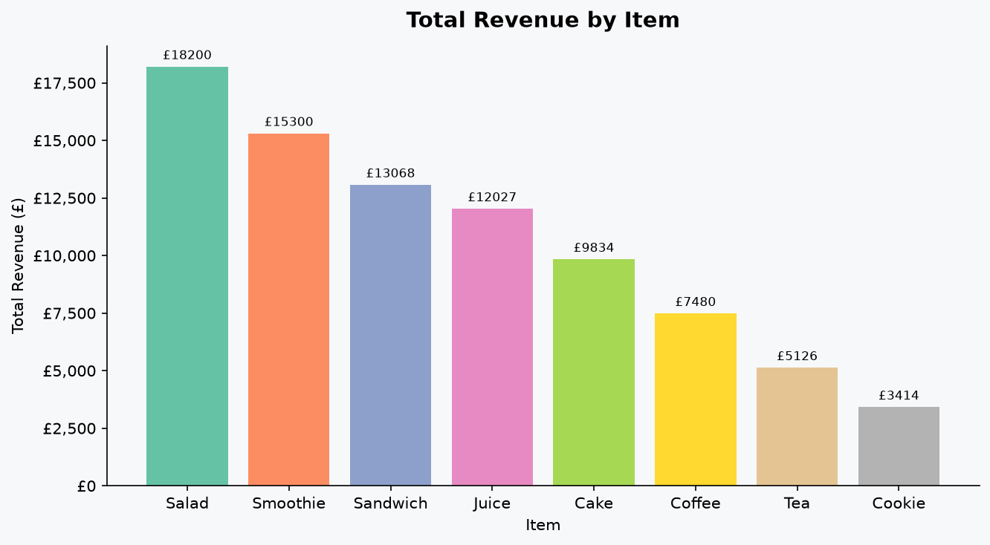
Figure 1 – Total Revenue by Item

3.2 Monthly Revenue Trend
Month | Revenue
Jan | £7,238.00
Feb | £6,608.00
Mar | £7,156.00
Apr | £7,164.00
May | £6,872.50
Jun | £7,334.00
Jul | £6,806.50
Aug | £7,092.50
Sep | £6,851.00
Oct | £7,269.00
Nov | £6,941.00
Dec | £7,116.00

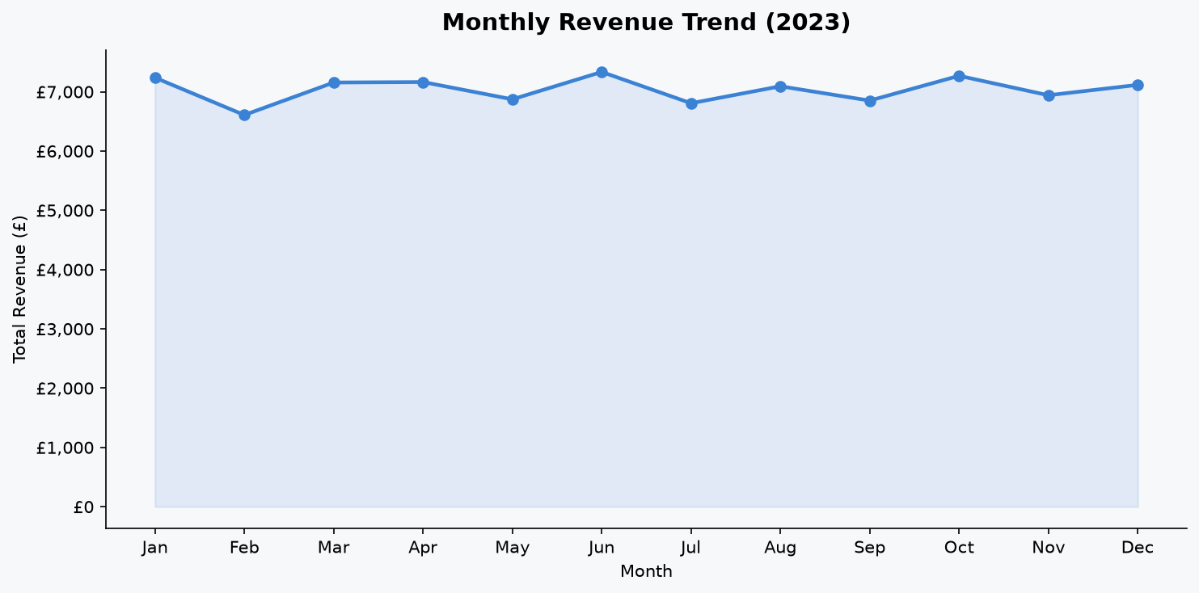
Figure 2 – Monthly Revenue Trend (2023)

3.3 Quarterly Revenue
Quarter | Revenue | Transactions
Q1 | £21,002.00 | 2357
Q2 | £21,370.50 | 2349
Q3 | £20,750.00 | 2364
Q4 | £21,326.00 | 2399

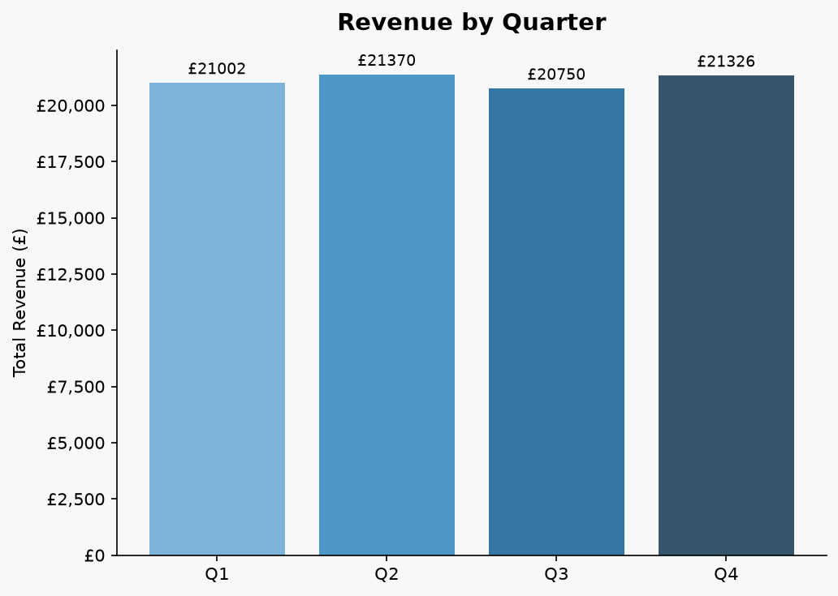
Figure 8 – Revenue by Quarter

4. Sales Volume by Item
Item | Units Sold
Juice | 4009.0
Smoothie | 3825.0
Coffee | 3740.0
Salad | 3640.0
Tea | 3417.0
Cookie | 3414.0
Cake | 3278.0
Sandwich | 3267.0

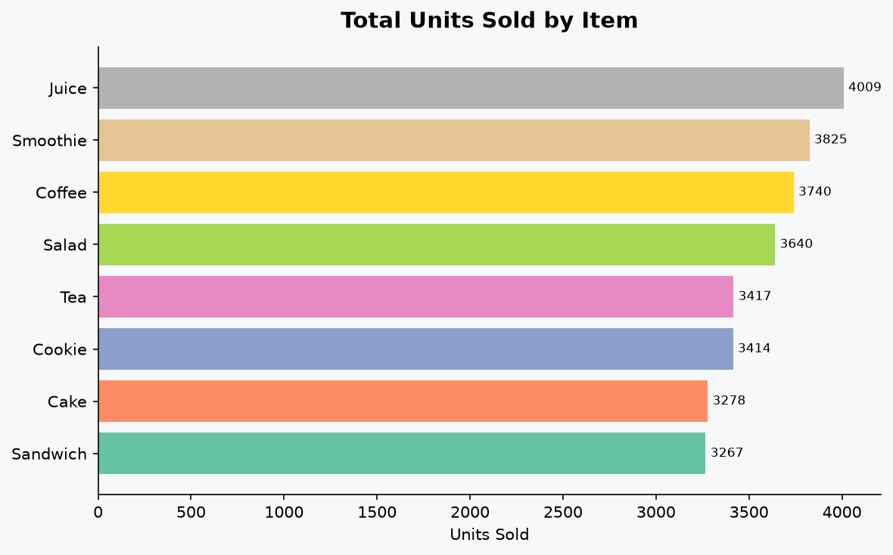
Figure 3 – Total Units Sold by Item

5. Customer Behaviour

5.1 Payment Methods
Payment Method | Transactions | Share %
Digital Wallet | 2183 | 33.7%
Credit Card | 2151 | 33.2%
Cash | 2148 | 33.1%

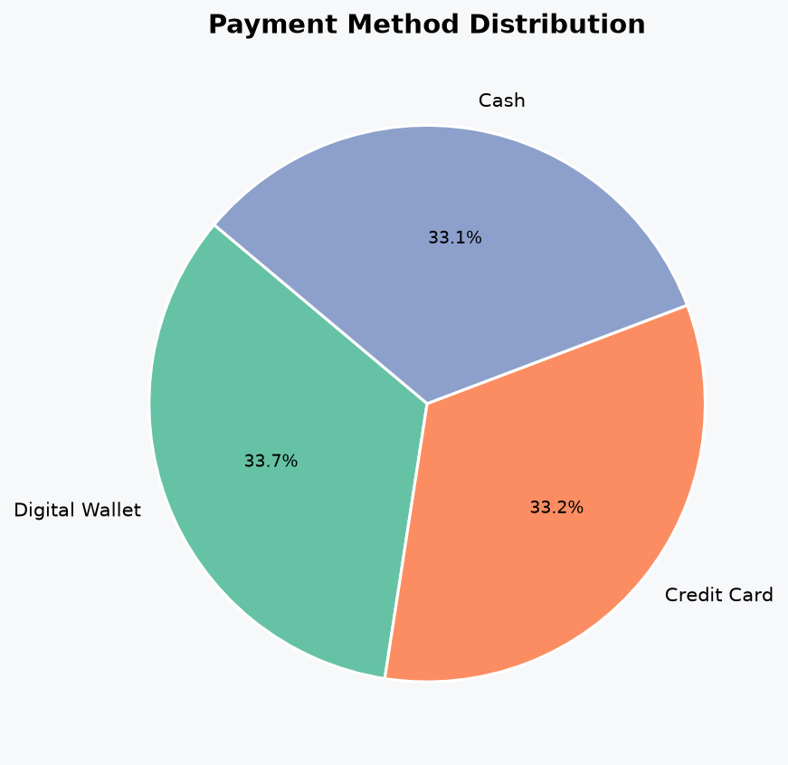
Figure 4 – Payment Method Distribution

5.2 Location
Location | Transactions | Share %
Takeaway | 2869 | 50.2%
In-store | 2850 | 49.8%

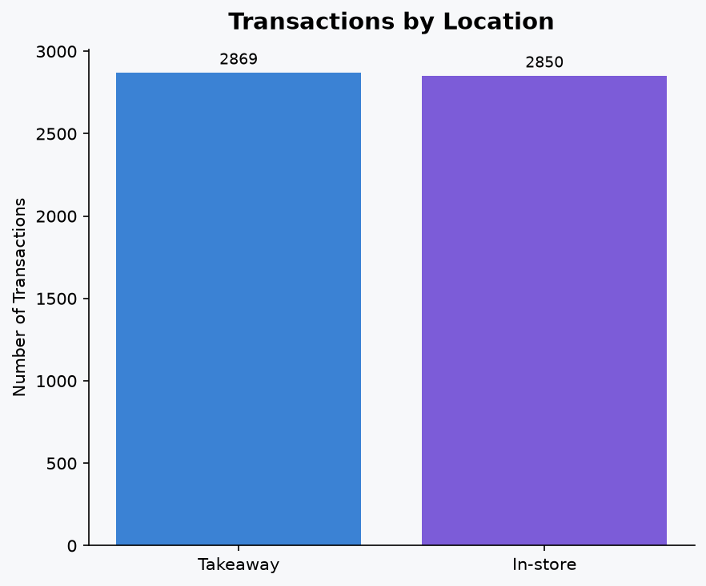
Figure 5 – Transactions by Location

6. Sales Patterns Over Time

6.1 Day-of-Week Revenue
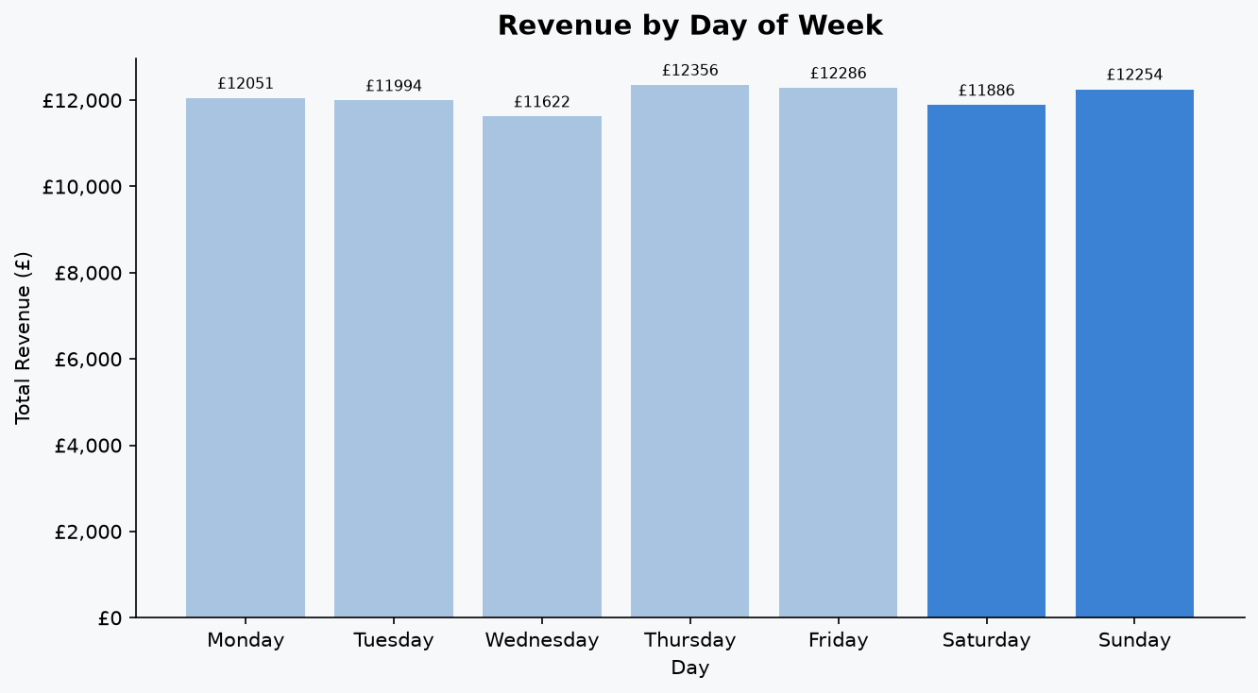
Figure 6 – Revenue by Day of Week

6.2 Item × Month Heatmap
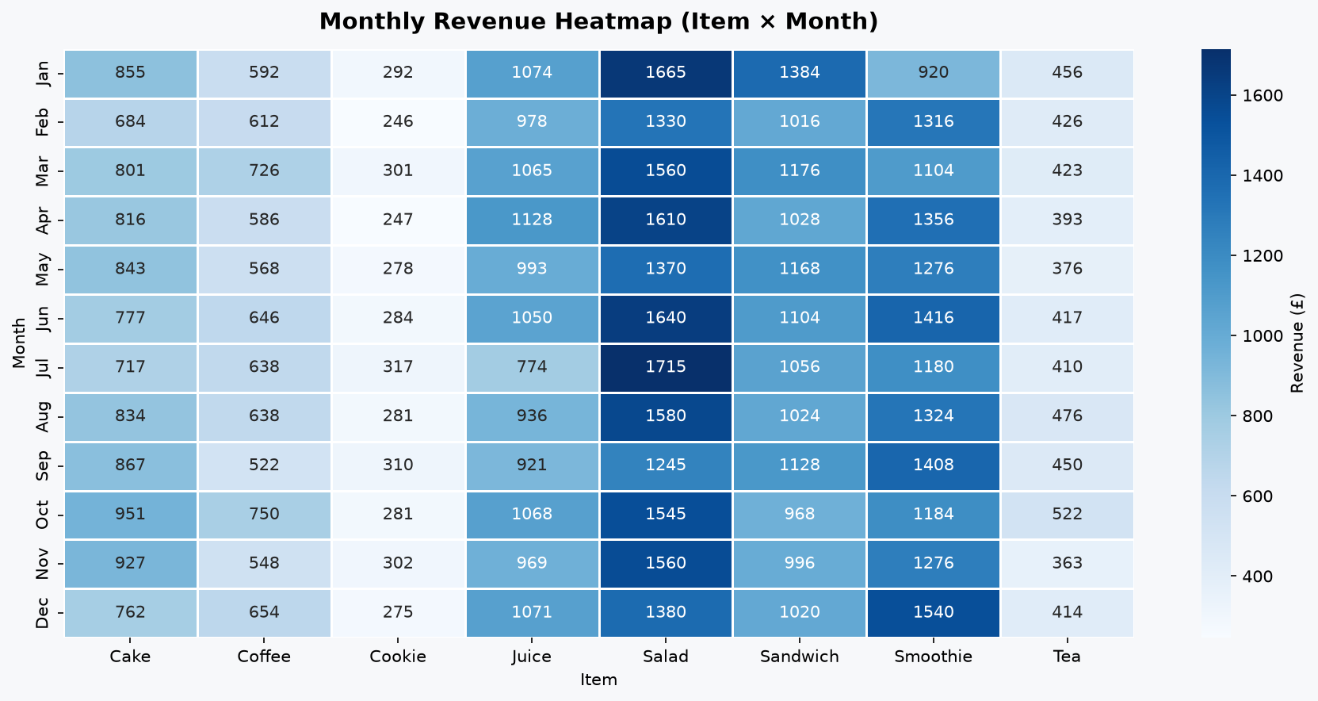
Figure 7 – Monthly Revenue Heatmap (Item × Month)

7. Key Findings & Recommendations
- Top 3 revenue-generating items are: Salad, Smoothie, Sandwich.
- Peak sales month is Jun; lowest-revenue month is Feb — consider promotions or seasonal menu changes in Feb.
- 'In-store' location drives the highest revenue and should be prioritised for staffing and stock allocation.
- Cash, Credit Card, and Digital Wallet payments are the three primary payment channels. Ensuring all three are always available reduces friction.
- The day-of-week chart shows weekend revenue — consider weekend-only specials.
- Approximately 69% of raw rows had at least one data-quality issue; investing in POS system validation would significantly improve data integrity.

Appendix – All Charts
Figure 1 – Total Revenue by Item

Figure 2 – Monthly Revenue Trend

Figure 3 – Total Units Sold by Item

Figure 4 – Payment Method Distribution

Figure 5 – Transactions by Location

Figure 6 – Revenue by Day of Week

Figure 7 – Monthly Revenue Heatmap

Figure 8 – Revenue by Quarter

Generated by Cafe Sales Data Analysis Pipeline · Python 3.15

