COLLEGE OF COMPUTER STUDIES
CMSC 203 – Object-Oriented Programming

Final Project: Object-Oriented Application Development
EVENT REGISTRATION SYSTEM
A Web-Based, Object-Oriented Management System

Submitted by:
[Group member 1]
[Group member 2]
[Group member 3]

Submitted to:
[Instructor name]

October 2026

Table of Contents
1 | Introduction
2 | Statement of the Problem
3 | Objectives
4 | Scope and Limitations
5 | System Features
6 | System Design (OOP, UML Class Diagram, Flowcharts)
7 | Screenshots of the Application
8 | Testing Results
9 | Conclusion
10 | References

1. Introduction
Schools and colleges hold many events every year, such as seminars, workshops, meet-ups and department nights. Organizers usually collect sign-ups through paper forms, group chats or spreadsheets. These methods make it hard to know how many seats are left, who actually registered and who showed up.
The Event Registration System is a web-based application built for the College of Computer Studies. Students create an account, browse upcoming events and reserve spots. An administrator creates and manages events, views every registration and records attendance. The system was written in Python using the Flask framework and applies the object-oriented programming concepts taught in CMSC 203: classes and objects, constructors, encapsulation, inheritance, polymorphism, abstraction, method overloading, abstract classes and custom exception handling. The web interface was approved by the instructor as the graphical user interface for this project.

2. Statement of the Problem
Manual event registration causes the following problems:
- Organizers cannot easily tell how many spots remain, so events can be overbooked.
- The same student can sign up several times, and records are scattered across forms and chats.
- Attendance is not recorded in a consistent way, so there is no reliable history of who attended.
- Event details (date, time, place, capacity) change often and are hard to keep updated for everyone.
- Student and event data can be lost or corrupted when stored in unorganized files.
This project addresses these problems with one system that keeps events, accounts, registrations and attendance in one place and enforces the registration rules automatically.

3. Objectives
General objective: to design and develop an object-oriented Event Registration System that lets students reserve event spots online and lets an administrator manage events and attendance.
Specific objectives:
- Provide participant sign up and login, and a separate administrator login.
- Allow the administrator to add, edit, delete, search and display events.
- Allow participants to browse, search and filter events, reserve spots, and cancel reservations.
- Prevent duplicate reservations and prevent reservations that exceed an event's capacity.
- Allow the administrator to view participants and registrations and to record attendance.
- Save and load all data in a JSON file without losing records.
- Apply the OOP principles of encapsulation, inheritance, polymorphism and abstraction in a modular code base.
- Handle invalid input, empty fields, wrong data types and file errors, including at least one custom exception.

4. Scope and Limitations
Scope
- Two kinds of users: participants (students) and one administrator.
- Free events only; a reservation reserves one or more spots (no payment).
- Event management, registration, cancellation, attendance tracking, search, filtering and dashboards.
- Data stored in a local JSON file (data.json) with atomic saving and automatic upgrade of older records.
- Runs in any modern web browser; the server is started with Python.
Limitations
- There is only one administrator account, configured through environment variables.
- The JSON file suits a small school deployment; it is not meant for thousands of simultaneous users. The Repository class makes it possible to replace it with a real database later.
- There is no email notification, password reset or QR-code check-in.
- A participant's reservation is for the whole event; seats are not individually assigned.
- Participants cannot edit their own profile after sign up.

5. System Features

5.1 Functional requirements
Requirement | Implementation
User login | Participant sign up / login (passwords stored as salted hashes); separate administrator login
Add records | Admin adds events; participants add registrations (reserve spots)
Edit records | Admin edits event details; capacity cannot go below already reserved spots
Delete records | Admin deletes events (blocked if registrations exist); participants cancel their reservations
Search records | Search boxes for events, participants, registrations and attendance; category filter for events
Display records | Dashboards, event cards, tables, profile and attended-events list
Save data | JsonRepository.save() writes data.json atomically (temporary file, then replace)
Load data | JsonRepository.load() reads data.json and upgrades older records automatically

5.2 Participant features
- Dashboard with totals, featured events and recent registrations
- Browse events, search, filter by category
- Reserve spots (1 or more) for a free event; duplicate and over-capacity reservations are rejected
- View and cancel reservations (not after attendance has been recorded)
- Profile page and Attended Events history

5.3 Administrator features
- Dashboard with total events, participants, registrations and attendees
- Add, edit, delete and search events (with title, category, date, time, location, capacity, description)
- View participants and all registrations with search
- Attendance management: mark each registration as attended or absent

5.4 Validation and error handling
- Empty fields, invalid email, short password, duplicate email or Student ID
- Invalid dates and times, past event dates, capacity that is not a whole number or is less than 1
- Permission checks: participants cannot use admin pages and vice versa
- Damaged or unreadable data file reports a clear error instead of crashing
- A failed request never saves half-finished changes (transaction rollback)

6. System Design

6.1 Architecture
The code is split into layers so that every module has one job:
Layer | Module | Responsibility
Presentation | templates/, static/ | HTML, CSS and JavaScript user interface (browser)
Routes | routes.py | Thin Flask routes; convert HTTP requests to service calls and results to JSON
Services | services/ | Business rules: AuthService, EventService, RegistrationService
Models | models/ | Domain classes: Entity, Person, Participant, Admin, Event, Registration, Database
Data access | repository.py | Repository (abstract) and JsonRepository
Support | exceptions.py, validation.py, config.py | Custom exceptions, reusable validators, settings

6.2 Object-oriented concepts applied
Concept | Where it is used
Classes and objects | Participant, Admin, Event, Registration, Database, the three services and JsonRepository
Constructors | __init__ of every class, e.g. Event(title, date, time, location, capacity, ...); factories Event.create(), Participant.create(), Registration.for_participant()
Encapsulation | Private attributes (_capacity, _password_hash, _attendance_status, _quantity) exposed through validated properties and methods; callers cannot store invalid values
Inheritance | Entity → Person → Participant / Admin; Entity → Event; Entity → Registration; Repository → JsonRepository; EventSystemError → ValidationError, ConflictError → DuplicateAccountError, etc.
Polymorphism | describe(), to_dict(), from_dict() and check_password() behave differently in each subclass but are called the same way
Abstraction | Abstract classes Entity, Person and Repository (ABC with @abstractmethod) define contracts; services depend on Repository, not on the JSON file
Method overloading | EventService.get() accepts an event id (str) or an Event object using functools.singledispatchmethod; many methods use default arguments
Interfaces / abstract classes | Entity, Person and Repository cannot be instantiated (tested in test_repository_is_abstract)
Custom exceptions | EventSystemError hierarchy: ValidationError, AuthenticationError, PermissionDeniedError, NotFoundError, ConflictError, DuplicateAccountError, DuplicateRegistrationError, EventFullError, StorageError

6.3 UML Class Diagram
Figure 1 shows the classes, their attributes and operations, inheritance (hollow triangles), aggregation (hollow diamonds) and dependencies (dashed arrows). Italic names are abstract. The same diagram is available as docs/uml_class_diagram.png and .svg.
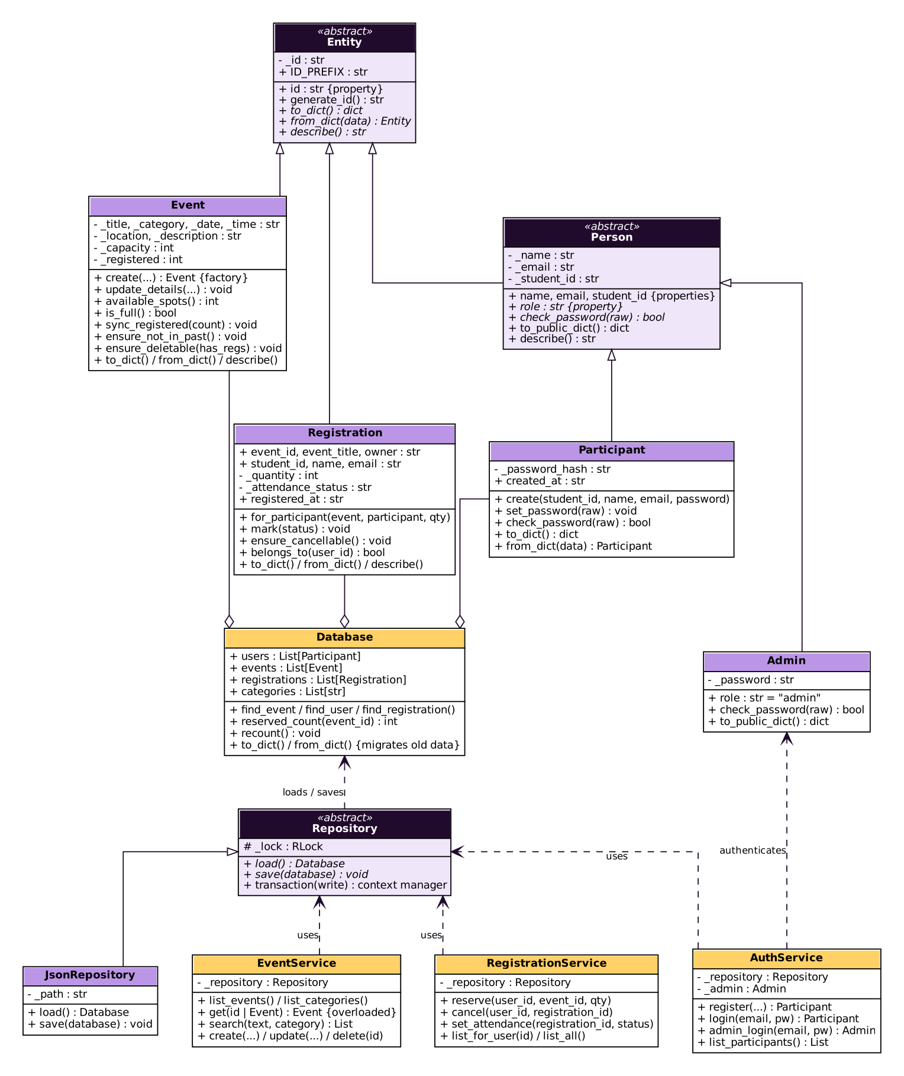
Figure 1. UML Class Diagram

6.4 Flowcharts
Figure 2 shows how a user moves through the system. Figure 3 follows one request in detail: reserving a spot.
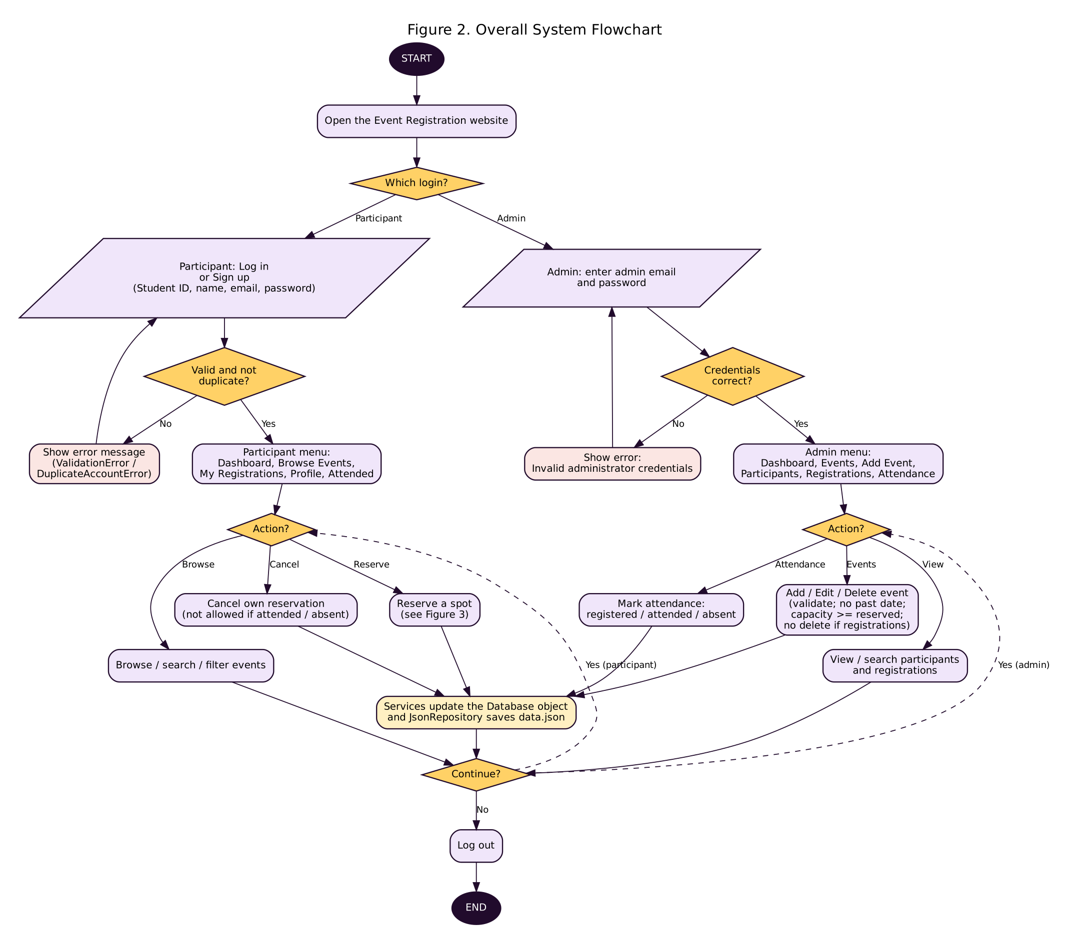
Figure 2. Overall system flowchart
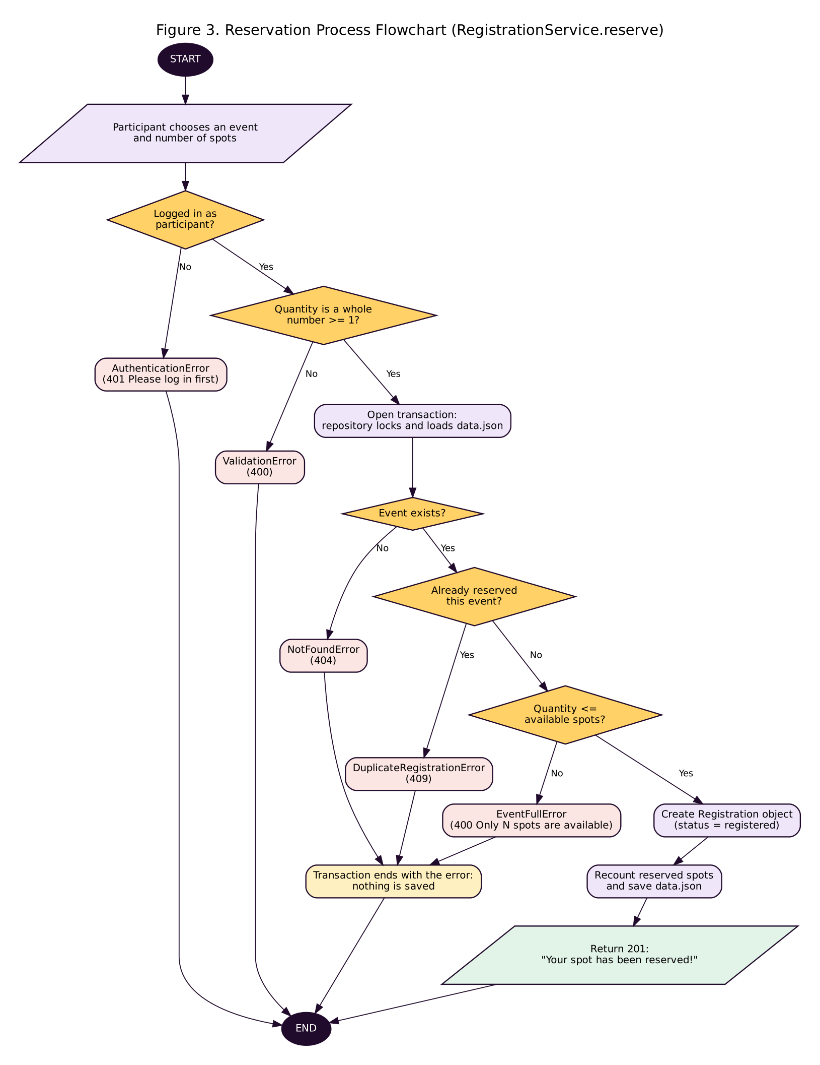
Figure 3. Reservation process flowchart

6.5 Data storage
All data is stored in data.json with four collections: events, categories, registrations and users. The Database class holds them as objects while the program runs. Every change happens inside Repository.transaction(), which locks the file, loads the data, lets the service make its changes, recalculates the reserved spots, and saves. If an exception is raised, nothing is saved.

7. Screenshots of the Application
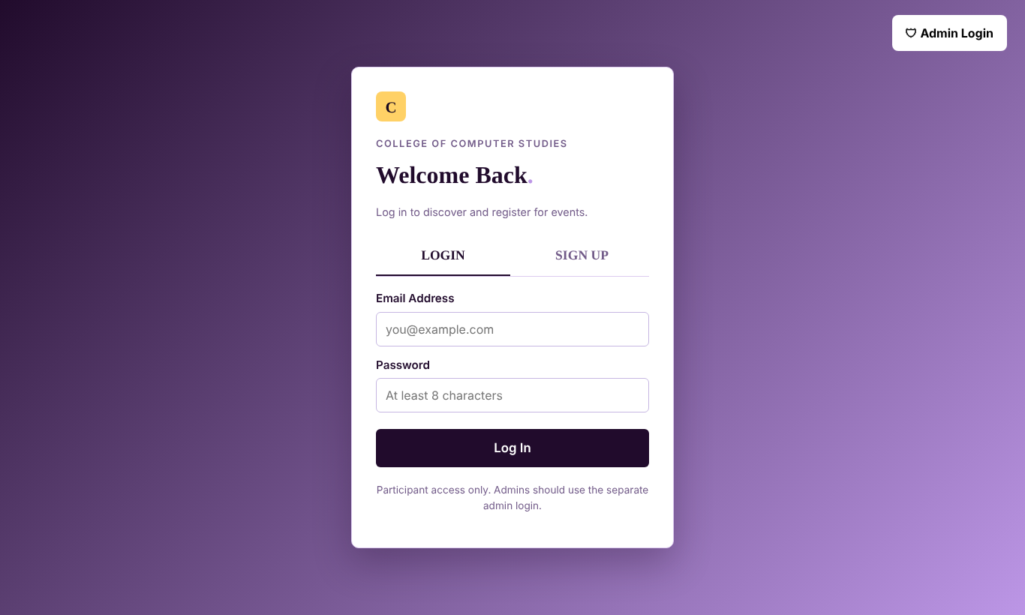
Figure 4. Login and sign-up screen
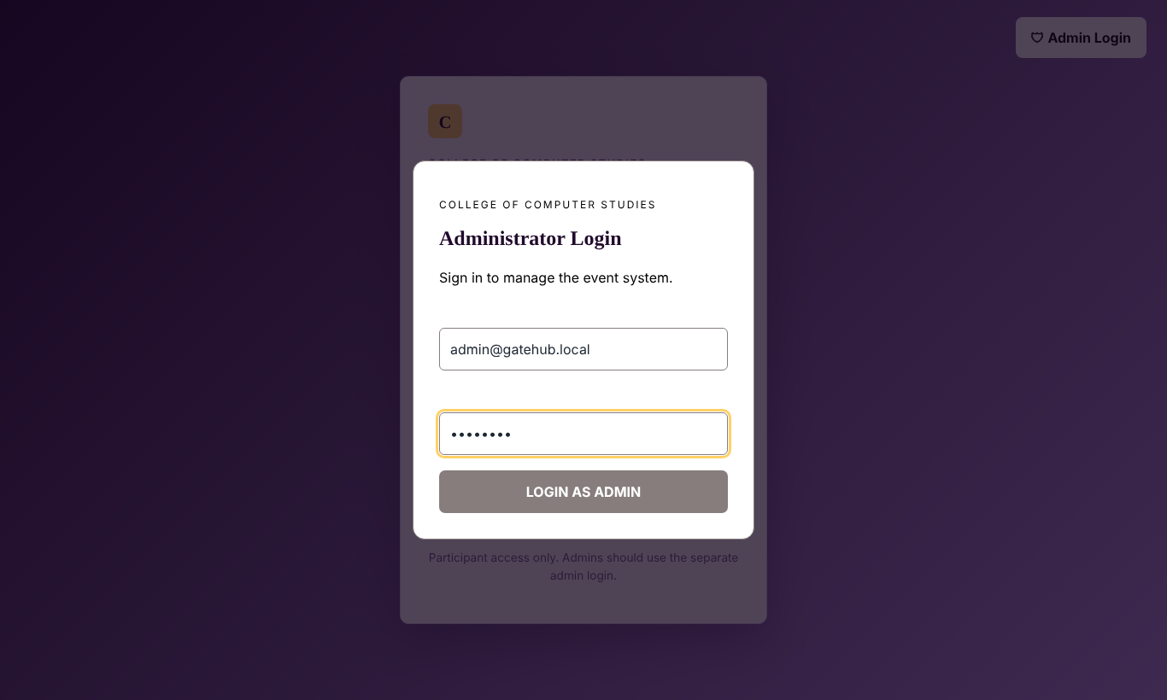
Figure 5. Administrator login window
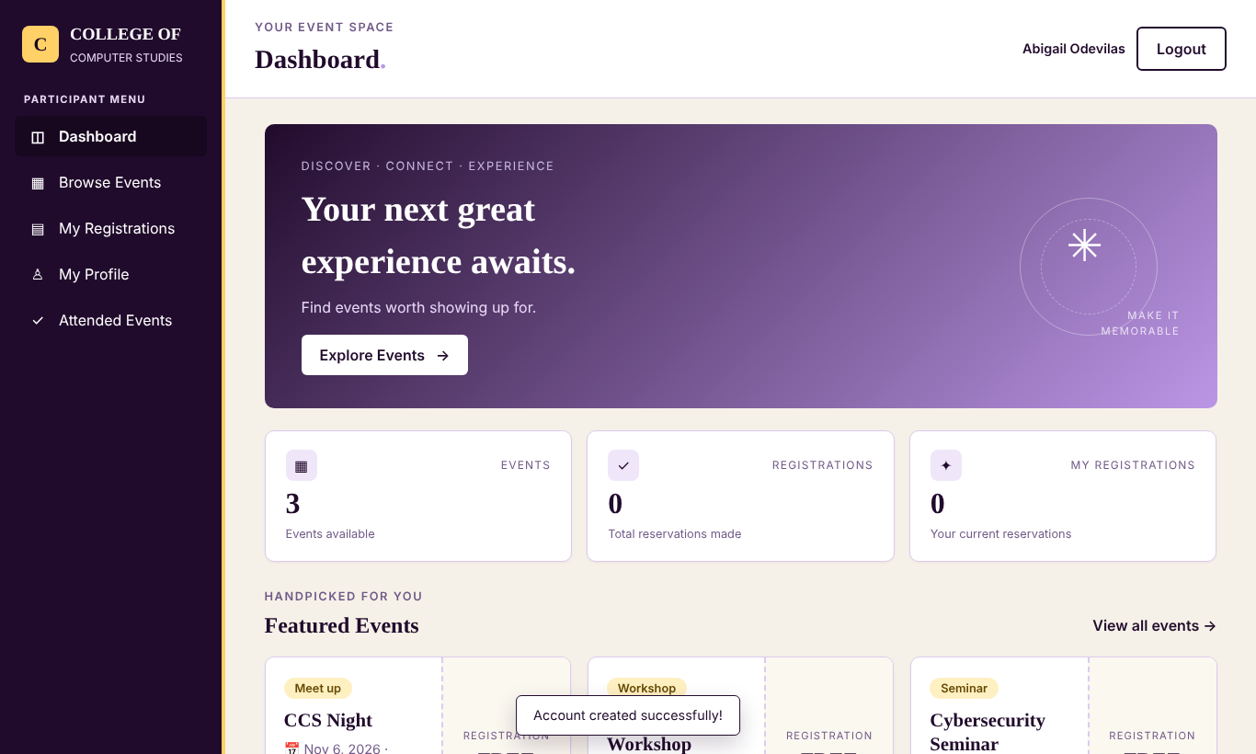
Figure 6. Participant dashboard
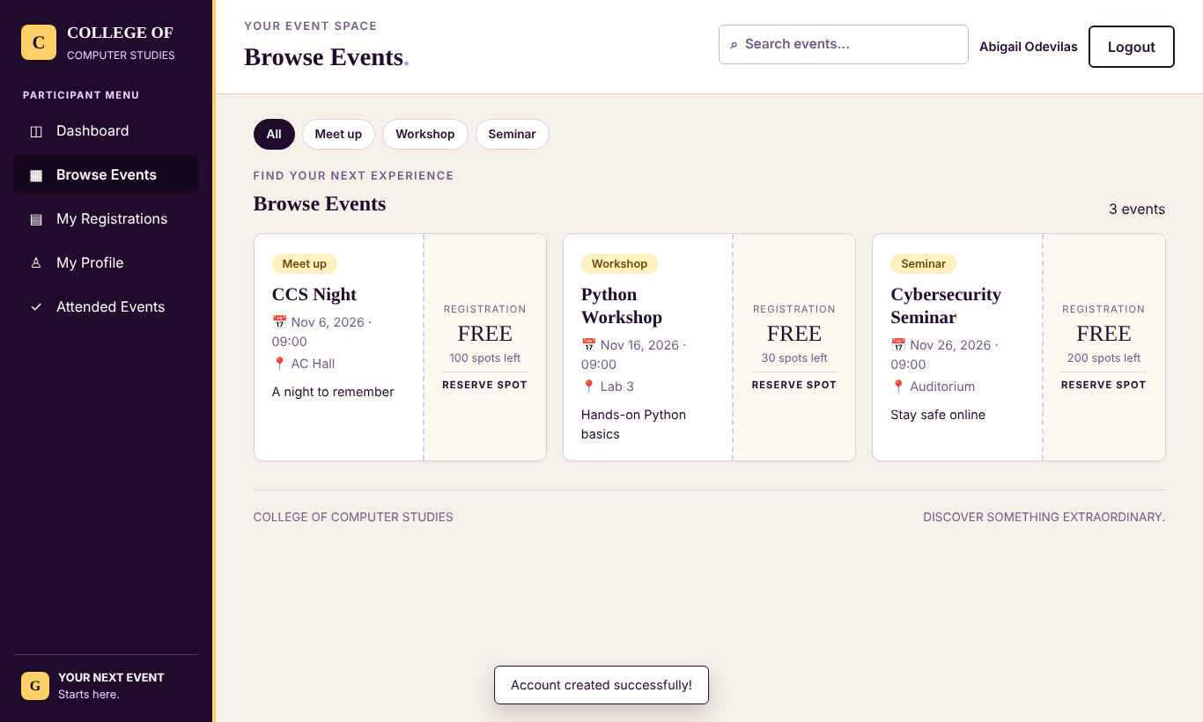
Figure 7. Browse events (search and category filter)
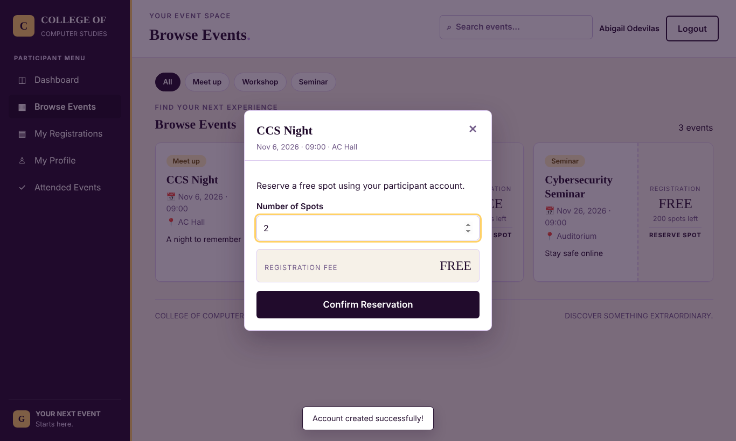
Figure 8. Reserve spots window
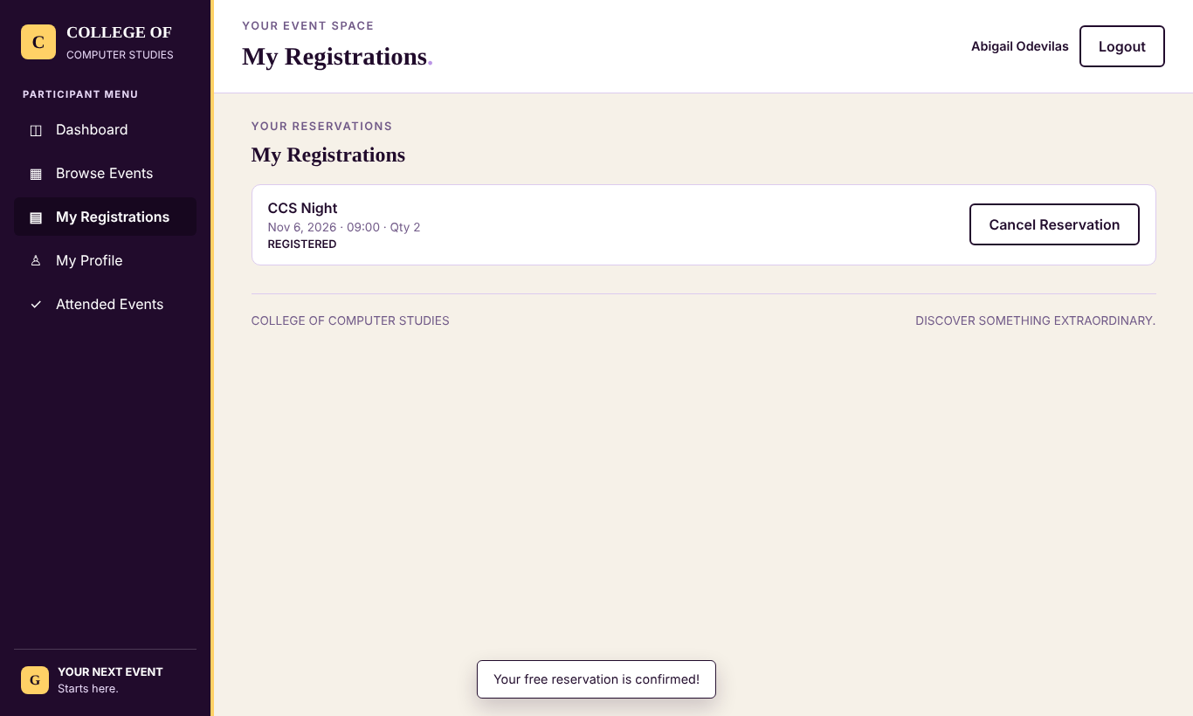
Figure 9. My Registrations
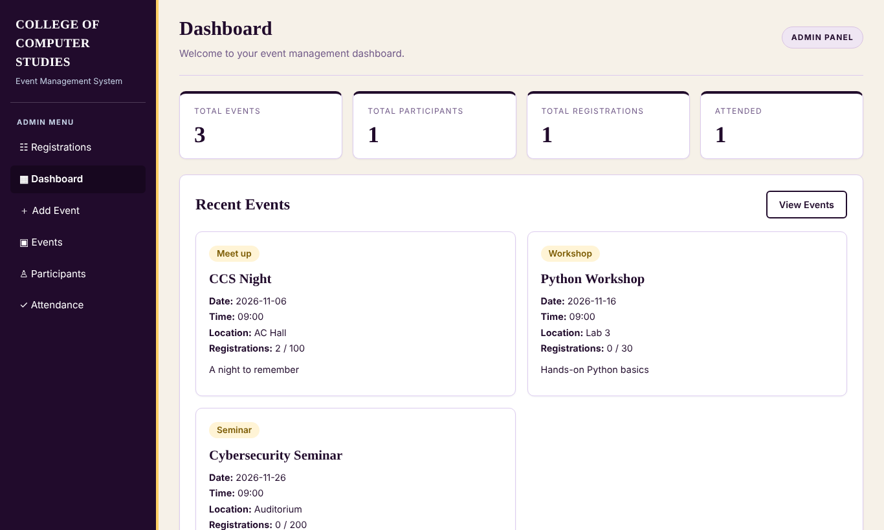
Figure 10. Admin dashboard
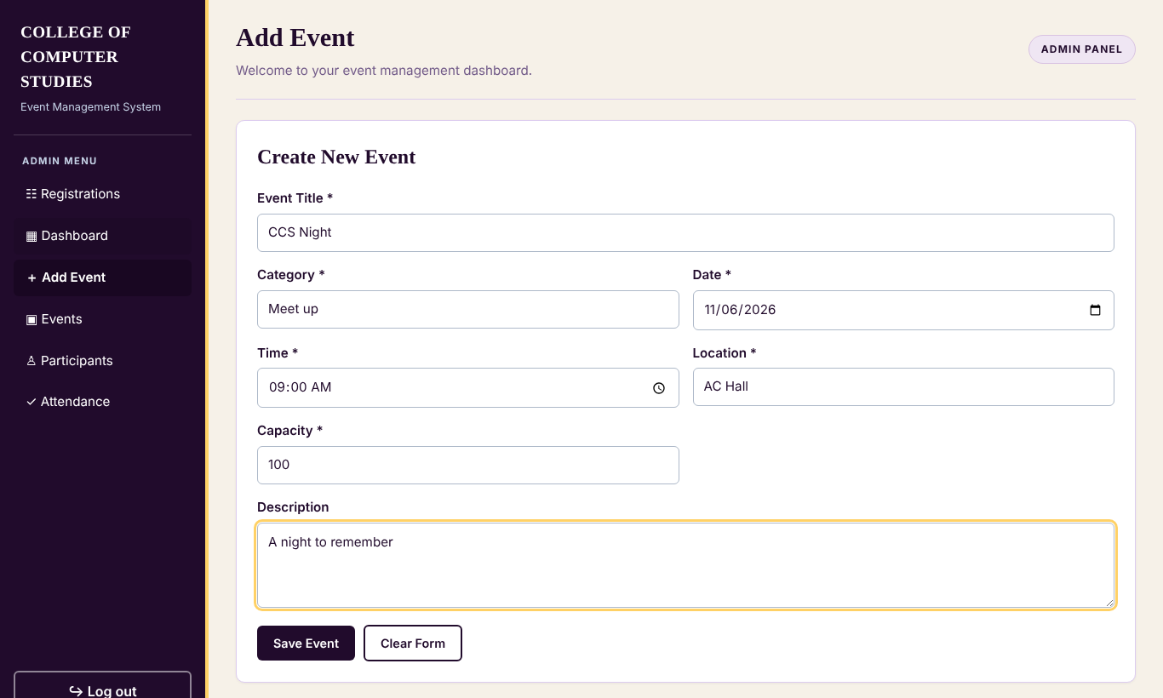
Figure 11. Admin: add event form
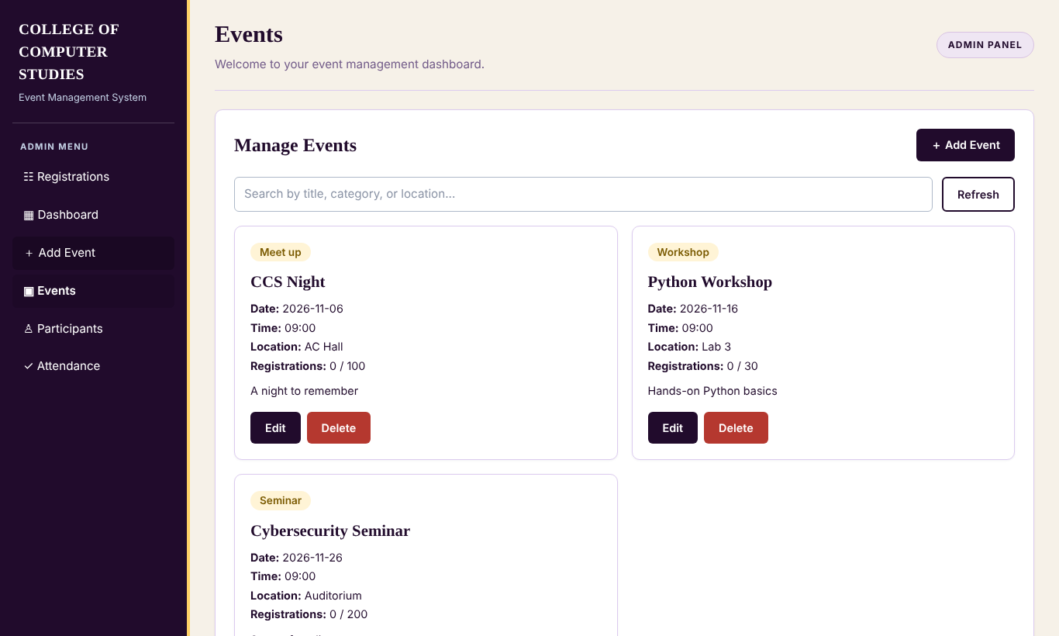
Figure 12. Admin: manage events
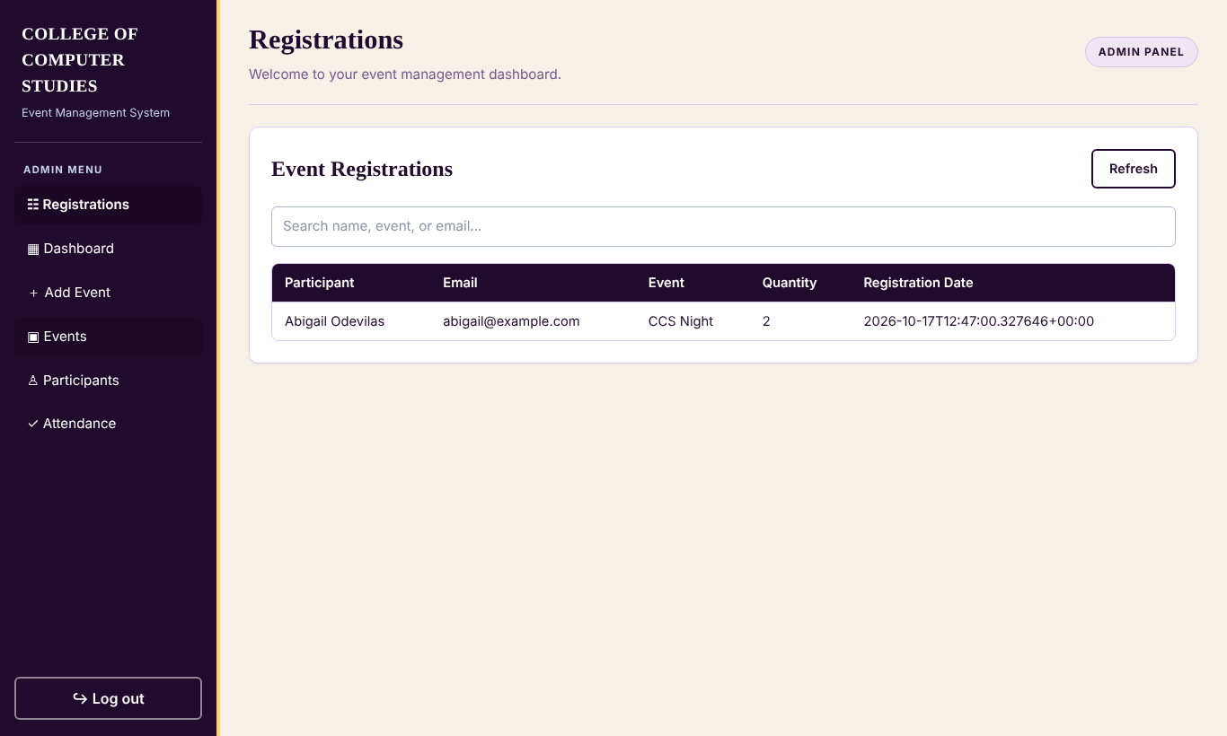
Figure 13. Admin: event registrations
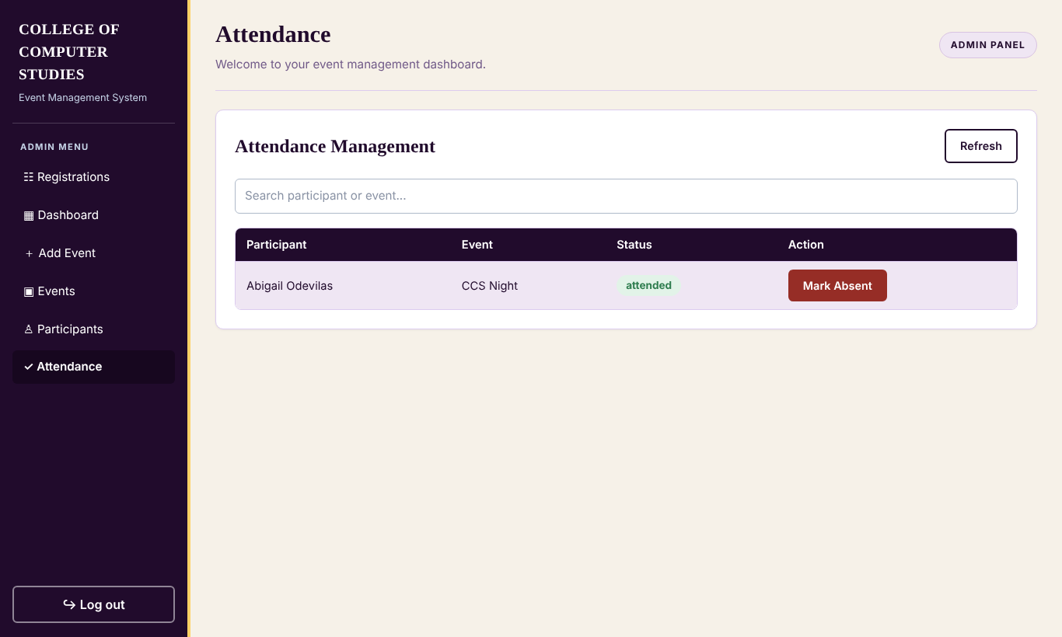
Figure 14. Admin: attendance management
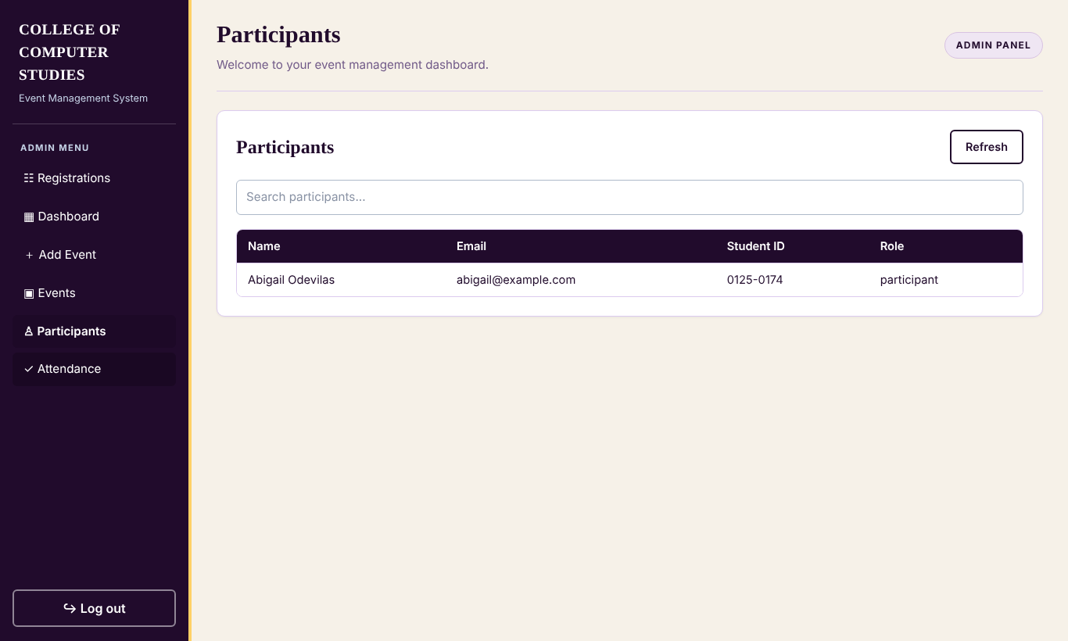
Figure 15. Admin: participants

8. Testing Results

8.1 Automated tests
25 automated unit and integration tests (tests/test_system.py, run with "python -m unittest discover -s tests -v") were executed. Result: Ran 25 tests – OK (all passed).
# | Test | Area | Result
1 | admin login and permissions | Accounts and login | Passed
2 | duplicates rejected | Accounts and login | Passed
3 | password hash never exposed | Accounts and login | Passed
4 | signup login logout | Accounts and login | Passed
5 | signup validation | Accounts and login | Passed
6 | wrong password and admin email | Accounts and login | Passed
7 | cannot lower capacity or delete with registrations | Event management | Passed
8 | create edit delete and categories | Event management | Passed
9 | event input errors | Event management | Passed
10 | custom exceptions | Custom exceptions | Passed
11 | event rules | Model classes | Passed
12 | participant encapsulation and hashing | Model classes | Passed
13 | polymorphism describe | Model classes | Passed
14 | registration status and cancel rules | Model classes | Passed
15 | repository is abstract | Model classes | Passed
16 | attendance flow | Reservations and attendance | Passed
17 | cancel frees spots | Reservations and attendance | Passed
18 | cannot cancel someone elses | Reservations and attendance | Passed
19 | duplicate and overbooking blocked | Reservations and attendance | Passed
20 | invalid quantity | Reservations and attendance | Passed
21 | reserve updates count | Reservations and attendance | Passed
22 | damaged file raises storage error | Data file | Passed
23 | failed transaction does not save | Data file | Passed
24 | legacy data is migrated | Data file | Passed
25 | missing file gives empty database | Data file | Passed

8.2 Manual test cases (through the web interface)
These scenarios were verified through the automated API tests above and a full walkthrough of the running application in a browser (sign up, admin login, add event, reserve, view registrations, mark attendance), during which no JavaScript errors were reported.
No. | Test case | Expected result | Actual result
1 | Sign up with all fields valid | Account created, participant dashboard opens | Passed
2 | Sign up with an email already used | Error "An account with this email already exists." | Passed
3 | Log in with a wrong password | Error "Invalid email or password." | Passed
4 | Admin logs in with correct credentials | Admin dashboard opens | Passed
5 | Admin adds an event with all fields | Event appears in Events list and in the participant's Browse Events | Passed
6 | Admin adds an event with an empty title | Form is rejected with an error message | Passed
7 | Admin adds an event with a past date | Error "The event date cannot be in the past." | Passed
8 | Participant reserves 2 spots | Reservation saved; available spots reduced by 2 | Passed
9 | Participant reserves the same event again | Error "You have already reserved this event." | Passed
10 | Another participant asks for more spots than remain | Error "Only N spots are available." | Passed
11 | Participant cancels a reservation | Reservation removed; spots returned to the event | Passed
12 | Admin marks a registration as attended | Status changes; shows in the participant's Attended Events | Passed
13 | Admin deletes an event that has registrations | Deletion refused with an explanation | Passed
14 | Open the admin pages as a participant | Access denied (403) | Passed
15 | Start the program with a damaged data.json | Clear storage error instead of a crash | Passed

9. Conclusion
The Event Registration System meets its objectives. Students can register for events and see their history, and administrators can manage events and attendance, all through a clean web interface. The back end is written with object-oriented design: abstract base classes define contracts, subclasses specialise behaviour, attributes are encapsulated behind validated properties, and a custom exception hierarchy turns every kind of error into a clear message. The layered structure (routes, services, models, repository) keeps the code readable and testable, as shown by the 25 passing automated tests.
Possible future improvements are email confirmations, QR-code check-in, a waiting list for full events, multiple administrators with roles, and moving from the JSON file to a database such as SQLite or PostgreSQL by writing a new Repository subclass.

10. References
- Python Software Foundation. (2026). Python 3 documentation. https://docs.python.org/3/
- Python Software Foundation. (2026). abc – Abstract Base Classes; functools.singledispatchmethod. https://docs.python.org/3/library/
- Pallets Projects. (2026). Flask documentation. https://flask.palletsprojects.com/
- Pallets Projects. (2026). Werkzeug documentation: Security helpers. https://werkzeug.palletsprojects.com/
- Object Management Group. (2017). Unified Modeling Language (UML) specification, version 2.5.1. https://www.omg.org/spec/UML/
- Graphviz. (2026). Graphviz documentation (used to draw the diagrams). https://graphviz.org/documentation/
- CMSC 203 – Object-Oriented Programming course materials and Final Project instructions.

