Tutorial – Oracle Report

In this tutorial, you are going to create a user defined chart using Oracle SQL Developer. You can use the ROBCOR data warehousing in the dw account and import those tables into your account. The tables that are relevant to the ROBCOR data warehouse are: dw.charter_fact, dw.time, dw.pilot, and dw.model.

Creating a User Defined Chart
- In the SQL Developer, select View.
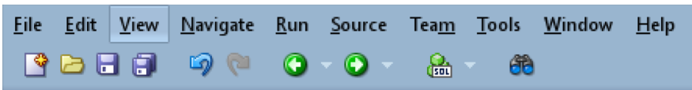

- Select Reports.
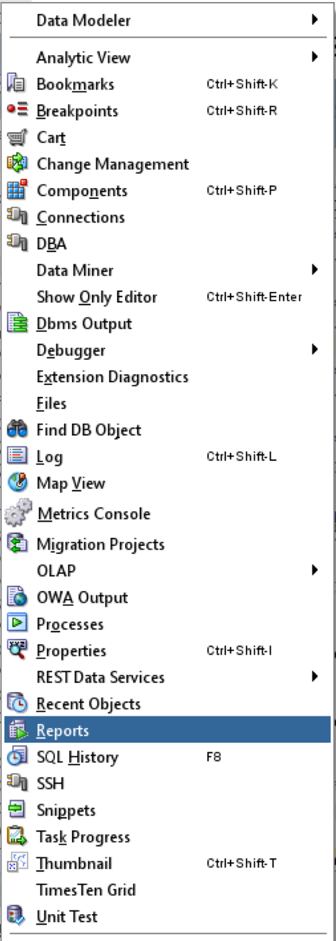

The Reports tab will be displayed.

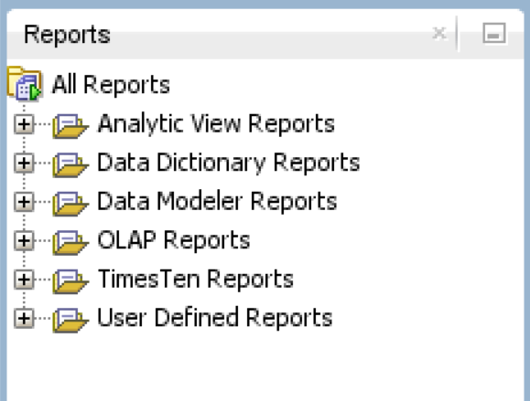

- Right click on the “User Defines Reports” and then select “New Report”.
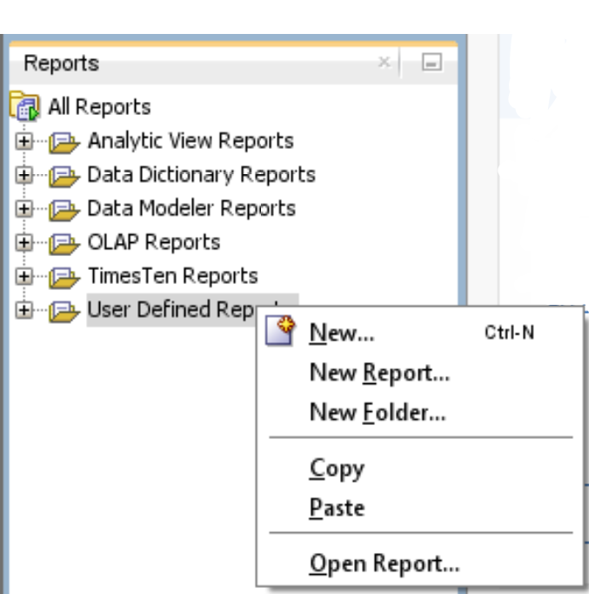

- In the Create Report dialog box, choose the FIT5195 SQL connection and ensure that the Advanced check box is ticked. Fill in the report’s name to Charter and choose the Style to Chart as shown in the figure below.

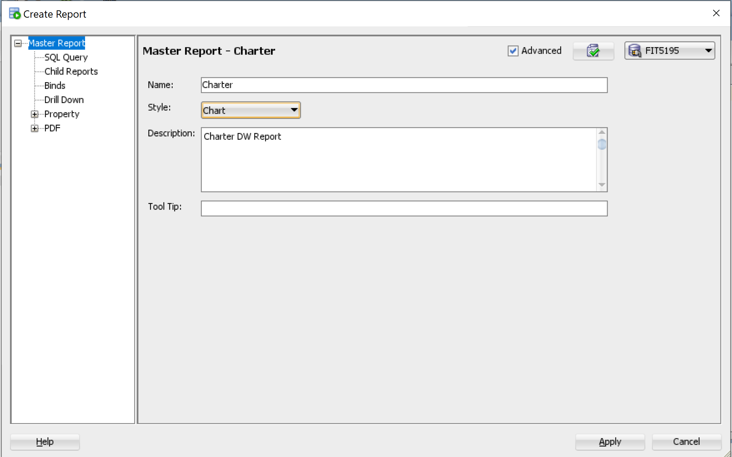

- Select SQL Query and enter the following query:

select m.mod_code as model_code, m.mod_name as model_name,
sum(c.tot_fuel) as total_fuel_used
from charter_fact c, model m
where m.mod_code = c.mod_code
group by m.mod_code, m.mod_name;

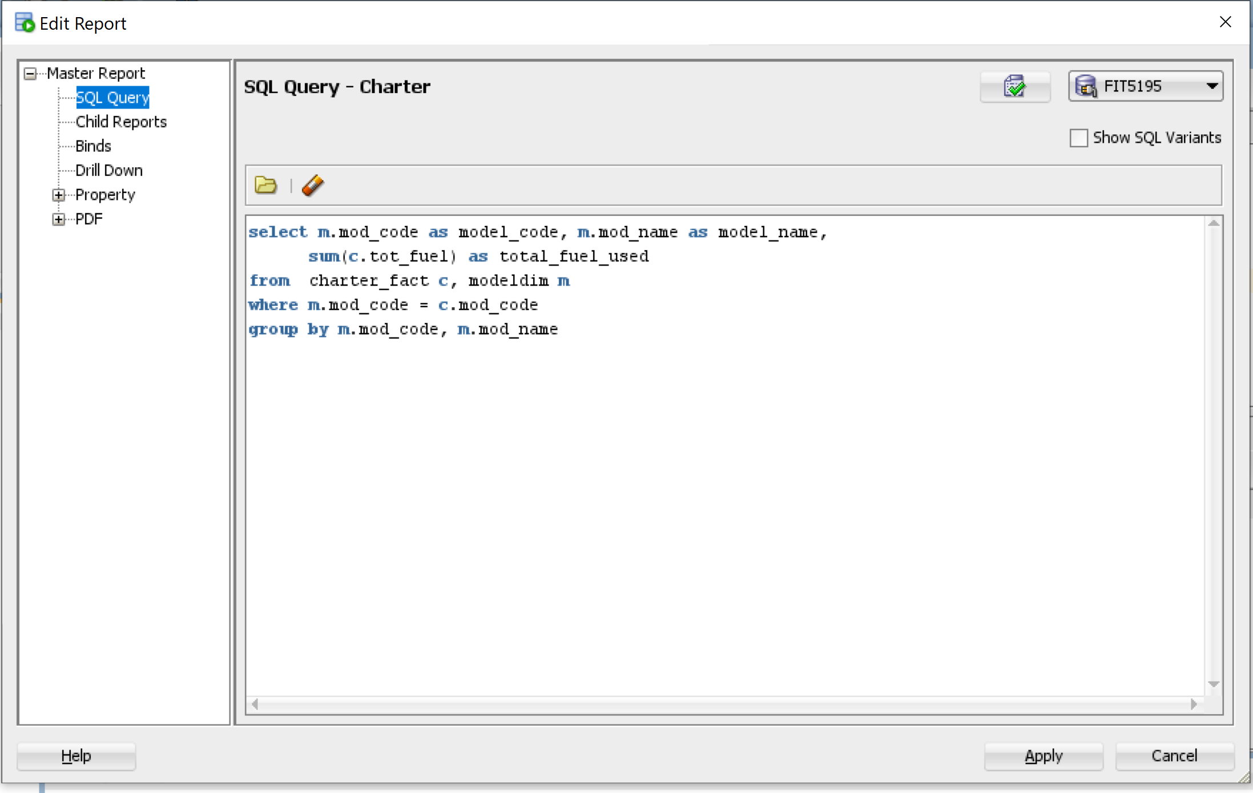

- Expand the Property menu and click on it. In this dialog box, you can choose the Chart Type. For now, we can choose the “Bar – Vertical Cluster”.

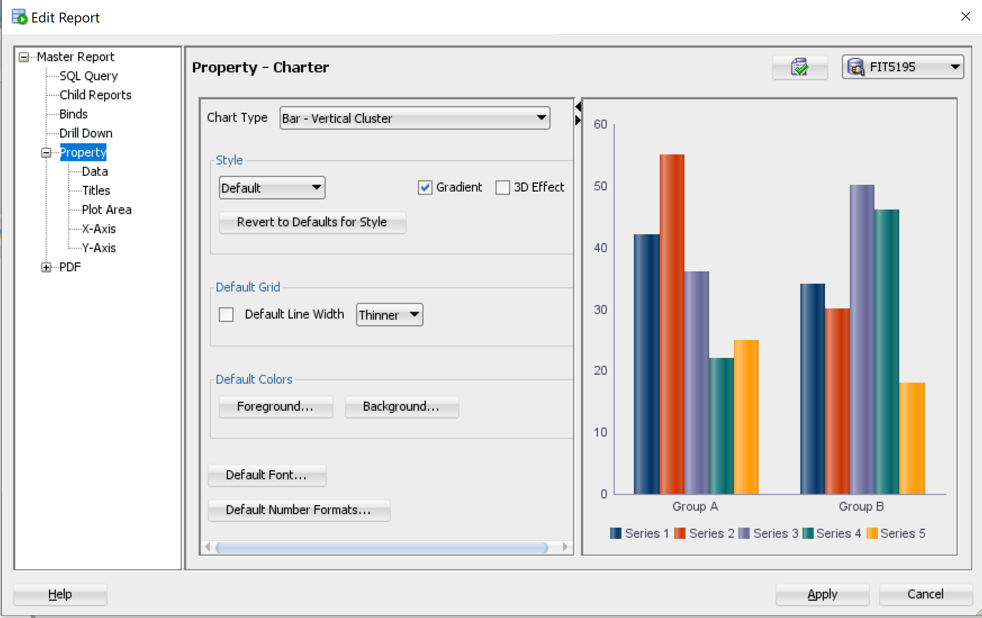

- You can see how the chart looks like by clicking on the 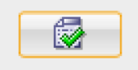 (Test Report) button on the top right corner. A new dialog box will appear like the image below.

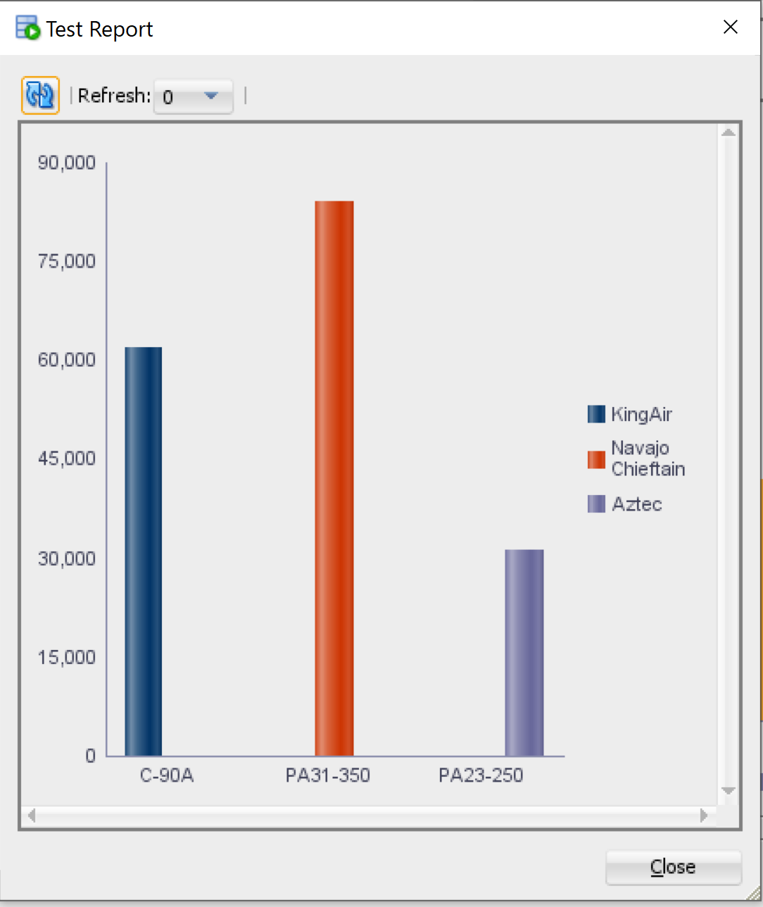

- Click on the Apply button to save the chart.

- The Oracle Reports can be generated into HTML. To generate the HTML for the chart we just created, right click on Charter in the User Defined Reports then select HTML.

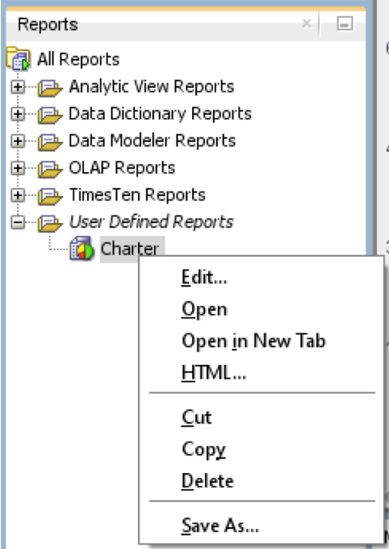

- Make sure to choose the FIT5195 SQL connection and select your preferred destination to save the HTML file, then click Apply.

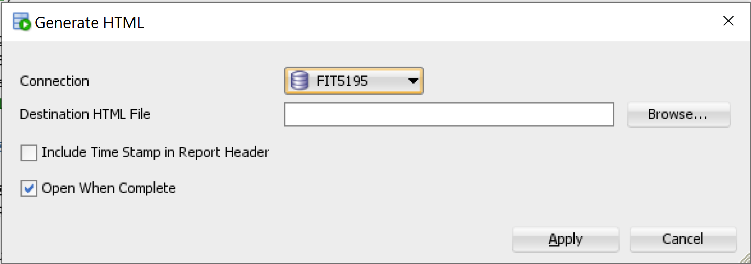

The figure below displays the chart created from the Charter Data Warehouse in HTML.

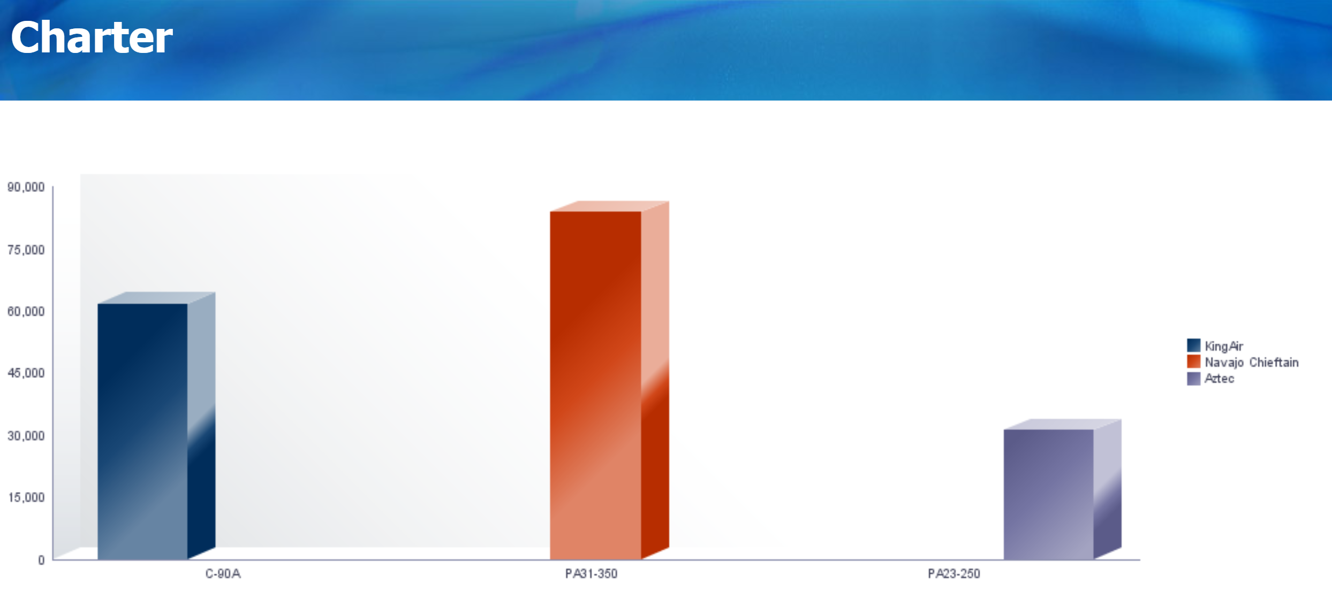

You can also try creating different charts for the OLAP queries in last week’s tutorial.

