React-state,props

1. ) Create Hello World React program show below?

import React from 'react';

import ReactDOM from 'react-dom/client';

import './App.css';

function App() {

return (

<div className="App">

<h1>React App</h1>

<img src="https://upload.wikimedia.org/wikipedia/commons/a/a7/React-icon.svg" alt="React Logo" className="logo" />

<h1>Hello World</h1>

</div>

);

}

const root = ReactDOM.createRoot(document.getElementById('root'));

root.render(

<React.StrictMode>

<App />

</React.StrictMode>

);

body {

margin: 0;

padding: 0;

display: flex;

justify-content: center;

align-items: center;

height: 100vh;

background-color: black;

}

.App {

text-align: center;

color: cyan;

}

.logo {

width: 100px;

margin-bottom: 20px;

}

Output:

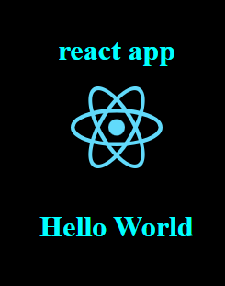

1. ) Create counter app program shown below.

Sol--

import React, { useState } from 'react';

const Counter = () => {

const [count, setCount] = useState(0);

return (

<div style={{ textAlign: 'center', marginTop: '50px' }}>

<h1>Counter App</h1>

<h2>{count}</h2>

<button

onClick={() => setCount(count + 1)}

style={{ marginRight: '10px', padding: '10px', backgroundColor: 'green', color: 'white' }}

>

Increment

</button>

<button

onClick={() => setCount(count - 1)}

style={{ padding: '10px', backgroundColor: 'red', color: 'white' }}

>

Decrement

</button>

</div>

);

};

export default Counter;

import React from 'react';

import ReactDOM from 'react-dom/client'; // For React 18

import Counter from './Counter';

import './App.css';

function App() {

return (

<div>

<Counter />

</div>

);

}

const root = ReactDOM.createRoot(document.getElementById('root'));

root.render(

<React.StrictMode>

<App />

</React.StrictMode>

);

export default App;

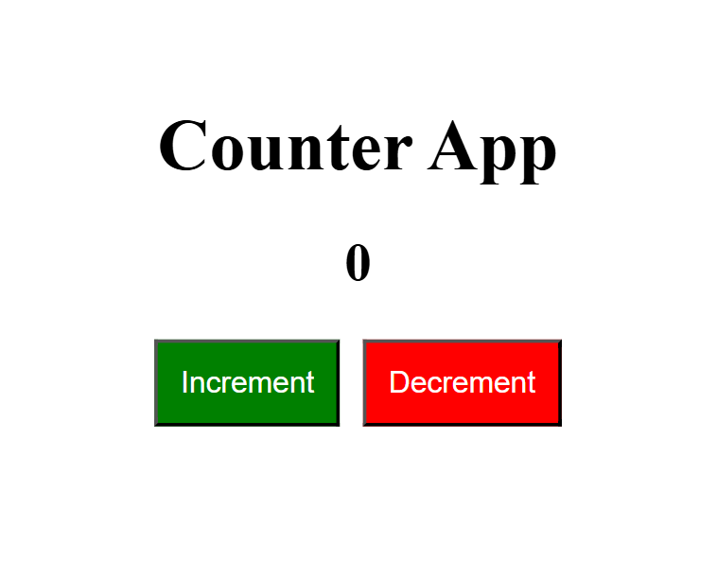

1. ) Create Login Lout React program as below

Sol--Make navigation component.js file

import React from 'react';

const Navigation = ({ isLoggedIn, handleLogin }) => {

return (

<nav style={{ padding: '10px', backgroundColor: 'orange' , display: 'flex', justifyContent: 'space-between', alignItems: 'center' }}>

<h2>Navigation</h2>

<button onClick={handleLogin} style={{ padding: '10px', margin: '10px', backgroundColor: 'white', color: 'orange', border: 'none', borderRadius: '5px' }}>

{isLoggedIn ? 'Logout' : 'Login'}

</button>

</nav>

);

};

export default Navigation;

Now make Public view.js file

import React from 'react';

const PublicViews = () => (

<div>

<h2>Public Views</h2>

</div>

);

export default PublicViews;

Now lets make privateView.js file or component file

import React from 'react';

const PrivateViews = () => (

<div>

<h2>Private Views</h2>

</div>

);

export default PrivateViews;

Now lets make footer file.js

import React from 'react';

const Footer = () => (

<footer style={{ padding: '10px', backgroundColor: 'green', marginTop: '20px', textAlign: 'center' }}>

<p>Footer</p>

</footer>

);

export default Footer;

Now Make the file called handlelogin.js file

import React, { useState } from 'react';

import Navigation from './Navigation';

import PublicViews from './PublicViews';

import PrivateViews from './PrivateViews';

import Footer from './Footer';

function App() {

const [isLoggedIn, setIsLoggedIn] = useState(false);

const handleLogin = () => {

setIsLoggedIn(!isLoggedIn);

};

return (

<div className="App">

<Navigation isLoggedIn={isLoggedIn} handleLogin={handleLogin} />

{isLoggedIn ? <PrivateViews /> : <PublicViews />}

<Footer />

</div>

);

}

export default App;

