**## Jenkins CLI**

**Jenkins has a built-in command line interface (CLI) that allows users and administrators to access Jenkins from a script or shell environment.**

**This can be convenient for scripting of routine tasks, bulk updates, troubleshooting, and more.**

**We can do all the things from Jenkins GUI, but Jenkins CLI is also easier and faster and you can access Jenkins from remote machine by using Jenkins CLI commands.**

**## Jenkins CLI Configuration**

Go to **manage Jenkins** 🡪 go to **Jenkins cli you will get Jenkins cli commands window**

or  in browser **<your Jenkins URL>/cli** and enter it will take you to Jenkins cli window

***example***: http://18.205.24.13:8080/cli/

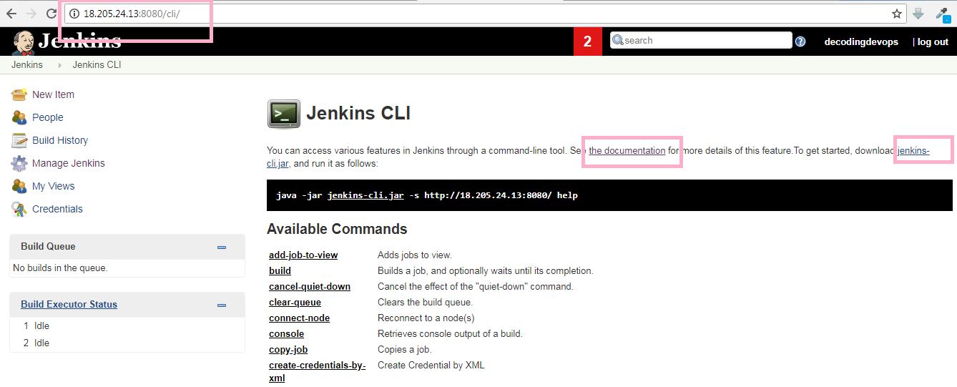

**in this window you can see jenkins-cli.jar, we will need to download this jar file wherever we want to run the Jenkins CLI commands.**

**### access Jenkins cli commands from Linux**

to run the Jenkins cli command in Linux machine, you need to install java in your Linux machine.

**### Install Java**

**On Ubuntu Linux OS**

sudo add-apt-repository ppa:openjdk-r/ppa

sudo apt-get update

sudo apt-get install -y openjdk-8-jdk

download **jenkins-cli.jar** file from the Jenkins UI as shown above

To download use below command

wget http://**<Jenkins-URL>**/jnlpJars/jenkins-cli.jar

go to the location where you downloaded the jenkins-cli.jar file and execute below Jenkins cli commands as below

**# To List All Jenkins Jobs**

java -jar jenkins-cli.jar -s http://18.205.24.13:8080/ -auth admin:password list-jobs

In the above command

http://18.205.24.13:8080/ 🡪 is my Jenkins URL or path.

admin 🡪 is my username

password 🡪 is my password

ensure to replace your Jenkins Login Credential accordingly

java -jar jenkins-cli.jar -s <http://18.205.24.13:8080/> -auth username:password

**# To List all Jenkins CLI Commands**

java -jar jenkins-cli.jar -s http://18.205.24.13:8080/ -auth admin:password

**# Run Jenkins Jobs from Command line**

java -jar jenkins-cli.jar -s http://18.205.24.13:8080/ -auth admin:password build jobname

**# See the Console output after executing Job**

java -jar jenkins-cli.jar -s http://18.205.24.13:8080/ -auth admin:password build jobname -s -v

**# Run Jenkins job from command line with parameters**

java -jar jenkins-cli.jar -s http://18.205.24.13:8080/ -auth admin:password build jobname -p name=value

**# Jenkins safe-restart**

java -jar jenkins-cli.jar -s http://18.205.24.13:8080/ -auth admin:password safe-restart

**# to know about particular command**

java -jar jenkins-cli.jar -s http://18.205.24.13:8080/ -auth admin:password help build

**# To Copy a Job**

java -jar jenkins-cli.jar -s http://18.205.24.13:8080/ -auth admin:password copy-job SRC DEST

SRC: name of the job to copy

DEST: name of the new job to be created

**# To Delete a Job**

java -jar jenkins-cli.jar -s http://18.205.24.13:8080/ -auth admin:password delete-job test