Name: abdullah hassan abdullah mohammed id: 1317

Section: 10

1. Introduction: The Contact Book Application is a simple program developed in C++ to manage contacts. Its purpose is to provide users with a convenient way to store and organize their contacts' information, such as names, phone numbers, and email addresses. This documentation report provides an overview of the project, including its design, implementation, testing process, and conclusion.
2. Design: The Contact Book Application is designed using object-oriented principles and consists of the following classes:

* Phone: Represents the contact's phone information, including the city, email, and notes. It provides getter and setter methods to access and modify these attributes.
* Contact: Represents an individual contact with a name and one or more phone numbers. It uses the Phone class to store and manage the contact's phone information. The Contact class has methods to retrieve and set the contact's name and phone numbers.
* ContactBook: Manages a collection of contacts. It provides methods to add new contacts, delete existing contacts, search for contacts by name, and display all contacts in the contact book. The ContactBook class uses an array to store and manage the contacts.

1. Implementation: The implementation of the Contact Book Application involves the following:

* The main function serves as the entry point of the program. It displays a menu to the user, allowing them to choose from various options.
* The user can select to add a new contact by entering the contact's name, city, email, and notes. The ContactBook class is responsible for adding the contact to the contact book.
* Deleting a contact involves entering the name of the contact to be deleted. The ContactBook class searches for the contact and removes it from the contact book if found.
* Searching for a contact requires entering the name of the contact to search for. The ContactBook class searches the contact book and displays the contact's details if found.
* Displaying all contacts simply prints the details of all contacts stored in the contact book using the ContactBook class.

1. Test : at the first we will try all options
2. 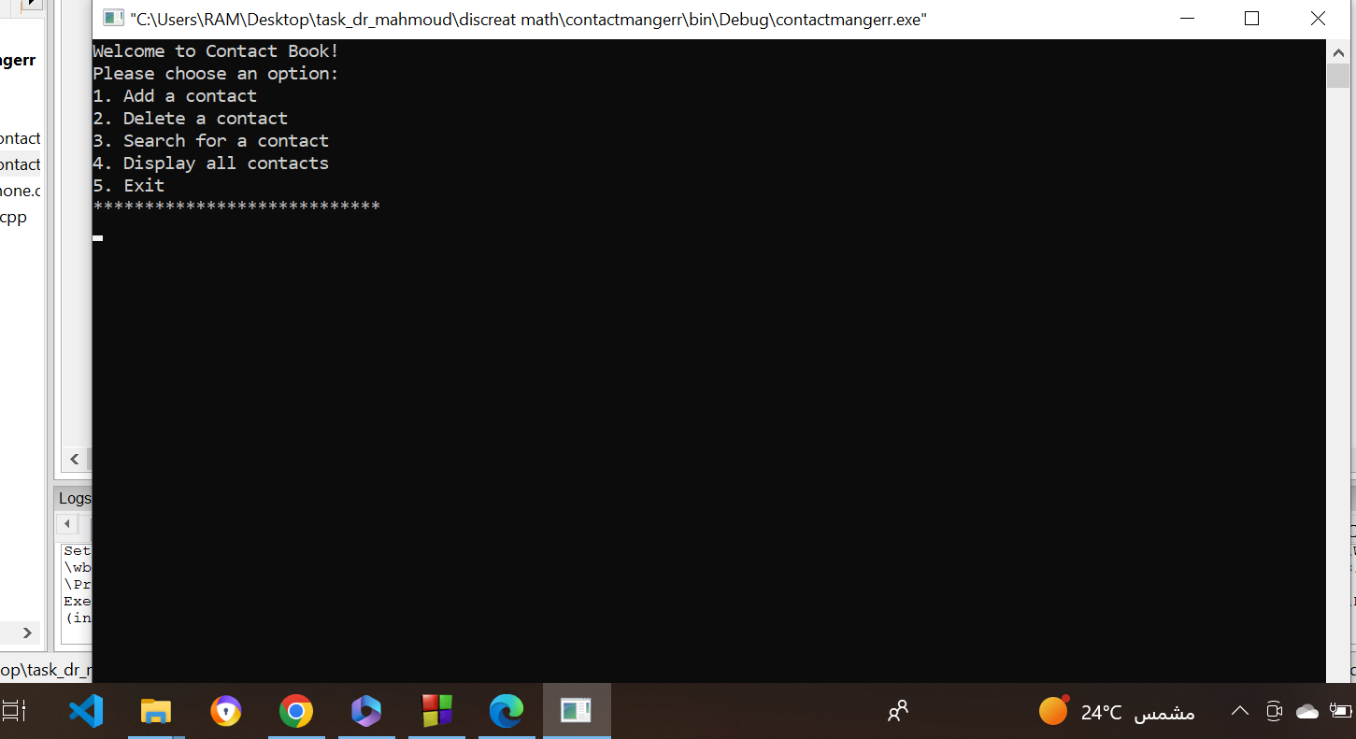

The main menu of the project .

1. 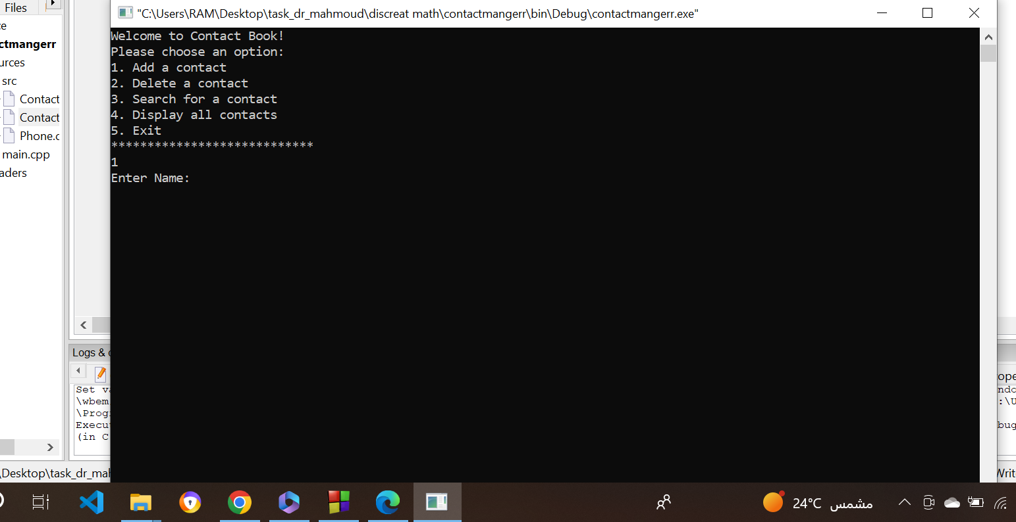

Entering user data.

1. 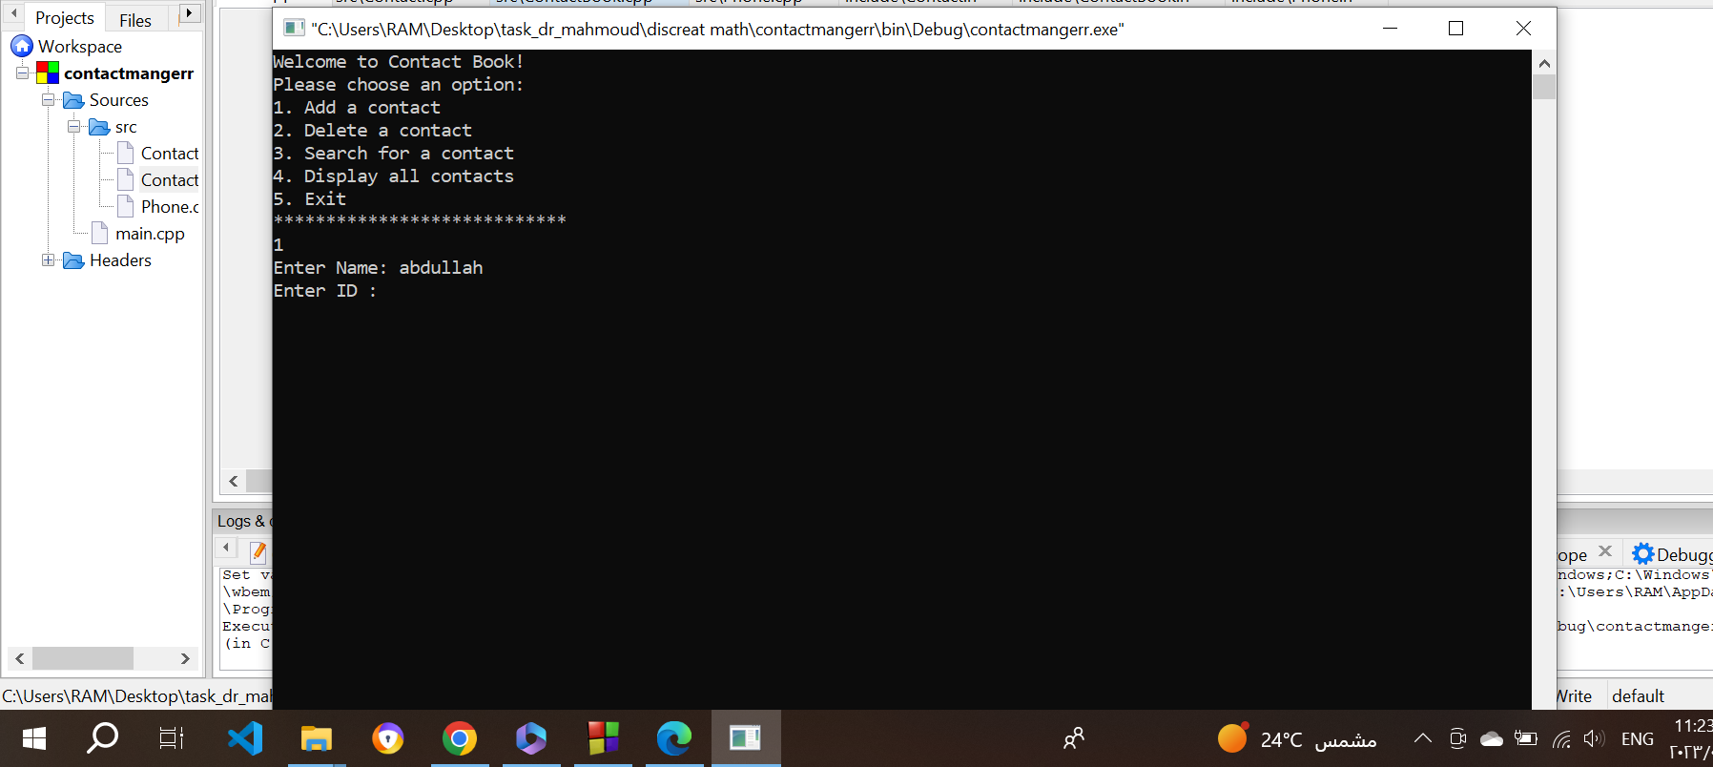
2. 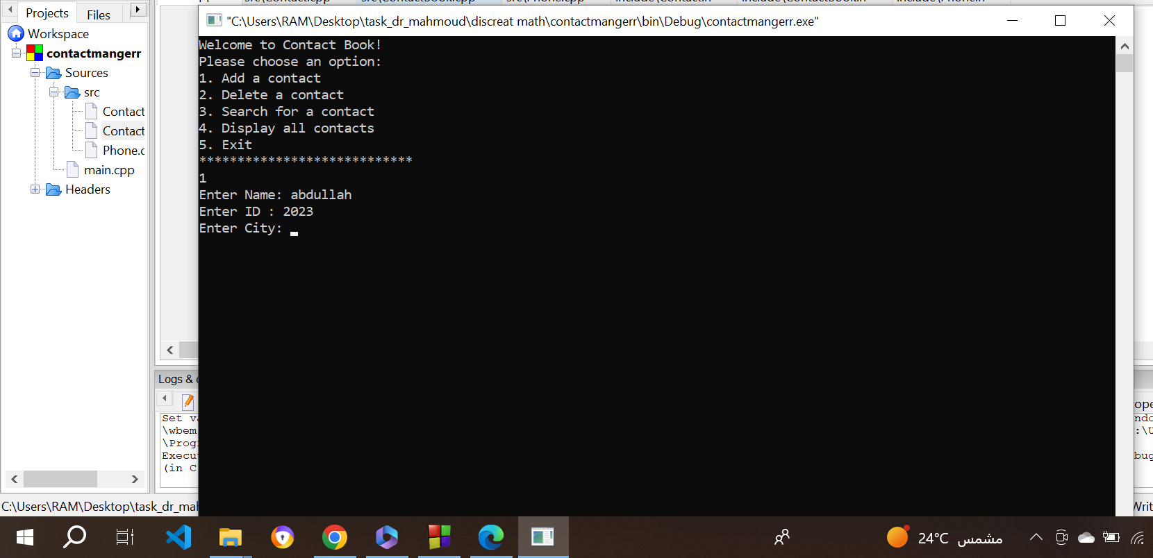
3. 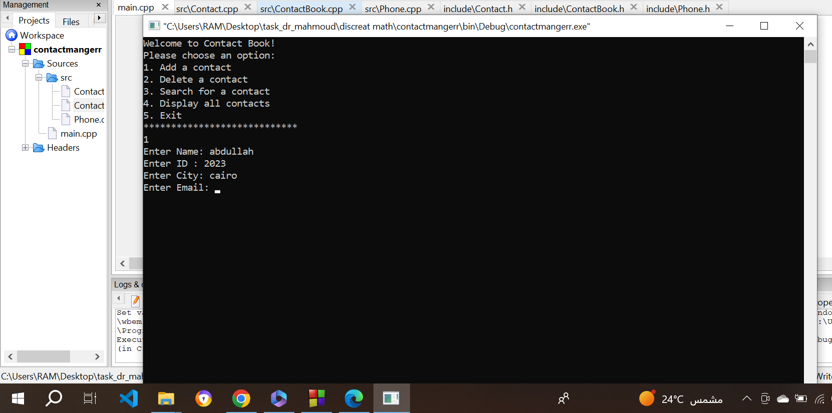
4. 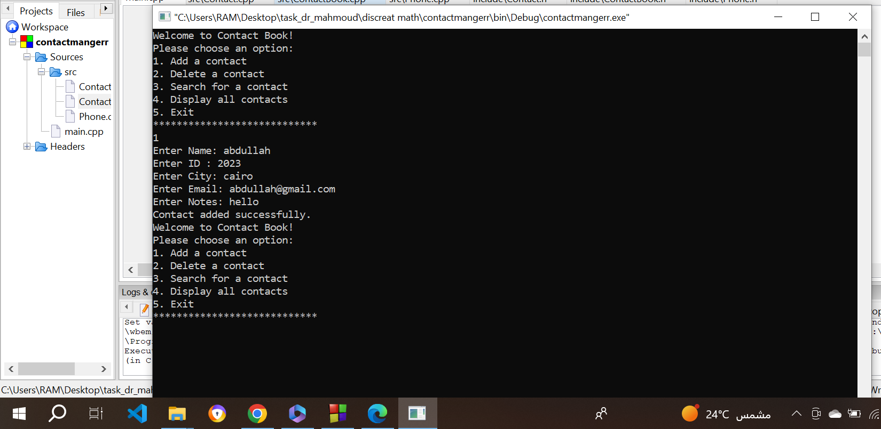

All data added successful

1. 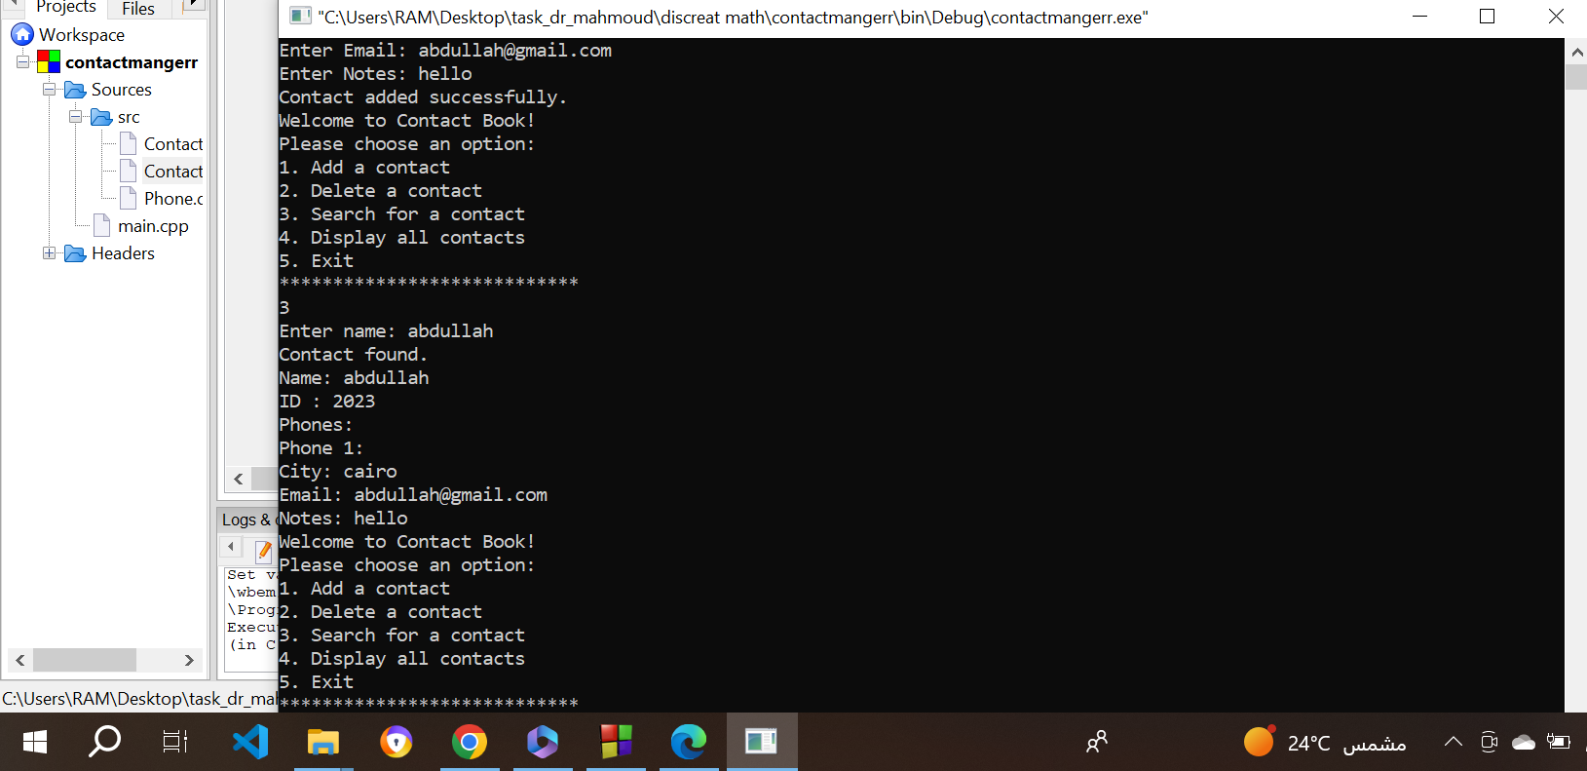

Search option done.

1. 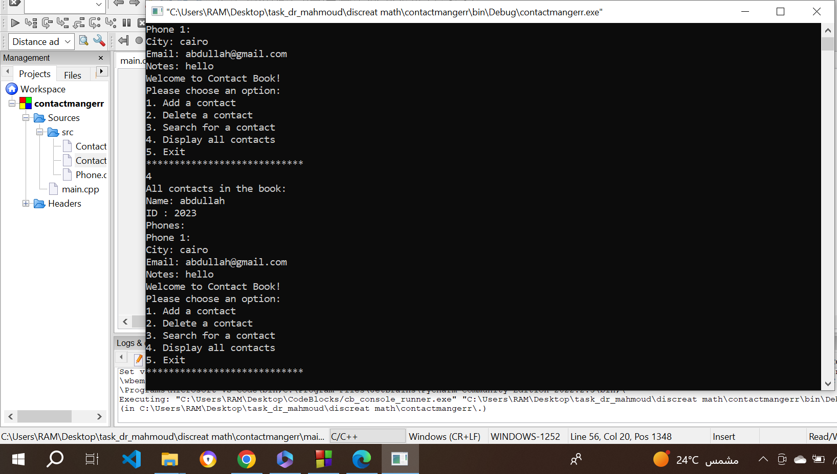

Display all contact done .

1. 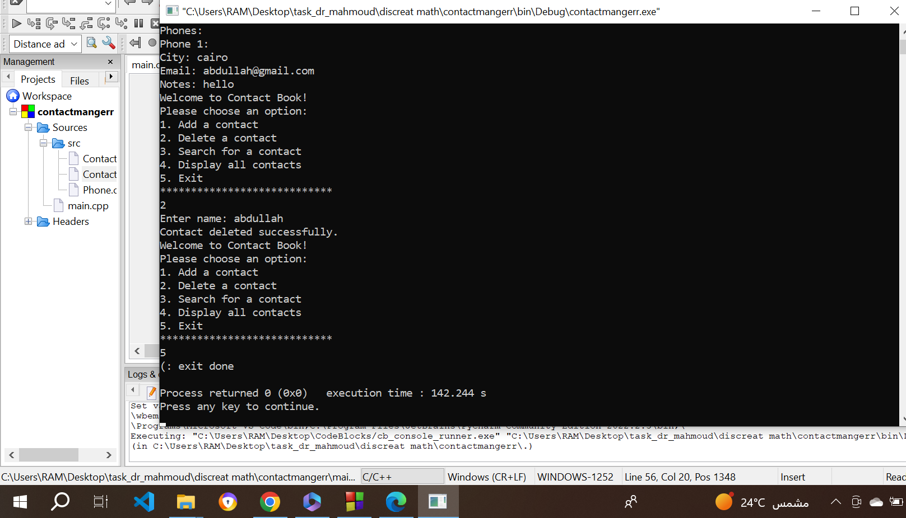

Exit done .

10.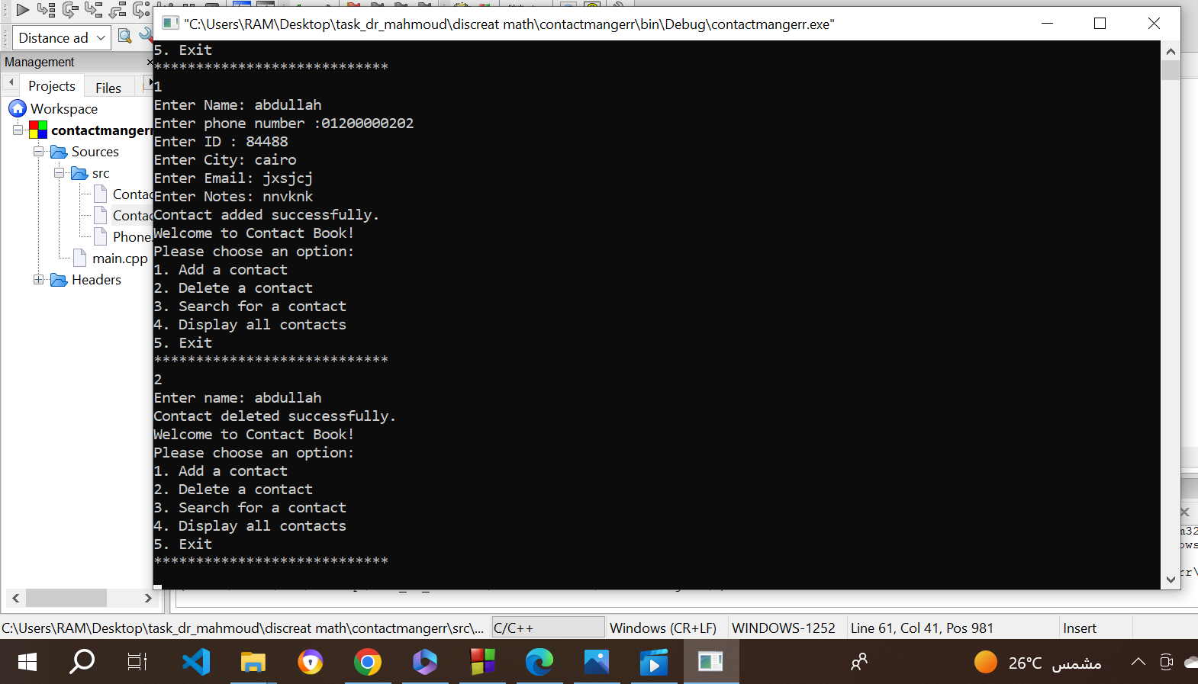

Delete done.

1. Conclusion: The Contact Book Application provides a user-friendly solution for managing contacts in C++. It successfully implements the basic features of adding, deleting, searching, and displaying contacts. The application's design and implementation follow object-oriented principles, promoting code reusability and maintainability.

In conclusion, the Contact Book Application project achieved its objectives by providing a functional and efficient solution for contact management. It can be further enhanced with additional features, such as sorting contacts, exporting/importing contacts, or integrating with other systems. Overall, the project demonstrates the use of C++ programming concepts and serves as a valuable learning experience in software development.