**Survey Configurator**

This application made to store deferent kind of questions in database, these questions used to get feedback of some services provided; at this point, we are showing the usage of this application for different audiences:

* **End user** :

The main window contain three buttons to do some actions. For example, when you click on add button, a new window appear to fill question and some related data, we will mention them later. In addition, the main window contain list of already saved questions that will change every time you manipulate database.

As we mentioned, add button used to add question and data related to this question. For example, you have to select a type of question in box called Question type. As result of question’s type selection, boxes will show down the window. These boxes contain default values written in gray color. If you want to enter different values, you have to be aware to what you have entered, there some rules on each value. See appendix A.

The Edit button also shows a new window when be clicked and it is used to edit a selected question from the list in main window. If you want to edit a question, you have to select it before click Edit button. The new window show the selected question at top of window and show one or many boxes depending on the type of selected question. When editing the values of question you have to follow the rules in appendix A.

Finally, Delete button used to delete selected question in the list, so you have to select a question before delete it. When Delete button clicked, conformation dialog appear to continue or cancel delete process.

* **Administrator** :

The application relay on databases that attached to local server. During install process, connection string must been changed to appropriate connection string of local server.

Connection string is in App.config file in application folder, open it to change connection string.

Be aware that database is attached to local server, or error will occur.

* **Developer :**

Database used by the application called Questions, this database contain four tables called questions, Smiley, Slider, Stars, the last three tables represent type of question, and each contains values related for that type and contain foreign key refer to a primary key in questions table called question_O. The foreign key is also primary key for each table because each question has one type so foreign key cannot be duplicated. The values in each attribute in Smiley, Slider, Stars tables will been checked too.

The application composed of four classes; Base class is an abstract and contain many concrete classes. Add_dialog and Edit_dialog are classes that derived from Base class and responsible for adding, editing questions respectively. The application contain many comments that clarifies the functionality of each methods.

At the begin, we decided to insert values to database by events, but some event executed before another causes to insert database with default data regarding if user enter values or not, for that reason we add save button to save data after all values entered.

Here is ER-diagram for the database to clarify the relations between tables :



And Here UML diagram that clarify question classes in the application :

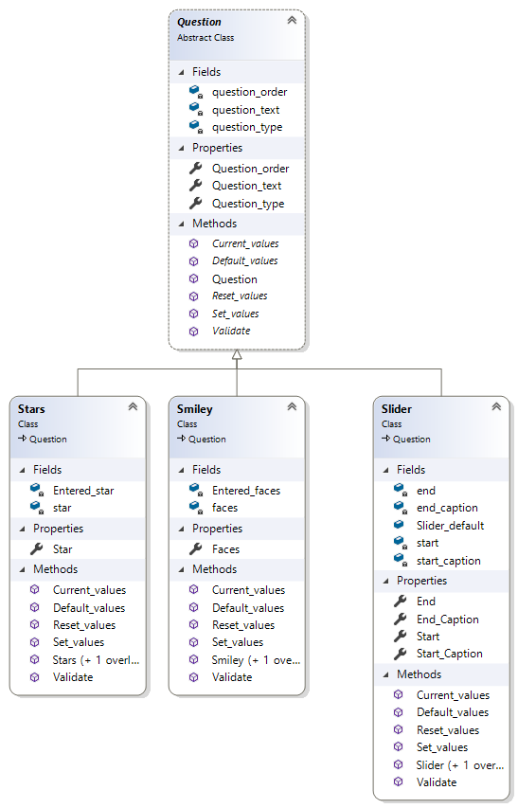

**Appendix A**

* Rules of Slider questions :

All values should be positive integer and within range (0-100). Also,

* Start value should be less than the following values :
* Start caption.
* End value.
* End caption.
* Start caption should be higher than Start value and less than the following :

* End value.
* End caption.
* End value should be the highest value.
* End caption should be higher than start value and Start caption and lower than End value.
* Rules of Smiley questions :

The maximum number of smiles allowed is 5 and the number should be between 2 and 5 as integer.

* Rules of Stars questions :

The maximum number of stars allowed is 10 and the number should be between 0 and 10 as integer.