//Color-Theory//

1- Font-colors have to be consistent with the words

\*Color-Moods\*

a-RED

love-energy-intensity

b-Yellow

joy-intellect-attention

c-Green

freshness-safety-growth

d-blue

stabilty-trust-serenity

e-purple

royalty-wealth-femininity

//Combining-Colors//

\*Analogous-Colors\*

look alike colors for thing that are not very important things that dont pop out

/colors that are next in the color wheel

\*Complementary-Colors\*

not look alike colors for thing that are important things that pop out

/color on that obesite side of the color wheel/// dont use those for font coloring ///

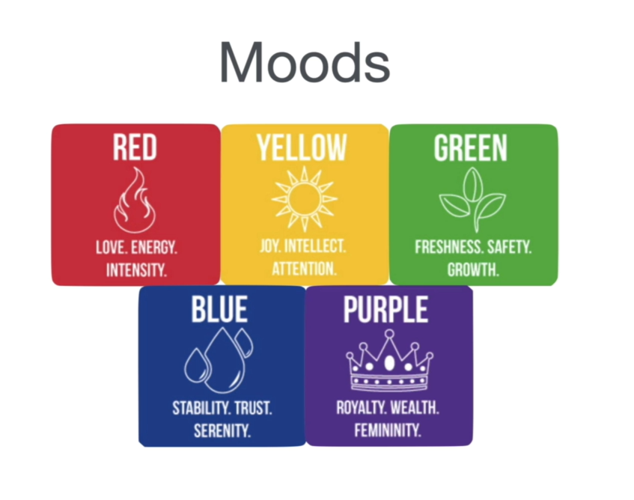

//Font-theory//

Don’t use more that 2 fonts in the same web site

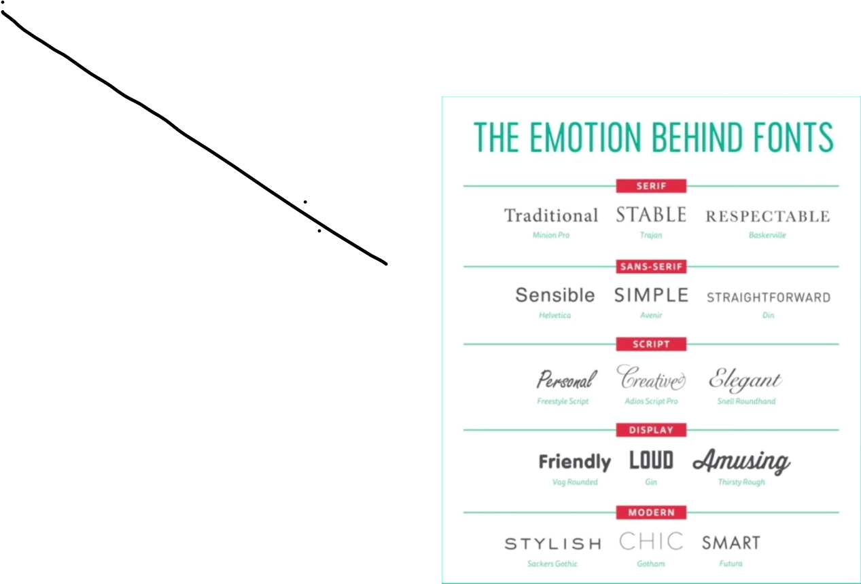

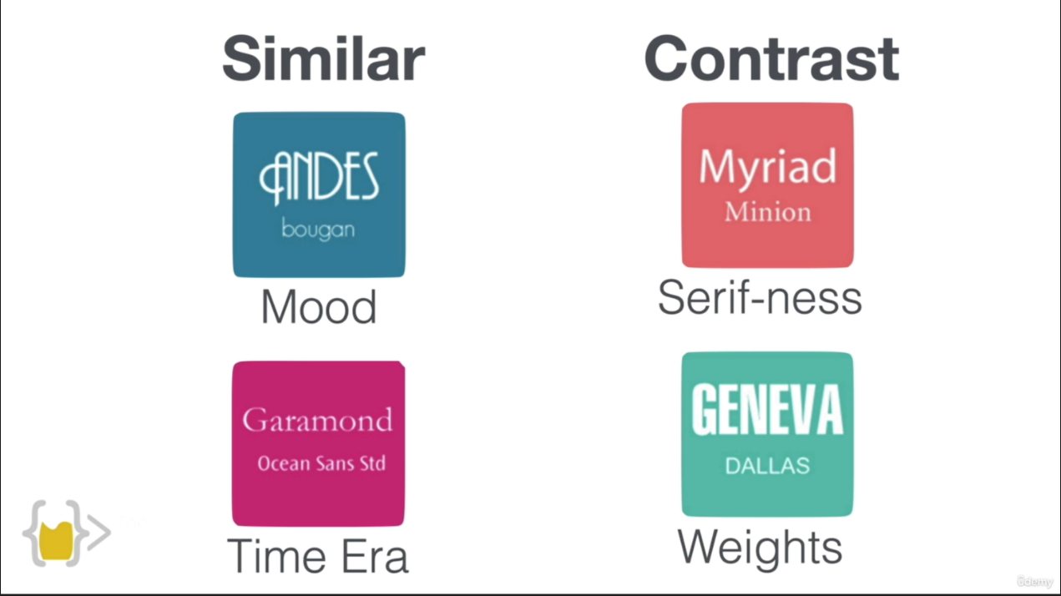

//User-interface//

1-Hierarchy(color & size)

2-Layout

3-Alignment(postioning)

4-White space

5-Audience

//User-experince//

Do what the user want

1-Simplicity

2-Consistency

3-Reading patterns (F-layout && Z-layout)

4-All platform design (phone & tablet & laptop)

5-Don’t use Your Power for EVIL (Do what the user want )

