AI-Guided Self-Reflection Session Platform

System Design & Technical Specification — MVP
Prepared for: Client
Prepared by: AsapStudio
Date: March 2026
Version: 1.0 (MVP)

1. Project Overview

What We’re Building
A web-based platform where an AI avatar guides users through structured self-reflection sessions. The avatar acts as a compassionate listener — asking pre-defined questions, listening to responses, and gently guiding the conversation forward.

Key Principles
- AI does NOT give advice — it follows scripts and listens
- AI does NOT search the internet — fully scripted flow
- Human-driven — the user reflects, discovers, and gains personal insight
- Safe space — no judgment, no labeling, no diagnosis
- Not therapy — but uses therapeutic process design

MVP Scope (This Phase)
- ✅ One pre-defined question script (5–6 questions)
- ✅ AI avatar asks questions and listens to responses
- ✅ Re-ask logic if user’s response is unclear or off-topic
- ✅ Full session transcript stored in database
- ✅ Doctor can view completed session transcripts
- ✅ Target latency: < 1.5 seconds response time

2. System Architecture

High-Level Flow

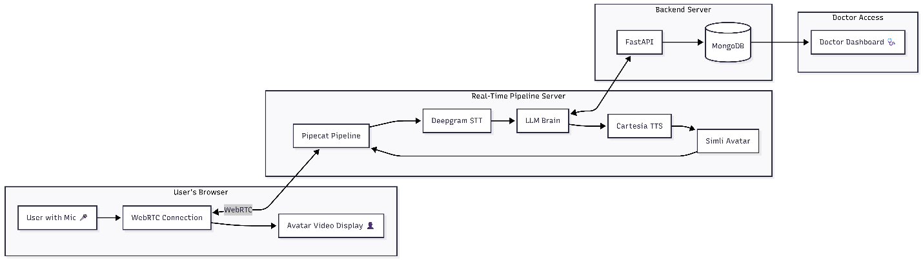How a Session Works (Step by Step)

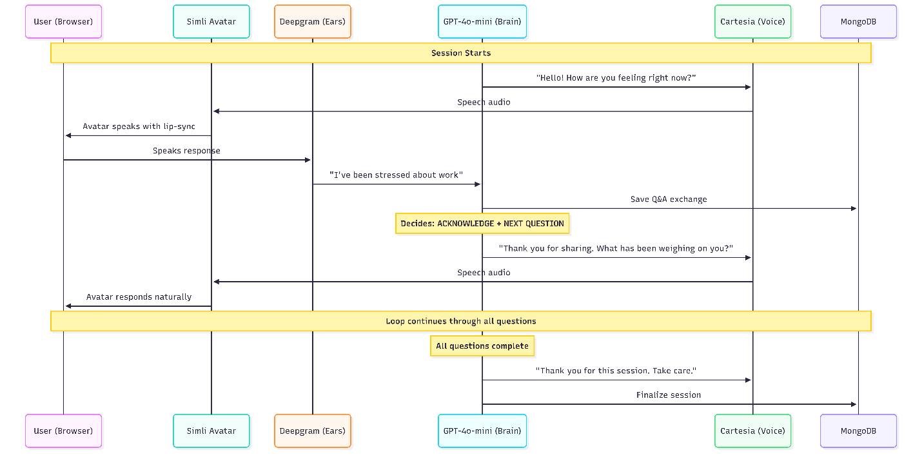

3. Technology Stack
Component | Technology | Why This Choice
Real-time Pipeline | Pipecat (Python) | Open-source framework for real-time voice AI bots. Handles audio/video streaming, turn-taking, and all service integrations out of the box
Avatar | Simli | Converts speech audio → lip-synced avatar video in real-time
Speech-to-Text | Deepgram (Nova-3) | Industry-leading streaming STT with ~200ms latency
Text-to-Speech | Cartesia (Sonic) | Ultra-low latency TTS (~200ms), natural-sounding voices
LLM (Brain) | GPT-4o-mini via LangChain | Fast, cost-effective, follows scripted instructions accurately
Backend API | FastAPI (Python) | REST API for session management, doctor dashboard
Database | MongoDB | Flexible document storage for sessions, messages, and Q&A
Transport | WebRTC | Real-time audio/video streaming between browser and server
Voice Detection | Silero VAD (built-in to Pipecat) | Detects when user starts/stops speaking for natural turn-taking

What is Pipecat?
Pipecat is an open-source Python framework for building real-time voice and video AI agents. Instead of manually wiring together STT → LLM → TTS → Avatar (which takes weeks), Pipecat provides a pipeline where data flows through each stage automatically and in parallel:
pipeline = Pipeline([
transport.input(), # Captures user's mic audio
stt, # Deepgram: audio → text (streaming)
llm, # GPT-4o-mini: decides response (streaming)
tts, # Cartesia: text → speech audio (streaming)
simli_avatar, # Simli: audio → lip-synced video
transport.output(), # Sends video + audio back to browser
])
Key benefit: Everything streams in parallel — while the LLM is generating words, the TTS is already converting earlier words to speech, and Simli is already rendering video. This is how we achieve < 1.5 second response time.

4. Cloud API Costs

Cost Breakdown Per Service
Service | What It Does | Free Tier / Trial | Pay-As-You-Go Cost
Simli | Avatar video rendering | 120 free minutes + $10 credit on signup | $0.05 / minute
Deepgram | Speech-to-Text (ears) | $200 free credit (~433 hours of audio) | $0.0077 / minute (Nova-3)
Cartesia | Text-to-Speech (voice) | 10,000–20,000 free characters | ~$0.05 / 1,000 characters
OpenAI GPT-4o-mini | LLM Brain (intelligence) | Standard API access (pay-per-use) | $0.15 / 1M input tokens, $0.60 / 1M output tokens
MongoDB Atlas | Database | Free cluster (512 MB storage) | $0.00 for MVP

Alternative LLM Options
LLM Model | Input Cost (per 1M tokens) | Output Cost (per 1M tokens) | Free Tier | Notes
GPT-4o-mini ✅ | $0.15 | $0.60 | No | Fast, cheap, accurate for scripted tasks
GPT-4o | $2.50 | $10.00 | No | Higher accuracy, 17× more expensive
Gemini 2.5 Flash | $0.30 | $2.50 | ✅ Yes (daily quota) | Google alternative, free tier available
GPT-5 Nano | $0.05 | $0.40 | No | Cheapest OpenAI option

Alternative TTS Options
TTS Service | Free Tier | Cost per 1K Characters | Latency | Quality
Cartesia ✅ | 10K–20K free chars | ~$0.05 | ~200ms | Good
ElevenLabs | 10K chars/month | $0.24–0.30 | ~300ms | Excellent
Deepgram Aura | Part of $200 credit | $0.03 | ~250ms | Good

Estimated Cost Per Session
Scenario: A 10-minute session with 6 Q&A exchanges
Service | Calculation | Cost
Simli (avatar) | 10 min × $0.05/min | $0.50
Deepgram (STT) | 10 min × $0.0077/min | $0.08
Cartesia (TTS) | ~2,000 characters × $0.05/1K | $0.10
GPT-4o-mini | ~3K input + ~1K output tokens | < $0.01
MongoDB | Free tier | $0.00
Total per 10-min session |  | ~$0.68
For a 20-minute session: ~$1.30
For a 5-minute session: ~$0.35

Free Tier Capacity for Demo/Testing
Service | Free Allowance | How Many 10-min Sessions
Simli | 120 minutes | ~12 sessions
Deepgram | $200 credit (~433 hours) | ~2,598 sessions
Cartesia | 10K–20K characters | ~5–10 sessions
Limiting factor | Cartesia / Simli | ~5–10 free demo sessions

5. Session Logic

LLM Decision Engine
For each user response, the LLM decides one action:
Action | When | Avatar Response Example
NEXT | Clear, relevant response | “Thank you. Now, what has been on your mind today?”
REASK | Unclear, too brief, off-topic | “That’s okay. Take your time — how would you describe what you’re feeling?”
ACKNOWLEDGE | Emotional or vulnerable response | “Thank you for sharing that. It takes courage.” → then next question
CLOSE | All questions completed | “Thank you for this session. I hope it was a moment of reflection.”

LLM Rules (Strictly Enforced)
✅ ALWAYS | ❌ NEVER
Follow the script sequence | Give advice or opinions
Keep responses short (1–2 sentences) | Search the internet
Acknowledge the user warmly | Diagnose or label feelings
Be gentle when re-asking | Provide solutions or suggestions
Stay on topic | Reference external information

Pre-defined Script Example
{
"script_name": "Daily Check-In",
"questions": [
{"order": 1, "text": "How are you feeling right now, in this moment?", "category": "opening"},
{"order": 2, "text": "What has been occupying your thoughts today?", "category": "exploration"},
{"order": 3, "text": "When you think about that, what emotion comes up for you?", "category": "deep_reflection"},
{"order": 4, "text": "Have you experienced this feeling before? When was that?", "category": "deep_reflection"},
{"order": 5, "text": "What would you say to a friend going through the same thing?", "category": "perspective"},
{"order": 6, "text": "As we wrap up, what is one thing you would like to carry forward?", "category": "closing"}
]
}

6. Database Design (MongoDB)

sessions — One document per session
{
"_id": "session_abc123",
"patient_name": "John Doe",
"script_name": "Daily Check-In",
"status": "completed",
"started_at": "2026-03-07T10:00:00Z",
"ended_at": "2026-03-07T10:12:30Z",
"duration_seconds": 750,
"total_questions": 6,
"total_reasks": 1
}

messages — Every message between avatar and user
{
"_id": "msg_001",
"session_id": "session_abc123",
"role": "avatar",
"content": "How are you feeling right now, in this moment?",
"question_index": 1,
"llm_action": null,
"timestamp": "2026-03-07T10:00:05Z"
}
{
"_id": "msg_002",
"session_id": "session_abc123",
"role": "user",
"content": "I have been feeling stressed about work lately",
"question_index": 1,
"llm_action": "ACKNOWLEDGE",
"timestamp": "2026-03-07T10:00:35Z"
}

scripts — Pre-defined question sets
{
"_id": "script_daily_checkin",
"name": "Daily Check-In",
"questions": [
{"order": 1, "text": "How are you feeling right now?", "max_reasks": 2},
{"order": 2, "text": "What has been on your mind?", "max_reasks": 2}
],
"is_active": true
}

7. Latency Analysis

How We Achieve < 1.5 Second Response Time
Each stage processes data in parallel (streaming), not sequentially:
Sequential (slow):
[===STT 300ms===] → [===LLM 800ms===] → [===TTS 500ms===] → [===Simli 300ms===]
Total: ~1.9 seconds ❌
Pipelined/Streaming (our approach):
[===STT 300ms===]
[===LLM streaming===]
[===TTS streaming===]
[===Simli streaming===]
Total perceived: ~1.0–1.4 seconds ✅
Stage | Latency
Voice Activity Detection (Silero) | ~100ms
Deepgram STT (streaming) | ~200–300ms
GPT-4o-mini (streaming) | ~200–400ms
Cartesia TTS (streaming) | ~200ms
Simli avatar rendering | ~100–200ms
Total (pipelined) | ~1.0–1.4 seconds

8. MVP Timeline Estimate
Phase | Duration | Deliverable
Setup & Integration | 3–4 days | Pipecat pipeline + Simli + Deepgram + Cartesia working
Session Logic | 4–6 days | LangChain brain with script follow, reask, acknowledge
Backend API + Database | 3 days | FastAPI + MongoDB, session/message storage
Frontend | 2–3 days | Session page with avatar + doctor review page
Testing & Polish | 4 days | End-to-end testing, latency optimization
Total | ~15–20 days | Fully working MVP demo

