Abdallah Sayed Thabet lab2 bash Assuit-os

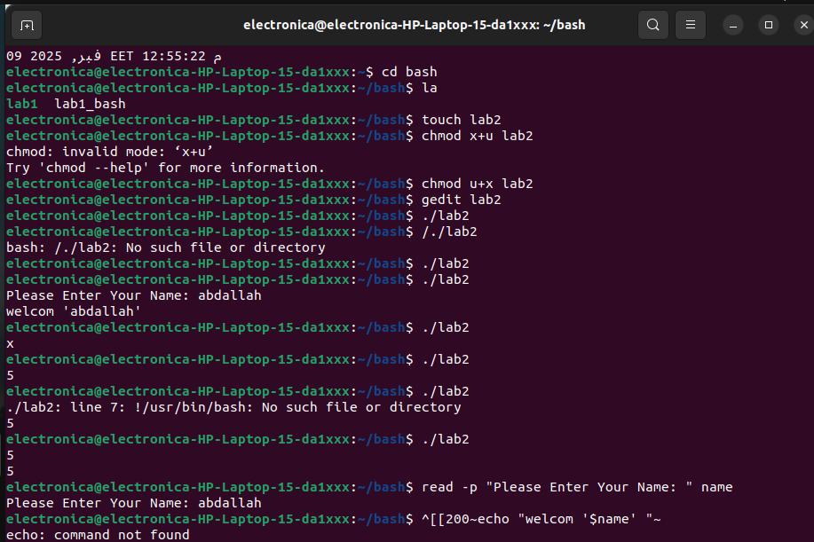
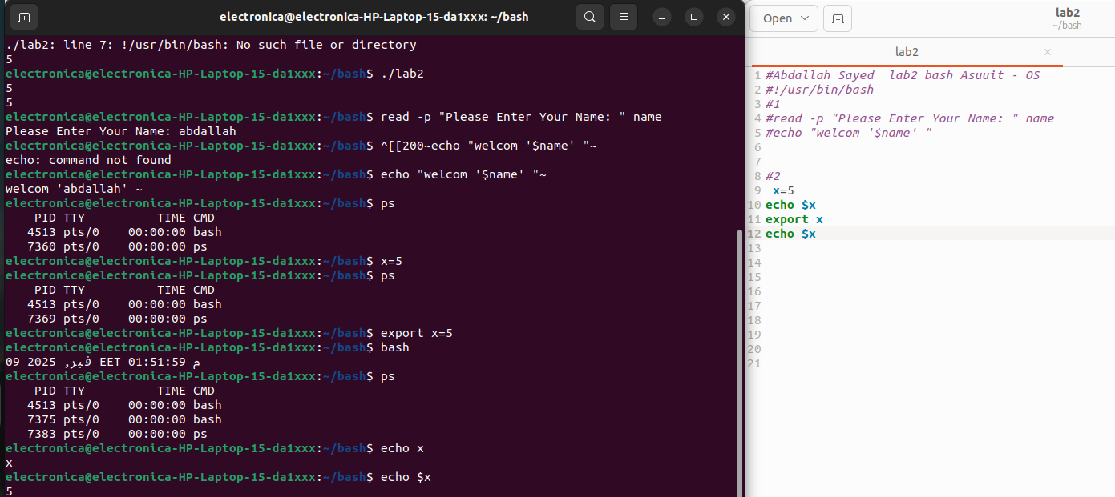

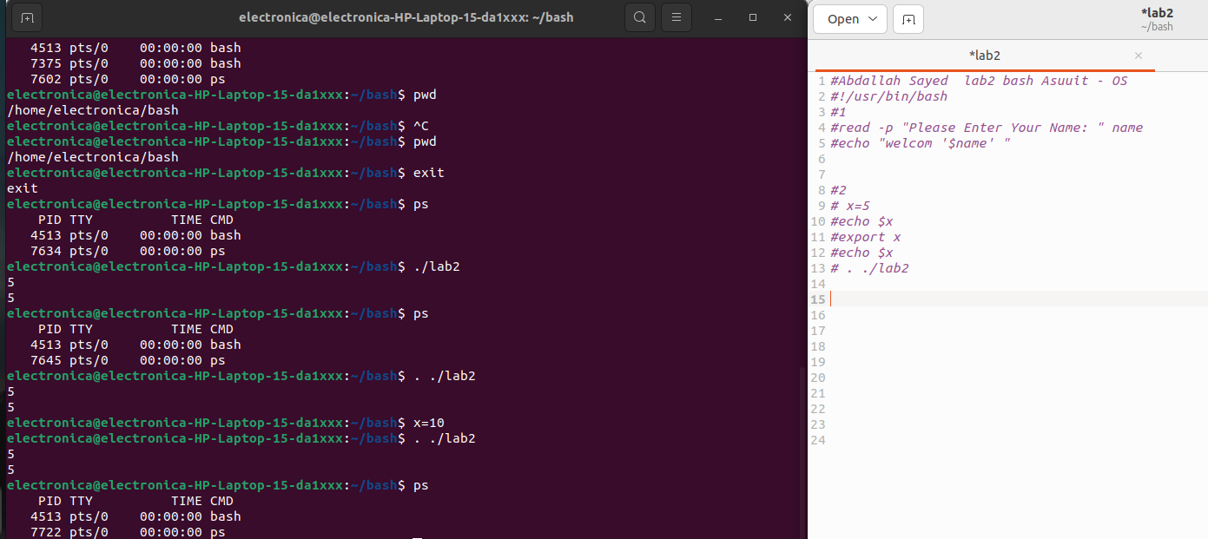
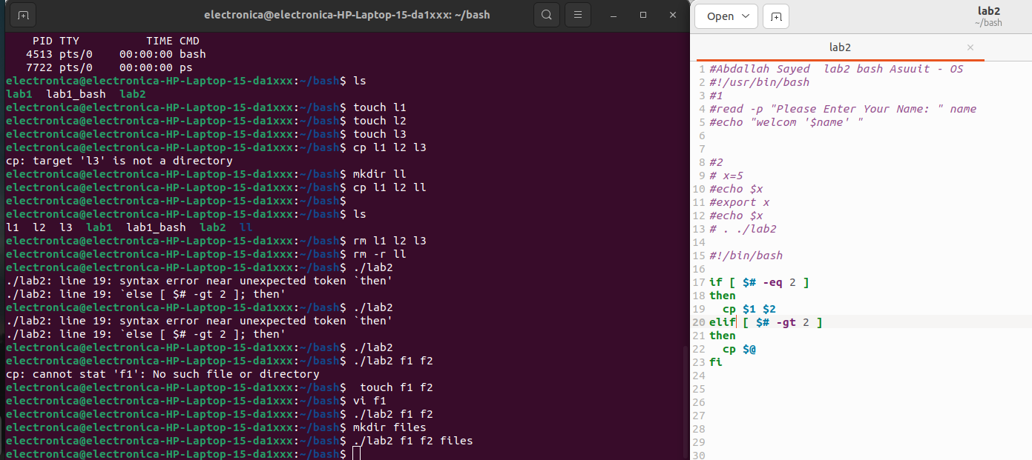

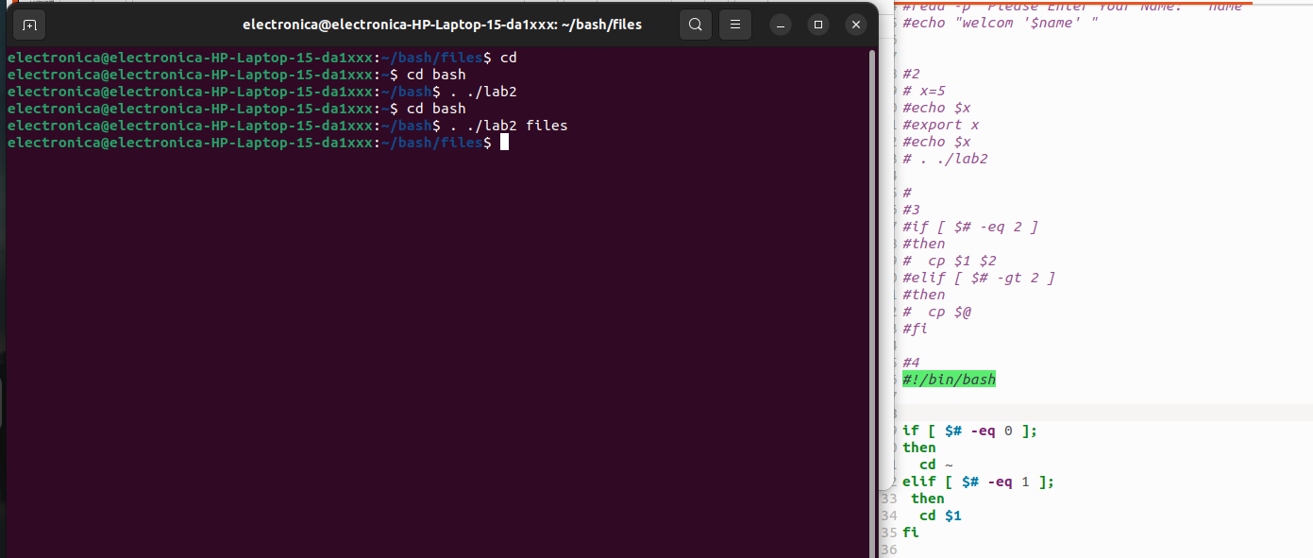
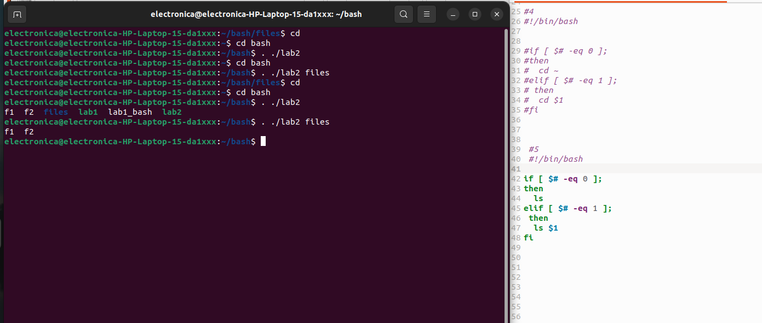
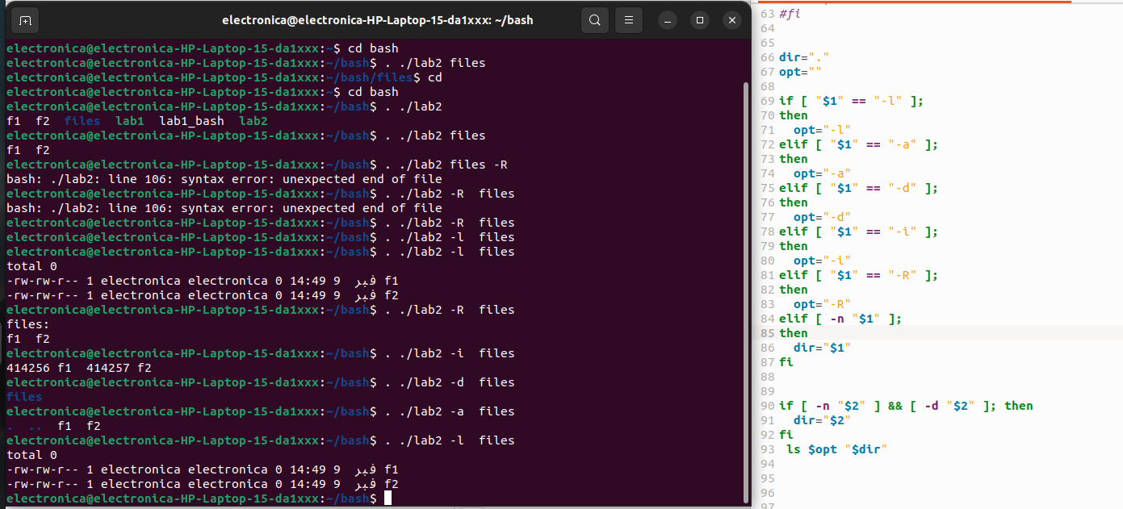
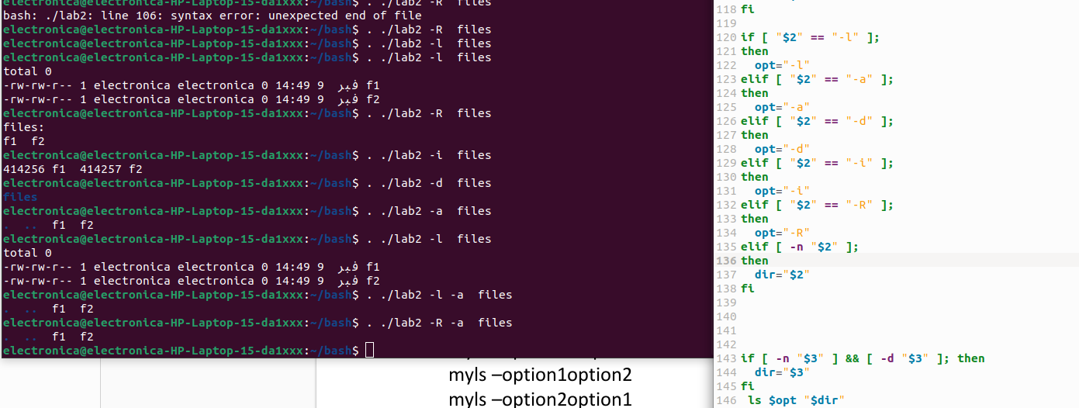

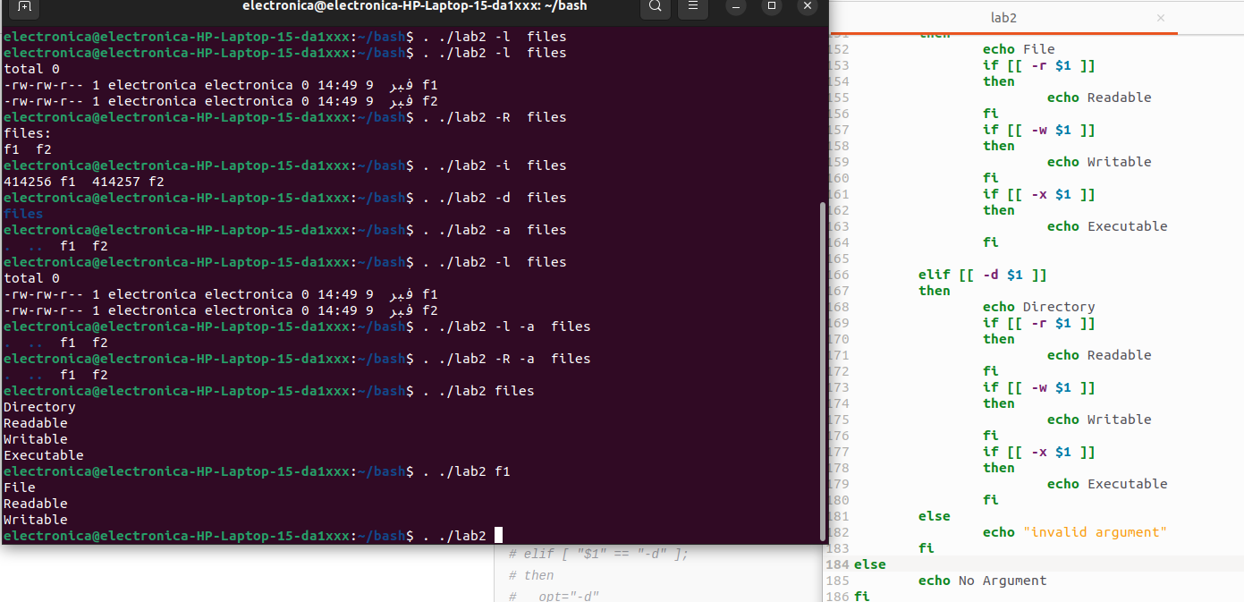
#Abdallah Sayed lab2 bash Asuuit - OS

#!/usr/bin/bash
#1
#read -p "Please Enter Your Name: " name
#echo "welcom '$name' "

#2
# x=5
#echo $x
#export x
#echo $x
# . ./lab2

#
#3
#if [ $# -eq 2 ]
#then
# cp $1 $2
#elif [ $# -gt 2 ]
#then
# cp $@
#fi

#4
#!/bin/bash

#if [ $# -eq 0 ];
#then
# cd ~
#elif [ $# -eq 1 ];
# then
# cd $1
#fi

#5
#!/bin/bash

#if [ $# -eq 0 ];
#then
# ls
#elif [ $# -eq 1 ];
# then
# ls $1
#fi

#6

#!/bin/bash

#if [ $# -eq 0 ];
#then
# ls
#elif [ $# -eq 1 ];
# then
# ls $1
#fi

#dir="."
#opt=""

#if [ "$1" == "-l" ];
#then
# opt="-l"
#elif [ "$1" == "-a" ];
#then
# opt="-a"
#elif [ "$1" == "-d" ];
#then
# opt="-d"
#elif [ "$1" == "-i" ];
#then
# opt="-i"
#elif [ "$1" == "-R" ];
#then
# opt="-R"
#elif [ -n "$1" ];
#then
# dir="$1"
#fi

#if [ -n "$2" ] && [ -d "$2" ]; then
# dir="$2"
#fi
#ls $opt "$dir"

# bouns
# dir="."
# opt=""

# if [ "$1" == "-l" ];
# then
# opt="-l"
# elif [ "$1" == "-a" ];
# then
# opt="-a"
# elif [ "$1" == "-d" ];
# then
# opt="-d"
# elif [ "$1" == "-i" ];
# then
# opt="-i"
# elif [ "$1" == "-R" ];
# then
# opt="-R"
# elif [ -n "$1" ];
# then
# dir="$1"
# fi

# if [ "$2" == "-l" ];
# then
# opt="-l"
# elif [ "$2" == "-a" ];
# then
# opt="-a"
# elif [ "$2" == "-d" ];
# then
# opt="-d"
# elif [ "$2" == "-i" ];
# then
# opt="-i"
# elif [ "$2" == "-R" ];
# then
# opt="-R"
# elif [ -n "$2" ];
# then
# dir="$2"
# fi

# if [ -n "$3" ] && [ -d "$3" ]; then
# dir="$3"
# fi
# ls $opt "$dir"

#bouns
if [[ $# -gt 0 ]]
then
if [[ -f $1 ]]
then
echo File
if [[ -r $1 ]]
then
echo Readable
fi
if [[ -w $1 ]]
then
echo Writable
fi
if [[ -x $1 ]]
then
echo Executable
fi

elif [[ -d $1 ]]
then
echo Directory
if [[ -r $1 ]]
then
echo Readable
fi
if [[ -w $1 ]]
then
echo Writable
fi
if [[ -x $1 ]]
then
echo Executable
fi
else
echo "invalid argument"
fi
else
echo No Argument
fi

