**Software requirements specification (SRS)**

For

**Bank system**

Version 1.0

Prepared by Abdullrahman Ghazal.

13 November 2023.

**Revision History**

|  |  |  |  |
| --- | --- | --- | --- |
| Version | Date | Author | Description |
| 1.0 | 13 November | Abdullrahman Ghazal | Initial release |

**Table Of Contents**

1.Introduction 4

1.1 Purpose 4

1.2 Scope 4

1.3 Intended Audience 4

2.System Overview 4

2.1 System Purpose 4

2.2 Key Features 4

3.Stakeholder Information 4

4.Context Diagram 5

- describes how external entities interact with an internal software system(Bank). 5

5. Use case diagrams and specifications 5

- a set of possible sequences of interactions between systems and users and how users will perform tasks in the Bank system. 5

6. Functional Requirements 6

7. Quality Attributes 7

-Performance 7

-Reliability 7

-Security 7

-Usability 7

8. System Constrains 7

1.Regulatory Compliance( 7

2. Security Standards 7

4. Interoperability 7

5. Legacy System Integration 7

6. Scalability 7

9. Hardware Requirements 7

1. Server Infrastructure 7

2. Database Servers 7

3. Network Components 7

4. Load Balancers 7

5. Storage Systems 7

# 1.Introduction

## 1.1 Purpose

The purpose of this document is to outline the requirements for the development of a comprehensive Banking System that caters to the needs of both customers and bank administrators.

## 1.2 Scope

This SRS defines the functional and non-functional requirements for the Banking System, including account management, transaction processing, and security features.

## 1.3 Intended Audience

This document is intended for the project team, stakeholders, and anyone involved in the development, testing, and deployment of the Banking System.

# 2.System Overview

## 2.1 System Purpose

The Banking System is designed to provide a secure, efficient, and user-friendly platform for customers to perform banking transactions and for administrators to manage accounts and monitor the overall system.

## 2.2 Key Features

-Account Management

-Transaction Processing

-Customer Authentication

-Security and Access Control

-Reporting and Monitoring

# 3.Stakeholder Information

Stakeholders in the Banking System include customers, bank administrators, regulatory authorities, and system administrators. Each stakeholder has specific roles and responsibilities within the system.

# 4.Context Diagram

## - describes how external entities interact with an internal software system(Bank).

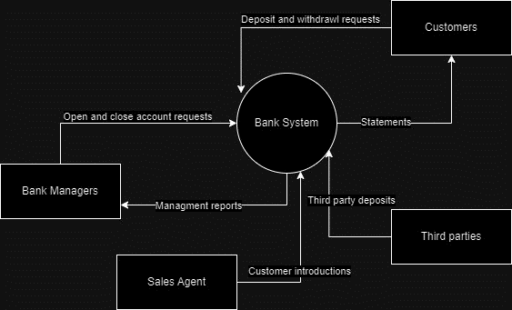

# 5. Use case diagrams and specifications

## - a set of possible sequences of interactions between systems and users and how users will perform tasks in the Bank system.

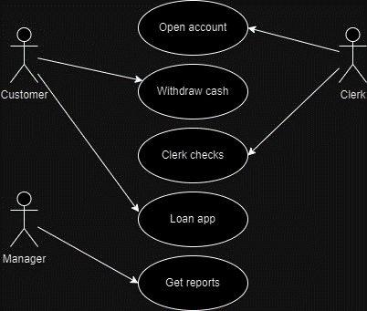

# 6. Functional Requirements

1.The system shall allow users to register for a new account by providing necessary personal information, including but not limited to name, address, contact details, and a valid identification document.

1.1The system shall verify user identity during the registration process through a secure authentication mechanism, such as email verification or SMS confirmation.

1.2Once registered, users shall have the ability to log in securely using unique credentials (username and password).

2. Users shall be able to create various types of accounts, including savings, checking, and fixed deposit accounts.

2.1The system shall provide users with the capability to view and update their account information, including contact details and account preferences.

2.2Users shall have the option to close an existing account through a secure and authenticated process.

3. The system shall facilitate secure fund transfer between accounts, both within the same bank and to external accounts.

3.1Users shall receive real-time transaction notifications and shall be able to view a detailed transaction history for each account.

4. Users shall have access to electronic account statements, which include details of transactions, interest earned, and account balances.

4.1The system shall generate periodic reports for users, summarizing account activity and financial trends.

5. The system shall implement robust security measures, including encryption protocols, to safeguard user data and financial transactions.

5.1Users shall be provided with the option for two-factor authentication to enhance the security of their accounts.

# 7. Quality Attributes

-Performance (response times, system scalability)

-Reliability (system uptime, data integrity)

-Security (encryption, access control)

-Usability (intuitive user interfaces)

# 8. System Constrains

1.Regulatory Compliance(Changes in regulatory requirements must be promptly integrated into the system).

2. Security Standards(Strict access controls and data privacy measures must be implemented).

3. Data Privacy(Access to sensitive customer information is restricted to authorized personnel).

4. Interoperability(The system must be compatible with existing financial systems and payment gateways).

5. Legacy System Integration(Integration with legacy systems must be carefully planned and executed).

6. Scalability(Regular scalability testing must be conducted to identify and address performance issues).

# 9. Hardware Requirements

1. Server Infrastructure(The banking system requires a robust server infrastructure with redundant servers for high availability).

2. Database Servers(The database server must support high-speed data retrieval and storage capabilities).

3. Network Components(Network components must include firewalls and intrusion detection/prevention systems to ensure data security).

4. Load Balancers(Load balancing mechanisms must be scalable to accommodate increased user loads).

5. Storage Systems(Adequate storage systems, such as RAID configurations, are essential for data redundancy and fault tolerance).