Add these two fields in **quotation2_children** table

1. topMultiLockingSystem (Varchar)
2. topHungSelectedLock (Number)

How to add these two fields? So look;

Step 1:

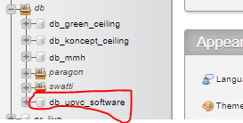

Step 2: Click on table

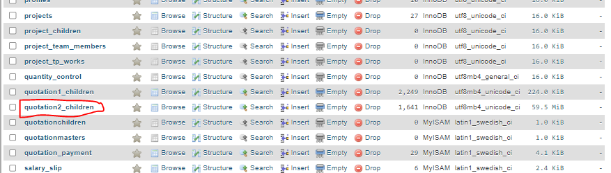

Step 3: Click on Structure

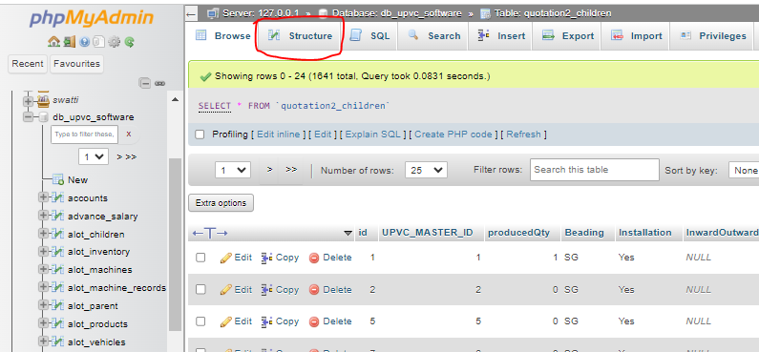

Step 4: Scroll down and click on “Go”

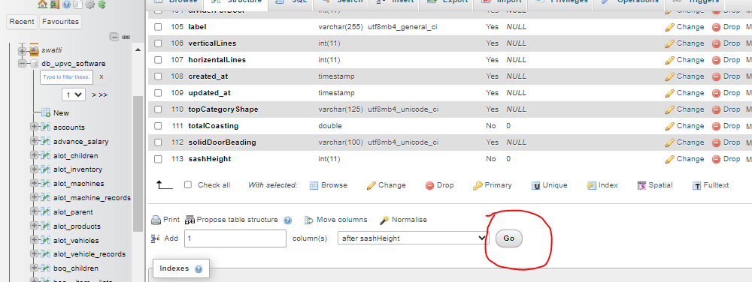

Step 5: Fill out these fields and click on “Save”

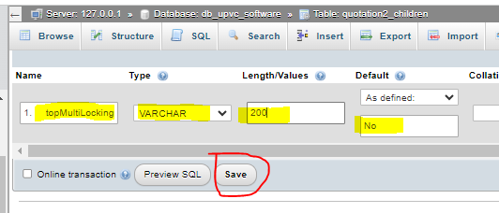

Step 6: Repeat step 4 and 5 to add another column.

**Note:** Do not Fill **Length/Values** field for this as it is of type **INT** and don’t require length.

