**Task 1:**

#include<iostream>

using namespace std;

int main(){

int sum,i;

for(i=1;i<=10;i++){

cout<<"enter a number:";

cin>>i;

sum=sum+i;

cout<<"the sum is :"<<sum<<endl;

}

return 0;

**Output:**

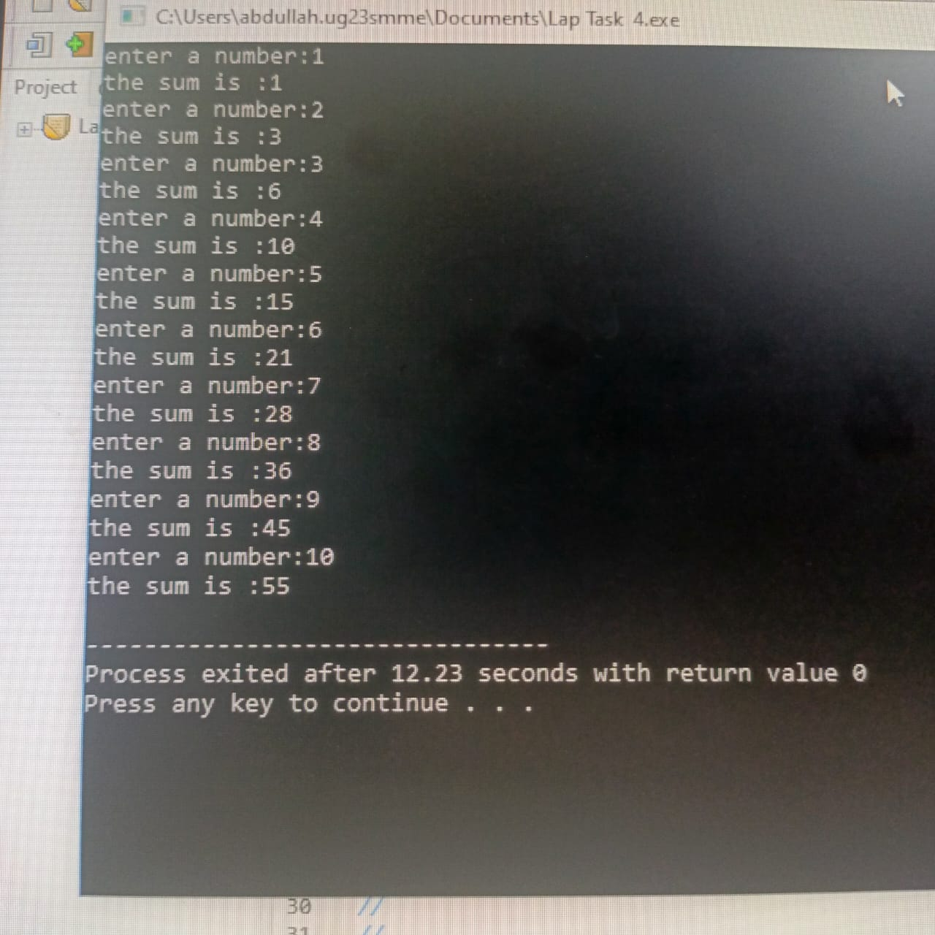

**Task 2:**

#include<iostream>

using namespace std;

int main(){

int num , table;

cout<<"enter a Number :";

cin>> table;

for(num=1;num<=10;num+=1){

cout<<"Table of " << table<<" is : " ;

cout<<" a * "<<num<<"="<<num*table<<endl;

}

return 0;

}

**Output:**

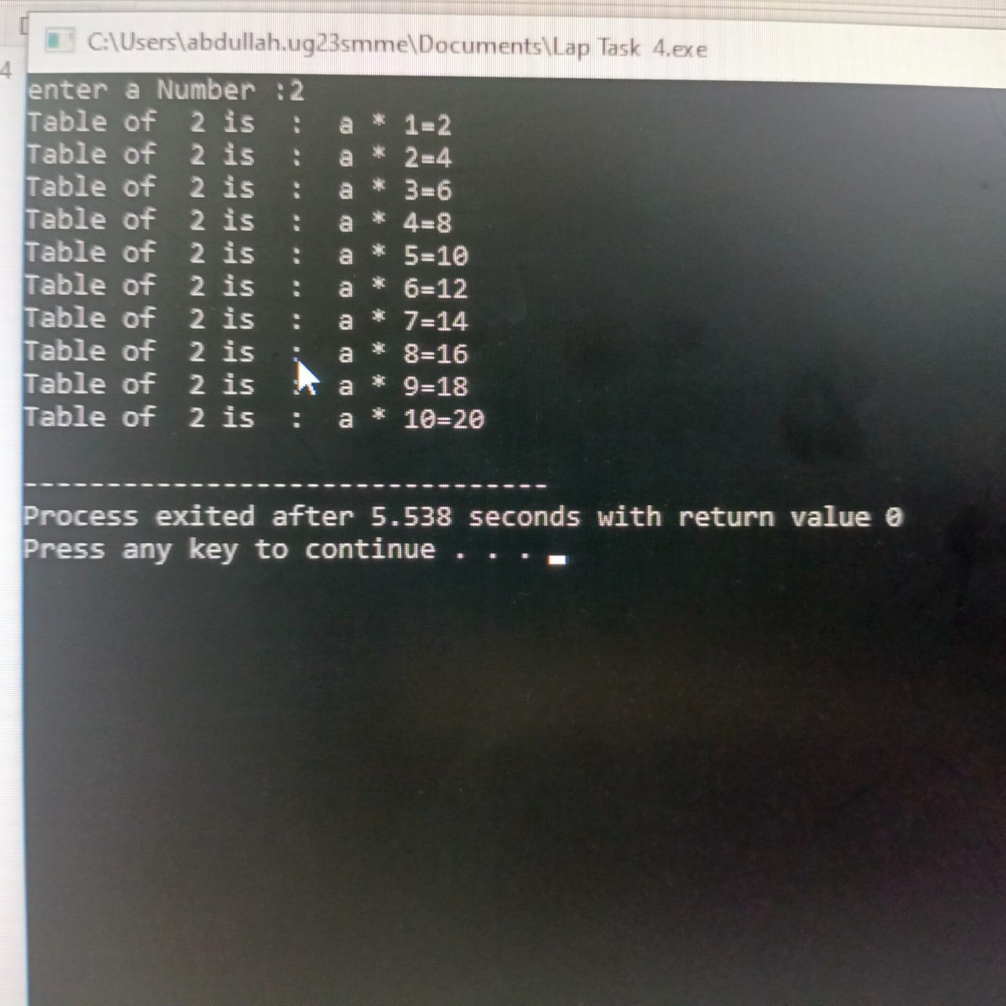

**Task 3:**

#include<iostream>

using namespace std;

int main(){

int i , fact=1,num;

cout<<"enter any number : ";

cin>> num;

for(i=1;i<=num ;i++){

fact=fact*i;

}

cout<<"Factorial of "<<num<<" is : "<<fact<<endl;

return 0;

**Output:**

