**1-Constant Block**

**Definition:** This block is used to generate constant signal value.

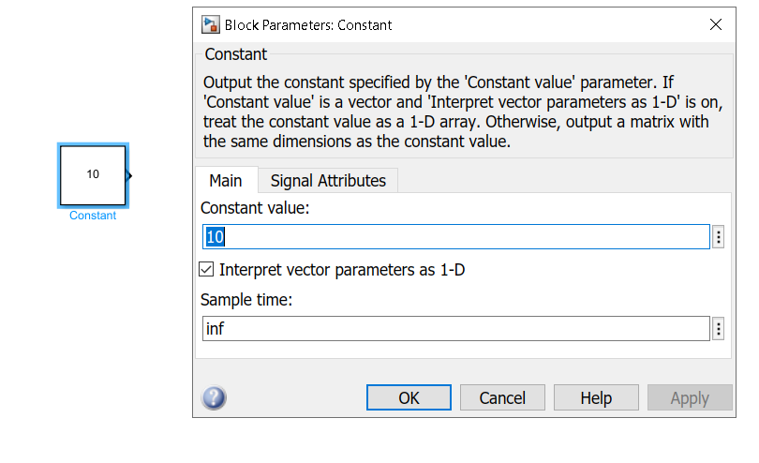

**2-Display Block**

**Definition:** this block is used the visualization the signal numeric value that is came for it as input.

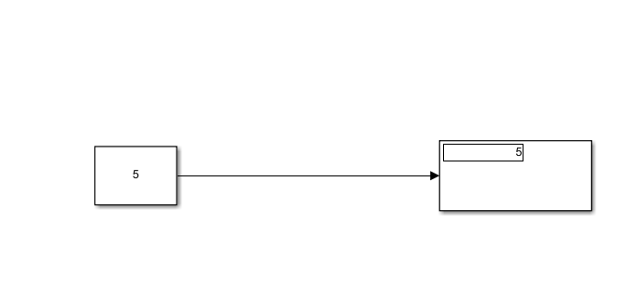

**4-Sum Block**

**Definition:** it’s block that is used to sum or subtract signals that came for it as input and it’s used most time in control systems**.**

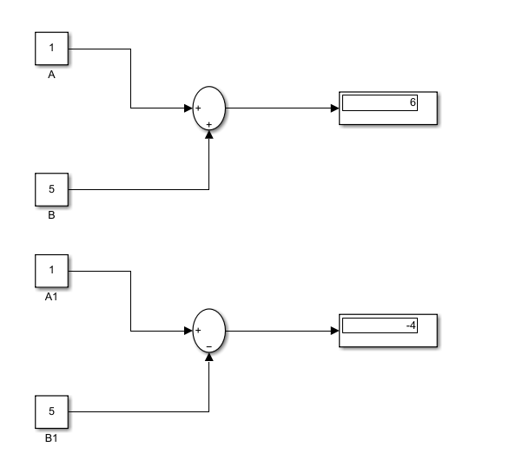

**5- The product block**

**Definition:** This block is used for multiplication or division input signals.

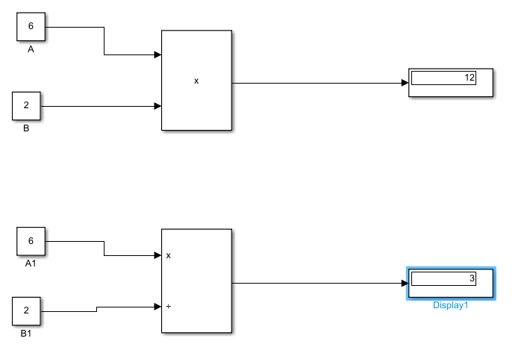

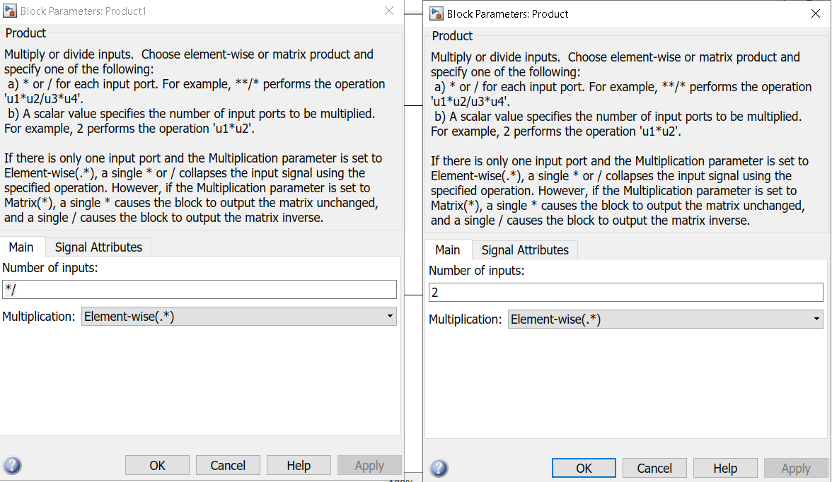

**6- Gain Block**

**Definition:** this block is used to Amplification or Attenuation input signals, it’s used in control systems.

