Supervisor briefing — update since the fifth meeting (8 October 2026)
Can a soundtrack's emotion predict a film's genre? This page covers what was done after the fifth meeting: the four notes, a data error found while answering the second one, and what both changed. The briefing for the fourth meeting is archived in docs/archive/current_state_2026-10-07.md; every earlier round is in briefing_full.md, and every experiment in detail in the technical log, docs/README.md (section 24 for this round). The thesis on Overleaf is up to date with everything below.
All genre scores are film-level macro-F1 (the clip probabilities of a film are averaged and the film is scored once); the clip-level value of the same predictions is given where it matters.

1. Your notes from the meeting
# | Your note | What was done | Result
1 | Blockbuster cross-validation as a bar chart, but with SD | Two bar charts with error bars (section 3) | Blockbuster in-domain: the routes are level; across datasets the error bars show how much a single split can move
2 | Films common to Eerola and Blockbuster (leakage) | Checked every IMDb id and title (section 4) | No film is in both datasets. But inside Eerola one film was counted twice — fixed, and every Eerola result re-run (section 2)
3 | F1, precision and recall per genre; the best model per genre; a diagram | Per-genre heatmap and table (section 5) | The emotion route is best on Action, Crime and Comedy; MIR on Drama; CLAP on Horror
4 | Focus the Evaluation on a few results; be more precise in the Discussion | Evaluation rebuilt around the core results, the rest in a new Appendix A; Discussion shortened (section 6) | Evaluation 990 → about 530 lines, Discussion 340 → about 200

2. A data error found while checking note 2
Eerola clip 256 is labelled "The Portait of a Lady" (a typo), the film's six other clips "The Portrait of a Lady" — the same film (same IMDb id). Every split groups clips by this name, so the film counted as two films and one of its clips could be tested while the other six were in training: a small leak, and wrong film counts everywhere.
- Fixed in the loader (the two spellings are merged); the dataset has 42 films on eight genres and 40 on five, not 43 and 41; clips per film range from 2 to 18.
- Every Eerola experiment that groups by film was re-run (16 scripts, about two hours). Each re-run reproduced the one before it exactly, so the changes come from the grouping alone.
- The numbers moved by about the size of the split noise (0.01 to 0.03), because merging the two names changes which films land in which fold. Some conclusions changed with them (section 7).

3. Note 1 — bar charts with SD
Blockbuster in-domain (10×5 cross-validation over the 110 films; error bars = SD of the 10 repeat means):
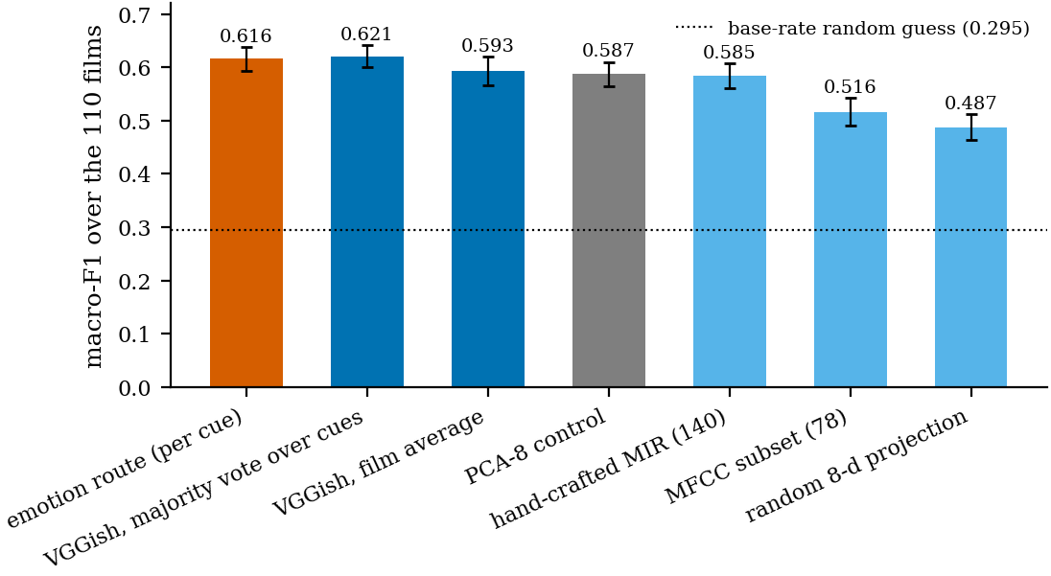
Blockbuster in-domain cross-validation
The emotion route (0.616 ± 0.022) is level with direct audio: VGGish film average 0.593 ± 0.028 (Nadeau–Bengio p = 0.536), VGGish with a majority vote over cues 0.621 ± 0.020, PCA-8 0.587, hand-crafted MIR 0.585; random guess 0.295.
Across datasets (error bars: bootstrap SD over the test films for the two transfer directions, SD of the 5 repeat means for the pooled design):
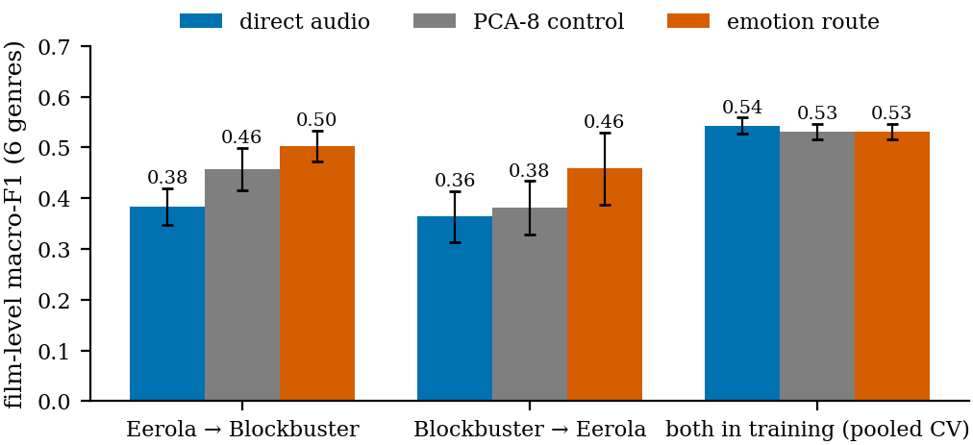
The three cross-dataset designs
design | emotion | PCA-8 | direct | emotion − direct
Eerola → Blockbuster (re-implementation) | 0.503 ± 0.030 | 0.457 | 0.383 ± 0.037 | +0.121, p = 0.007
Blockbuster → Eerola, 40 films | 0.458 ± 0.071 | 0.381 | 0.364 ± 0.050 | +0.089, p = 0.102
both in training (pooled, per film) | 0.531 ± 0.015 | 0.531 | 0.543 ± 0.016 | -0.011, p = 0.688

The error bars of a single transfer split are large (about ±0.03 to ±0.07), which is why the comparisons rest on the paired bootstrap rather than on the bars overlapping or not.

4. Note 2 — leakage between the datasets
- No common film. None of the 42 Eerola films' IMDb ids occurs among the 110 Blockbuster films, and no title matches (also not loosely). The Eerola films are all from before 2011, the Blockbuster films from 2014 to 2019.
- Shared composers, not shared films. Some composers scored films in both, e.g. Danny Elfman (Batman in Eerola, Justice League in Blockbuster, which quotes his Batman theme). That is stylistic overlap, not a leak; the thesis names it as a limitation.
- The leak that did exist was inside Eerola (section 2), and it is fixed.

5. Note 3 — results per genre
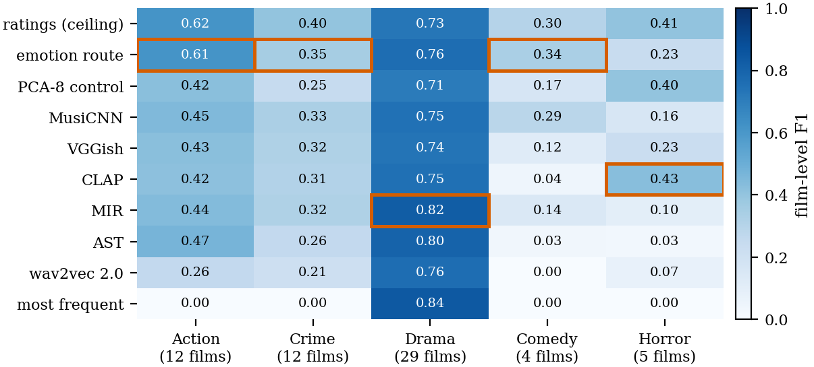
Film-level F1 per genre and route; the best route per genre is boxed
genre | films | best route (F1) | emotion route P / R / F1 | VGGish P / R / F1
Action | 12 | emotion route (0.61) | 0.52 / 0.76 / 0.61 | 0.39 / 0.47 / 0.43
Crime | 12 | emotion route (0.35) | 0.28 / 0.47 / 0.35 | 0.29 / 0.37 / 0.32
Drama | 29 | MIR (0.82) | 0.87 / 0.68 / 0.76 | 0.79 / 0.69 / 0.74
Comedy | 4 | emotion route (0.34) | 0.22 / 0.78 / 0.34 | 0.12 / 0.12 / 0.12
Horror | 5 | CLAP (0.43) | 0.15 / 0.50 / 0.23 | 0.21 / 0.26 / 0.23

- The emotion route is the best route for Action, Crime and Comedy; the hand-crafted MIR features are best on Drama and CLAP on Horror.
- Its advantage is mostly recall on the rare genres: averaged over the five genres recall 0.64 vs 0.38 for VGGish, at precision 0.41 vs 0.36. Comedy is the clearest case (recall 0.78 vs 0.12).
- Horror is the exception: the emotion route finds half the Horror films but predicts the genre for too many others (precision 0.15).
- With 4 Comedy and 5 Horror films, one film moves a genre's F1 by about 0.2: this is a description, not a test.

6. Note 4 — a focused Evaluation and a more precise Discussion
Main text of Chapter 5 now: Stage 1 (emotion regression, short) → RQ1 → emotion vs direct audio with one 4-row comparison table → results per genre (new) → emotional signatures and their replication → transfer (Blockbuster in-domain chart, leakage check, zero-shot, the three cross-dataset designs with SD) → a one-page summary.
Moved to the new Appendix A (each with one sentence and a pointer in the main text): all paired comparisons and the Nadeau–Bengio limit, the metric family and the threshold analysis, stability over seeds, the emotion ablation, the waveform representation, all eight genres, the reproduction of Ma et al. with the cue-level analysis, and the error analysis.
Discussion: built around one table of all settings; one paragraph each for the in-domain and the cross-dataset result; the "why" section reduced to meaning vs compression, scarce data and domain shift; limitations as short paragraphs.

7. What changed in the numbers (before → after the duplicate fix)
 | before | after
emotion route, 5 genres (film level) | 0.469 | 0.460
ratings (ceiling) | 0.521 | 0.491
direct VGGish / best direct (MusiCNN) | 0.375 / 0.385 | 0.367 / 0.396
PCA-8 control | 0.418 | 0.390
emotion vs VGGish (film bootstrap) | +0.095, p = 0.047 | +0.093, p = 0.052
emotion vs PCA-8 | +0.051, p = 0.326 | +0.070, p = 0.089
predicted vs rated emotion | −0.053, p = 0.053 | -0.032, p = 0.277
8 genres: emotion vs VGGish | +0.096, p = 0.002 | +0.093, p = 0.001
zero-shot: emotion vs direct | 0.511 vs 0.407, p = 0.018 | 0.508 vs 0.403, p = 0.013
Blockbuster → Eerola (per film) | +0.077, p = 0.127 | +0.089, p = 0.102
Stage 1, best R² | 0.561 | 0.558

What this changes in the thesis.
- In-domain, the emotion route is still ahead of every direct representation in nearly every repeat and under every seed, but its lead is now significant only against the weaker ones (AST, hand-crafted MIR, wav2vec 2.0). Against VGGish it just misses (p = 0.052), against CLAP, MusiCNN and PCA-8 it is not significant.
- Film level is the stricter unit. Over clips the film bootstrap finds the lead significant against VGGish, CLAP, MusiCNN and PCA-8; over films it does not. So the film-level choice does not favour the method — the thesis says so.
- The zero-shot result is unchanged in substance; the cross-dataset conclusions stand.

8. Open items
1. Write the held-back parts (abstract, Chapter 7, contributions). The drafts in docs/latex/held_back/ quote numbers from before the film-level switch and the fix; use section 7 above.
2. Read Chapters 5, 6 and Appendix A in full. They were rebuilt today; the Discussion's interpretation must become your own.
3. Zero-shot with a threshold tuned on the source dataset — still not run.
4. AI declaration: two red notes and the date.

9. Questions to expect, and the answers
Is the emotion route better in-domain? It is ahead of every direct audio representation (by +0.093 over VGGish, its own input) in 9 or all ten repeats and under every seed, but on 40 films its lead is significant only against the weaker representations; against VGGish p = 0.052. Part of the gain is compression (PCA-8 is also ahead of VGGish under every seed) and part is the default threshold (with tuned thresholds the routes converge, 0.420–0.433 over clips).
What is the main result then? The emotion route is clearly ahead where the classifier is trained on the small Eerola dataset — in-domain and from Eerola to Blockbuster (0.508 vs 0.403, p = 0.013) — and level where it is trained on the 110 Blockbuster films or on both. Its emotional signatures replicate on Blockbuster (r = 0.836).
Could the transfer result come from films that are in both datasets? No: no film is in both (section 4).
Why do the numbers differ from the last meeting? A film was counted twice in Eerola; fixing it changed every split (section 2).
Why is box office not in the thesis? It answers a question about commercial success, not genre: classification quality does not relate to gross (Eerola ρ = +0.197), and the score's emotions relate to it only through the budget (anger ρ = +0.43, budget–gross ρ = +0.78).

Headline numbers as they stand
Each row is its own label space, compared only against its own chance level:
setting | emotion route | best direct audio | random guess
Eerola, 5 genres, in-domain, film level | 0.460 | 0.396 (MusiCNN); VGGish 0.367 | 0.309
Eerola, 5 genres, in-domain, clip level | 0.405 | 0.366 (VGGish) | 0.307
Eerola, 5 genres, clip level, tuned thresholds | 0.420 | 0.423 (VGGish) | 0.307
Eerola, 8 genres, film level | 0.349 | 0.257 (VGGish) | 0.226
Eerola, 8 genres, clip level | 0.317 | 0.278 (AST) | —
Eerola → Blockbuster, zero-shot | 0.508 | 0.403 (VGGish) | 0.292
Blockbuster → Eerola, 40 films | 0.458 | 0.364 (VGGish) | 0.240
Blockbuster, in-domain | 0.616 | 0.621 (VGGish, majority vote) | 0.295

Significance, in-domain (5 genres, film bootstrap): emotion vs VGGish p = 0.052, vs PCA-8 p = 0.089; over clips, Nadeau–Bengio p = 0.086 vs VGGish. Zero-shot: +0.106 [+0.021, +0.184], p = 0.013. Stability (clip level): SD over the 10 repeats 0.019 for the emotion route. Exact match of the most-frequent baseline: 0.283.

