Appendix F — Additional Screenshots

F.1 Authentication Screens
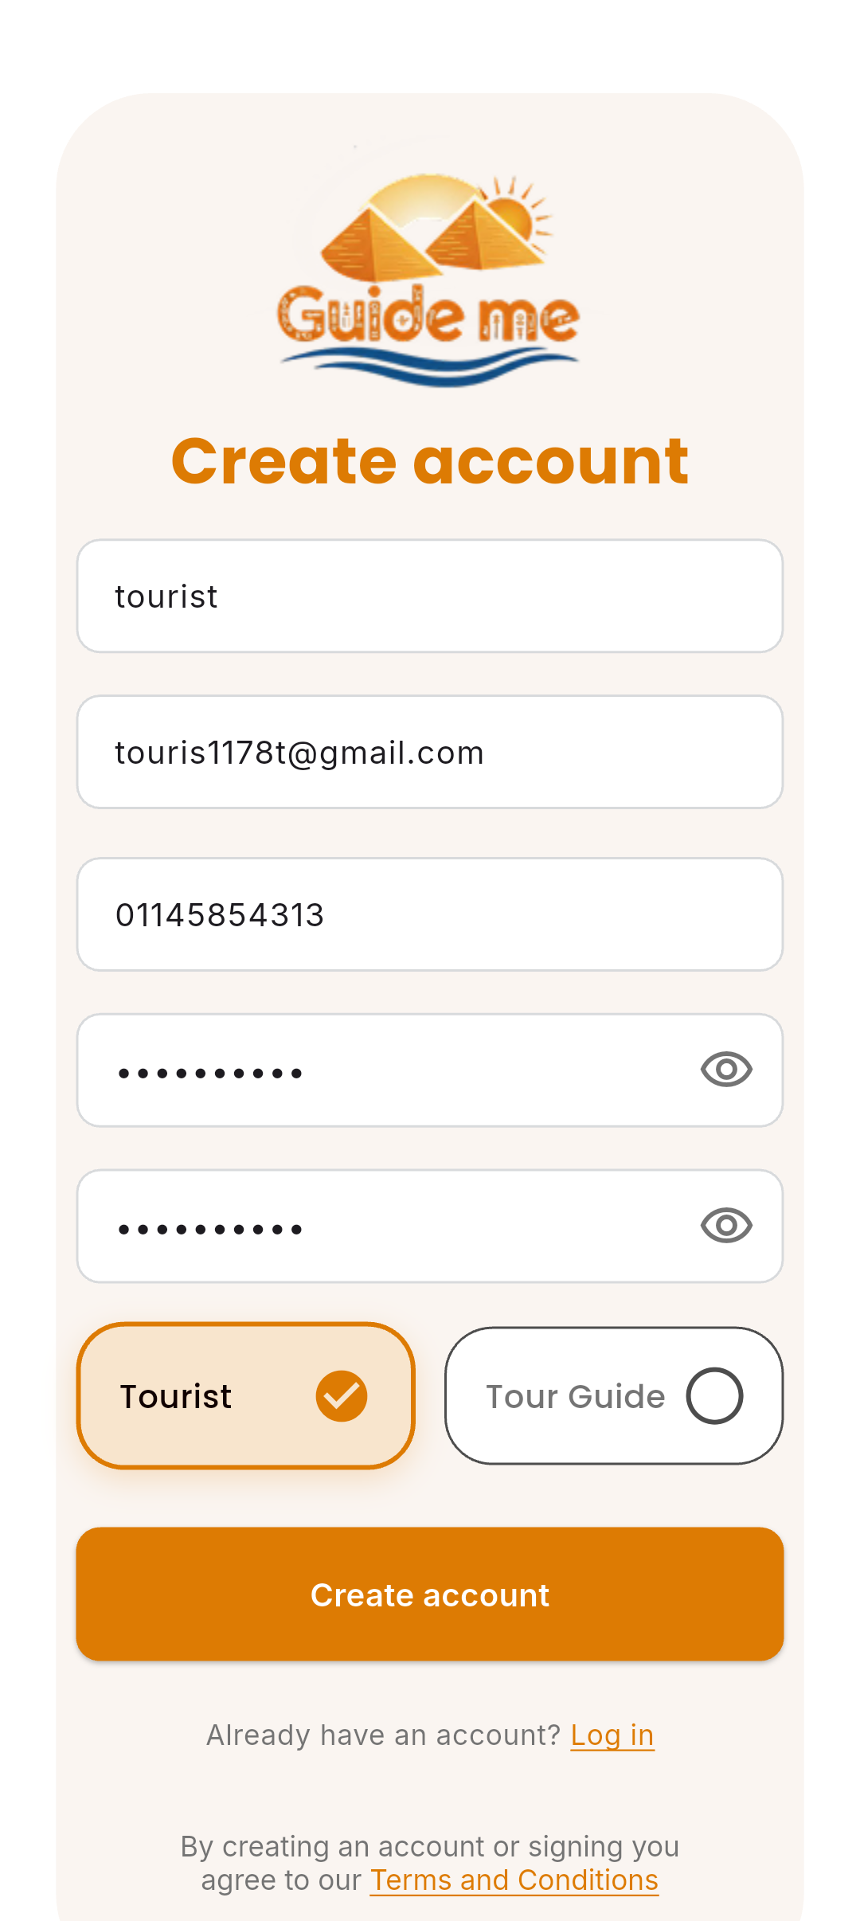
Figure F.1: Tourist account creation interface demonstrating the registration form, input validation cues, and account setup options.
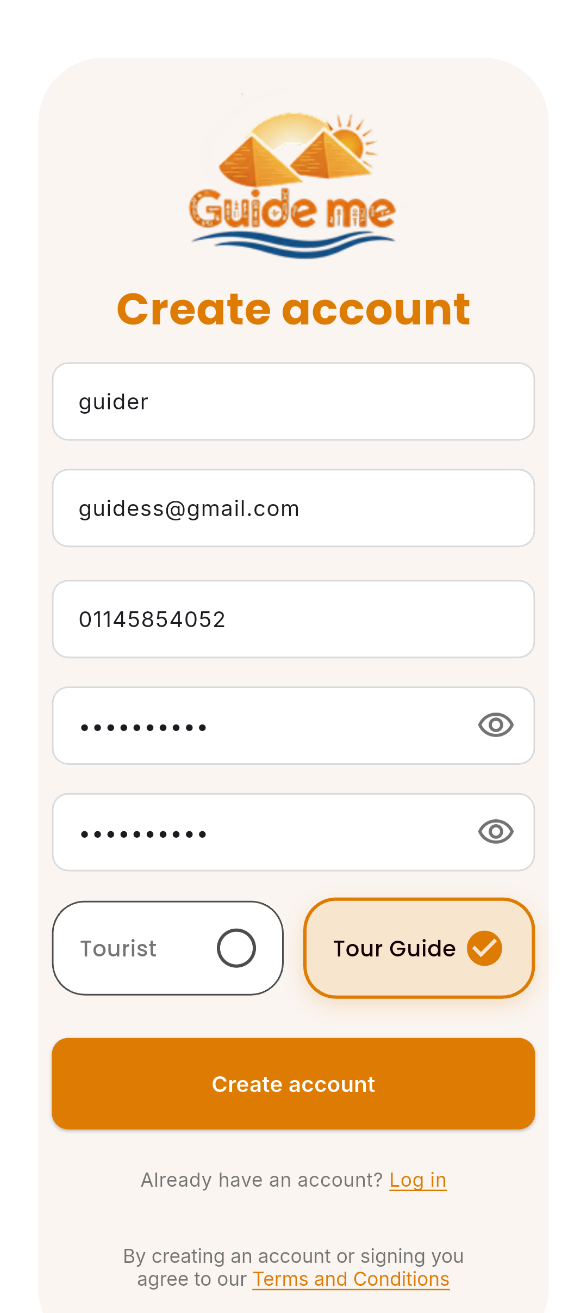
Figure F.2: Guide registration interface displaying professional profile fields, service categories, and verification prerequisites.

F.2 Tourist Screens
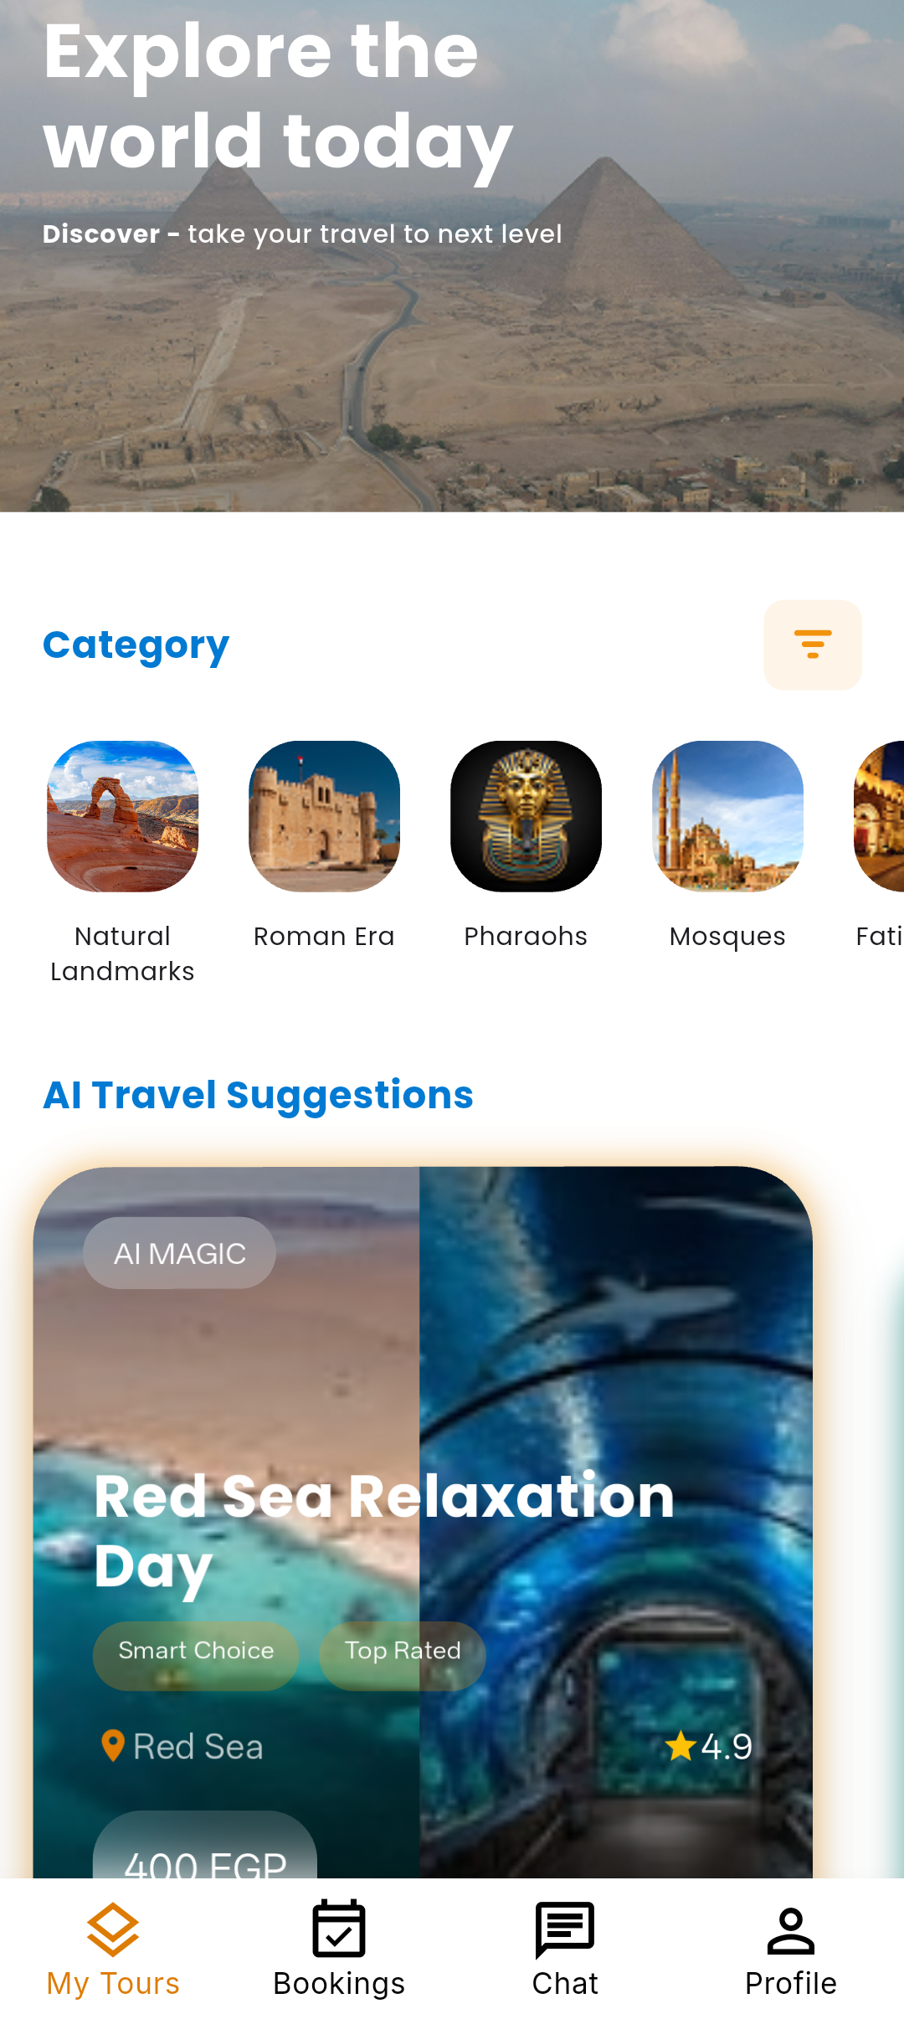
Figure F.3: Tourist home interface presenting personalized content, featured destinations, and primary navigation elements.
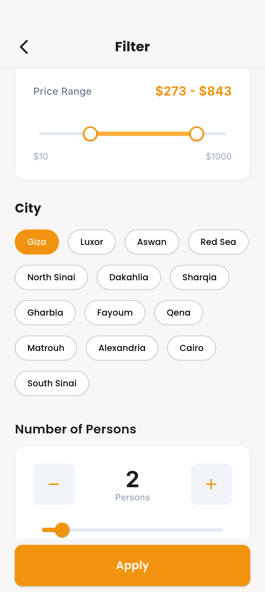
Figure F.4: Filter and search interface enabling multi-criteria refinement (categories, distance, rating) for targeted discovery.
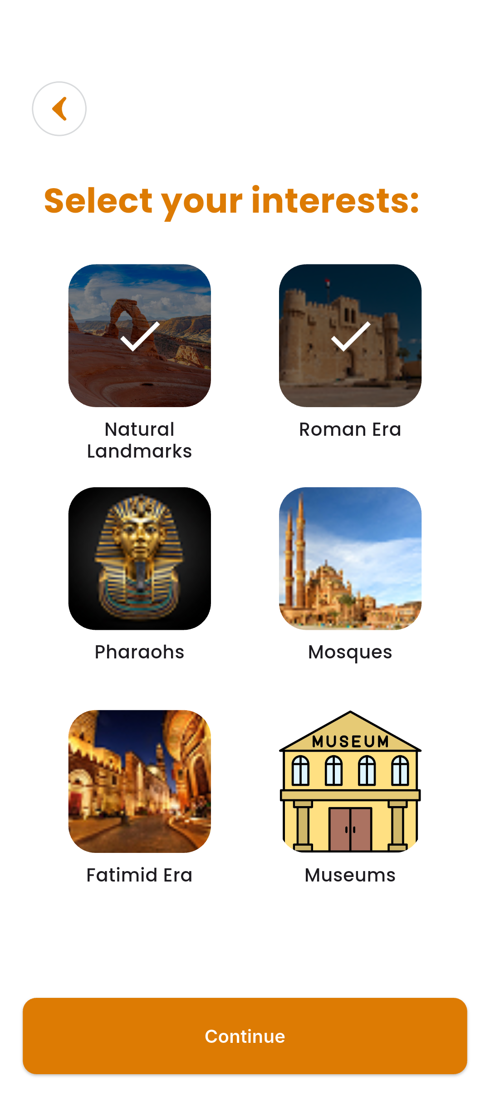
Figure F.5: Interests selection interface used to capture user preferences that drive personalization and recommendation models.
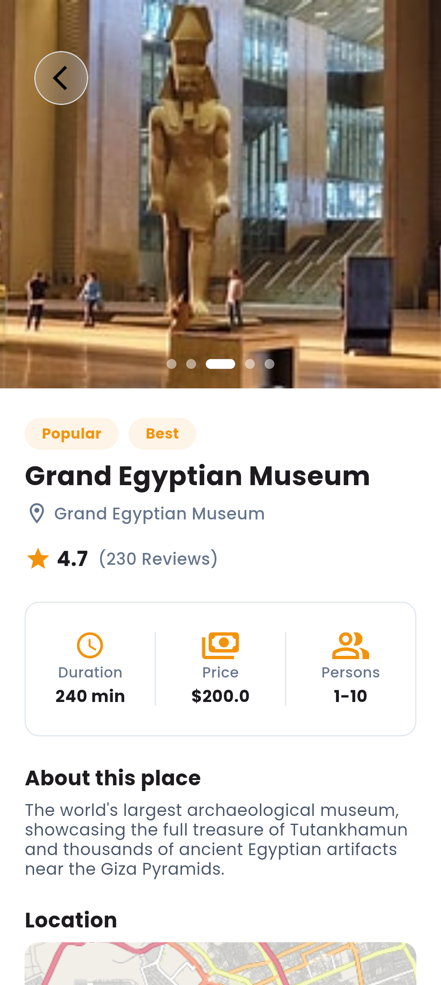
Figure F.6: Place details interface presenting multimedia content, location metadata, itinerary highlights, and user reviews.
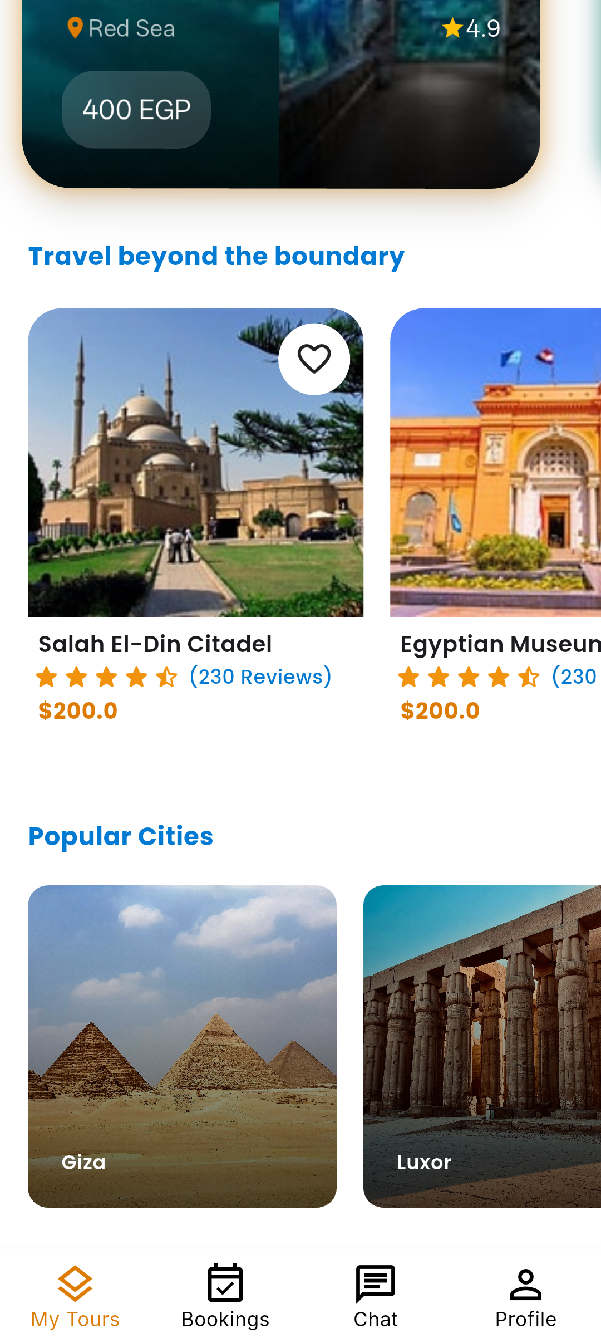
Figure F.7: Travel inspiration screen showcasing curated editorial content and destination highlights to support trip planning.

F.3 AI Recommendation Screens

Figure F.8: AI suggested packages interface presenting ranked recommendations with key attributes and relevance indicators.
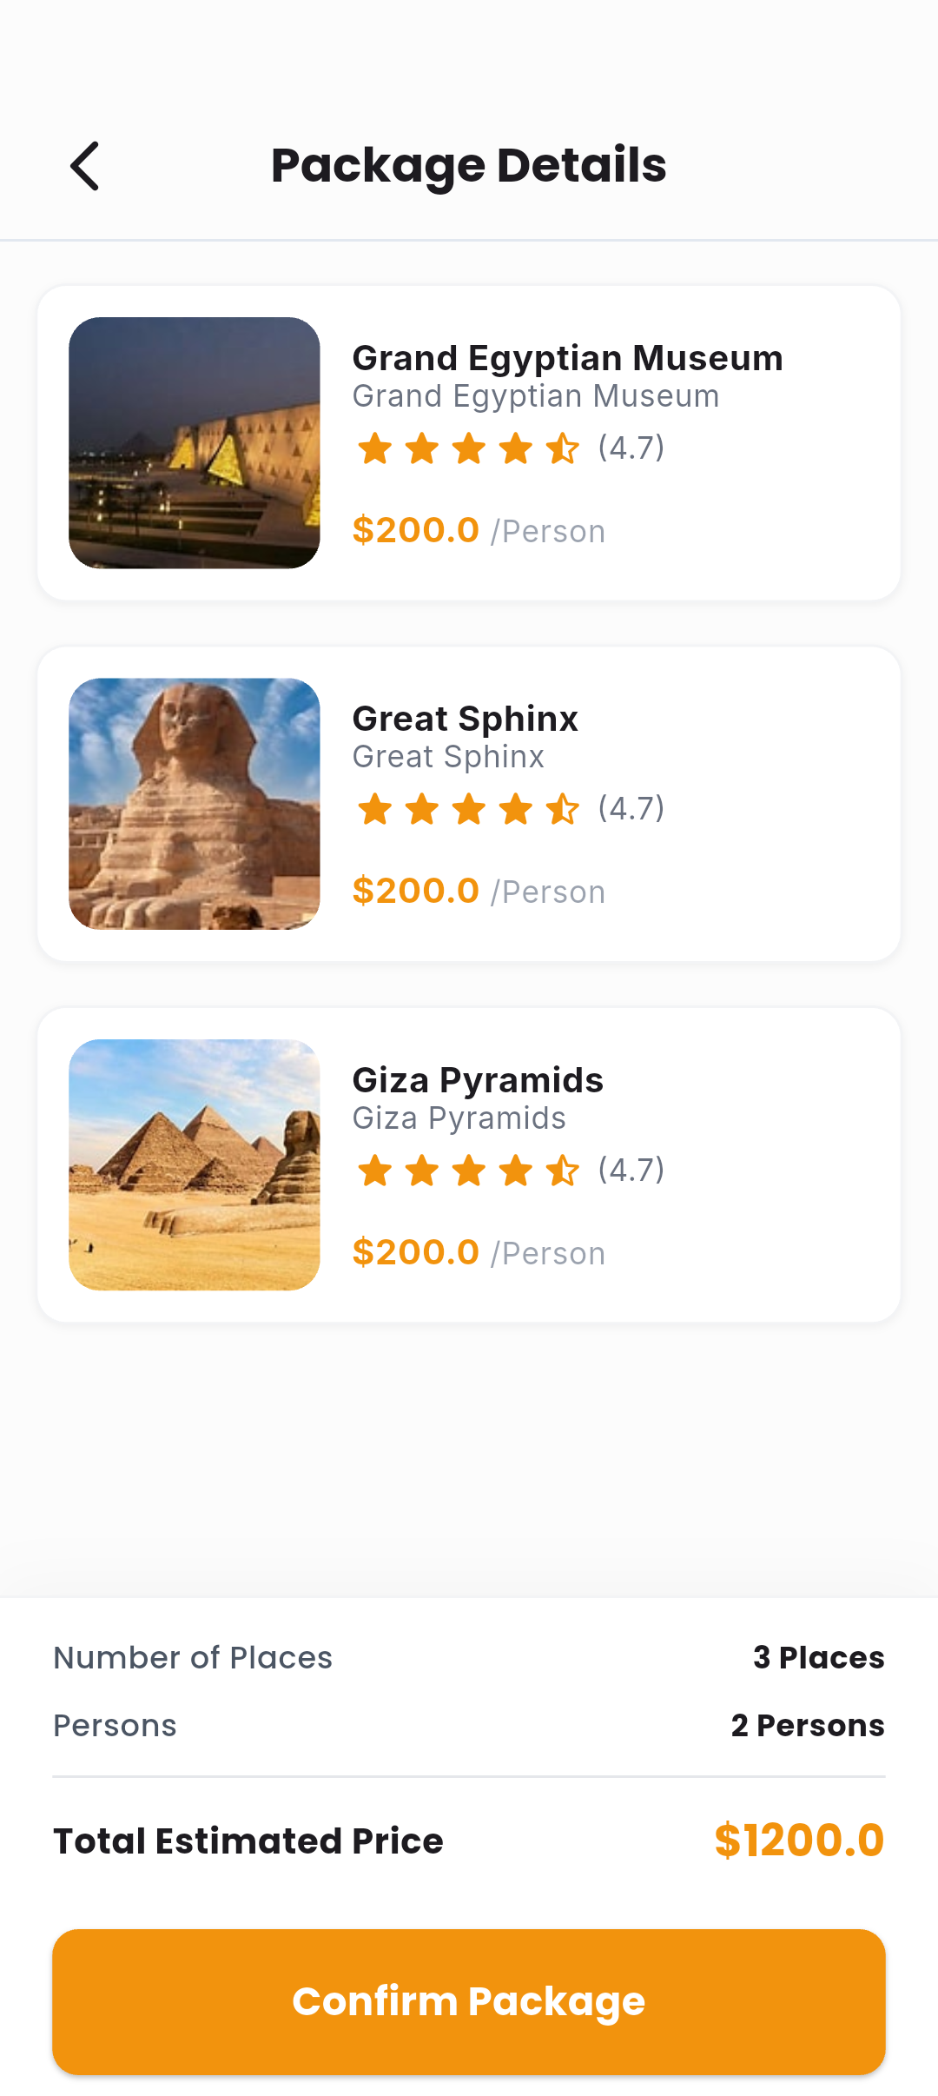
Figure F.9: Recommended package details interface showing itinerary breakdown, pricing, and included services for AI-selected offers.
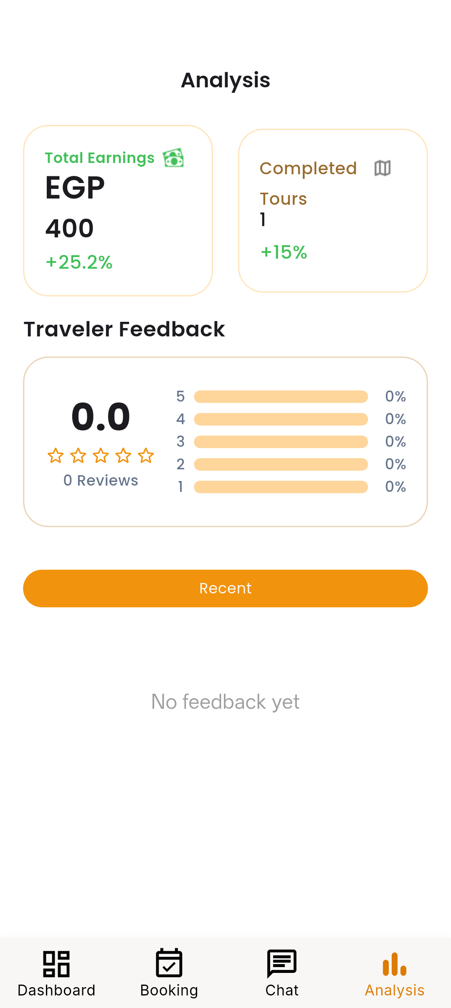
Figure F.10: AI analysis and insights interface displaying model rationale, scoring metrics, and suggested personalization adjustments.

F.4 Booking Screens
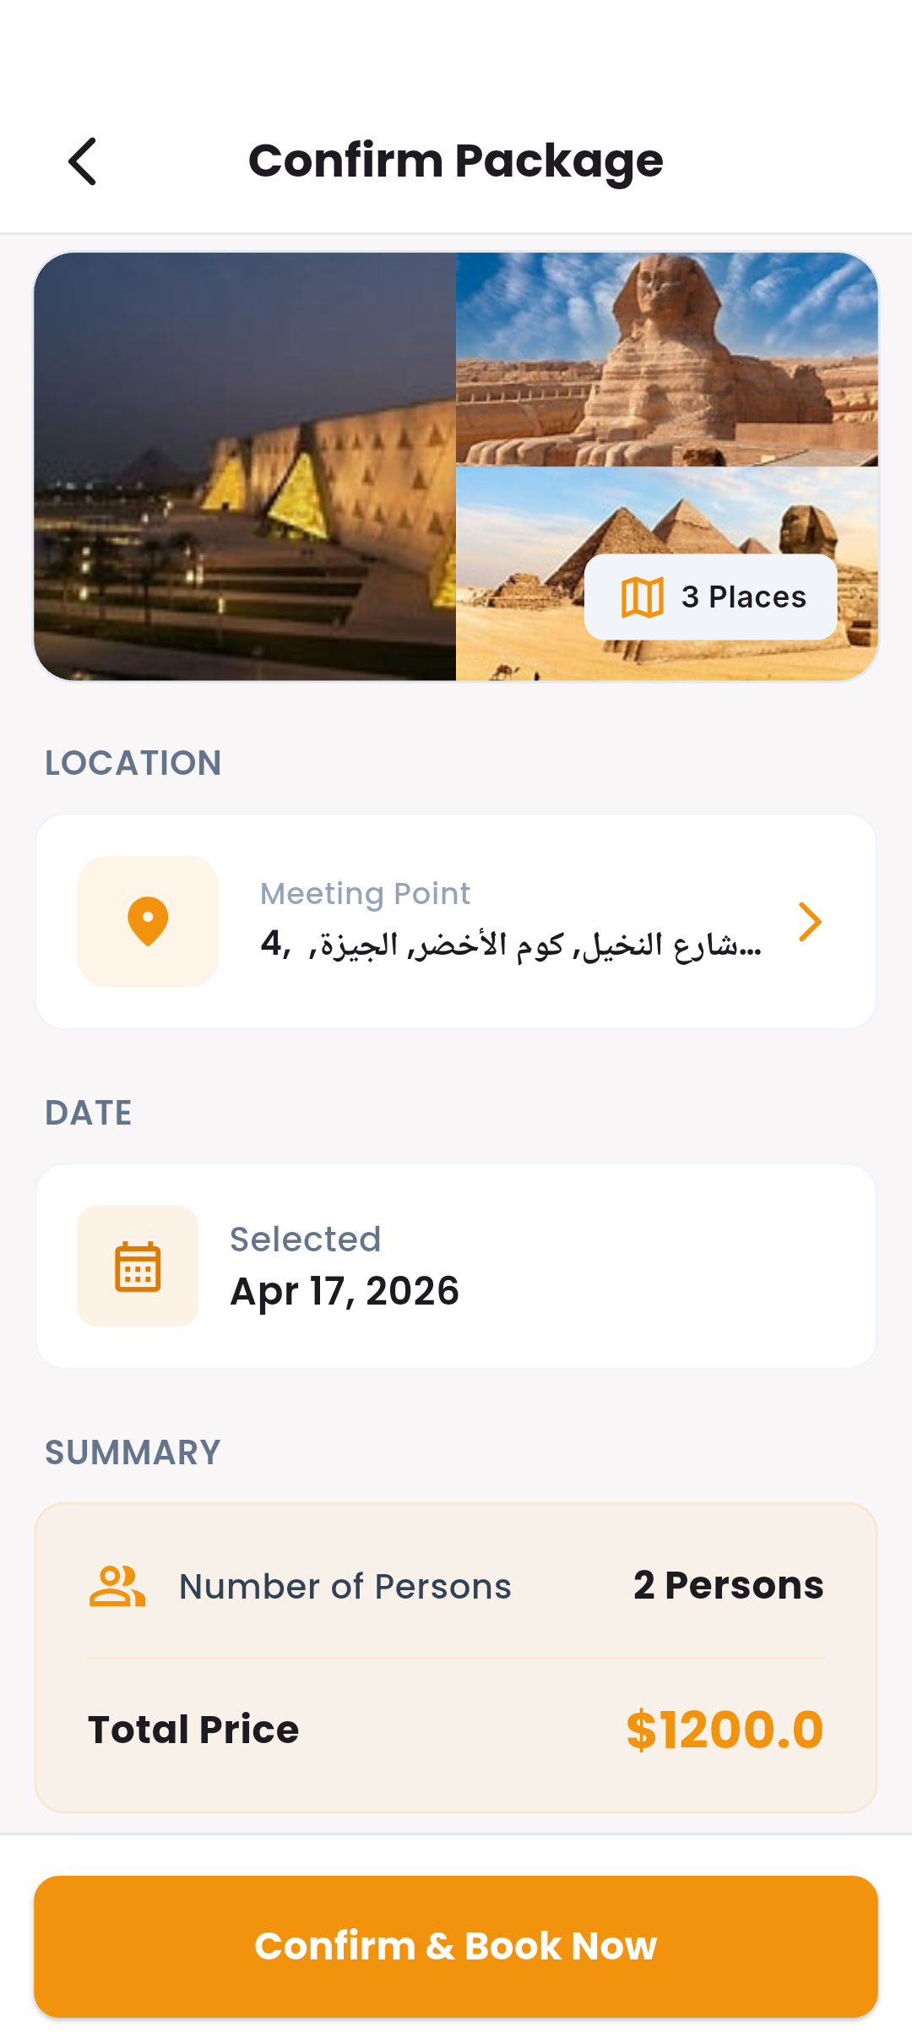
Figure F.11: Package confirmation interface where the user reviews booking details, terms, and confirmation options.
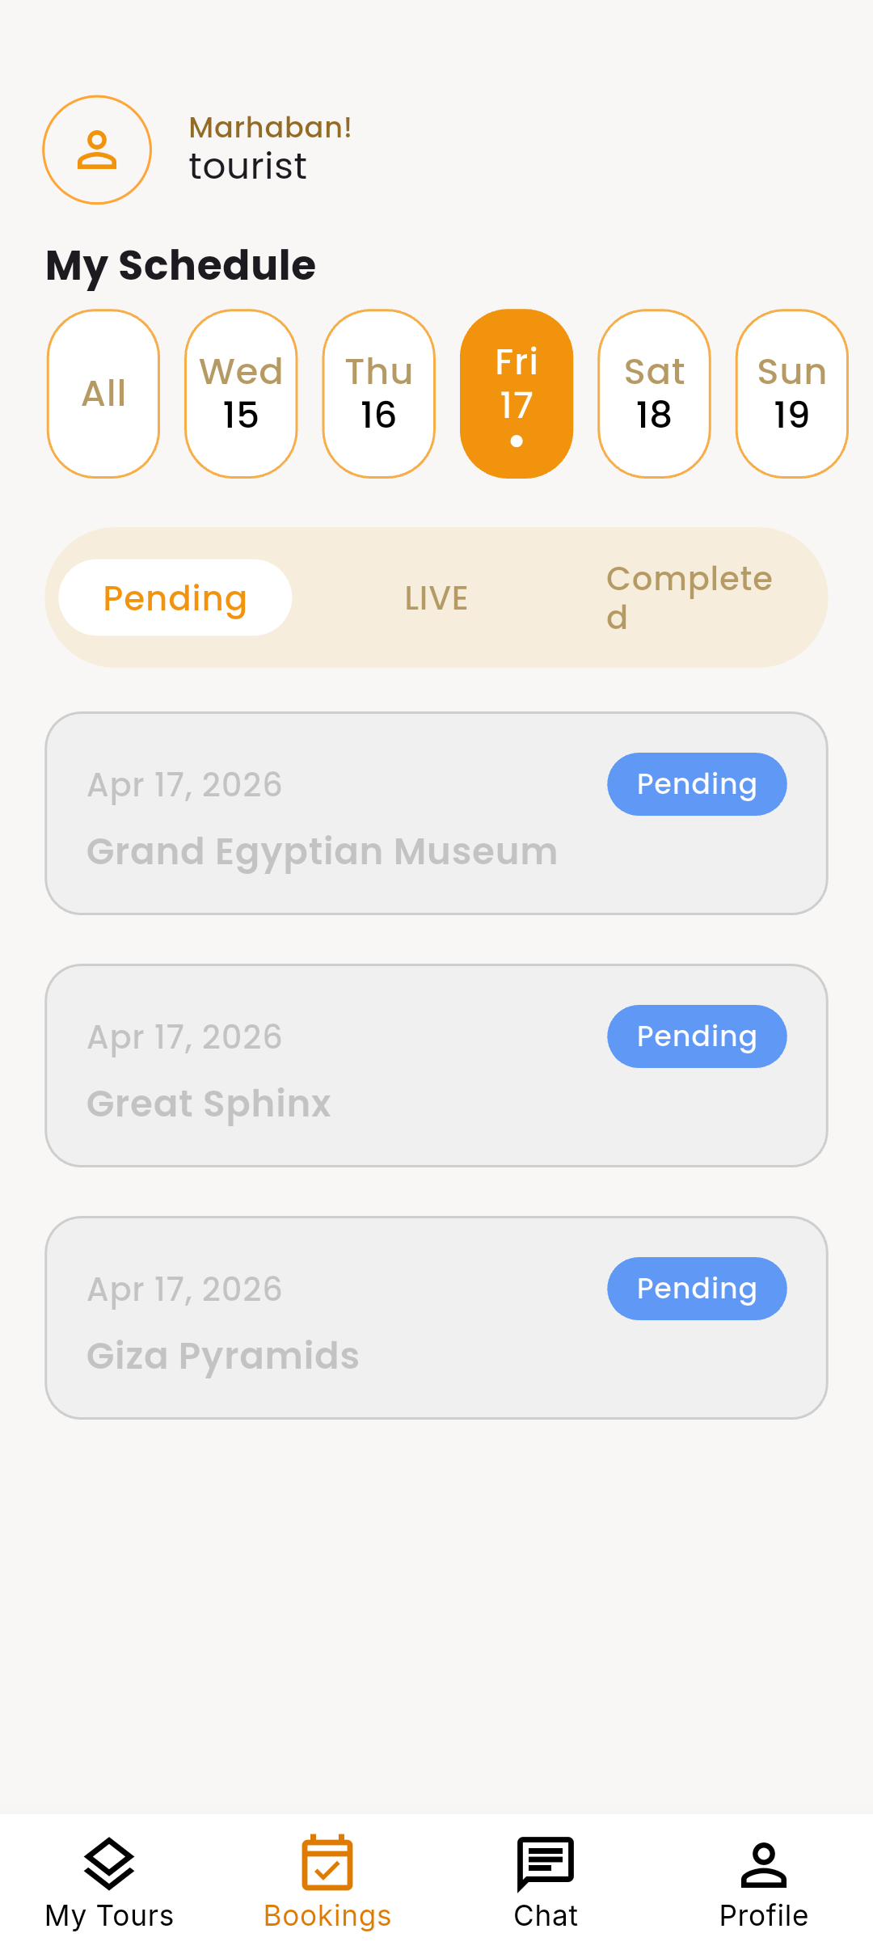
Figure F.12: Booking pending status interface indicating a request awaiting guide confirmation, with status timestamps and action prompts.
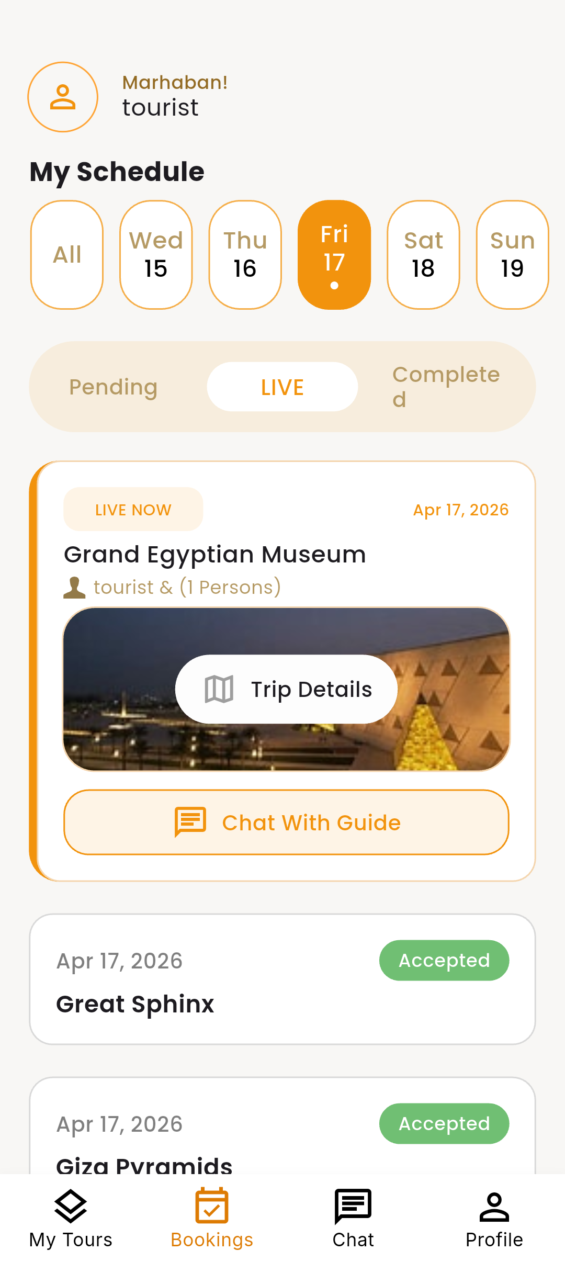
Figure F.13: Live booking tracking interface showing active session status and real-time indicators for ongoing excursions.
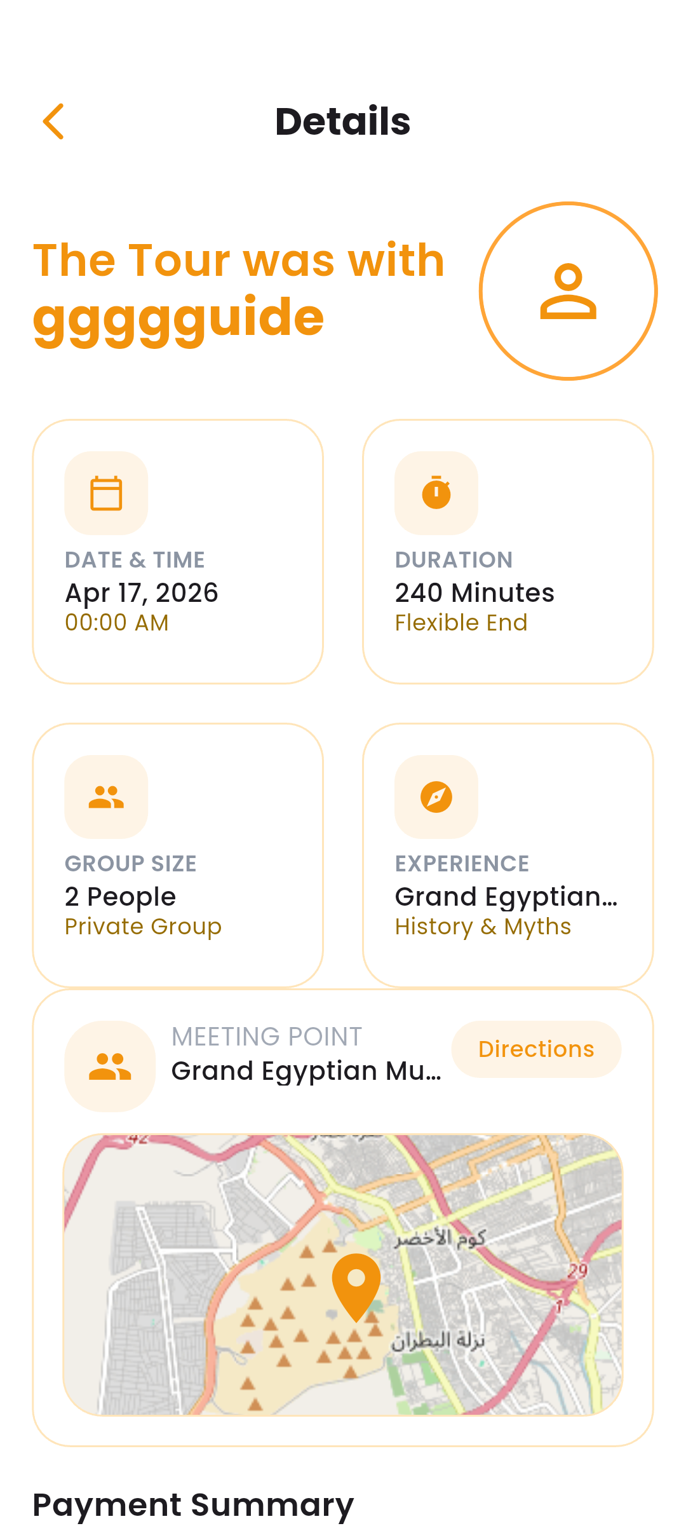
Figure F.14: Live booking details interface presenting active-session metadata, participants, and realtime controls.
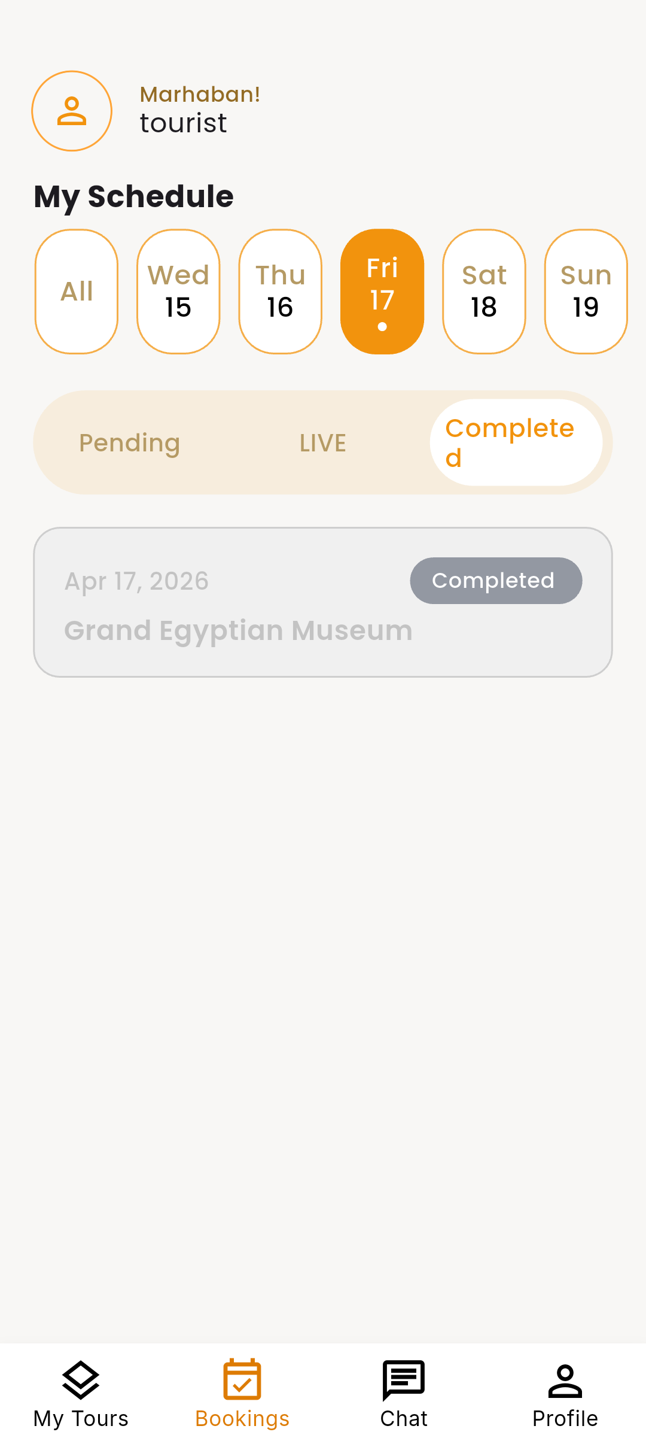
Figure F.15: Booking completion confirmation interface displaying final status, receipt information, and post-trip actions.

F.5 Chat and Communication Screens
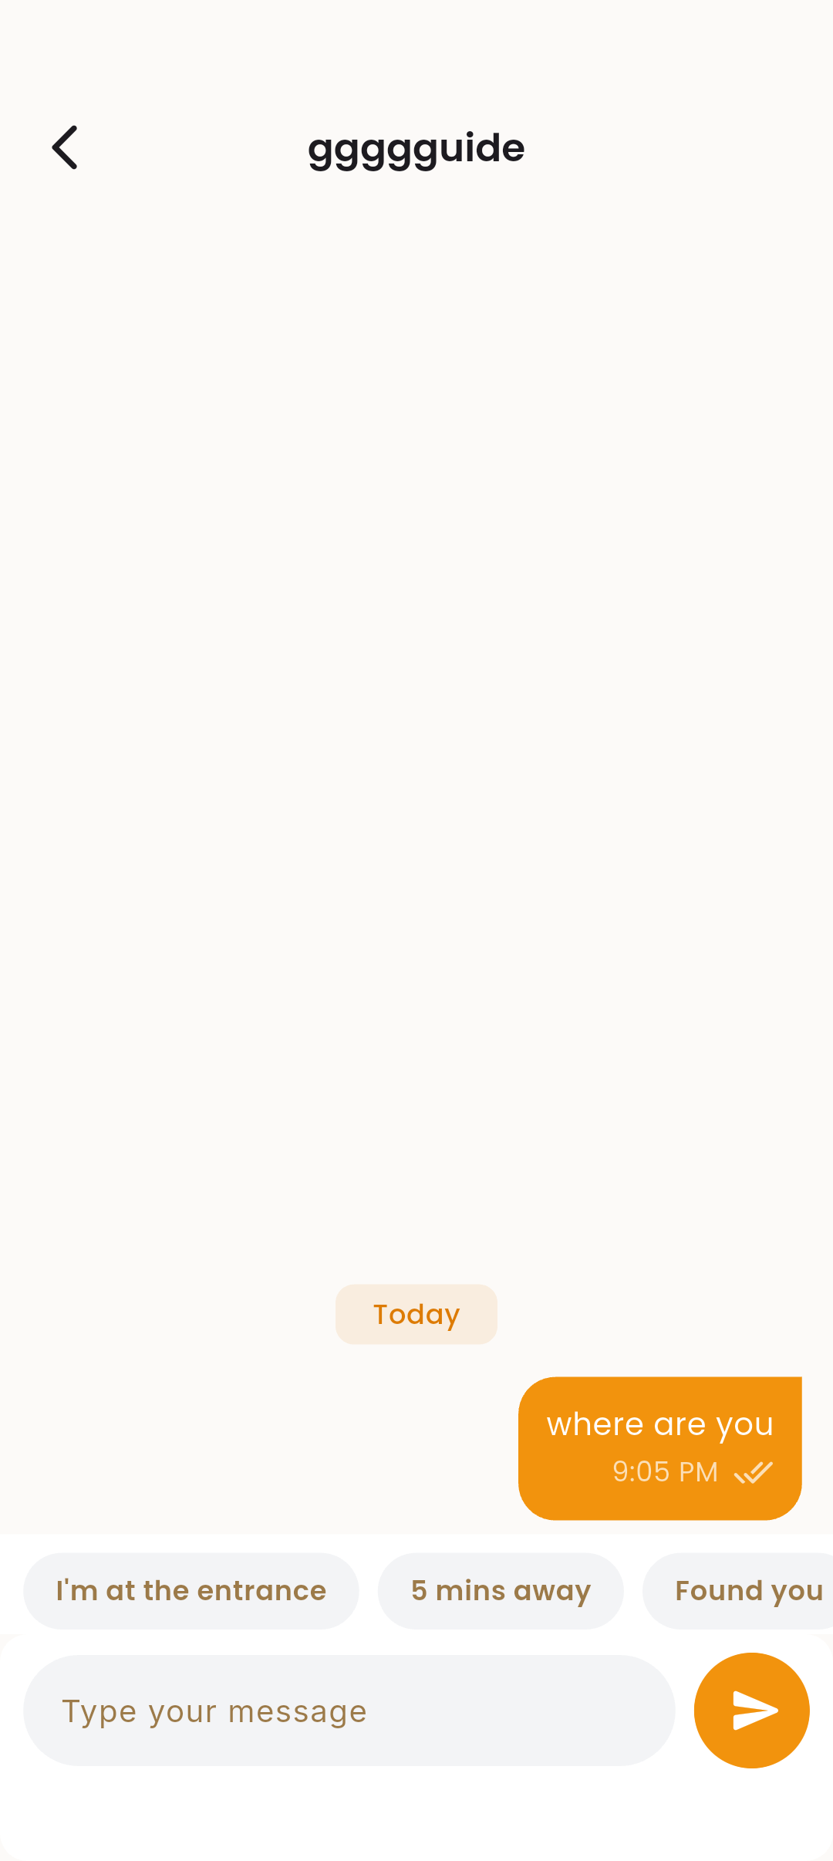
Figure F.16: Tourist-to-guide chat interface supporting real-time messaging, media attachments, and time-stamped conversation threads.
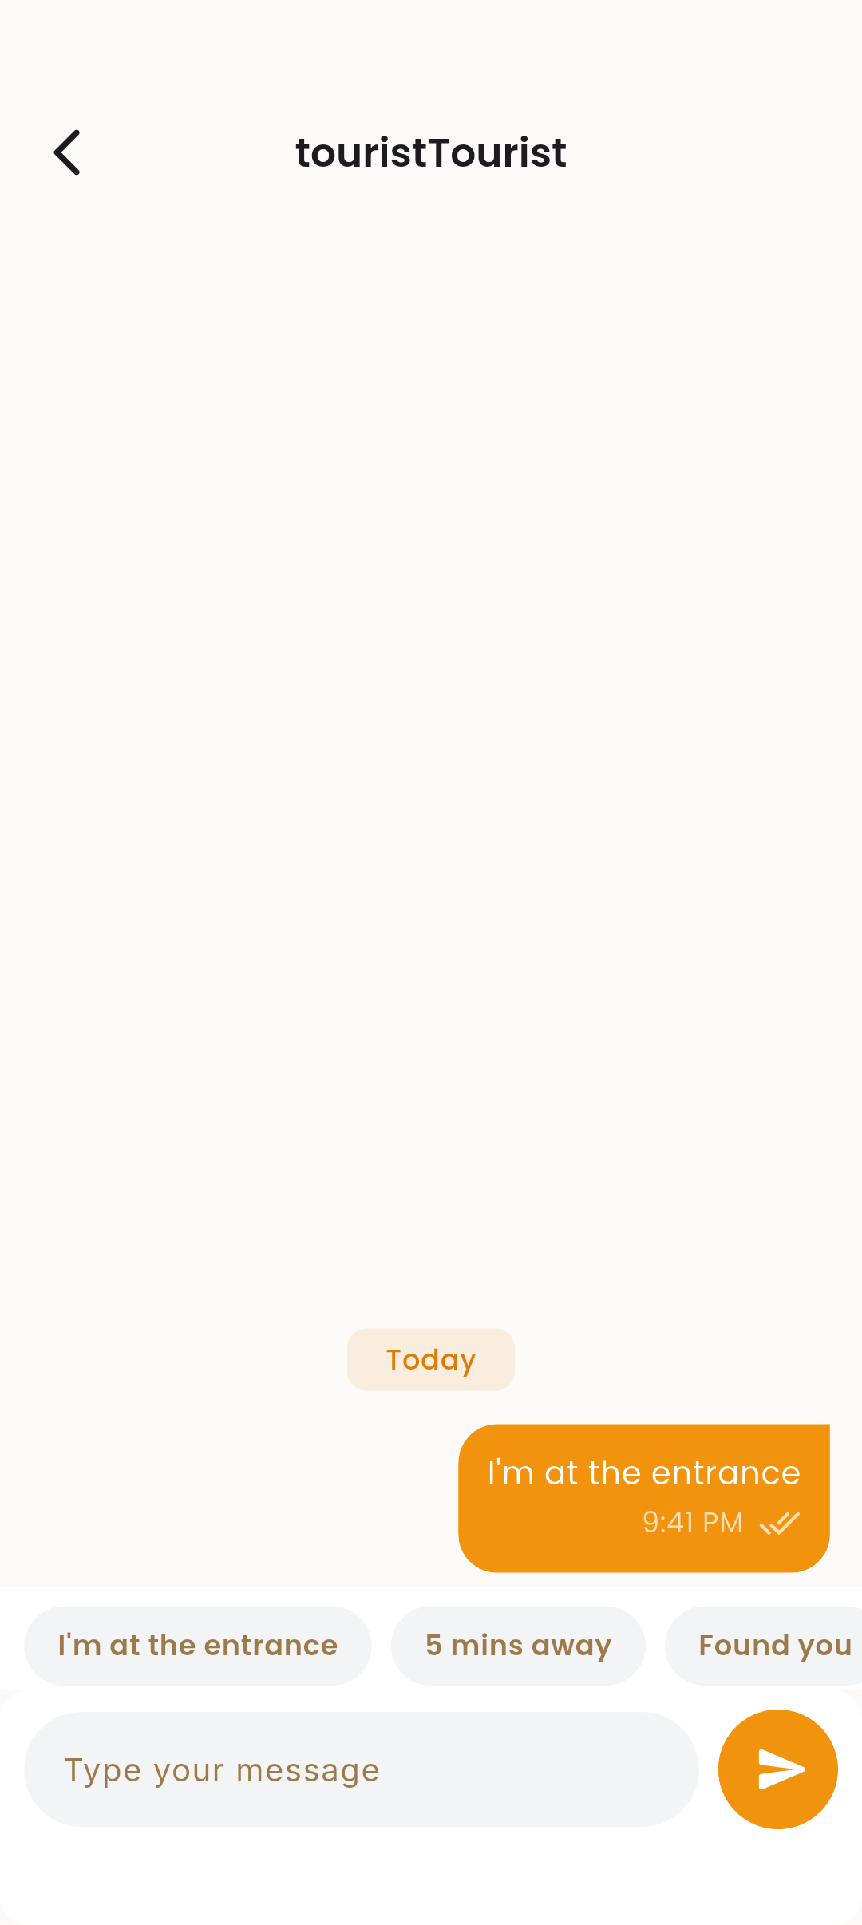
Figure F.17: Guide-side communication interface for managing inbound messages, quick replies, and session coordination tools.

F.6 Guide Dashboard Screens
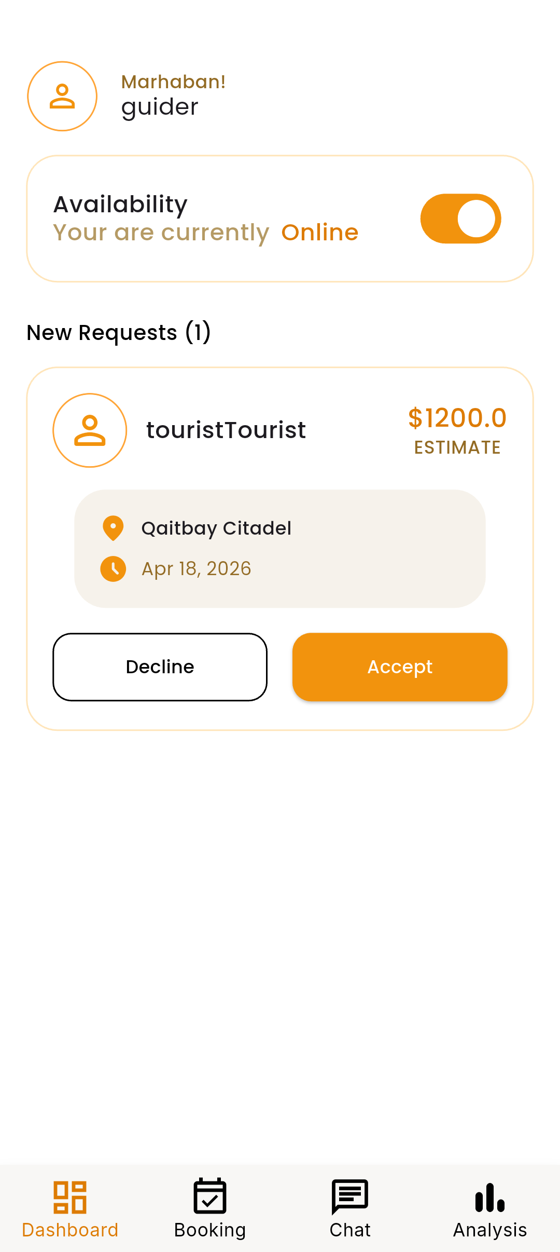
Figure F.18: Guide dashboard requests overview presenting incoming service requests, aggregate status indicators, and prioritization controls.
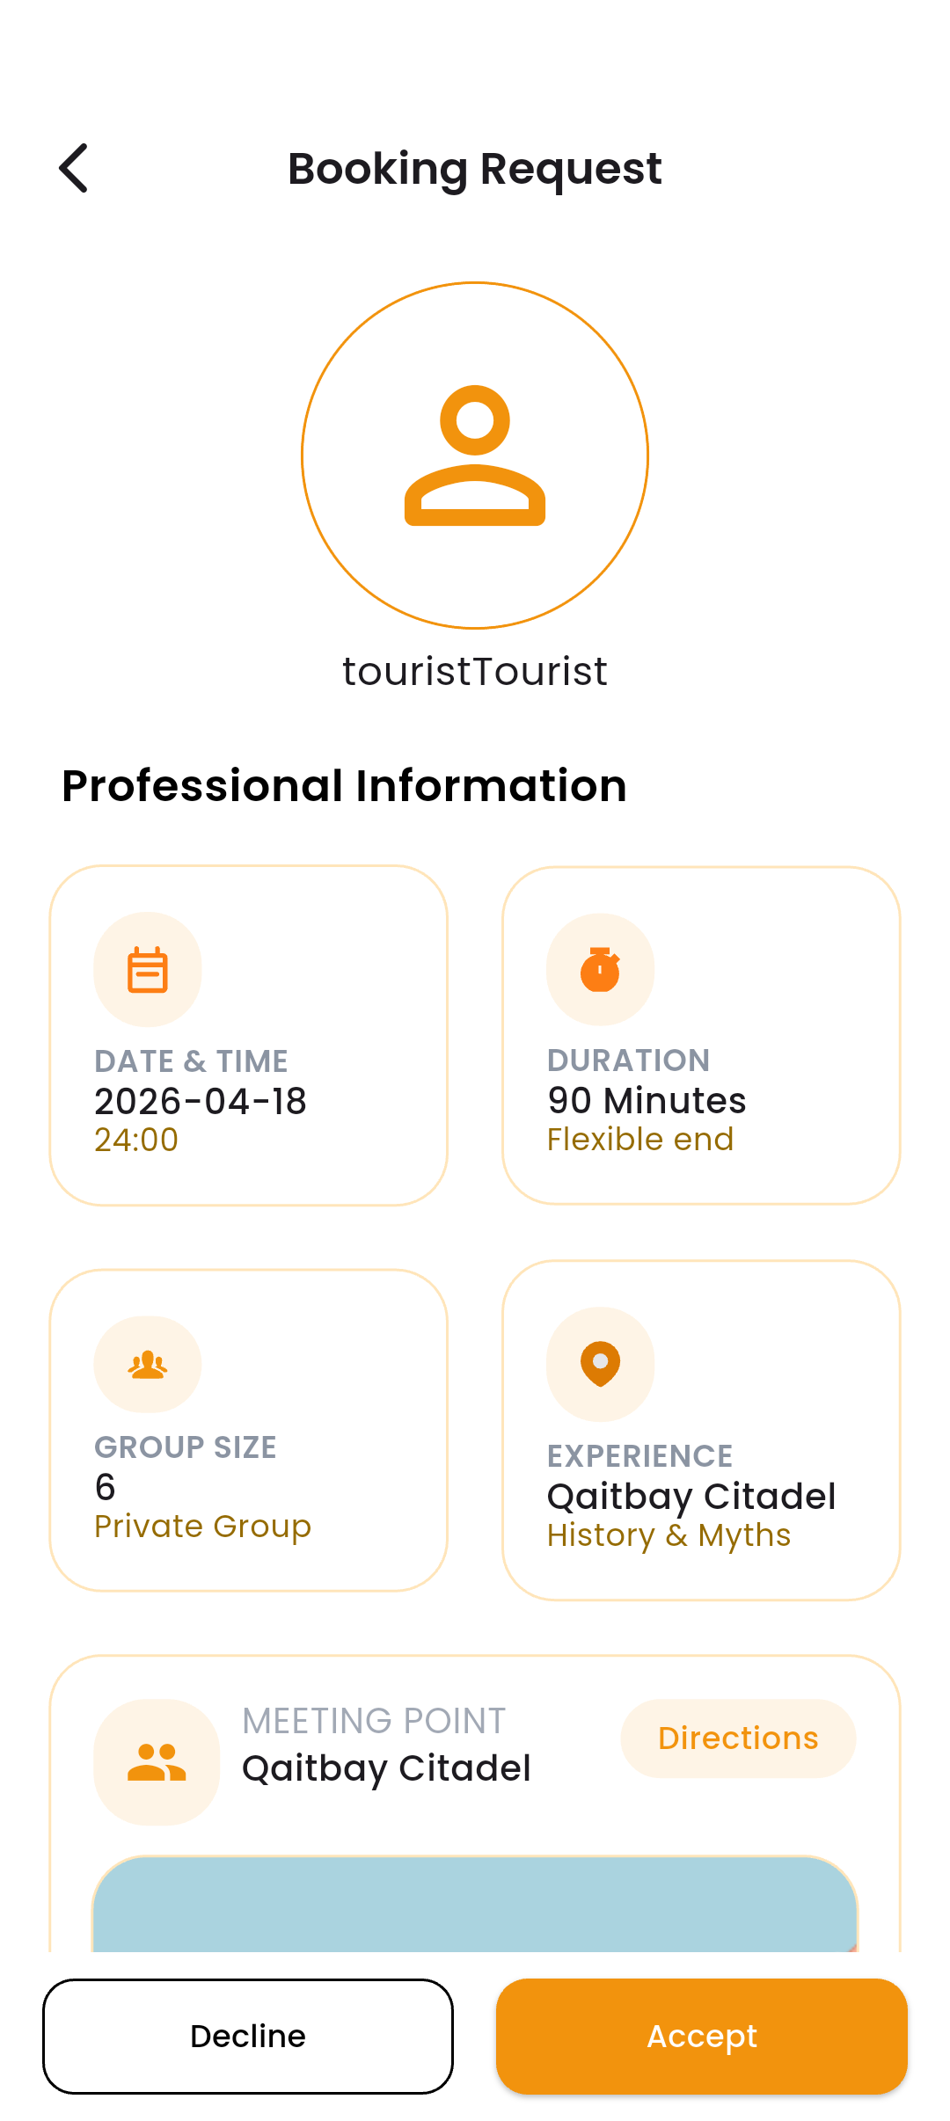
Figure F.19: Guide dashboard request detail view showing request context, tourist information, and actionable response controls.
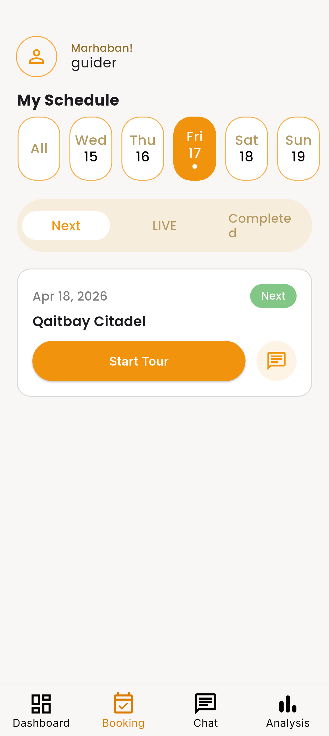
Figure F.20: Guide booking acceptance and management interface illustrating accepted trips, scheduling controls, and session management tools.

F.7 Guide Verification and Profile Screens
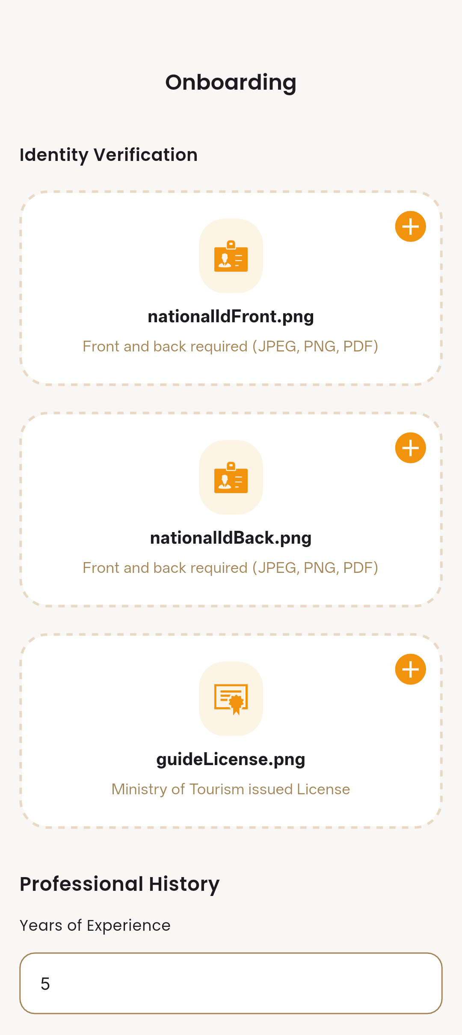
Figure F.21: Guide verification — identity submission interface outlining required identity fields and verification instructions.
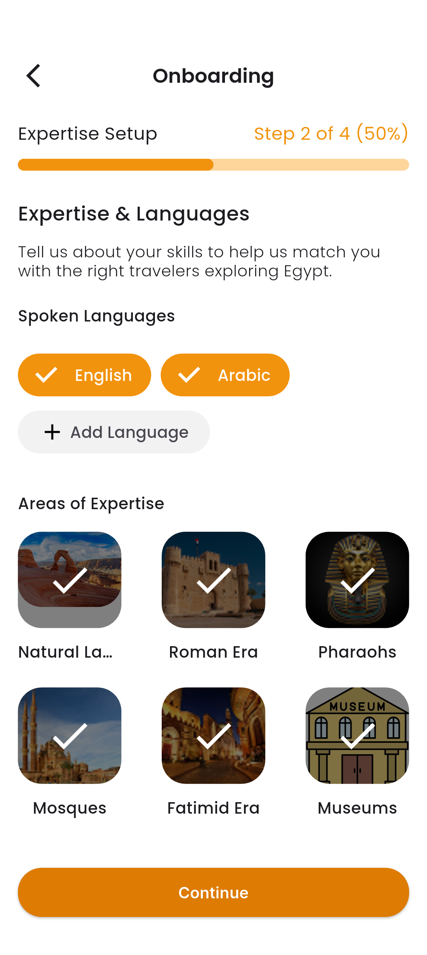
Figure F.22: Guide verification — documentation upload interface for submitting certifications, identification, and supporting evidence.
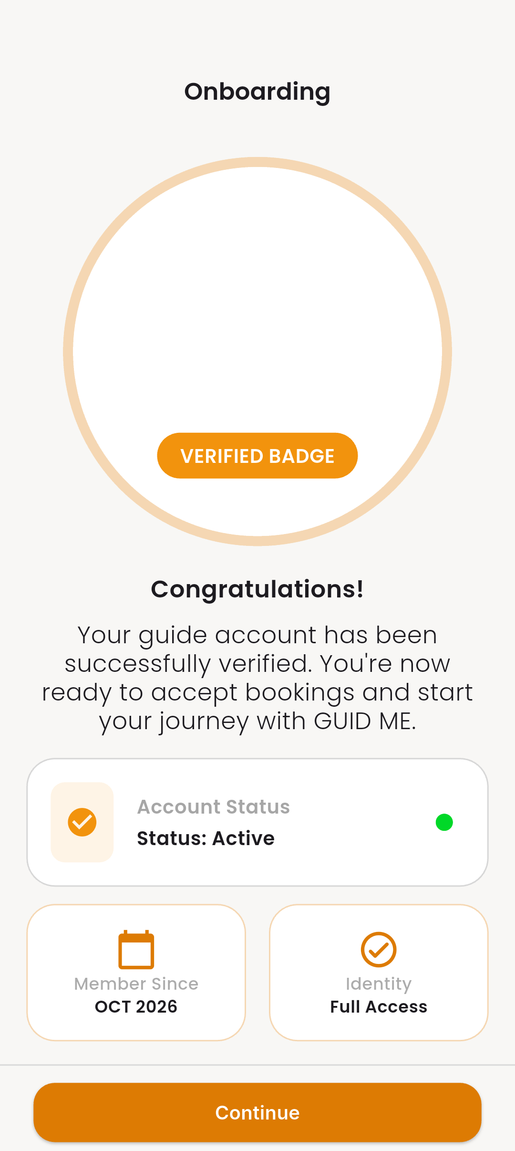
Figure F.23: Guide onboarding approval confirmation interface indicating successful verification and account activation.
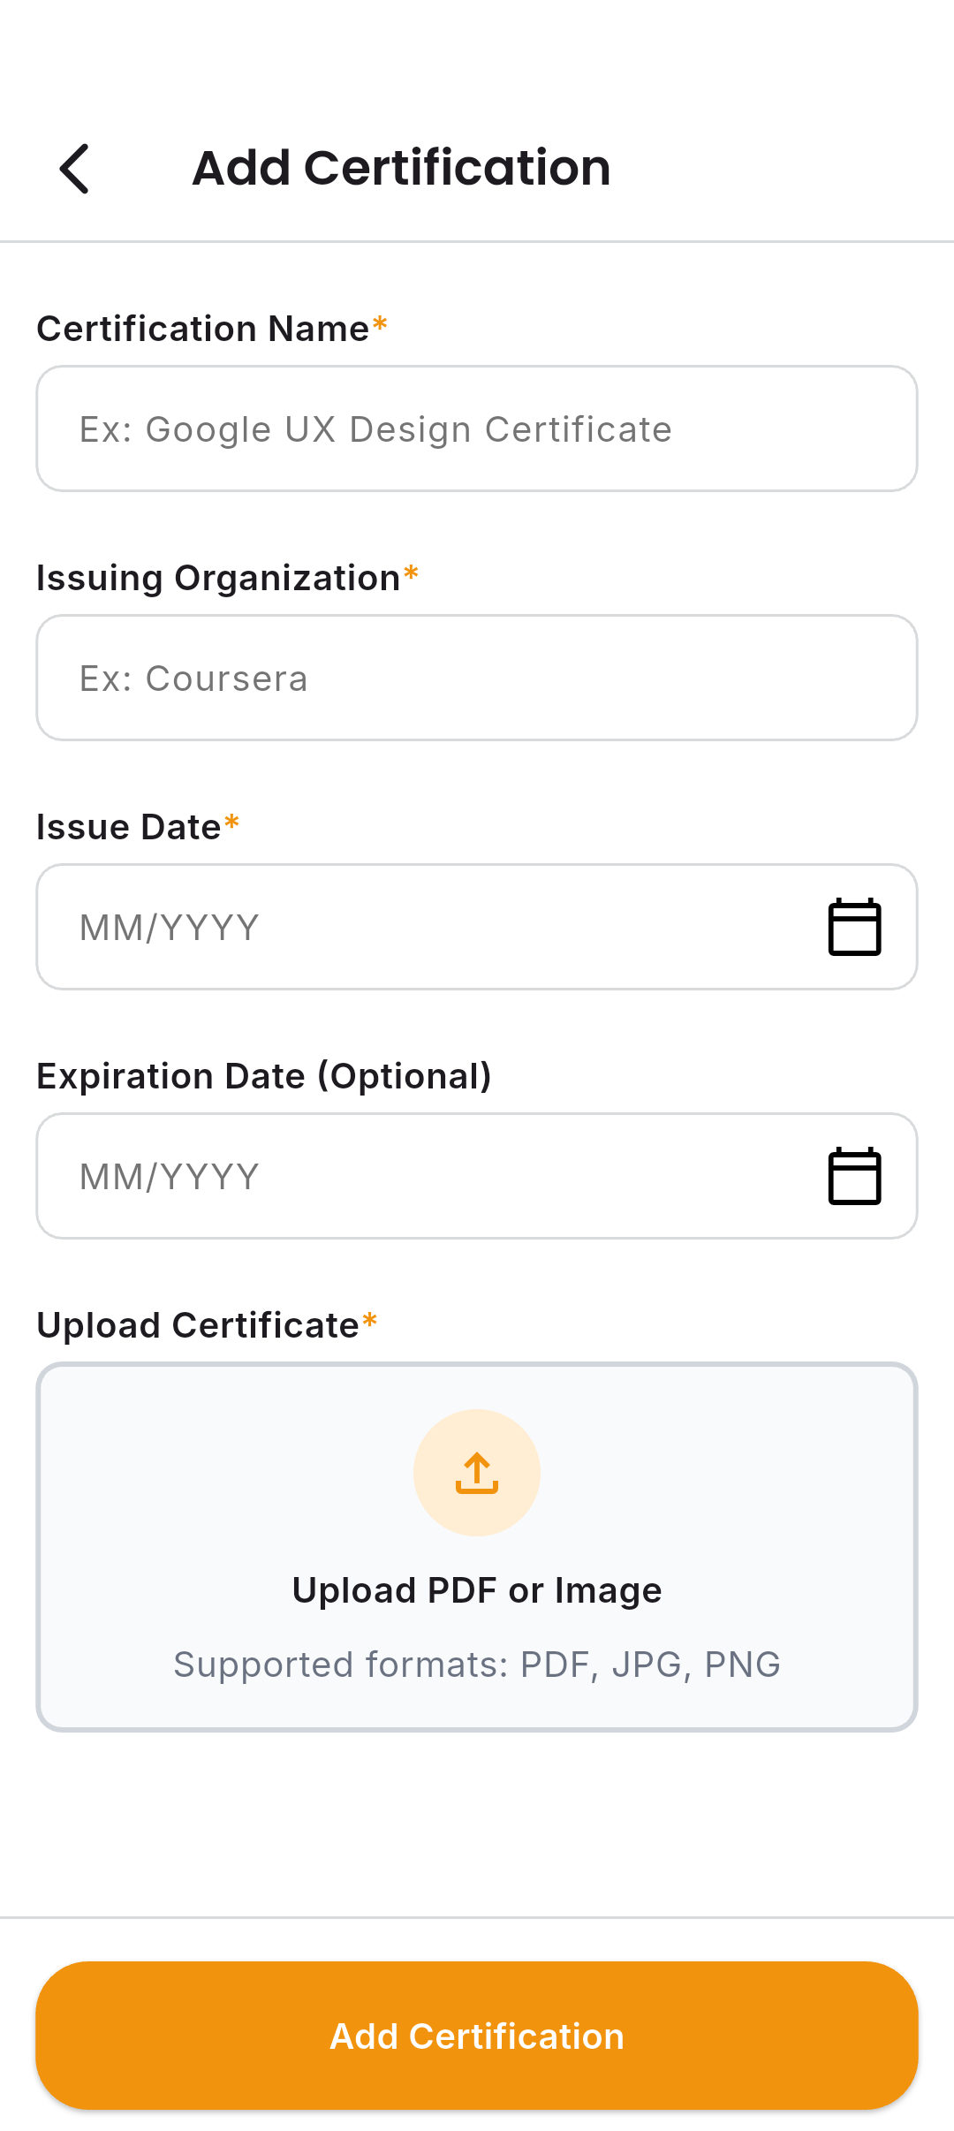
Figure F.24: Guide profile certification management interface enabling addition and management of professional credentials and portfolio items.

