**How to run the project**

1. Download Eclipse
2. 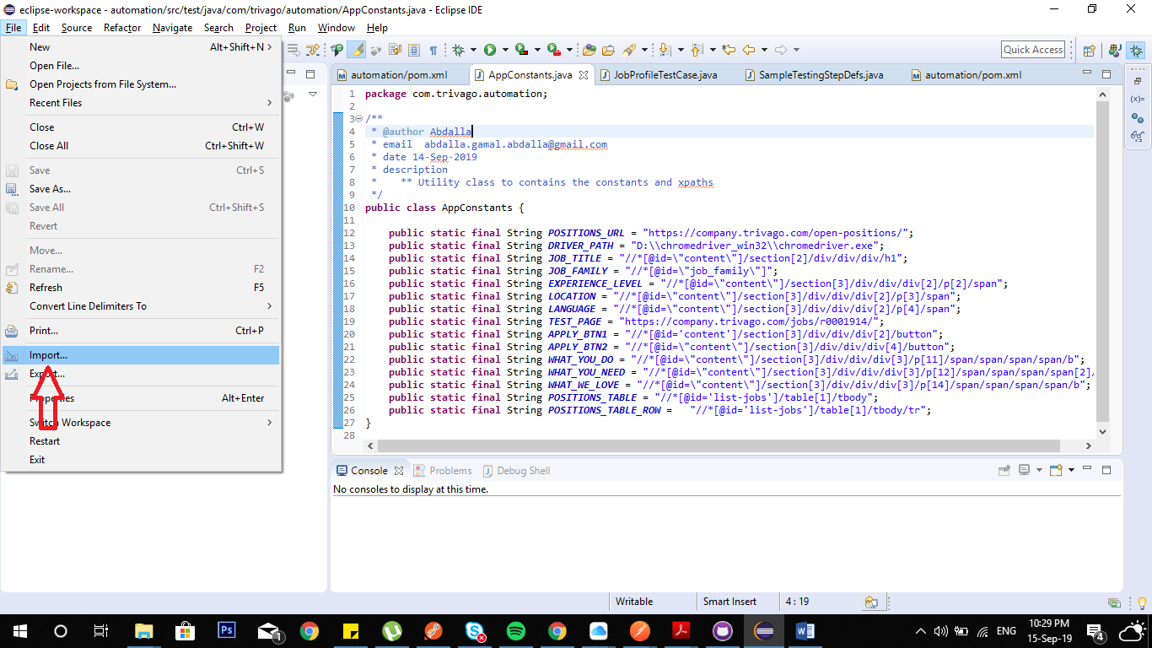 Import file
3. 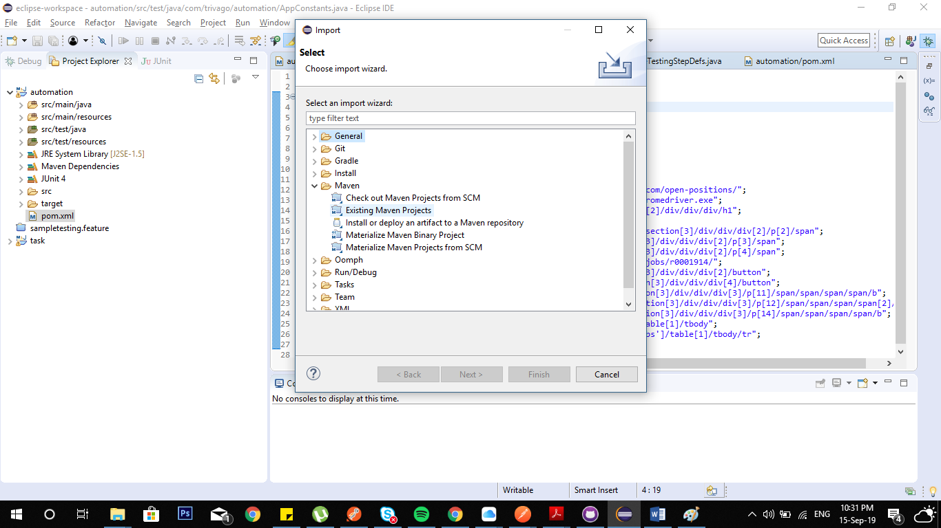Select Existing Maven project
4. Change The Variable Name **DRIVER_PATH**  in **AppConstants.java** class to **chromedriver.exe** path in your local environment **“*you will find the driver at automation\src\test\resources”***
5. 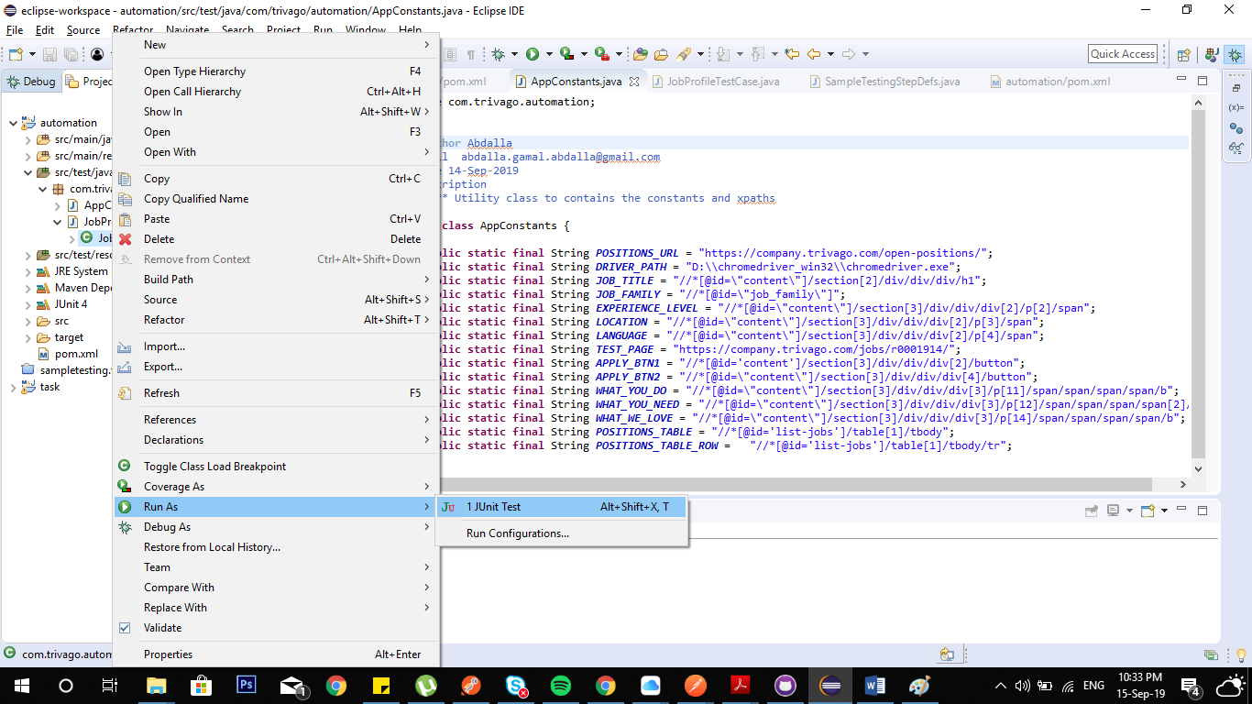 Right click on JobProfileTestCase.java > Run as >Junit Test