* Task1

On your page, show alert for the user that say “Welcome to my site”, then show him prompt ask him to enter his name The user has to choose either (red, green or blue color), take his choice via prompt and write to the page “welcome + his name”

* Task2
* 1.1 Write a script to determine whether the entered string is palindrome or not. Ask the user whether to consider case of the entered string or not, handle both cases in your script i.e. RADAR NOON MOOM are palindrome. Note: raDaR is not a palindrome if user requested considering case of entered string.

1.3 Write a script that reads from the user his info; validates and displays it with a welcoming message.

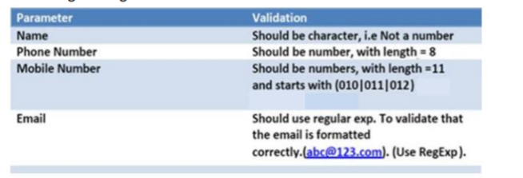

* Array Object Task3

3.1 Fill an array of 3 elements from the user, and apply each of the following mathematical operations on it (+, *, /). Format the output as shown in Fig

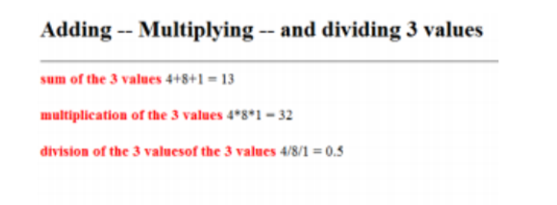

**Task4**

* sort Array

3.2 Fill an array of 5 elements from the user, sort it in descending and ascending orders then display the output as shown in Fig

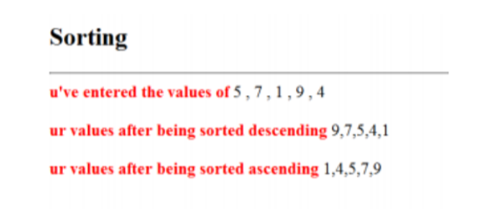

Task5

* Math Object

2.1 Write a script that ask the user to Enter the value of a circle’s radius in order to calculate its area.