Task1

Make a function that takes date string as a parameter, and returns the Day name (Saturday, Sunday,) of the given date.

Task2

* Dom exercise

1.d Given a web document as shown below in Fig. a, with only these few lines of code in shown in Fig. b. Using DOM Nodes to access, create, modify or remove any of its elements to have it finally as shown in Fig. c

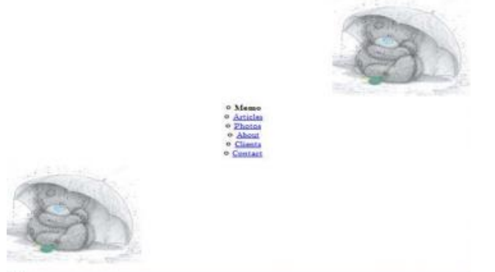

1- list : bullets type and position

2-copy the image and change the position

Task3

1. Clone HTML div when it is clicked and change the background of the new copy to a random color then append it to the body.
2. Simple Calculator. Implement the required functions in an external file to let calculator.html works properly.

3- Apply different styles over a paragraph according to checked radio button. Implement the required functions in an external .js file to let TextStyle.html works properly

