🌍

CHARITY DONATION TRACKER
Blockchain DApp — Project Documentation

Project Idea 5
Technologies of Cryptocurrencies
Academic Year 2024 / 2025

Built with Solidity • Python (web3.py) • React.js • Ganache

1. Project Overview
The Charity Donation Tracker is a decentralized application (DApp) built on the Ethereum blockchain using Ganache as a local test network. The goal of the system is to provide a fully transparent donation platform where every contribution to a charity campaign is permanently recorded on-chain and can never be hidden or altered.

Unlike traditional donation platforms where a central authority controls the records, every transaction in this system is stored in a Smart Contract — meaning the data is immutable, auditable by anyone, and cannot be manipulated.

1.1 Key Features
Feature | Description
Transparent Donations | Every donation is stored on-chain permanently and publicly
Donor Coin (DNC) Rewards | Users earn DNC tokens automatically when they donate ETH
Role-Based Access Control | Admin has privileged controls; normal users are rejected from them
Emergency Pause Switch | Admin can instantly pause or resume all donations
Ownership Transfer | Admin rights can be securely transferred to any address
React GUI Bonus | Full modern web interface in addition to the terminal app

1.2 Technology Stack
Layer | Technology | Purpose
Smart Contracts | Solidity 0.8.0 | Business logic on the blockchain
Blockchain Network | Ganache 2.7.1 | Local Ethereum test network
Backend / CLI | Python + web3.py | Terminal app and background scripts
GUI (Bonus) | React.js + ethers.js v6 | Web-based graphical interface
Compiler | py-solc-x 0.8.0 | Compile Solidity inside Python

2. Smart Contracts

2.1 CharityTracker.sol
The core contract of the system. It stores all charity campaigns, processes donations, manages user registration, and enforces access control.

Admin Functions
Function | What It Does
addCampaign(name, desc, target) | Creates a new charity campaign on-chain
updateCampaign(id, ...) | Edits an existing campaign's details
batchAddCampaigns(...arrays) | Adds multiple campaigns in a single transaction
pause() / resume() | Emergency stop — blocks or re-enables all donations
transferOwnership(newAdmin) | Transfers admin rights permanently to another address
withdraw(campaignId, recipient) | Sends raised ETH from a campaign to a recipient
adminMint(to, amount) | Mints DNC tokens and sends them to any address

User Functions
Function | What It Does
registerUser(displayName) | Registers a display name once per wallet address on-chain
donate(campaignId) payable | Sends ETH to a campaign and auto-receives DNC reward tokens

2.2 DonorCoin.sol (DNC Token)
Property | Value
Token Name | Donor Coin
Symbol | DNC
Decimals | 18 (same as ETH)
Who Can Mint | Only CharityTracker contract (after auto_setup.py transfers ownership)
Reward Rate | 100 DNC per 1 wei donated = 1×10²⁰ DNC per 1 ETH donated
Standard | ERC-20 (balanceOf, transfer, approve, transferFrom, mint)

3. Setup & Installation

3.1 Requirements
- Python 3.10 or higher
- Node.js 18 or higher (for React GUI only)
- Ganache Desktop App 2.7.1 — running on port 7545

3.2 Install & Run
pip install web3 py-solc-x
cd project_output
python auto_setup.py # deploy contracts + seed data
python terminal_app.py # run the main terminal app

For the React GUI:
copy deployed_addresses.json react_gui\public\
copy contract_abis.json react_gui\public\
cd react_gui
npm install
npm start # opens at http://localhost:3000

4. React GUI — Screenshots
The React GUI is a complete web-based graphical interface that connects directly to the Ganache blockchain. All operations available in the terminal app are also available through this modern dark-themed interface.

4.1 Dashboard
The main landing page after login. Shows real-time stats pulled from the blockchain: total campaigns, total ETH raised across all campaigns, the user's personal ETH balance, and their DNC coin balance. Active campaigns are listed below with fundraising progress bars.
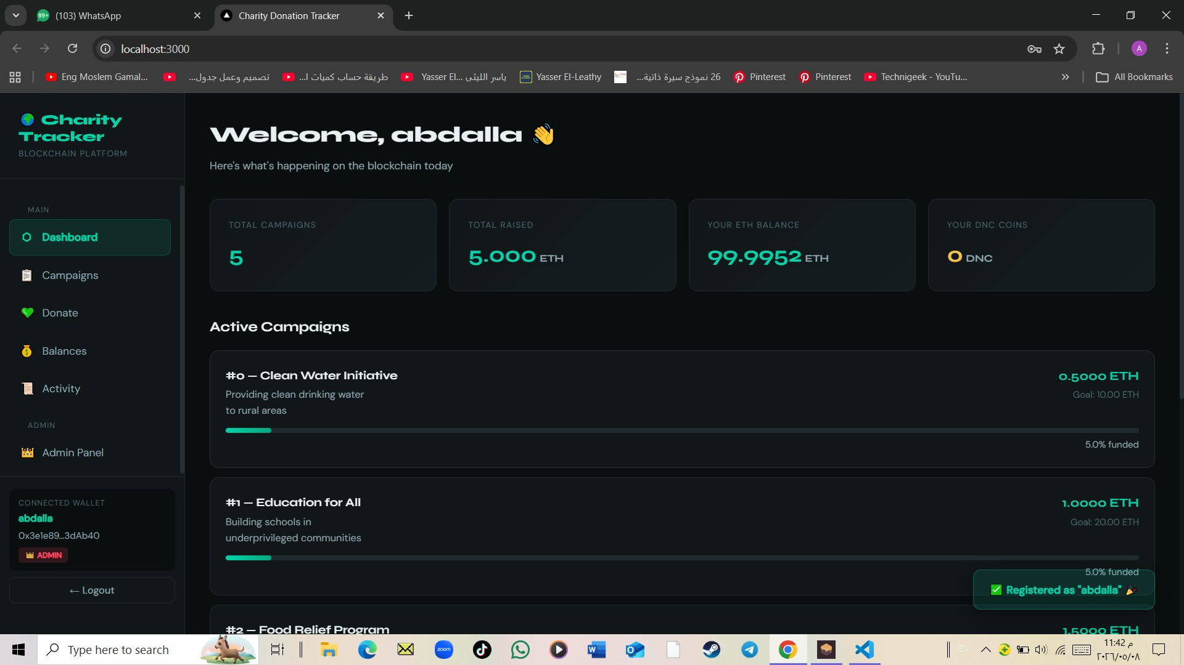
Figure 1 — Dashboard: real-time blockchain stats and campaign overview

4.2 All Campaigns
Displays every charity campaign stored on the blockchain as an individual card. Each card shows the campaign name, description, ETH raised so far, fundraising goal, a visual progress bar, and the percentage funded. The Refresh button re-reads data from the blockchain.
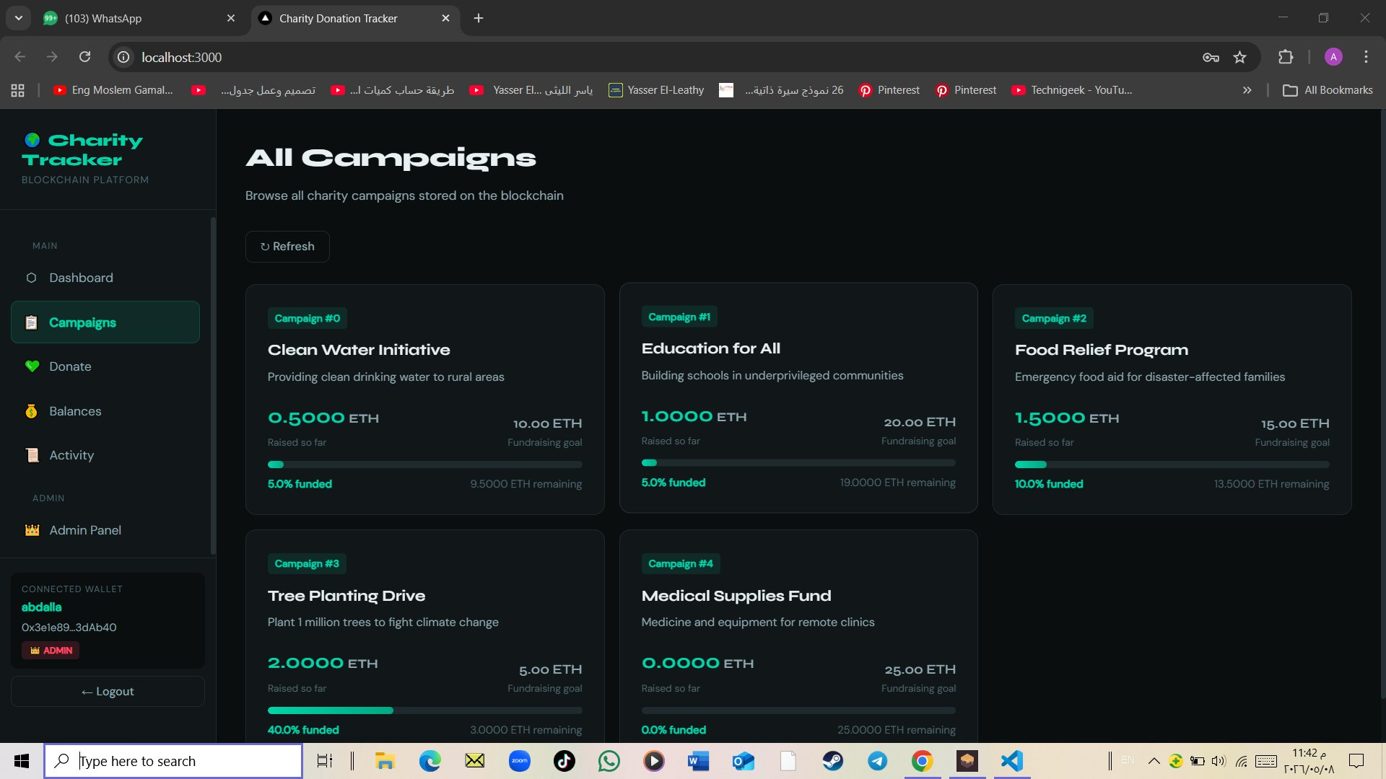
Figure 2 — Campaigns: all on-chain charity campaigns with live progress bars

4.3 Donate
The donation page allows users to select a campaign, choose a quick amount or enter a custom ETH value, and preview the DNC reward they will earn before confirming. The transaction is signed using the user's private key and sent directly to the blockchain. Upon success, a confirmation screen is shown with the exact DNC tokens earned.
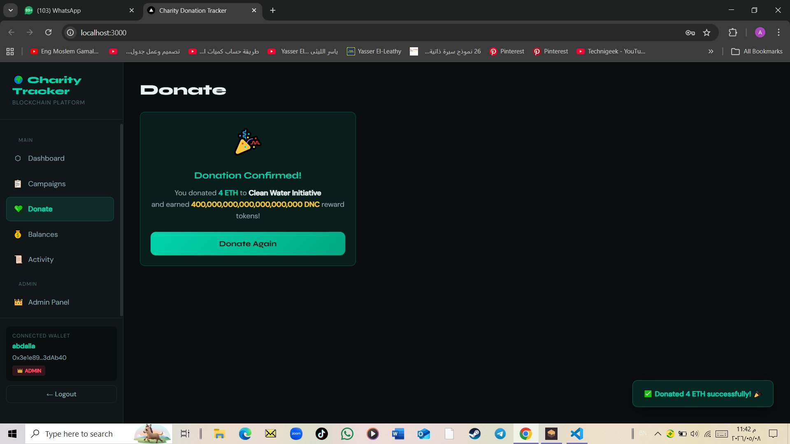
Figure 3 — Donate: confirmed donation of 4 ETH with DNC reward displayed

4.4 Check Balances
Allows the user to look up any wallet address and view both its ETH balance and DNC Donor Coin balance side by side. The Mine button auto-fills the currently logged-in wallet address. The display name registered on-chain is also shown if the address has been registered.
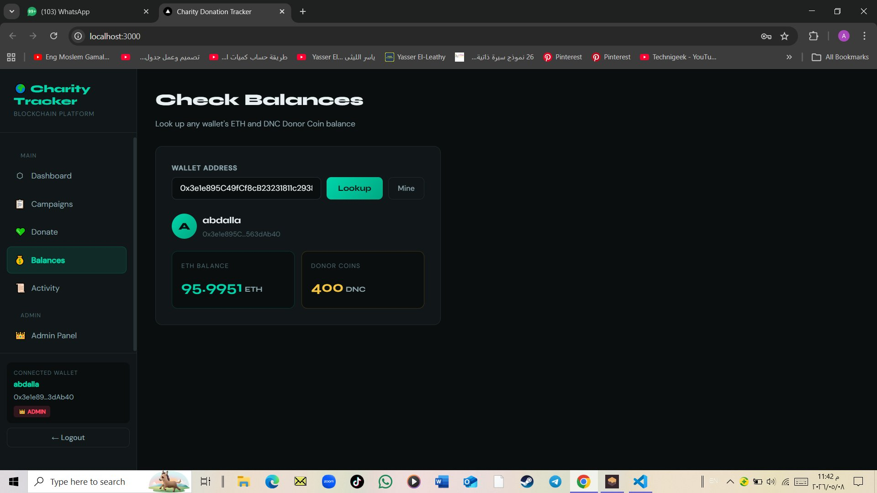
Figure 4 — Balances: ETH and DNC balance lookup for any wallet address

4.5 Activity History
Scans the entire blockchain from block 0 to the latest block and returns a table of every transaction that the searched address has performed on either the CharityTracker or DonorCoin contracts. Each row shows the block number, direction (SENT/RCVD), ETH value, and the transaction hash.
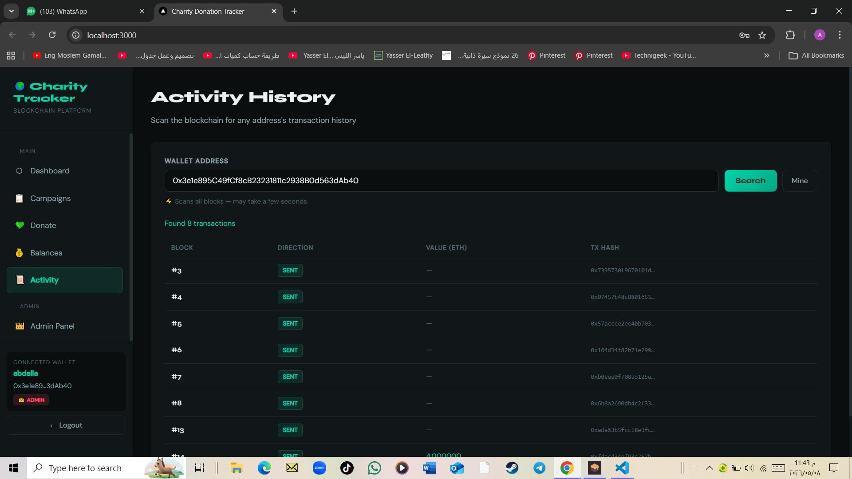
Figure 5 — Activity History: full transaction history scanned from the blockchain

4.6 Admin Panel
Only visible to the wallet address that is currently the contract admin. Provides four tabs: Campaigns (add or update campaigns), Mint Coins (send DNC to any address), Control (pause/resume contract and withdraw funds), and Danger Zone (transfer ownership to a new admin address permanently).
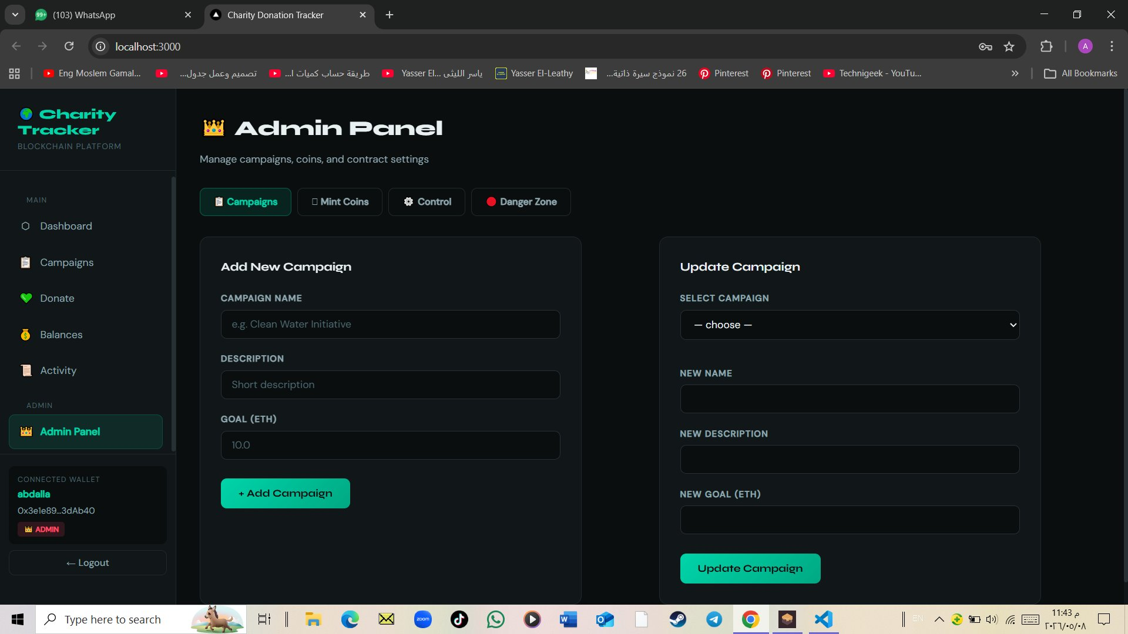
Figure 6 — Admin Panel: campaign management with add and update forms

5. Background Scripts
These scripts run independently from the terminal app and provide additional system capabilities.

Script | Command | What It Does
Admin Dashboard | python admin_dashboard.py | System summary: campaigns, coins minted, top 3 users
Live Alert System | python live_alert.py | Prints ALERT on every new donation detected
Data History Report | python data_history_report.py | ETH raised per campaign scanned from blockchain
Balance Snapshot CSV | python balance_snapshot_exporter.py | Exports all account balances to a CSV file
Security Tests | python security_test.py | 7 automated PASS/FAIL access control tests
Ownership Transfer Test | python ownership_transfer_test.py | 5-step test: transfer → block old admin → new admin works

6. Project Requirements Checklist

6.1 Admin Tasks
Requirement | Implemented In | Status
Core Smart Contract | CharityTracker.sol | ✔ DONE
Custom ERC-20 Coin | DonorCoin.sol | ✔ DONE
Auto-Setup Script | auto_setup.py | ✔ DONE
Access Control Module | onlyOwner + getAdmin() in CharityTracker.sol | ✔ DONE
Admin Dashboard Script | admin_dashboard.py | ✔ DONE
Batch Admin Operations | batchAddCampaigns + batchUpdateCampaigns | ✔ DONE

6.2 Normal User Tasks
Requirement | Implemented In | Status
Transaction Sender | transaction_sender.py | ✔ DONE
Terminal App | terminal_app.py | ✔ DONE
User Registration & Profile | registerUser() in CharityTracker.sol | ✔ DONE
Personal Activity History | personal_activity_history.py | ✔ DONE
Coin & ETH Balance Checker | terminal_app.py option [3] | ✔ DONE

6.3 System Tasks
Requirement | Implemented In | Status
Security Testing | security_test.py | ✔ DONE
Live Alert System | live_alert.py | ✔ DONE
Data History Report | data_history_report.py | ✔ DONE
System Documentation | README.md + this document | ✔ DONE
Balance Snapshot Exporter | balance_snapshot_exporter.py | ✔ DONE
Pause & Resume Switch | paused + whenNotPaused in CharityTracker.sol | ✔ DONE
Admin Ownership Transfer | transferOwnership() + ownership_transfer_test.py | ✔ DONE
GUI Bonus | react_gui/ — Full React Web Application | ✔ BONUS

Charity Donation Tracker
Technologies of Cryptocurrencies | Final Project Documentation

