 Cairo University  
Faculty of Computers and Information



**CS251**

**Software Engineering I**

**Game-based Educational Platform**

**Software Requirements Specifications**

Abdelaziz Mahmoud CS_3

Abdallah Abdelazim CS_2

Mohammed Amged CS_3

Fatma Elsayed CS_3

November, 2016

Contents

Team 3

Document Purpose and Audience 3

Introduction 3

Software Purpose 3

Software Scope 4

Definitions, acronyms, and abbreviations 4

Requirements 4

Functional Requirements 4

Non Functional Requirements 4

System Models 5

Use Case Model 5

Use Case Tables 5

Ownership Report 6

Policy Regarding Plagiarism: 6

# Team

|  |  |  |  |
| --- | --- | --- | --- |
| **ID** | **Name** | **Email** | **Mobile** |
| 20140169 | Abdelaziz Mahmoud Abdelaziz | zizomody2511@gmail.com | 01063930937 |
| 20140219 | Mohamed Amged Hamed | popop9933@yahoo.com | 01006093286 |
| 20140203 | Fatma Elsayed | Elsayedfatoma@yahoo.com | 01205867520 |
| 20140170 | Abdallah Abdelazim Abdallah | Abdallah.abdelazim@hotmail.com | 01110095611 |

# 

# Document Purpose and Audience

**What is this document?**

* **This document is a requirements elicitation for an educational website where a teacher can log in and create a game in a field and the student will be also able to log in and play and learn from this games**

**The targeted audience**

* **The client**
* **The Project manager**
* **The Developers**

# Introduction

## Software Purpose

## The project will be a game-based educational platform. This platform will help students to understand basic educational concepts while they will be playing simple games. These concepts will be related to subjects like science, technology and math.

## Software Scope

* The Project will consist of creating a web application where students can learn while they are playing simple games that were created by expert teachers from all over the globe. Any teacher can register an account and immediately start creating a game with ease. The website will be a platform providing numerous templates for teachers to choose the appropriate one, build their games and publish them on our application for students to play and learn. The Project will be completed by the end of the year 2016. The application will include an easy-to-use interface, simple games, login page for current users and registration page for new users to create account, easy to use game builder to help the teachers with creating games, games on the application will be created for educational purpose, games will be played by one student (Single player) and Each game should belong to one category.

## Definitions, acronyms, and abbreviations

|  |  |
| --- | --- |
| **requirements elicitation** | * collecting the requirements of a software form the user |
| **UI** | * User Interface |

# 

# Requirements

## Functional Requirements

The Student & teacher should be able to:

* **Log in and create account:** Each student & teacher shall have an account in the website or they can create one.

They can login to their account and then continue on the site. The account shall hold the user basic info (name, age, gender, etc.) and also it should contain student’s achievements (Scores he/she get in each game).

* **Play games:** Both the student and the teacher can play any game they want. For the student he needs to choose the field and the category he wants and then play

For the teacher it’s the same but if he wants to play a game he made he will go to his profile and choose it from there

* **Rate Games:** Students can rate any game (interesting, normal, boring) and write comments for each game.
* **Create game:** The teacher will be able to create a game by selecting the field of the game (math, science, etc.) and then he will select the category (matching pictures, run code games, multiple choices games) and after that he will make the actual game with fixed templates that exist on the site
* **Edit game:** The teacher can edit or change any game he made he just needs to go to his profile and choose the game and he will see the edit option
* **Remove game:** The teacher can remove any game he created. He just needs to go to his profile and choose the game and he will see the remove option
* **Replay to comment:** The teacher can replay to the comments on his games and take feedback.
* **Play mode:** The system shall only support single player games. Games will be played by one student and will be created by teacher. Each game should belong to one category.
* **Logout:** after finishing playing & navigating the site, the users can logout. All the changes they made will be saved.

## Non Functional Requirements

* Price

The site is completely free

* Security

The account of the user is protected and can be retrieved if there was a hacking situation and the user need a password in order to get to his data

* Stability

The number of the website visitors will be checked regularly to see if the number keep getting up the servers of the site will be updated

* Performance

Manage the page load time in two seconds and his option done in 5 seconds to make sure it’s fast for the user

* Safety

Any content that it’s uploaded to the site is reviewed in order to make sure that the content is save for all users

* Accessibility

The user can access the site form any device that is connected to the internet

* Usability

The site is easy to use and the use must be at least 10 years old

* Platform

There is no app to access to the serves only the website

* Privacy

Any information about the user is private and can’t be accessed without the user permission

# System Models

## Use Case Model

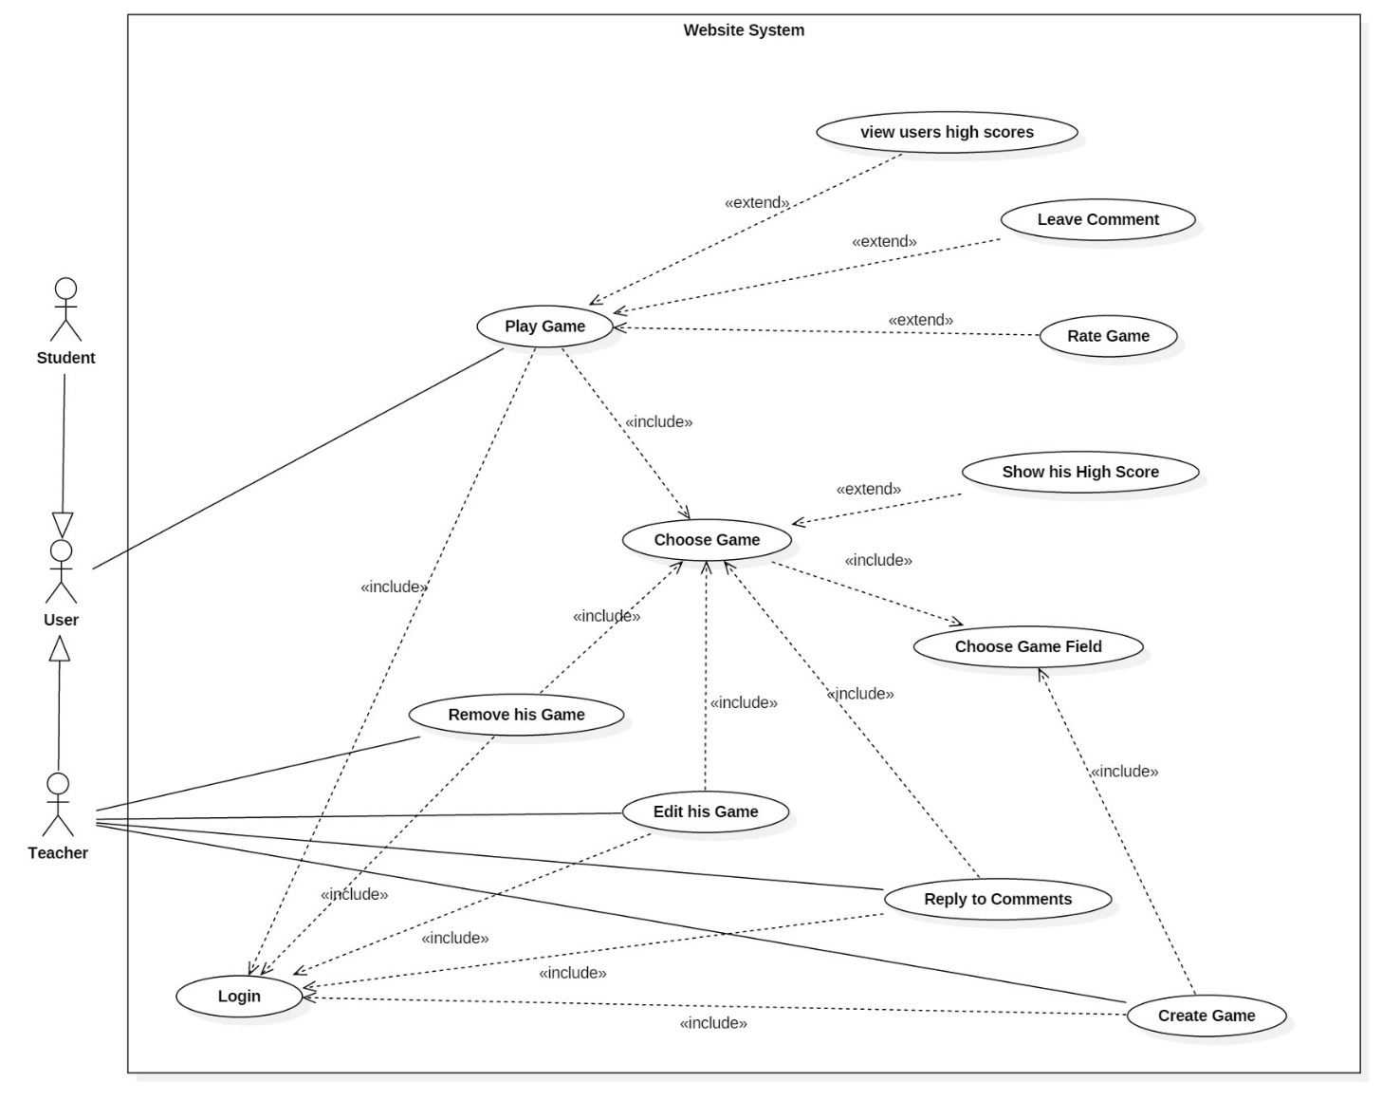

## Use Case Tables

|  |  |  |
| --- | --- | --- |
| Use Case ID: | 1 | |
| Use Case Name: | Login | |
| Actors: | User. | |
| Pre-conditions: | User is not logged in. | |
| Post-conditions: | User is logged in to his account. | |
| Flow of events: | **User Action** | **System Action** |
| 1- User Selects to login.  2-User enters his information |  |
|  | 5- System Verify his information |
| Exceptions: | **User Action** | **System Action** |
| 1- User Enter username and Password. |  |
|  | 2-username does not exist or password is wrong.  3- System rejects the Login  4-System demands the user to enter correct username and password |
| Includes: | Login as Student , Login as Teacher | |
| Notes and Issues: |  | |

|  |  |
| --- | --- |
| Use case ID | 2 |
| Use case name | Choose game field |
| Actors | Teacher , User (Student) |
| Pre-conditions | The user must be logged in to his account. |
| Post-conditions |  |
| Flow of events | |  |  | | --- | --- | | User Actions | System Actions | |  | 1. the website shows the available fields. | | 2.the teacher , user (student) chooses the field he wants. |  | |
| Exceptions | |  |  | | --- | --- | | User Actions | System Actions | | 1.the teacher log in |  | |  | 2.password or username not valid | |
| Includes |  |
| Notes and issues |  |

|  |  |
| --- | --- |
| Use case ID | 3 |
| Use case name | Choose game |
| Actors | Teacher ,student |
| Pre-conditions | choose field |
| Post-conditions | Choose game |
| Flow of events | |  |  | | --- | --- | | User Actions | System Actions | |  | 1-the website will show the games | | 2-techer/student chooses the game |  | |
| Exceptions | |  |  | | --- | --- | | User Actions | System Actions | |  |  | |  |  | |
| Includes | Login, Choose game field |
| Notes and issues | There must be a field to choose game |

|  |  |
| --- | --- |
| Use case ID | 4 |
| Use case name | Play game |
| Actors | User |
| Pre-conditions | Choose game |
| Post-conditions | See his new score |
| Flow of events | |  |  | | --- | --- | | User Actions | System Actions | |  | 1-the website show options in game. | | 2- the student choose play game when he finished. |  | |  | 3-Return his score and save changes and add the game to list for student and his new score | |
| Exceptions | |  |  | | --- | --- | | User Actions | System Actions | |  |  | |  |  | |
| Includes | Login ,choose field ,choose game |
| Notes and issues | if the game fails the check test it will not be saved |

|  |  |
| --- | --- |
| Use case ID | 5 |
| Use case name | View user high score |
| Actors | User |
| Pre-conditions | Choose game |
| Post-conditions | Get game result |
| Flow of events | |  |  | | --- | --- | | User Actions | System Actions | |  | 7- the website show options in game | | 8- choose get high score |  | |  | 9-Return his high score | |
| Exceptions | |  |  | | --- | --- | | User Actions | System Actions | |  |  | |
| Includes | Login, Choose field |
| Notes and issues |  |

|  |  |
| --- | --- |
| Use case ID | 6 |
| Use case name | Create a game |
| Actors | Teacher |
| Pre-conditions | Login |
| Post-conditions | The game is saved on the site and on the teachers profile |
| Flow of events | |  |  | | --- | --- | | User Actions | System Actions | | 1.the teacher go to his profile and choose the create game option |  | |  | 2.the website will show the choose game field option | | 3.the teacher chooses the field |  | |  | 4.the website give the teacher the tools and templates to create the game | | 5.the teacher finishes the game and save it |  | |  | 6.the website check the game and publish it to be played | |
| Exceptions | |  |  | | --- | --- | | User Actions | System Actions | |  |  | |
| Includes | Login, Choose game field |
| Notes and issues | If the game fails the check test it will not be saved |

|  |  |
| --- | --- |
| Use case ID | 7 |
| Use case name | Edit his game |
| Actors | Teacher |
| Pre-conditions | Login |
| Post-conditions | The new version of the game is saved on the site and on the teachers profile |
| Flow of events | |  |  | | --- | --- | | User Actions | System Actions | | 1.the teacher go to his profile and choose the game he wants to edit |  | |  | 2.the website will show the game options (Edit, Delete) | | 3.the teacher choose edit game |  | |  | 4.the website give the teacher the tools and templates to edit the game | | 5.the teacher finishes the editing of the game and save it |  | |  | 6.the website check the game and save it to be played | |
| Exceptions | |  |  | | --- | --- | | User Actions | System Actions | | 1.the teacher log in |  | | 3.teacher search for a game in his profile |  | |  | 4.game is not found | |
| Includes | Login, Choose game ,choose game field |
| Notes and issues | There must be a game in order to edit it |

|  |  |
| --- | --- |
| Use case ID | 8 |
| Use case name | remove a game |
| Actors | Teacher |
| Pre-conditions | Login |
| Post-conditions | The game is removed from site and the teachers profile |
| Flow of events | |  |  | | --- | --- | | User Actions | System Actions | | 1.the teacher go to his profile and choose the game he wants to remove |  | |  | 2.the website will show the choose game field option(Edit, Delete) | | 3.the teacher chooses remove game |  | |  | 4.the website gives a massage to the teacher to confirm the operation | | 5.the teacher confirm the operation |  | |  | 6.the website remove the game | |
| Exceptions | |  |  | | --- | --- | | User Actions | System Actions | | 1.the teacher log in |  | | 3.teacher search for a game in his profile |  | |  | 4.game is not found | |
| Includes | Login, Choose game, choose game field |
| Notes and issues | There must be a game in order to delete it |

|  |  |
| --- | --- |
| Use case ID | 9 |
| Use case name | reply to a comment |
| Actors | Teacher |
| Pre-conditions | Login |
| Post-conditions | The add reply will be add to the existing comment |
| Flow of events | |  |  | | --- | --- | | User Actions | System Actions | | 1.the teacher go to his profile and choose a game that someone commented on it |  | |  | 2.the website will show the choose the reply option under the comment | | 3.the teacher chooses reply and write his reply |  | |  | 4.the website will save his reply | |
| Exceptions | |  |  | | --- | --- | | User Actions | System Actions | | 1.teacher search for a game in his profile |  | |  | 2.game has no comments | |
| Includes | Login, Choose game , choose game filed |
| Notes and issues | There must be a comment on a game in order to reply to it |

|  |  |
| --- | --- |
| Use case ID | 10 |
| Use case name | Leave comment |
| Actors | User |
| Pre-conditions | Choose game |
| Post-conditions | Leave comment |
| Flow of events | |  |  | | --- | --- | | User Actions | System Actions | |  | 1- the website show options in game | | 2- write a comment |  | |  | 3-the website show the comment and save change | |
| Exceptions | |  |  | | --- | --- | | User Actions | System Actions | |  |  | |
| Includes | Login, Choose game ,choose filed |
| Notes and issues |  |

|  |  |
| --- | --- |
| Use case ID | 11 |
| Use case name | Rate |
| Actors | student |
| Pre-conditions | Choose game |
| Post-conditions | Add rate |
| Flow of events | |  |  | | --- | --- | | User Actions | System Actions | |  | 1- the website show options in game | | 2- Student selects the rate option. |  | |  | 3-the website displays the rate and save change | |
| Exceptions | |  |  | | --- | --- | | User Actions | System Actions | |  |  | |
| Includes | Login, Choose game ,choose filed |
| Notes and issues |  |

**GitHub Repo**

[**https://github.com/Abdallah-Abdelazim/Game-based-Educational-Platform**](https://github.com/Abdallah-Abdelazim/Game-based-Educational-Platform)

# Ownership Report

|  |  |
| --- | --- |
| **Item** | **Owners** |
| Use Case Diagram | *Abdallah Abdelazim/Abdelaziz Mahmoud* |
| Software purpose and scope | *Abdallah Abdelazim* |
| Document Purpose and Audience | *Mohammed Amged* |
| Functional and Nonfunctional Requirements | *Abdelaziz Mahmoud/Fatma Elsayed/Mohammed Amged* |
| Use Cases Tables | *All team.* |