Technical level: what it adds to the concept
SOW1 - SOW2 secure communication. The 30 technical requirements (TECH_CS_CONCEPT) compared with the 25 concept requirements (CS_CONCEPT).
1. In short
- The concept level says what must be true. The technical level says how to verify it, with numbered test steps.
- 18 of the 30 have the same text as their concept requirement. 5 differ slightly. 4 add new detail. 3 are new (row configuration).
- Of our 87 open SIQs, 3 are now answered and 15 are partly answered. 69 stay open.
- The technical level does not define the registers, frame layout, timers or reactions that we ask about. It also adds new gaps (section 4).
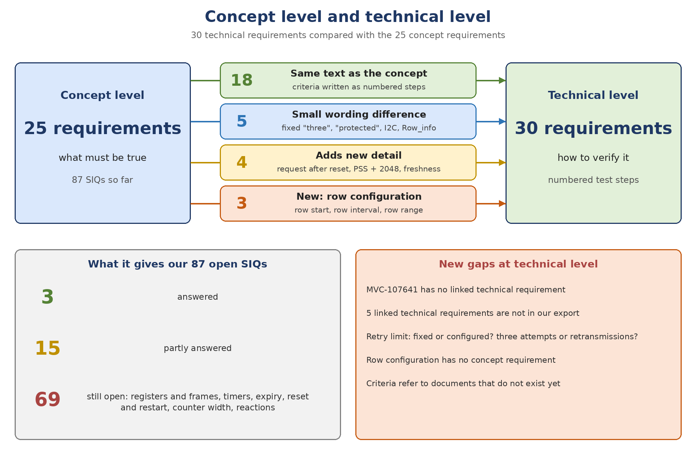
2. The 30 technical requirements
Colour: green = same text, blue = small difference, yellow = adds detail, orange = new. Order as in your list (T1 to T30).
# | Technical | Concept | Type | What it says or adds
T1 | MVC-106582 | MVC-119709 | Same text as concept | Same text. Wrong footer tag and changed frame data must both fail; full 128-bit compare.
T2 | MVC-106575 | MVC-103031 | Adds detail (new information) | Freshness, ordering and sequence check with the header counter; "counter-validation policy" not defined. Content is closer to MVC-113703.
T3 | MVC-106563 | MVC-107642 | Adds detail (new information) | New: RSASSA-PSS with SHA-256 and a 2048-bit key. Concept MVC-107641 has the same topic but no linked technical requirement.
T4 | MVC-106560 | MVC-103042 | Same text as concept | Same text. Steps include injecting a TRNG failure (software level).
T5 | MVC-106578 | MVC-103034 | Small wording difference | Adds: over I2C, the term Row_info, and no transmission if authentication or encryption fails. Message layout is "specified" but not defined.
T6 | MVC-106569 | MVC-103051 | Small wording difference | Concept: configured maximum. Here: fixed three attempts.
T7 | MVC-106581 | MVC-103044 | Same text as concept | Same text. SSK not used for protected traffic; a new establishment can start again ("recovery conditions" not defined).
T8 | MVC-106562 | MVC-103063 | Same text as concept | Same text and criteria. One step is about Secure Boot, which is another feature.
T9 | MVC-106567 | MVC-103046 | Same text as concept | Same text. Counts requests on I2C; step 5 says "configured limit" while the text says three.
T10 | MVC-106566 | MVC-103053 | Small wording difference | Concept: retry the process. Here: retransmit the authentication request up to three times.
T11 | MVC-106573 | MVC-103036 | Same text as concept | Same text. Detailed steps per trigger; the old SSK must no longer be accepted.
T12 | MVC-106561 | MVC-107642 | Adds detail (new information) | New: SOW2 requests Device_n, KID and Sig_device over I2C after reset or before the session. Not in the concept.
T13 | MVC-113727 | MVC-113703 | Same text as concept | Same text. Boundary tests; LastAcceptedCounter is updated after the frame is authenticated.
T14 | MVC-106564 | MVC-119710 | Same text as concept | Same text. A rejected frame must not reach downstream processing as trusted.
T15 | MVC-106571 | MVC-113706 | Same text as concept | Same text. Lists the interfaces to check (diagnostic, logs, debug, communication, memory).
T16 | MVC-109120 | MVC-119708 | Same text as concept | Same text. Frames are trusted only after session set-up and the integrity and freshness checks.
T17 | MVC-109121 | MVC-113702 | Small wording difference | Says "protected" commands. Adds a counter maximum and rollover policy and the start value after a new session, but defines neither.
T18 | MVC-106568 | MVC-103057 | Same text as concept | Same text. New SSK per session; no key generation after a failed authentication.
T19 | MVC-113726 | MVC-103031 | Same text as concept | Same text. A malformed or missing header counter must not authorize a frame.
T20 | MVC-106572 | MVC-113705 | Same text as concept | Same text. Exactly 128 bits from the footer; a malformed footer is not treated as extracted.
T21 | MVC-106574 | MVC-103055 | New: row-information configuration | New: row range limit start + 1 + (interval + 1) x (total - 1) <= image + embedded data lines.
T22 | MVC-106580 | MVC-103055 | Same text as concept | Same text as the first part of the concept (the concept adds a Samsung note). Criteria need the private key to decrypt.
T23 | MVC-106576 | MVC-103055 | New: row-information configuration | New: row start 0 or 1. Start 0 puts the header line with the frame counter into the CMAC input.
T24 | MVC-108741 | MVC-103055 | New: row-information configuration | New: row interval at least 10 (merge modes) or 30 (line reorder RAW12).
T25 | MVC-106583 | MVC-103033 | Same text as concept | Same text. Needs a known SSK and an independent reference tag.
T26 | MVC-108740 | MVC-113701 | Same text as concept | Same text. Needs a known SSK; "specified authenticated input" is not defined.
T27 | MVC-106565 | MVC-107642 | Adds detail (new information) | New: the signature covers Device_n and KID; the root key is RSA-2048.
T28 | MVC-106570 | MVC-119707 | Same text as concept | Same text. The tag follows the command; the field order is "specified" but not defined.
T29 | MVC-109119 | MVC-119714 | Small wording difference | Says "protected" control commands; the concept says all control commands.
T30 | MVC-106577 | MVC-103040 | Same text as concept | Same text. A missing or malformed key must not be used; the "reference key" question returns.
3. What it gives our open SIQs
3 answered, 15 partly answered. The comment "partly" means the technical requirement helps, but the value or policy is still not defined.
Concept requirement | SIQ | Status | What the technical level gives
MVC-107642 | SIQ-2 | Answered | The signed message is Device_n and KID (MVC-106565).
MVC-107641 | SIQ-3 | Answered | RSA key size 2048 bits (MVC-106563).
MVC-113703 | SIQ-2 | Answered | LastAcceptedCounter is updated after the frame is authenticated (MVC-113727).
MVC-103053 | SIQ-1 | Partly | SOW2 retransmits the authentication request (MVC-106566). What counts as failed is still open.
MVC-103051 | SIQ-2 | Partly | A new establishment can start again, under undefined "recovery conditions" (MVC-106581).
MVC-103051 | SIQ-3 | Partly | The technical level says a fixed three attempts (MVC-106569); the concept says configured.
MVC-103044 | SIQ-1 | Partly | The SSK is not used for protected traffic (MVC-106581); deletion is not stated.
MVC-119709 | SIQ-3 | Partly | With row start 0 the header line with the frame counter is part of the CMAC input (MVC-106576).
MVC-119709 | SIQ-6 | Partly | "Incorrect" = changed footer tag, "modified" = changed frame data (MVC-106582); "invalid" is not covered.
MVC-103031 | SIQ-3 | Partly | Invalid counter data must not authorize a frame (MVC-113726, MVC-106575); the policy is not defined.
MVC-113705 | SIQ-1 | Partly | An invalid tag is not treated as extracted (MVC-106572); the policy is not defined.
MVC-119708 | SIQ-2 | Partly | Trusted only after session set-up plus integrity and freshness checks (MVC-109120); the start of the stream is open.
MVC-119714 | SIQ-1 | Partly | The technical level says "protected" commands only (MVC-109119).
MVC-119707 | SIQ-1 | Partly | The tag follows the command (MVC-106570); the field format is not defined.
MVC-103042 | SIQ-5 | Partly | Steps include injecting a TRNG failure (MVC-106560), so a software-level negative test is expected.
MVC-103046 | SIQ-1 | Partly | Retransmissions are counted on I2C with the response suppressed (MVC-106567); the expected response is not defined.
MVC-107641 | SIQ-5 | Partly | Inspection of the configuration plus a modified-data test (MVC-106563).
4. New gaps found at the technical level
- Concept MVC-107641 (RSASSA-PSS, SHA-256) has no linked technical requirement. MVC-106563, which covers it, is linked to MVC-107642.
- Five technical requirements are linked from the concept but are not in our export: MVC-113724, MVC-106579, MVC-108739, MVC-113723, MVC-113725.
- Fixed or configured retry limit: "three" in the text, "configured limit" in MVC-106567 step 5 and in concept MVC-103051. Three attempts (MVC-106569) and three retransmissions (MVC-106566) differ by one.
- Three row-configuration technical requirements are linked to the encryption concept MVC-103055. The concept has no row-selection requirement.
- MVC-106575 is linked to MVC-103031 (extract counter) but its content is freshness validation (MVC-113703).
- Several criteria refer to things that do not exist yet: "approved interface specification" (MVC-106580), "specified message layout" (MVC-106578, MVC-106570), "counter-validation policy" (MVC-106575), "rollover policy" (MVC-109121).
- MVC-106563 numbers its criteria 1, 2, 4, 5 (step 3 is missing). MVC-109119 says "protected" commands, the concept says all commands.
5. Next
- Review the 30 technical requirements. For those with the same text, the comment is "Similar to concept REQ: MVC-xxxxx". Only differences and new items get their own SIQs.
- Send the five missing technical requirements (MVC-113724, MVC-106579, MVC-108739, MVC-113723, MVC-113725).

