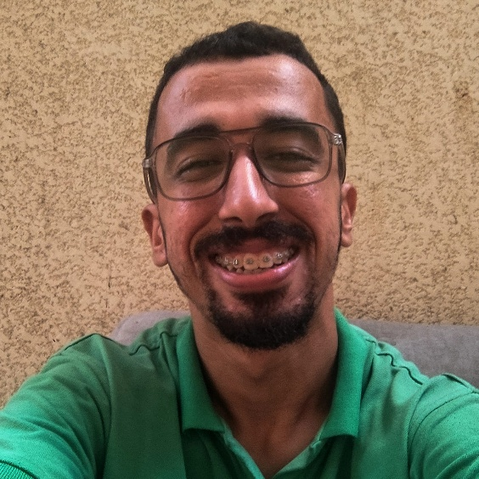 |  | Abdallah Badawi  - Front-End Developer  I am a mid-level Front-End Developer specializing in React.js, with a passion for building high-quality web applications and exceptional user experiences. I have strong Knowledge of HTML, CSS, and JavaScript, and I Focus on creating responsive and customizable interfaces.

Contact
abdallahbadawi956@gamil.com
(+972) 59-256-4113
Palestine, Gaza Strip

Language
Arabic (Fluent)
English (Intermediate)

Education

University of palestine
Gaza,
Bachelor Of IT:- IT - Management Information System (MIS)
2020 - 2025

Skills
- Project management
- Communication skills
- Problem-solving
- Active listening
- Team leadership and motivation
- Public speaking
- Calm under pressure
- Front-end development
- JavaScript frameworks

Projects\Courses
Bunyan Platform: A Digital Marketplace for Construction Materials and Services.
Project Description
The "Reconstruction Platform" is a website that aims to support the reconstruction process in Gaza by providing a digital space connecting buyers and sellers of materials and equipment used in construction and maintenance. The platform also offers additional services, such as delivery, and provides job opportunities for workers in the workshops and construction sectors, thus supporting local development and the economy.
Main Objectives of the Project

Resource Recycling:

Providing the possibility of reusing used materials such as scrap metal and construction tools.

Easy Access:

Enabling users to easily purchase products online.

Job Creation:

Providing opportunities for workers in the construction and maintenance fields.
PROFITABILITY:
Generating income through commission fees, delivery services, and advertising.

Front End

Successfully completed a 50-hour Front-End Development training program at Edraak Center, covering HTML, CSS, JavaScript, and responsive web design

