**Pharmacy Inventory Control System – Documentation**

**1. Project planning & management**

**Project proposal**

The "Pharmacy Management System (PMS)" aims to enhance the efficiency of pharmacy operations by automating inventory management, sales tracking, and expiration date monitoring. The system provides advanced technological solutions that reduce human errors, offer real-time data on stock levels, and improve customer experience through faster and more accurate transactions.

**Project plan**

The project follows a precise timeline that includes several key phases:

* System Analysis : Studying requirements and designing the initial system structure.
* Database Design: Developing a data structure to ensure efficient storage and fast data retrieval.
* Frontend & Backend Development: Creating the user interface and integrating it with the database and servers.
* Testing & Quality Assurance: Verifying performance, fixing bugs, and ensuring seamless user experience.
* Deployment & Evaluation: Launching the system and collecting user feedback for performance improvement.

**Task Assignment & Roles**

**Lead Developer**

* Responsible for designing and implementing the core system functionalities.
* Develops the backend services and APIs to ensure smooth data flow.
* Oversees system integration, ensuring seamless communication between

different components.

* Troubleshoots technical issues and optimizes system performance.

**Database Administrator (DBA)**

* Manages the database structure, ensuring efficient data storage and retrieval.
* Implement security measures to protect sensitive pharmacy data.
* Monitors database performance and optimizes queries for faster response times.
* Performs regular backups and recovery processes to prevent data loss.

**System Tester (Quality Assurance Engineer)**

* Conducts comprehensive testing to identify and fix bugs before deployment.
* Performs functional, performance, and security testing to ensure system stability.
* Simulates real-world scenarios to evaluate system behavior under various conditions.
* Documents test cases, reports issues, and verify that all features meet the

required standards.

**UI/UX Designer**

* Develops an intuitive and visually appealing user interface.
* Ensures a seamless user experience by focusing on accessibility and usability.
* Conducts user research and gathers feedback to refine the design.
* Collaborates with developers to ensure design feasibility and implementation

consistency.

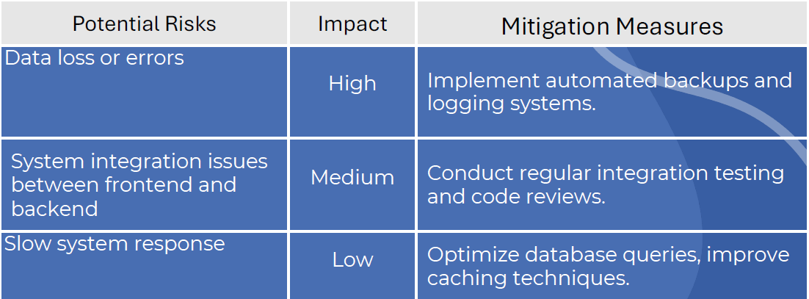**Risk Assessment & Mitigation plan**

**Key Performance Indicators (KPIs)**

* **Response Time :** The system ensures that operations and data loading are completed in less than two seconds, providing a fast and seamless user experience.
* **System Uptime :** Achieves 99.9% operational reliability, ensuring stable performance without any disruptions that may hinder workflow.
* **User Satisfaction Rate :** Aims to exceed 90% user satisfaction, by offering a flexible interface and high-quality performance that meets user expectations.

**2. Literature Review**

**Feedback & Evaluation**

**System Architecture**

This criterion assesses the efficiency of the system’s structure, ensuring a well-organized and scalable design. The system should allow seamless integration between the database and the user interface, enabling future modifications and expansions without compromising performance.

**Performance**

This focuses on the system’s ability to process inventory and sales data efficiently without slowdowns or delays. The system’s response time for searching medicines, updating stock, and generating reports is tested. Additionally, stability is assessed when multiple users access the system simultaneously.

**User Experience (UX)**

This criterion evaluates the ease of use for pharmacy staff, ensuring the interface is clear and intuitive. The system should allow for quick completion of daily tasks without requiring extensive training, thereby improving workflow efficiency within the pharmacy.

**Suggested Improvement**

* **Smart Notifications System :** Sends alerts about nearly expired drugs or low stock.
* **Billing System Integration :** Supports electronic payments and digital

invoices.

* **Security Enhancements :** Restricting access to sensitive data, logging

operations, encrypting inventory and sales, and securing login for authorized users only.

* **Advanced Data Analysis :** Utilizing historical data reports to identify sales trends and optimize inventory management based on expected demand.

Final grading criteria

**3. Requirements Gathering**

**Stakeholder Analysis**

The key stakeholders in the Pharmacy Inventory Control System are:

* **Admin**: Manages profiles and data.
* **Pharmacist**: places orders and generate bill.
* **Manager**: reviews reports and sends required order to suppliers.
* **Supplier**: Supplies medicines based on pharmacy orders.
* **Customers**: Purchase medicines and complete payments.

**User Stories & Use Cases**

The Pharmacy Inventory Control System is designed to efficiently manage and track medicine stock, ensure availability, and prevent shortages or expired products. The system enables manager to monitor inventory levels, process sales, generate reports, and reorder stock as needed.

This system integrates multiple functionalities such as inventory management, order processing, stock tracking, report generation, and supplier coordination, ensuring seamless pharmacy operations. The main goal is to reduce human error, optimize stock levels, and enhance customer service by ensuring medicines are always available.

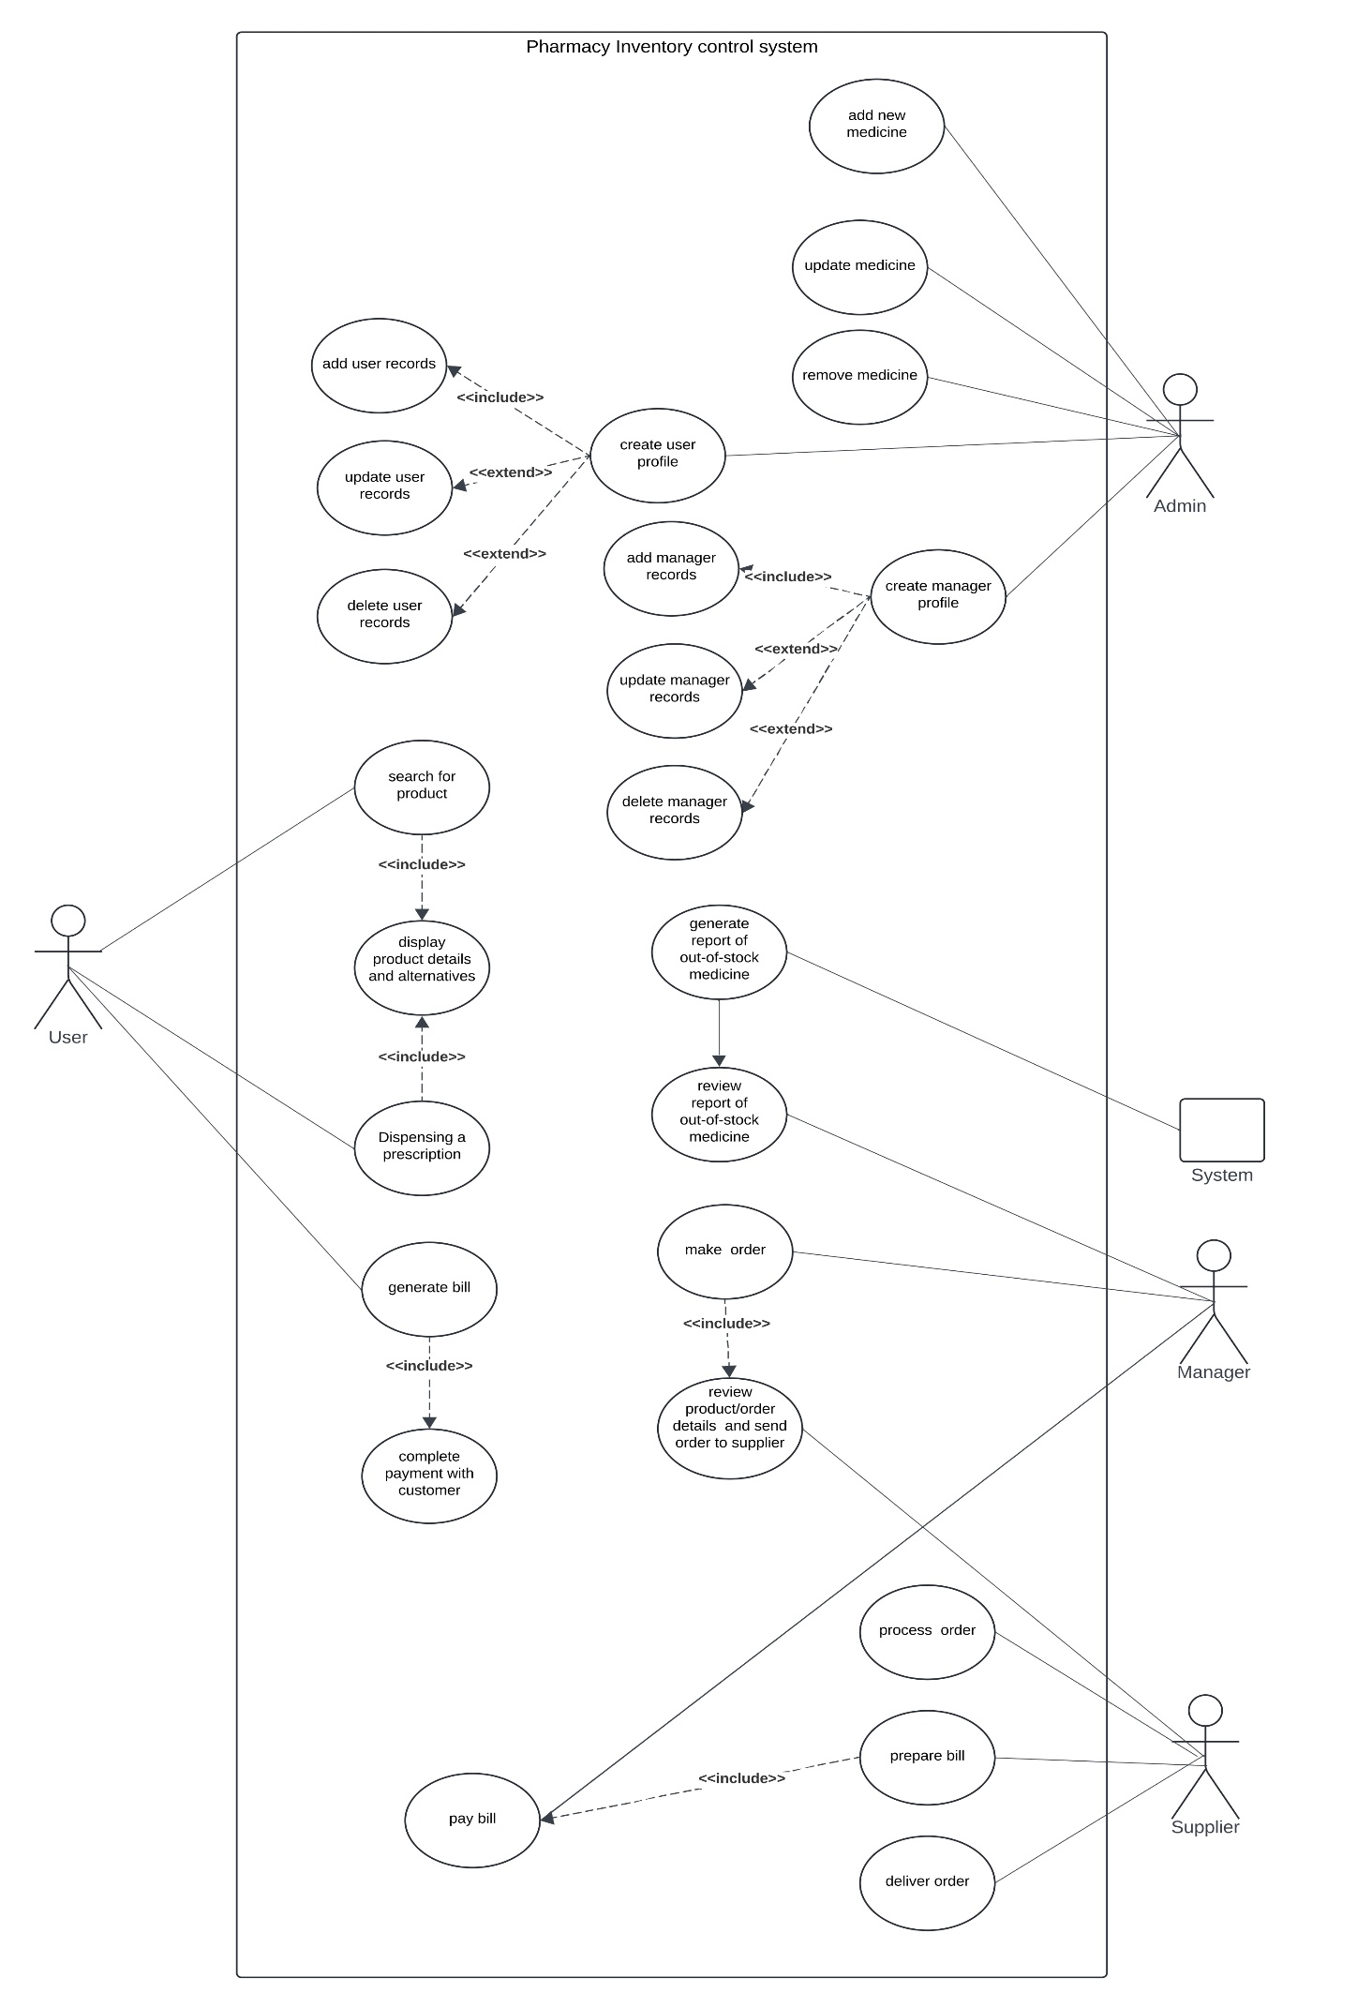

**Use case scenarios**

**Use Case: Add New Medicine**

* 1. Admin logs in the system by entering username and password.
  2. Admin browse through options.
  3. Admin selects "Add New Medicine" option.
  4. System prompts for medicine details (name, quantity, expiry date, etc.).
  5. Admin enters the required details.
  6. System validates and saves the new medicine information.
  7. confirms the addition of the new medicine.

**Use Case: Update Medicine**

* 1. Admin logs in the system by entering username and password.
  2. Admin browse through options.
  3. Admin selects "Update Medicine" option.
  4. System prompts for editing medicine details (name, quantity, expiry date, etc.).
  5. Admin enters the required details.
  6. System validates and saves the new medicine information.
  7. confirms the modification of the medicine.

**Use Case: Remove Medicine**

* 1. Admin logs in to the system by entering username and password.
  2. Admin browses through available options.
  3. Admin selects the "Remove Medicine" option.
  4. System prompts for medicine details (name, quantity, reason for removal, etc.).
  5. Admin enters the required details.
  6. System validates and updates the inventory by removing the specified medicine.
  7. System confirms the removal of the medicine.

**Use Case: Create Pharmacist Profiles**

* 1. Admin logs in the system by entering username and password.
  2. Admin browse through options
  3. Admin selects "**Create Pharmacist Profiles**" option.
  4. System prompts for pharmacist details (name, username, password, etc.).
  5. Admin enters the required details.
  6. System validates and saves the new pharmacist profile.
  7. System confirms the creation of the new pharmacist profile.

**Use Case: Update Pharmacist Profiles**

* 1. Admin logs in the system by entering username and password.
  2. Admin browse through options
  3. Admin selects "**Pharmacist Profiles**" option.
  4. Admin select the desired profile to update.
  5. Admin selects the details required to edit.
  6. System validates and saves the pharmacist profile.
  7. System confirms the updating of the pharmacist profile.

**Use Case: Delete Pharmacist Profiles**

* 1. Admin logs in the system by entering username and password.
  2. Admin browse through options
  3. Admin selects "**Pharmacist Profiles**" option.
  4. Admin select the desired profile to delete.
  5. System validates and delete the pharmacist profile.

**Use Case: Create** **Manager Profiles**

* 1. Admin logs in the system by entering username and password.
  2. Admin browse through options
  3. Admin selects "**Create Manager Profiles**" option.
  4. System prompts for manager details (name, username, password, etc.).
  5. Admin enters the required details.
  6. System validates and saves the new manager profile.
  7. System confirms the creation of the new manager profile.

**Use Case: Update Manager Profiles**

* 1. Admin logs in the system by entering username and password.
  2. Admin browse through options
  3. Admin selects " **Manager Profiles**" option.
  4. Admin select the desired profile to update.
  5. Admin selects the details required to edit.
  6. System validates and saves the manager profile.
  7. System confirms the updating of the manager profile.

**Use Case: Delete Manager Profiles**

* 1. Admin logs in the system by entering username and password.
  2. Admin browse through options
  3. Admin selects " **Manager Profiles**" option.
  4. Admin select the desired profile to delete.
  5. System validates and delete the manager profile.

**Use Case: Search for Medicine**

* 1. Pharmacist logs in the system by entering username and password.
  2. Pharmacist browse through options.
  3. Pharmacist selects "Search for Product" option
  4. System prompts for medicine name.
  5. Pharmacist enters the product name.
  6. System displays search results.
  7. Pharmacist selects the desired product.
  8. The pharmacist finds the product they were looking for.

**Alternate Flow: No Results Found**

* **Condition**: If no products match the search.
  1. System shows a message saying "No results found".
  2. Pharmacist can try searching again with a different name or alternative product.

**Use Case: Dispense Prescription**

1. Pharmacist logs in to the system by entering username and password.
2. Pharmacist browses through options.
3. Pharmacist selects "**Dispense Prescription**" option.
4. System prompts for prescription details.
5. Pharmacist enters the prescription details or scans an electronic prescription.
6. System verifies the prescription and checks for drug interactions.
7. Pharmacist retrieves the prescribed medication from inventory.
8. Pharmacist prepares the medication, ensuring correct dosage and packaging.
9. Pharmacist provides usage instructions and precautions to the patient.
10. System updates inventory and records the transaction.
11. Pharmacist hands over the medication to the patient.

**Use Case: Generate bill (Pharmacist)**

* 1. Pharmacist logs in the system by entering username and password.
  2. Pharmacist browse through options.
  3. Pharmacist selects "**Generate bill** " option.
  4. System prompts for customer and product details.
  5. Pharmacist enters the required details.
  6. System calculates the total amount.
  7. System generates the bill.
  8. Pharmacist provides the bill to the customer.

**Use Case: Make Order**

* 1. Manager logs in the system by entering username and password.
  2. Manager browse through options
  3. Manager selects "**Review report of out-of-stock medicine**" option.
  4. Manager chooses among suppliers to order the out-of-stock medicine .
  5. System validates and confirms order.

**Use Case: Generate Report of Out-of-Stock Medicine**

* 1. Operator logs in the system by entering username and password.
  2. Operator browse through options.
  3. Operator selects "Generate Report of Out-of-Stock Medicine" option.
  4. System retrieves the list of out-of-stock medicines.
  5. System generates the report.
  6. Operator reviews the report.

**Use Case: Process Order**

* 1. Manager sends request for required out-of-stock items from supplier.
  2. Supplier reviews the order request and waits for the purchase order confirmation.
  3. Operator confirms the list and purchase order.
  4. Supplier prepares the order based on the request and received list.
  5. Supplier confirms the order preparation.

**Functional Requirements**

* Add, update, and remove medicines.
* Process orders and manage inventory stock.
* Generate bills and complete payments.
* Track and generate reports for out-of-stock medicines.
* Manage user and supplier records.

**Non-Functional Requirements**

* **Performance**: The system should handle multiple transactions without delays.
* **Security**: Role-based access control to prevent unauthorized actions.
* **Usability**: Simple and intuitive UI for pharmacists and customers.
* **Reliability**: Ensure correct stock updates and prevent inventory mismatches.

**4. System Analysis & Design**

**1. Problem Statement & Objectives**

The **Pharmacy Inventory Control System** aims to **streamline inventory management**, prevent stock shortages, and **enhance operational efficiency** by automating tasks such as order processing, medicine tracking, and billing.

* **Use Case Diagram**:

* + Order Processing
  + Inventory Management
  + Bill generation
  + Supplier Management

**2. Database Design & Data Modeling**

* **Entity-Relationship Diagram (ERD)**:

**Entity-Relationship Diagram (ERD) Description – Pharmacy Inventory Control System**

This **ERD (Entity-Relationship Diagram)** represents the structure and relationships of entities within the **Pharmacy Inventory Control System**, showing how different entities interact with each other.

**Entities and Their Attributes:**

**1. Customer**

* **Attributes:**
  + CName (Customer Name)
  + Phone (Contact number)
* **Relationships:**
  + A customer **has** one or more **prescriptions** (1:M).

**2. Prescription**

* **Attributes:**
  + PName (Product/Medicine Name)
  + Quantity (Number of medicines prescribed)
* **Relationships:**
  + A prescription **contains** multiple **products** (M:M).
  + A prescription **is paid by** multiple **payments** (M:1).

**3. Payment**

* **Attributes:**
  + Type (Payment method: cash, card, etc.)
* **Relationships:**
  + A **prescription** can have multiple **payments** (M:1).

**4. Product**

* **Attributes:**
  + PName (Product Name)
  + PId (Product ID)
  + Price
  + Quantity
  + Type (Medicine type)
  + Barcode (Unique identification code)
  + ActiveSubstance (Main ingredient)
  + ExDate (Expiration Date)
* **Relationships:**
  + A product is **included in** multiple **orders** (M:M).

**5. Order**

* **Attributes:**
  + PName (Product Name)
  + Type
  + Old (Previous stock level)
  + Quantity
  + Date (Order date)
* **Relationships:**
  + An **order** **includes** multiple **products** (M:M).
  + A **supplier** **supplies** multiple **orders** (1:M).

**6. Supplier**

* **Attributes:**
  + SName (Supplier Name)
  + Phone
  + Email
* **Relationships:**
  + A **supplier** **supplies** multiple **orders** (1:M).

**Relationships Summary:**

1. A **Customer** can have multiple **Prescriptions**.
2. A **Prescription** contains multiple **Products** and is paid for using multiple **Payments**.
3. A **Product** can be part of multiple **Orders** and has details like **Expiration Date, Barcode, and Active Substance**.
4. A **Supplier** provides multiple **Orders**, which contain multiple **Products**.

**Key Insights from the ERD:**

* **Efficient Stock Management:** The system tracks product quantities, expiration dates, and active substances.
* **Order Processing:** The supplier-relationship ensures automated ordering and tracking.
* **Customer Transactions:** Each customer prescription is linked to payments for a streamlined purchase process.
* **Logical & Physical Schema**:

The **logical schema** represents the high-level structure of the database in a conceptual manner without focusing on implementation details like storage, indexes, or data types.

**Entities and Relationships in the Logical Schema:**

1. **Customer (CName, Phone)**
   * A customer can have multiple prescriptions (1:M).
2. **Prescription (PName, Quantity, CustomerID (FK))**
   * A prescription belongs to one customer but can include multiple products (M:M).
3. **Payment (PaymentID, Type, PrescriptionID (FK))**
   * A payment is associated with one or more prescriptions (M:1).
4. **Product (PId, PName, Price, Quantity, Type, Barcode, ActiveSubstance, ExDate)**
   * A product is included in multiple prescriptions and orders (M:M).
5. **Order (OrderID, PName, Type, OldQuantity, Quantity, Date, SupplierID (FK))**
   * An order can include multiple products and is linked to a supplier (M:M).
6. **Supplier (SupplierID, SName, Phone, Email)**
   * A supplier supplies multiple orders (1:M).

**Logical Schema Relationships:**

* **Customer → Prescription (1:M)**
* **Prescription → Product (M:M)**
* **Prescription → Payment (M:1)**
* **Product → Order (M:M)**
* **Order → Supplier (M:1)**

**Physical Schema**

The **Pharmacy Inventory Control System** is built using a **relational database model**, ensuring data integrity and efficient management of pharmaceutical stock. The database is implemented using **SQL**, where I designed and structured the schema to support core functionalities such as inventory tracking, supplier management, and sales records. Tables are properly normalized to optimize performance and reduce redundancy, while constraints such as primary keys, foreign keys, and indexes enhance data consistency and retrieval speed. The SQL queries handle data insertion, updates, retrieval, and reporting to maintain accurate inventory control.

**1. Billing Table (BillingTbl)**

Stores details of sales transactions, including the seller and the transaction amount.

CREATE TABLE [dbo].[BillingTbl] (

[Billid] INT IDENTITY (1, 1) NOT NULL,

[BillDate] DATE NOT NULL,

[Seller] INT NOT NULL,

[Amount] INT NOT NULL,

PRIMARY KEY CLUSTERED ([Billid] ASC),

CONSTRAINT [FKs] FOREIGN KEY ([Seller]) REFERENCES [dbo].[SellerTbl] ([Sellid])

);

**2. Category Table (CategoryTbl)**

Stores different medicine categories, ensuring unique category names.

CREATE TABLE [dbo].[CategoryTbl] (

[CatId] INT IDENTITY (1000, 1) NOT NULL,

[CatName] VARCHAR (50) NOT NULL,

PRIMARY KEY CLUSTERED ([CatId] ASC),

CONSTRAINT [UQ_CategoryTbl_CatName] UNIQUE NONCLUSTERED ([CatName] ASC)

);

**3. Manager Table (ManagerTbl)**

Contains information about managers, including login credentials and personal details.

CREATE TABLE [dbo].[ManagerTbl] (

[Mid] INT IDENTITY (1, 1) NOT NULL,

[MName] VARCHAR (50) NOT NULL,

[MEmail] VARCHAR (50) NOT NULL,

[MPass] VARCHAR (50) NOT NULL,

[MDOB] DATE NOT NULL,

[MGen] VARCHAR (10) NOT NULL,

[MAdd] VARCHAR (150) NOT NULL,

PRIMARY KEY CLUSTERED ([Mid] ASC)

);

**4. Medicine Table (MedicineTbl)**

Stores medicine details, including pricing, stock levels, expiration date, and category.

CREATE TABLE [dbo].[MedicineTbl] (

[MedCode] VARCHAR (50) NOT NULL,

[MedName] VARCHAR (50) NOT NULL,

[MedPrice] INT NOT NULL,

[MedStock] INT NOT NULL,

[MedExpDate] DATE NOT NULL,

[MedCategory] INT NOT NULL,

[MID] INT IDENTITY (1, 1) NOT NULL,

PRIMARY KEY CLUSTERED ([MID] ASC),

CONSTRAINT [FK3] FOREIGN KEY ([MedCategory]) REFERENCES [dbo].[CategoryTbl] ([CatId])

);

**5. Seller Table (SellerTbl)**

Contains seller information, including personal details and login credentials.

CREATE TABLE [dbo].[SellerTbl] (

[Sellid] INT IDENTITY (1, 1) NOT NULL,

[SellName] VARCHAR (50) NOT NULL,

[SellEmail] VARCHAR (50) NOT NULL,

[SellPass] VARCHAR (50) NOT NULL,

[SellDOB] DATE NOT NULL,

[SellGen] VARCHAR (10) NOT NULL,

[SellAdd] VARCHAR (150) NOT NULL,

PRIMARY KEY CLUSTERED ([Sellid] ASC)

);

**3. Data Flow & System Behavior**

* **Class Diagram**:
  + Classes: Customer , Prescription , Payment , Product , Order, Supplier.
  + Attributes: Customer (Name, Phone), Prescription (PName , Quantity), Payment(Type),Product (PID,PName,Barcode,Quantity,Price,Type,ExDate,ActiveSubstance),Order (OID,PName,SName,Quantity,Price,Sale,Type,Date), Supplier(SName,Phone,Email).

* **Sequence Diagrams**:
  + Customer searches for a product → System fetches details → Customer proceeds to payment.

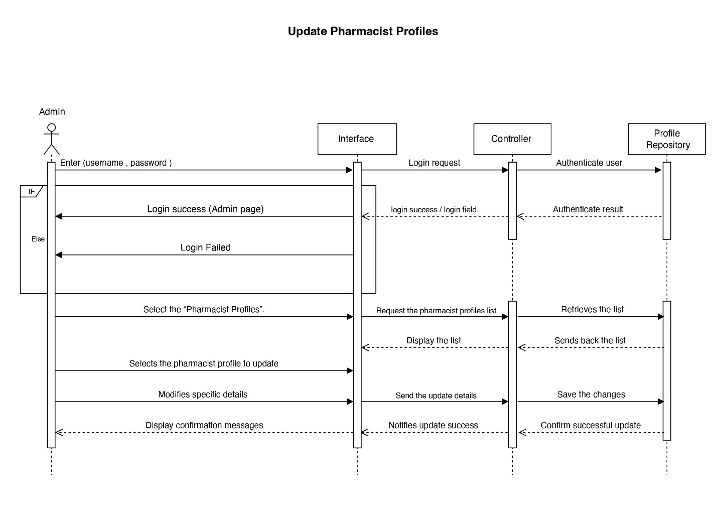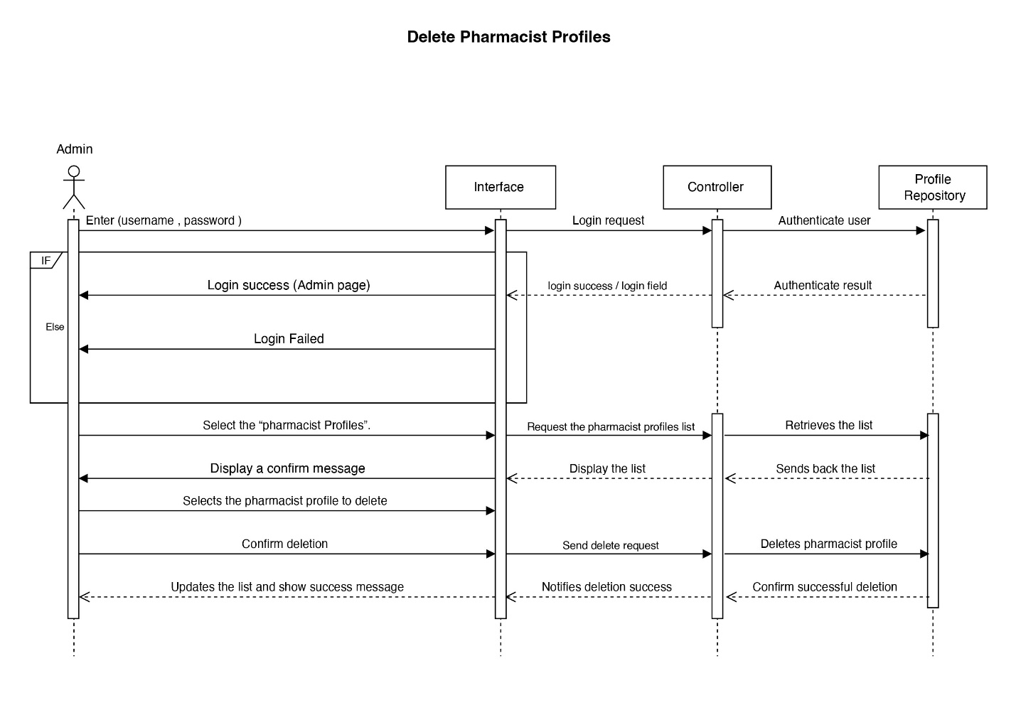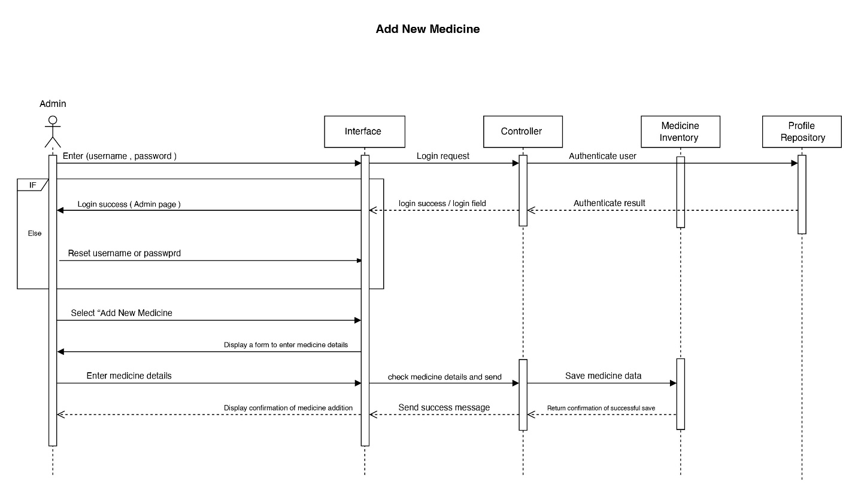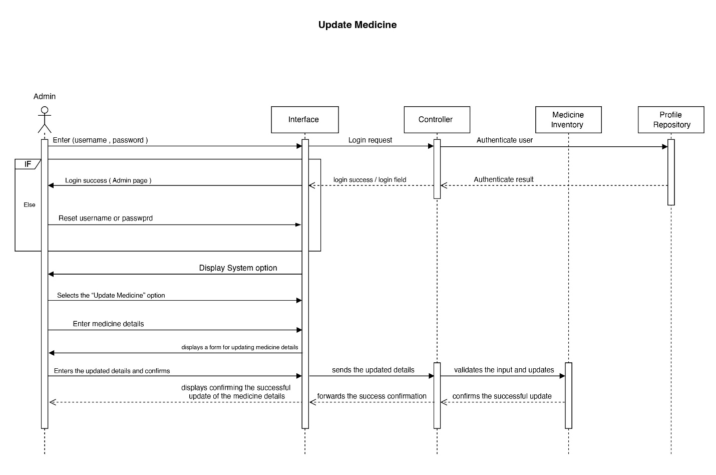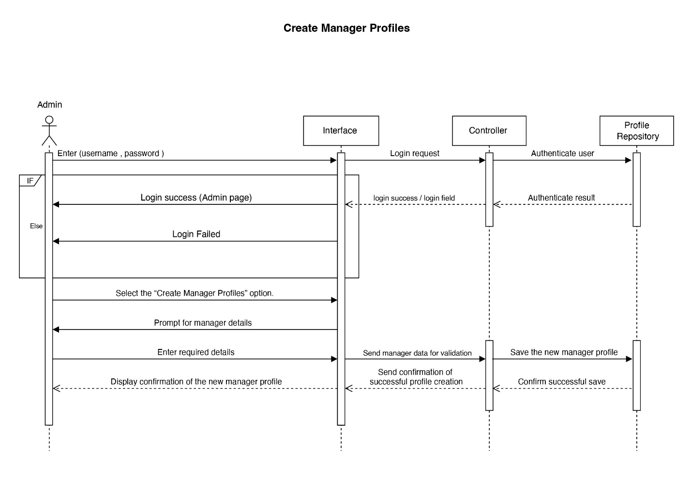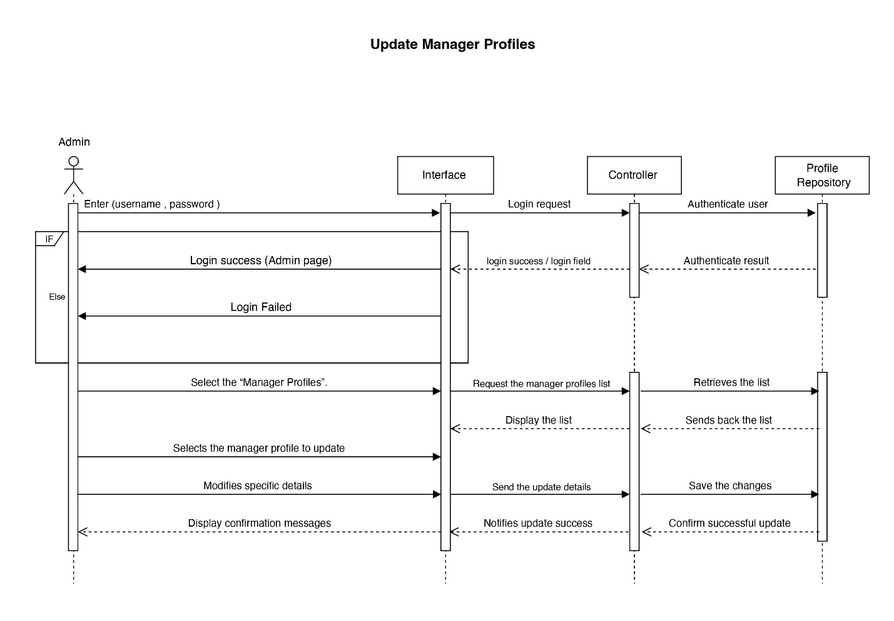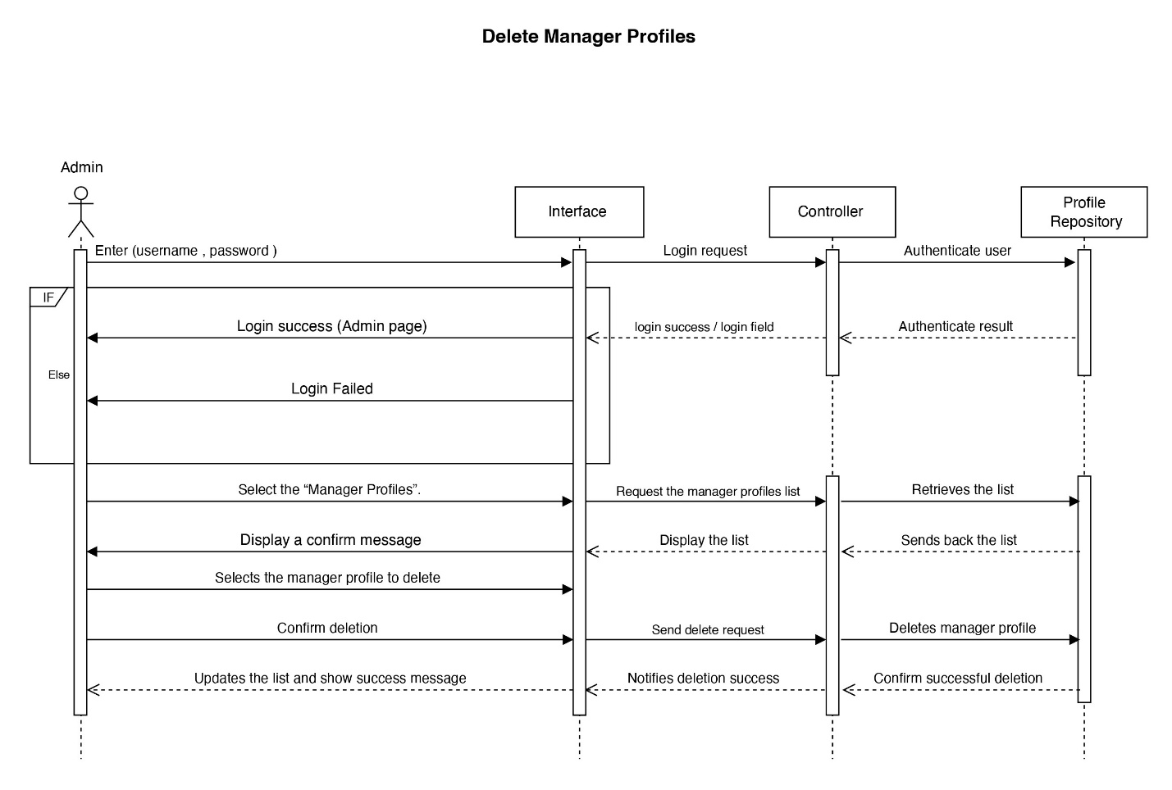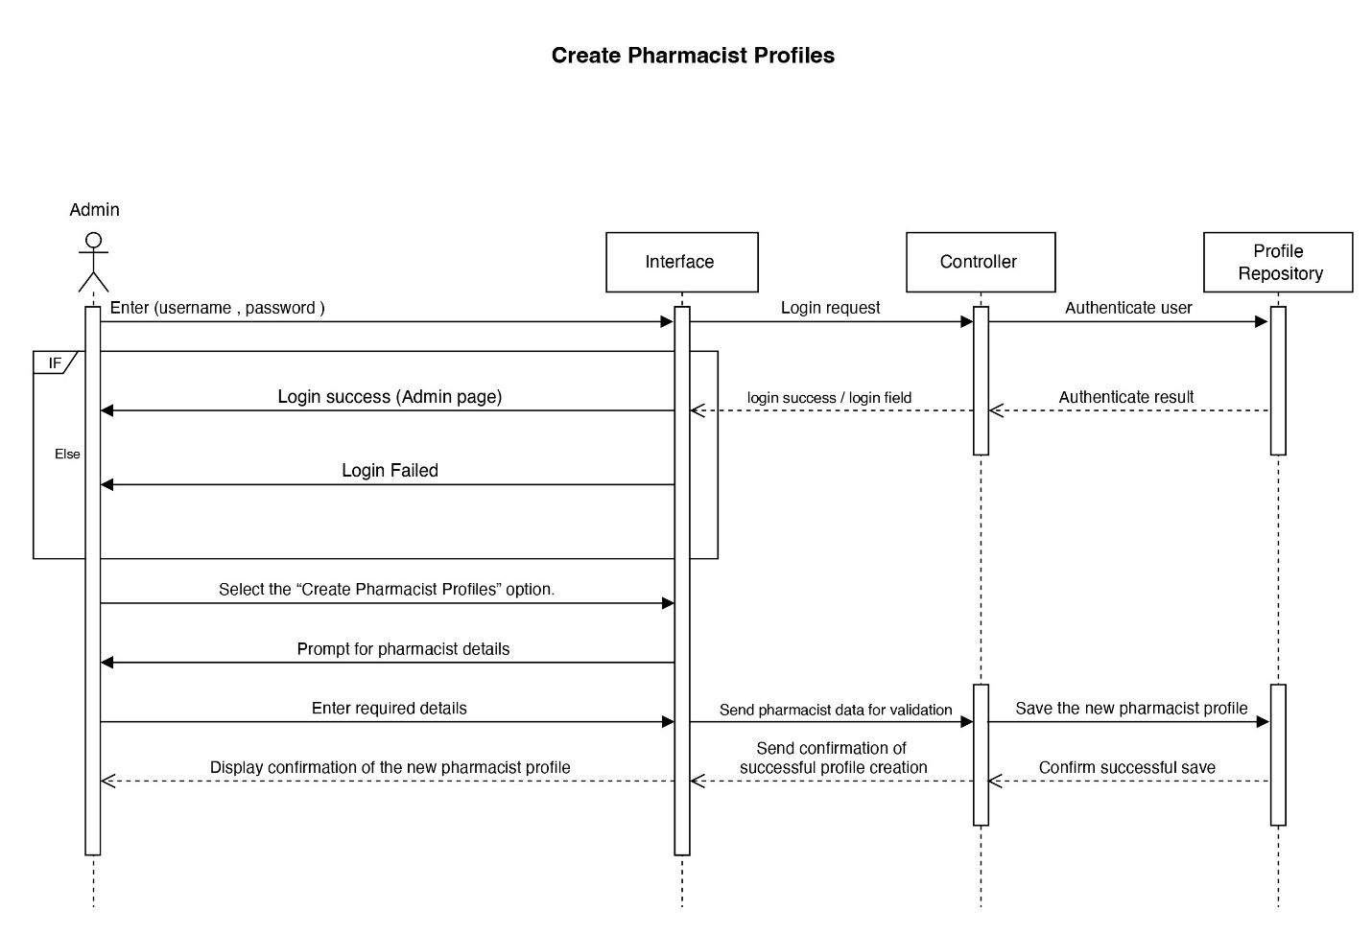

* **Activity Diagram**:
  + Steps for **ordering medicine** and **generating reports**.

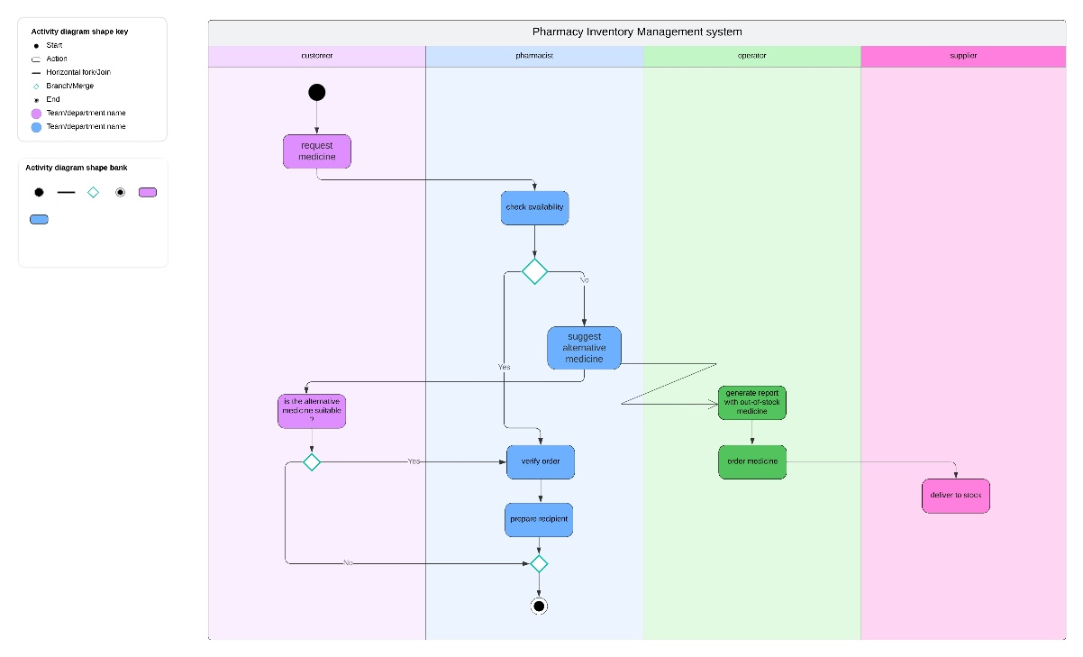

**4. UI/UX Design & Prototyping**

* **UI/UX Guidelines**:
  + **Minimalist design** with easy navigation.
  + **Color scheme** based on a medical/pharmacy theme.
  + **Typography** for easy readability.

