Computer Architectures – Milestone3 2016

Update your MIPS CPU design implemented in milestone 2 so that it can support additional instructions. These additional instructions are I-type instructions: lw, sw, beq, bne and J-type instruction: j. You may refer to lab08.

Required Instructions:

 | Instruction |  |  | Format |  |  | op |  |  | funct
 | add |  |  | R |  | 0 |  |  | 32
 | and |  |  | R |  | 0 |  |  | 36
 | sub |  |  | R |  | 0 |  |  | 34
 | nor |  |  | R |  | 0 |  |  | 39
 | Or |  |  | R |  | 0 |  |  | 37
 | Slt |  |  | R |  | 0 |  |  | 42
 | Lw |  |  | I |  | 35
 | Sw |  |  | I |  | 43
 | Beq |  |  | I |  | 4
 | Bne |  |  | I |  | 5
 | J |  |  | J |  | 2

- Your Implemented module should be named as "MainModule".

- Entity should look as follows:

START: IN STD_LOGIC;

CLK: IN STD_LOGIC;

RegFileOut1: OUT STD_LOGIC_VECTOR(31 downto 0);

RegFileOut2: OUT STD_LOGIC_VECTOR(31 downto 0);

ALUOut: OUT STD_LOGIC_VECTOR(31 downto 0);

PCOut: OUT STD_LOGIC_VECTOR(31 downto 0);

DataMemOut: OUT STD_LOGIC_VECTOR(31 downto 0);

1

Computer Architectures – Milestone3 2016

- Required design for MainModule:
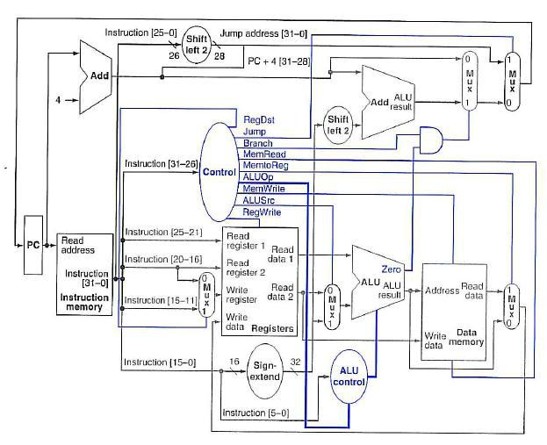

- CU should match the RTL design:
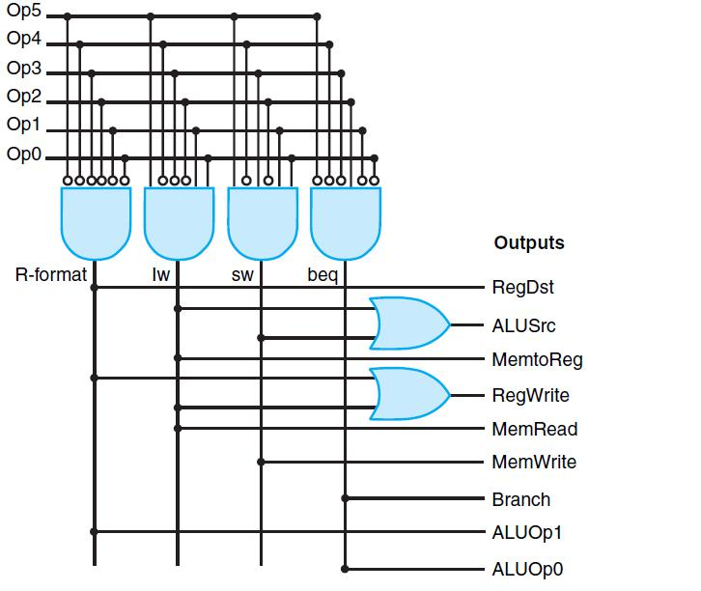

2

Computer Architectures – Milestone3 2016

- ALUControl should match the RTL design:
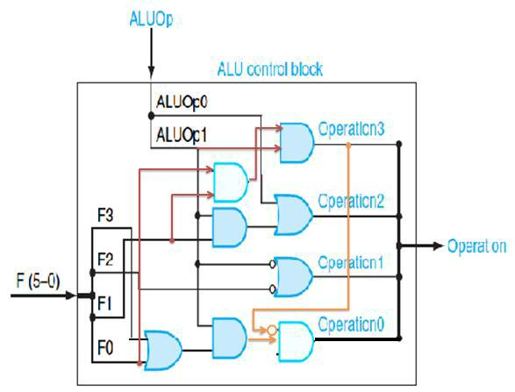

Given Modules:

- Data Memory

- Instruction Memory

- Generic Register (Rising Edge)

Important Notes:

- Complete missing instructions in CU.

- Add the implementation of the instruction bne to your design (you have to do two modifications, the 1st in MainModule and the 2nd in CU).

- Change back the register $1 to be initialized by 0 as other registers.

- All registers should work on Rising Edge.

- Test before submit (attached test case).

Test Case:

- Assembly program that calculate the first twelve Fibonacci numbers and store them in array at the beginning of the Data Memory.

- After the program finishes, you should see the following sequence in $s0:

1, 1, 2, 3, 5, 8, 13, 21, 34, 55, 89, 144, 0, -1

- Machine code is already loaded in the Mem’s.

3

Computer Architectures – Milestone3 2016

Delivery method:

- A dropbox folder named "Group#" is already shared with each team.

- Inside the shared folder, create new folder called "Milestone3".

- Milestone3 folder should include one zip file that includes the main modules and its dependencies (package, InstMem, mux, decoder, and so on …)

- The file is named "MainModule.zip"

Deadline: Thursday , 05 May, 2016 23:59.

Good luck☺

4

