

**Faculty of engineering - Shoubra**

**Benha University**

**Research Article / Research Project / Literature Review**

in fulfillment of the requirements of

|  |  |  |
| --- | --- | --- |
| **Department** | |  | | --- | | **Engineering Mathematics** |   **And physics** |
| **Division** | **----------------** |
| **Academic Year** | **2019-2020 preparatory** |
| **Course name** | **computer** |
| **Course code** | **ECE001** |

**Title: -**

**Operating systems**

By:

|  |  |  |  |
| --- | --- | --- | --- |
|  | Name | Edu mail | B.N |
| 1 | عبدالله عماد الدين بيومى علي شحاته | Abdallah1955520@feng.bu.edu.eg | 494 |

**Approved by:**

|  |  |
| --- | --- |
| Examiners committee | Signature |
| Dr.Ahmed Bayoumi |  |
| Dr.Shady Elmashad |  |
| Dr.Abdelhamid Attaby |  |
|  |  |

**Research objectives**

Because operating systems have become very important in our lives..and a basis for the advancement of the nation and one of its advantages is that:

* Allows you to hide details of hardware by creating an abstraction
* Easy to use with a GUI
* Offers an environment in which a user may execute programs/applications
* The operating system must make sure that the computer system convenient to use
* Operating System acts as an intermediary among applications and the hardware components
* It provides the computer system resources with easy to use format
* Acts as an intermediator between all hardware's and software's of the system

**Introduction**

An **operating system** (**OS**) is [system software](https://en.wikipedia.org/wiki/System_software) that manages [computer hardware](https://en.wikipedia.org/wiki/Computer_hardware), [software](https://en.wikipedia.org/wiki/Computer_software) resources, and provides common [services](https://en.wikipedia.org/wiki/Daemon_(computing)) for [computer programs](https://en.wikipedia.org/wiki/Computer_program).

[Time-sharing](https://en.wikipedia.org/wiki/Time-sharing) operating systems [schedule tasks](https://en.wikipedia.org/wiki/Scheduler_(computing)) for efficient use of the system and may also include accounting software for cost allocation of [processor time](https://en.wikipedia.org/wiki/Scheduling_(computing)), [mass storage](https://en.wikipedia.org/wiki/Mass_storage), printing, and other resources.

For hardware functions such as [input and output](https://en.wikipedia.org/wiki/Input_and_output) and [memory allocation](https://en.wikipedia.org/wiki/Memory_allocation), the operating system acts as an intermediary between programs and the computer hardware,[[1]](https://en.wikipedia.org/wiki/Operating_system#cite_note-1)[[2]](https://en.wikipedia.org/wiki/Operating_system#cite_note-2) although the application code is usually executed directly by the hardware and frequently makes [system calls](https://en.wikipedia.org/wiki/System_call) to an OS function or is [interrupted](https://en.wikipedia.org/wiki/Interrupt) by it. Operating systems are found on many devices that contain a computer – from cellular phones and video game consoles to [web servers](https://en.wikipedia.org/wiki/Web_server) and [supercomputers](https://en.wikipedia.org/wiki/Supercomputer).

The dominant desktop operating system is [Microsoft Windows](https://en.wikipedia.org/wiki/Microsoft_Windows) with a market share of around 82.74%. [macOS](https://en.wikipedia.org/wiki/MacOS) by [Apple Inc.](https://en.wikipedia.org/wiki/Apple_Inc.) is in second place (13.23%), and the varieties of [Linux](https://en.wikipedia.org/wiki/Linux) are collectively in third place (1.57%).[[3]](https://en.wikipedia.org/wiki/Operating_system#cite_note-3) In the [mobile](https://en.wikipedia.org/wiki/Mobile_operating_system) sector (including smartphones and [tablets](https://en.wikipedia.org/wiki/Tablet_computer)), [Android's](https://en.wikipedia.org/wiki/Android_(operating_system)) share is up to 70% in the year 2017.[[4]](https://en.wikipedia.org/wiki/Operating_system#cite_note-4) According to third quarter 2016 data, Android's share on smartphones is dominant with 87.5 percent with also a growth rate of 10.3 percent per year, followed by Apple's [iOS](https://en.wikipedia.org/wiki/IOS) with 12.1 percent with per year decrease in market share of 5.2 percent, while other operating systems amount to just 0.3 percent.[[5]](https://en.wikipedia.org/wiki/Operating_system#cite_note-5) [Linux distributions](https://en.wikipedia.org/wiki/Linux_distribution) are dominant in the server and supercomputing sectors. Other specialized classes of operating systems, such as [embedded](https://en.wikipedia.org/wiki/Embedded_system) and real-time systems, exist for many applications.

**Screenshots:**

**Mainpage**

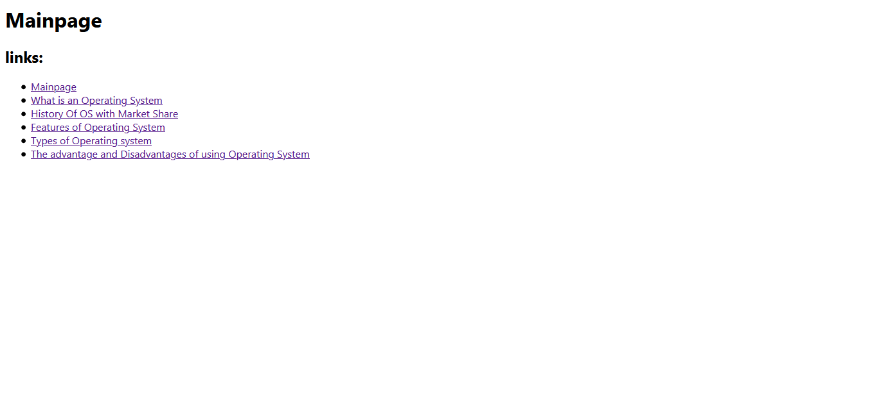

**Source code:**

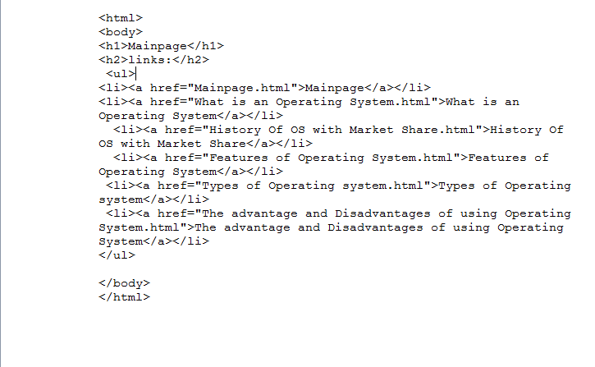

**What is an Operating System:**

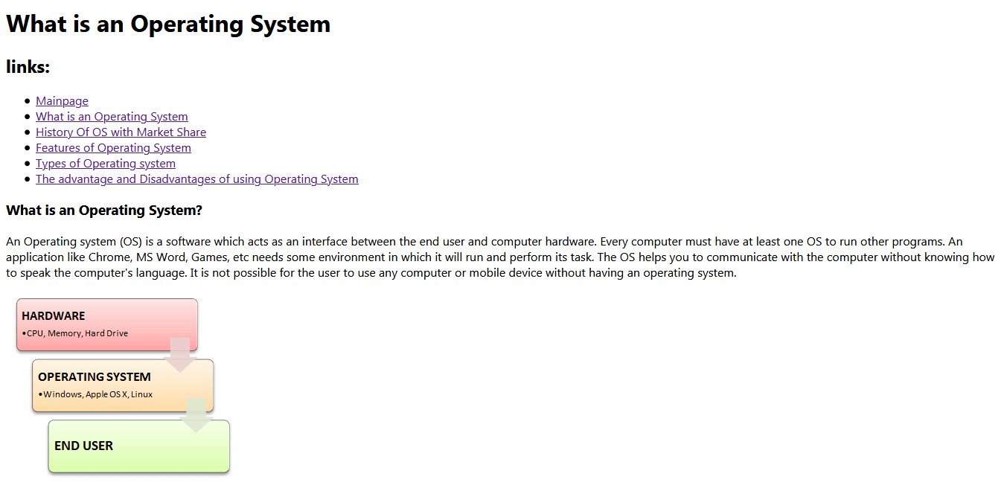

**Source code:**

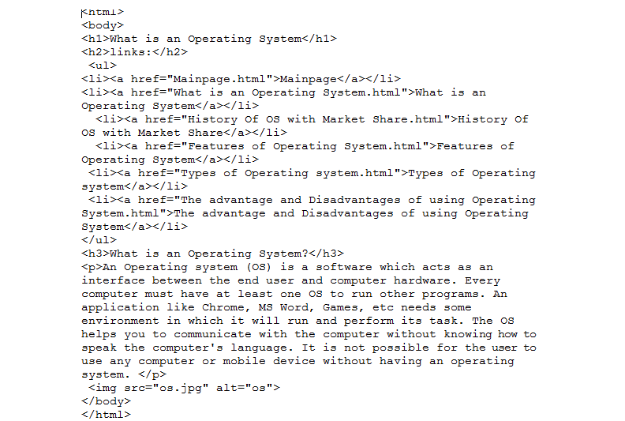

**History of os with Market Share:**

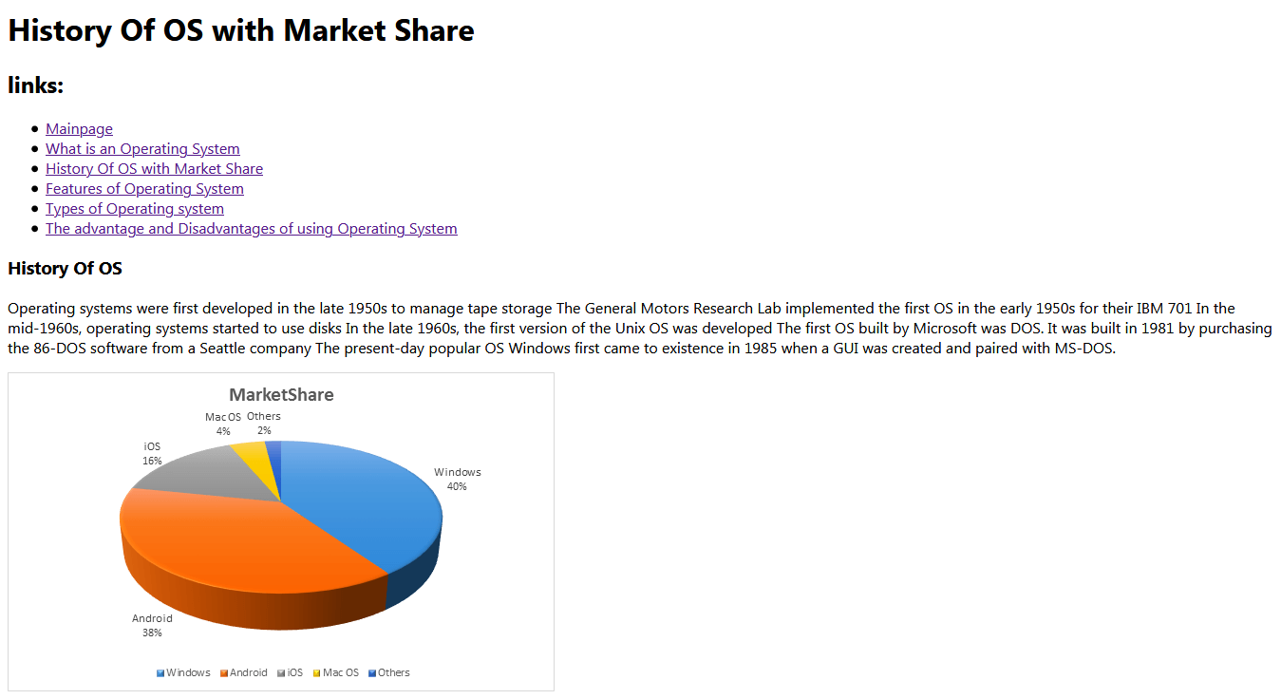

**Source code:**

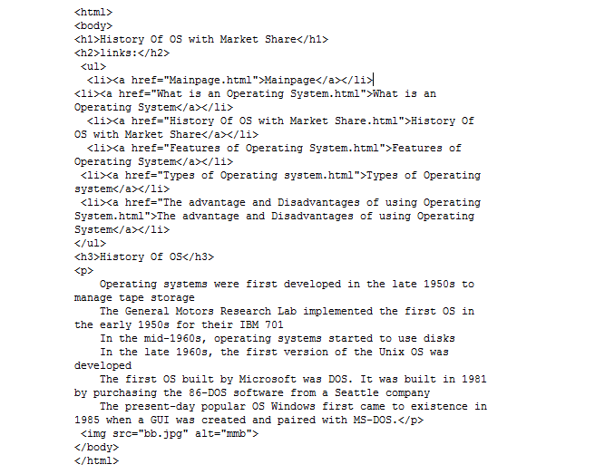

**Features of Operating System:**

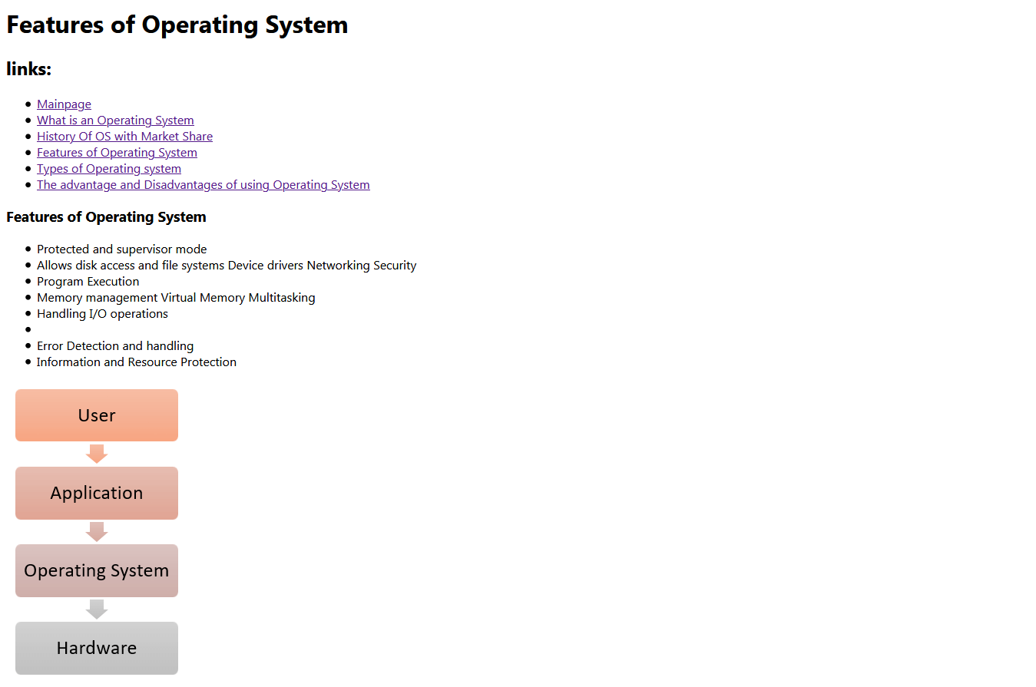

**Source code:**

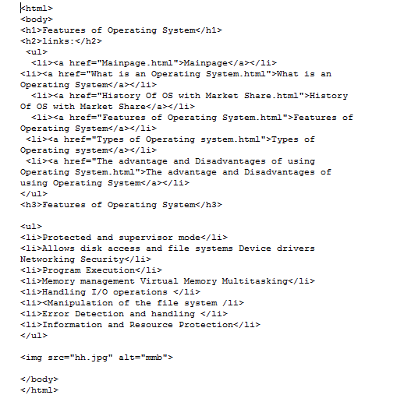

**Types of Operating system:**

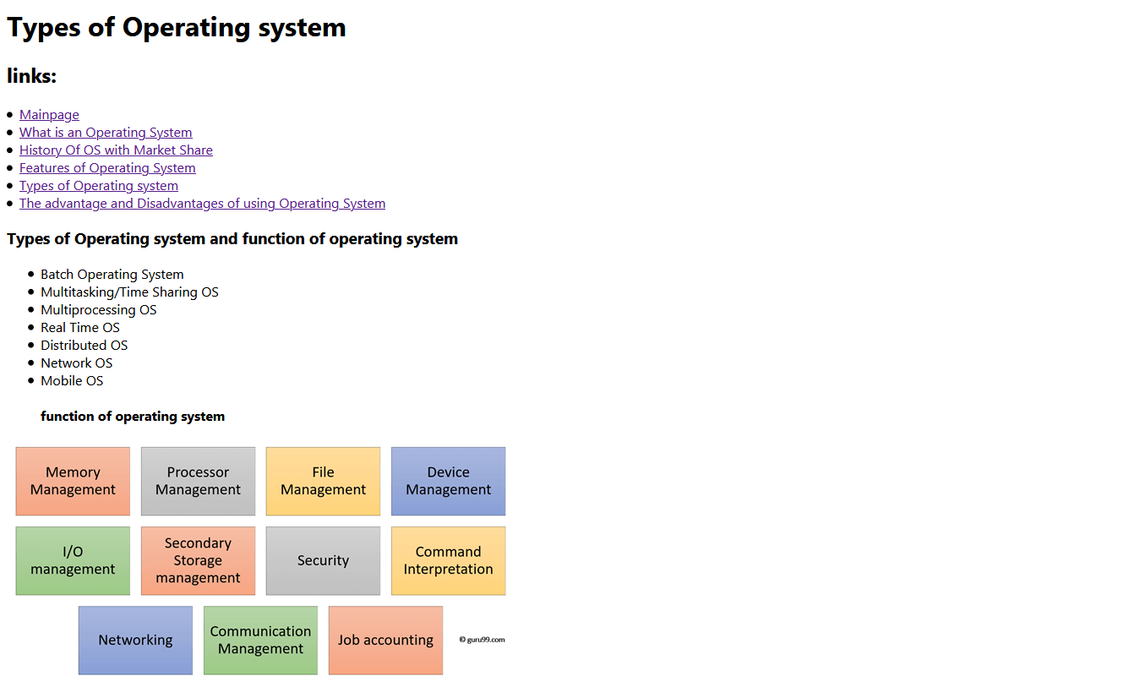

**Source code:**

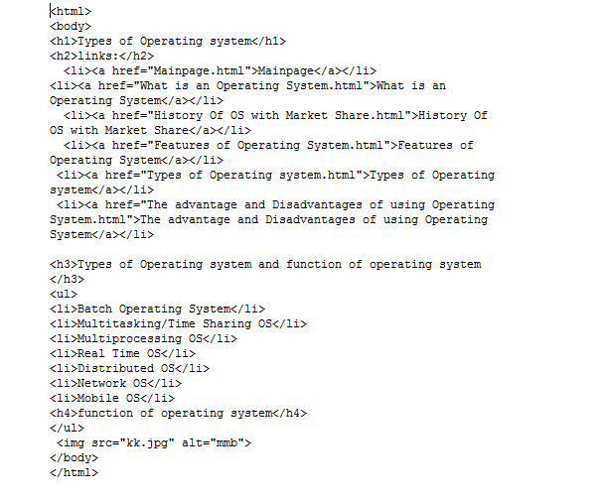

**The advantage and Disadvantages of using Operating System:**

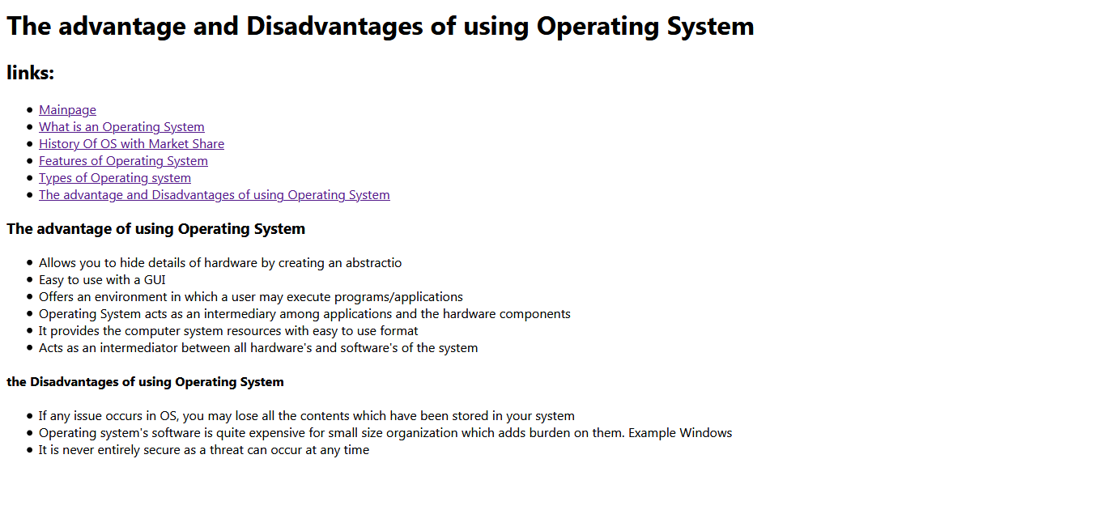

**Source code:**

