Cairo University  
Faculty of Computers and Artificial Intelligent

**CS251**

**Software Engineering I**

Parking Garage application

Software Design

June 2022

Contents

Team 3

Document Purpose and Audience 3

System Models 4

I. Class diagrams 4

II. Sequence diagrams 6

Class - Sequence Usage Table 10

Ownership Report 11

# Team

|  |  |  |  |
| --- | --- | --- | --- |
| **ID** | **Name** | **Email** | **Mobile** |
| 20200323 | Abdallah Emad Abdelhamed | abdallahelal102@gmail.com | 01098486290 |
| 20200381 | Farida Said Abdellatif | faridasaid830@gmail.com | 01127871312 |
| 20200184 | Rawda Atef Muhammad | rawdaattef@gmail.com | 01113318556 |
| 20200544 | Mostafa Muhammad Ali | mostafa.fcai@gmail.com | 01142627589 |

# Document Purpose and Audience

This document gives a perception about how a Parking Garage application works, which helps to manage parking areas to achieve the best benefit from it as a customer and an admin.

As this document shows how the system works by viewing the expected functionalities and the flow of the expected process.

So the expected audience for this document is the project manager and the developers to take an overall view about the system and how it works.

# System Models

## I. Class diagrams

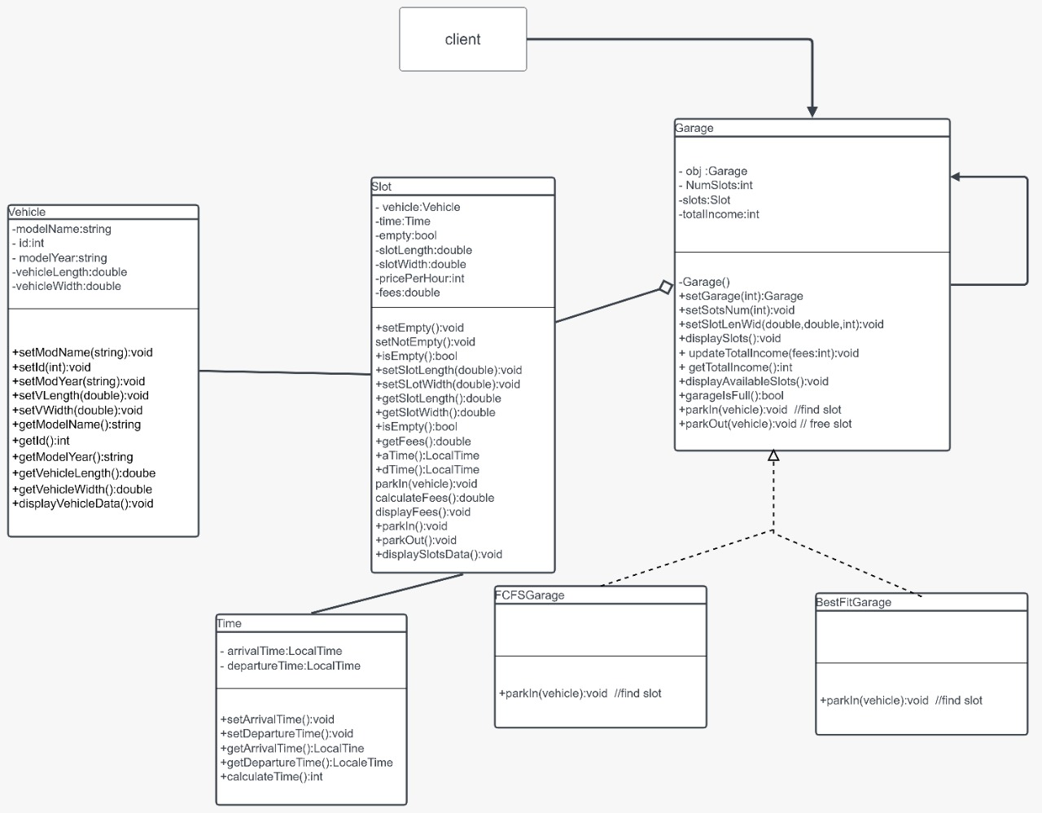

| **Class Name** | **Description & Responsibility** |
| --- | --- |
| Vehicle | Contains the vehicle’s information |
| Slot | Contains each parking space (slot)’s information |
| Garage | Contains the garage’s information and the functionality to calculate the total income |
| Time | Contains the arrival time and the departure time of every vehicle and the functionality to calculate the time-of-stay |
| FCFSGarage | A class that extends from class Garage and contains the function parkIn with (first come first served) behavior. |
| BestFitGarage | A class that extends from class Garage and contains the function parkIn with (searching for the best fit slot) behavior. |

## 

## II. Sequence diagrams

**Define new vehicle (UC-2)**

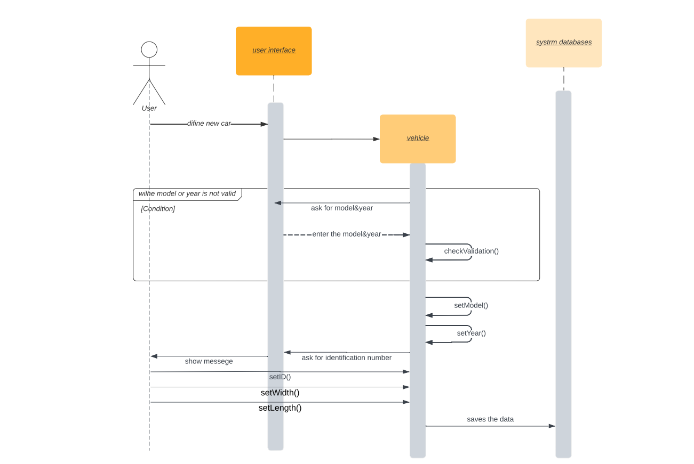

**Park in (UC-3)**

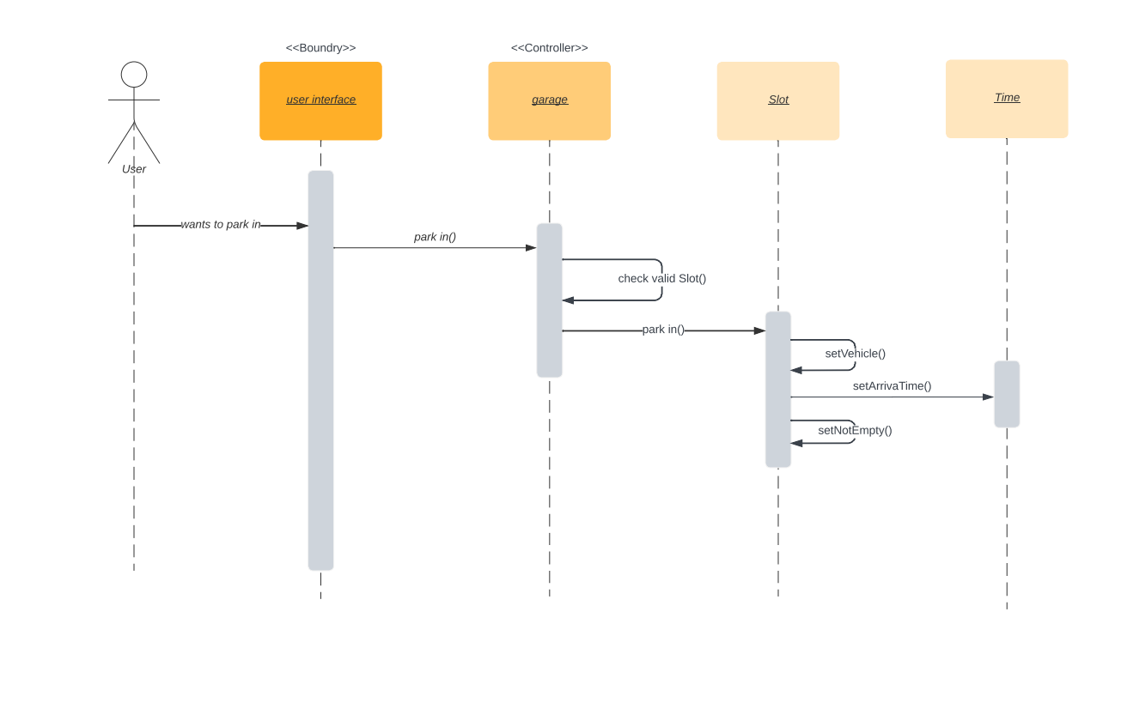

**Park out (UC-4)**

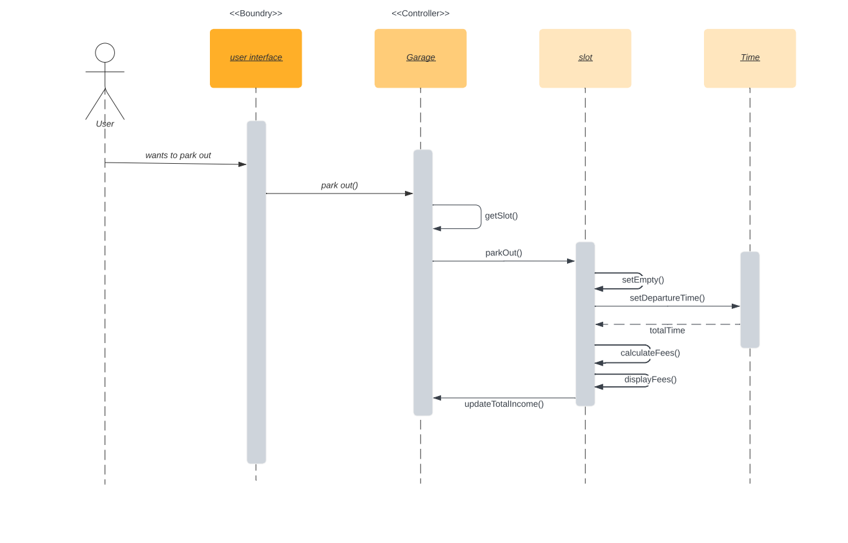

**Define Garage (UC-6)**

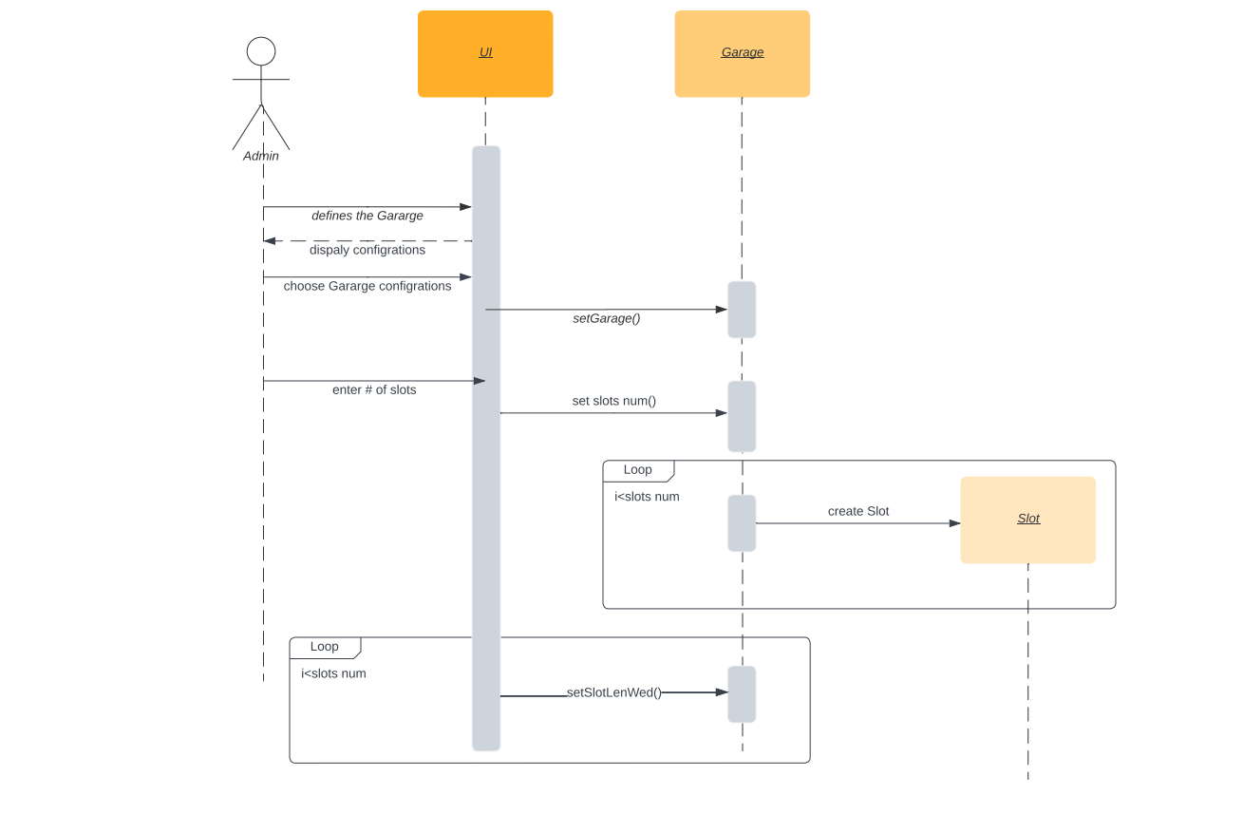

### 

### Class - Sequence Usage Table

| * **Class Name** | **Sequence Diagrams** | **Overall used methods** |
| --- | --- | --- |
| Vehicle | UC2 | setModName,setModeYear,setVLength,setVWidth |
| Slot | UC3,UC4,UC6 | parkIn,setNotEmpty,parkOut,setEmpty,calculateFees,displayFees |
| Garage | UC3,UC4,UC6 | parkIn,oarkOut,updateTotalIncome,setGarage,setSlotsNum |
| Time | UC3,UC4 | setArrivalTime,setDepartureTime |

# Ownership Report

|  |  |
| --- | --- |
| **Item** | **Owners** |
| Source code | *Farida,Abdallah,Mostafa,Rawda* |
| Requirements | *Farida,Abdallah,Mostafa,Rawda* |
| Use Case Model | *Farida,Abdallah,Mostafa,Rawda* |
| Use Case Tables | *Farida,Abdallah,Mostafa,Rawda* |
| Class Diagram | *Farida,Abdallah,Mostafa,Rawda* |
| Sequence Diagrams | *Farida,Abdallah,Mostafa,Rawda* |