|  |  |
| --- | --- |
| **Name** | عبدالله محمد عبدالله خليل خشب |
| **B.N** | 499 |
| **Date** | 29-5-2020 |
| **Topic** | Artificial Intelligence |
| **Github link** |  |
| **Github page** |  |

"Application brief "

Artificial Intelligence is a machine, robot, or product method for thinking about how smart human thinking is. And the research eventually develops intelligent software systems. AI aims to enhance computer functions related to human knowledge, such as reasoning, learning, and problem-solving.[1]

"**Screenshots**"

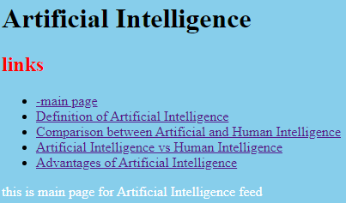

**Index**

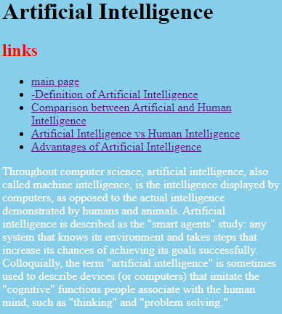

**P1**

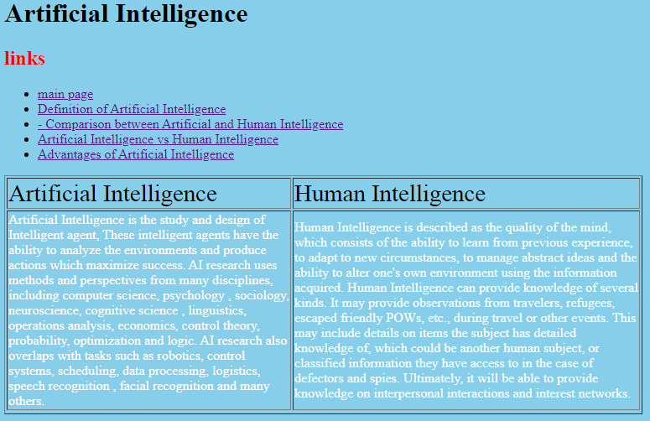

**P2**

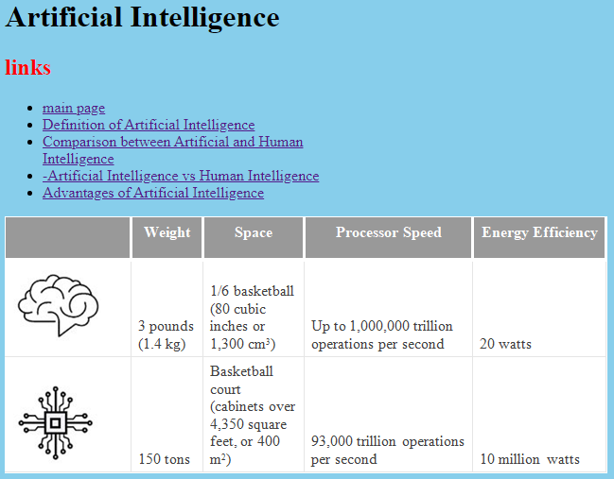

**P3**

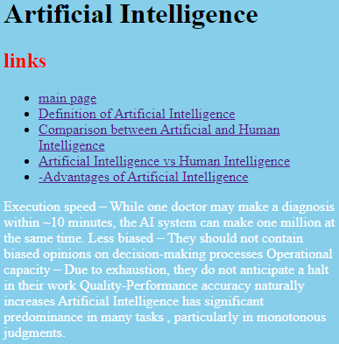

**P4**

**"Source Code"**

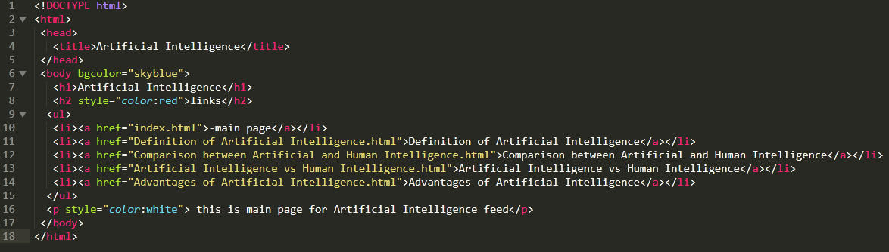

**Code of index**

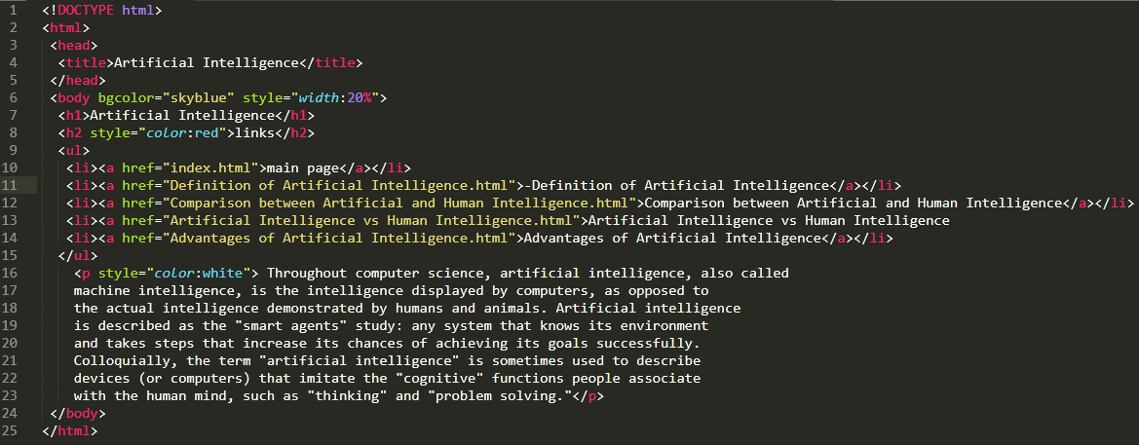

**Code of p1**

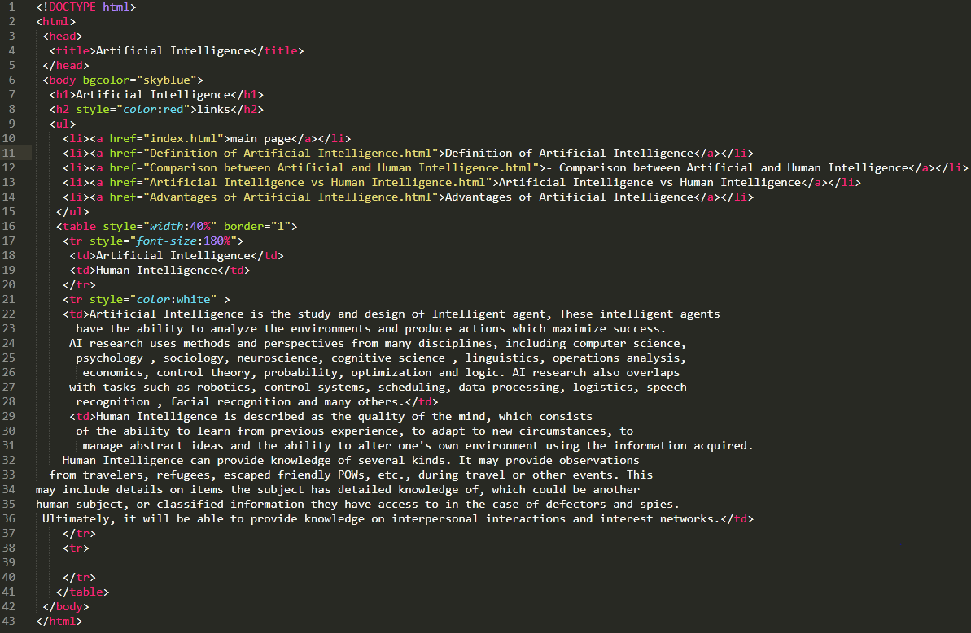

**Code of p2**

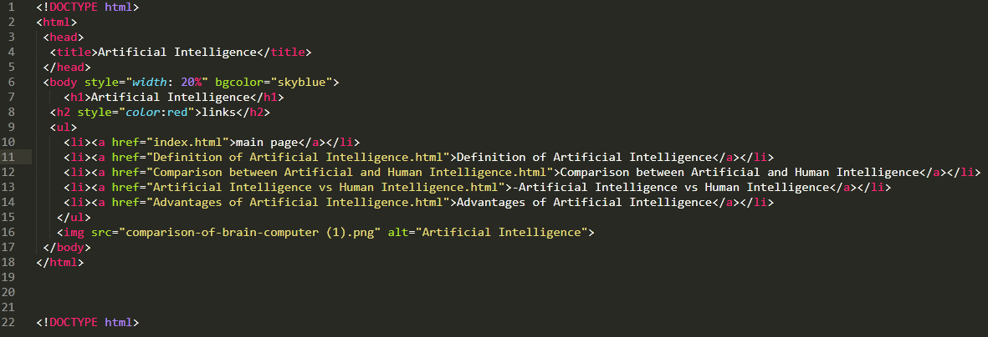

**Code of p3**

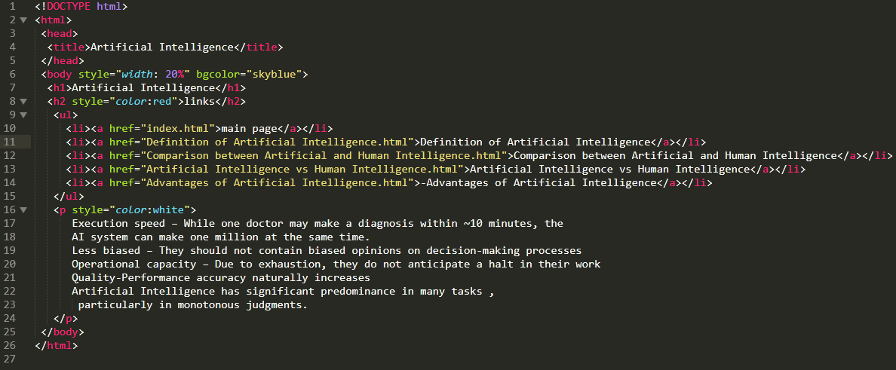

**Code of p4**

"References"

1. <https://dictionary.cambridge.org/us/dictionary/english/artificial-intelligence>