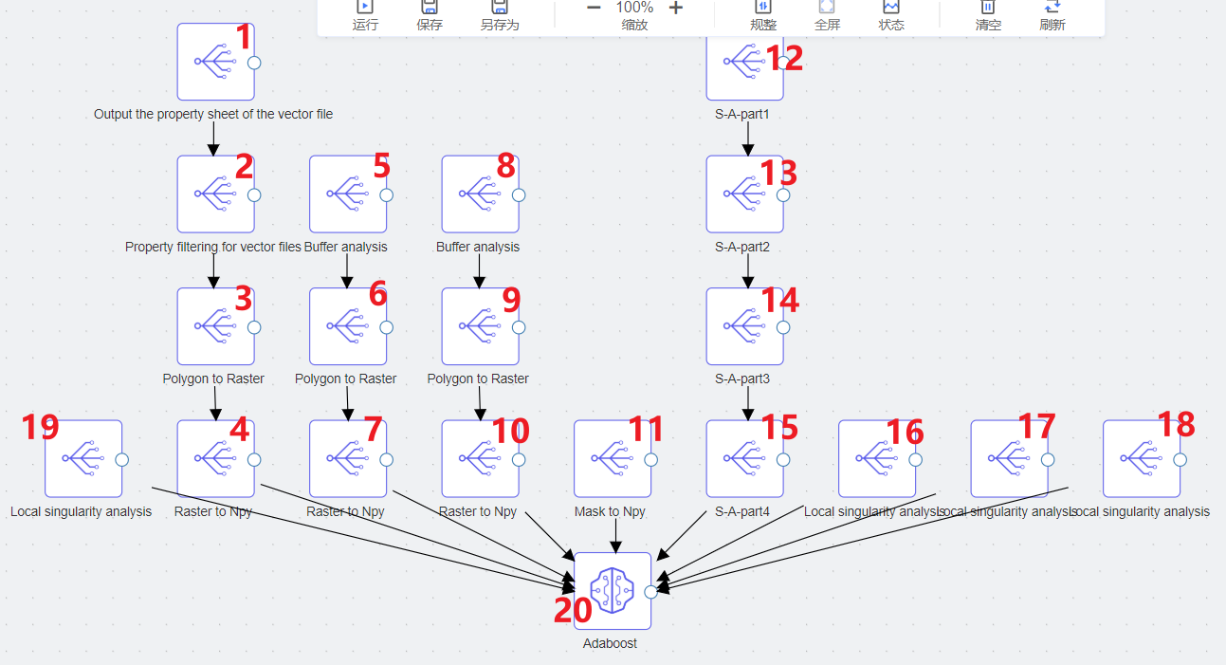

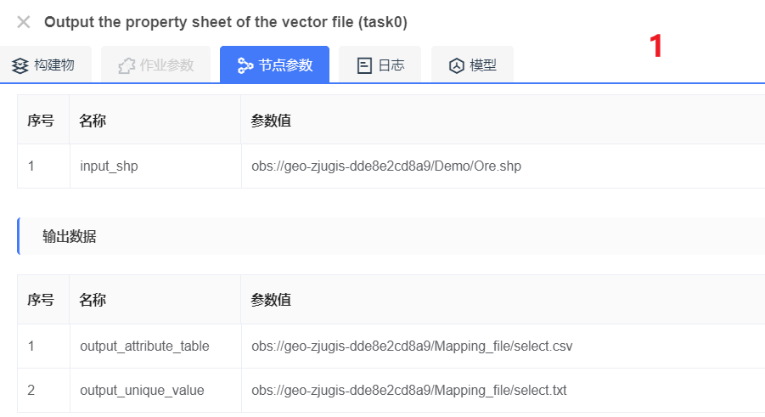

**输入数据**

| **序号** | | **名称** | **参数值** |
| --- | --- | --- | --- |
| 1 | input_shp | obs://geo-zjugis-dde8e2cd8a9/Demo/Ore.shp | |

**输出数据**

| **序号** | **名称** | **参数值** |
| --- | --- | --- |
| 1 | output_attribute_table | obs://geo-zjugis-dde8e2cd8a9/Mapping_file/select.csv |
| 2 | output_unique_value | obs://geo-zjugis-dde8e2cd8a9/Mapping_file/select.txt |

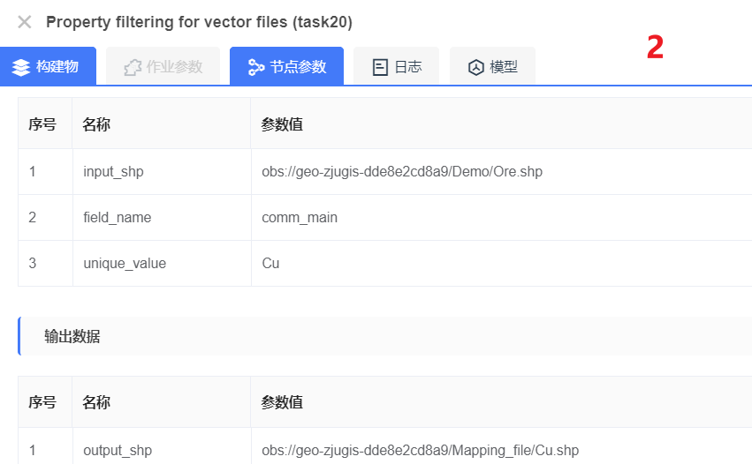

**输入数据**

| **序号** | | **名称** | **参数值** |
| --- | --- | --- | --- |
| 1 | input_shp | obs://geo-zjugis-dde8e2cd8a9/Demo/Ore.shp | |
| 2 | field_name | comm_main | |
| 3 | unique_value | Cu | |

**输出数据**

| **序号** | | **名称** | **参数值** |
| --- | --- | --- | --- |
| 1 | output_shp | obs://geo-zjugis-dde8e2cd8a9/Mapping_file/Cu.shp | |

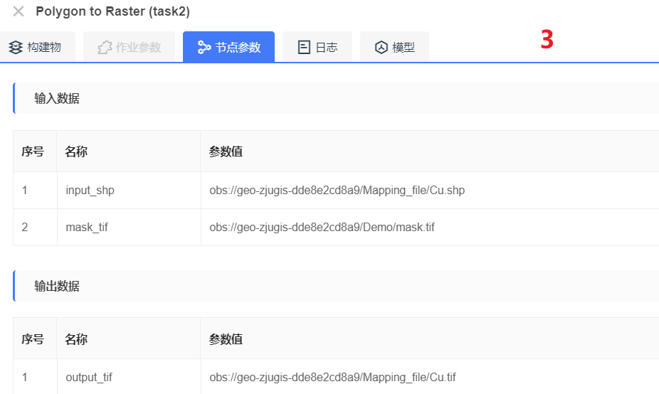

**输入数据**

| **序号** | | **名称** | **参数值** |
| --- | --- | --- | --- |
| 1 | input_shp | obs://geo-zjugis-dde8e2cd8a9/Mapping_file/Cu.shp | |
| 2 | mask_tif | obs://geo-zjugis-dde8e2cd8a9/Demo/mask.tif | |

**输出数据**

| **序号** | | **名称** | **参数值** |
| --- | --- | --- | --- |
| 1 | output_tif | obs://geo-zjugis-dde8e2cd8a9/Mapping_file/Cu.tif | |

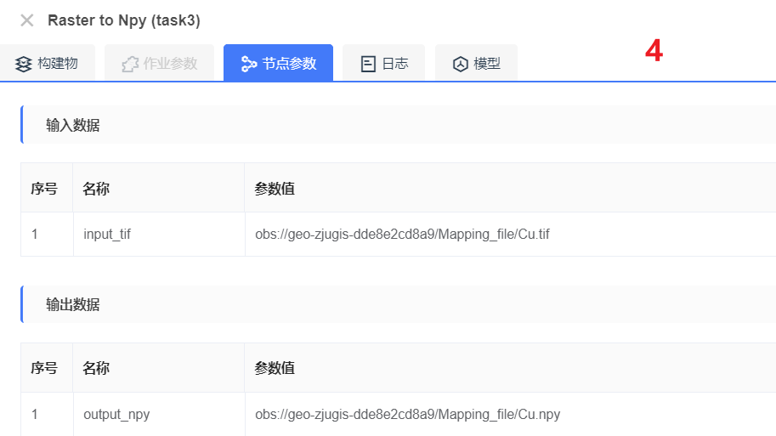

**输入数据**

| **序号** | | **名称** | **参数值** |
| --- | --- | --- | --- |
| 1 | input_tif | obs://geo-zjugis-dde8e2cd8a9/Mapping_file/Cu.tif | |

**输出数据**

| **序号** | | **名称** | **参数值** |
| --- | --- | --- | --- |
| 1 | output_npy | obs://geo-zjugis-dde8e2cd8a9/Mapping_file/Cu.npy | |

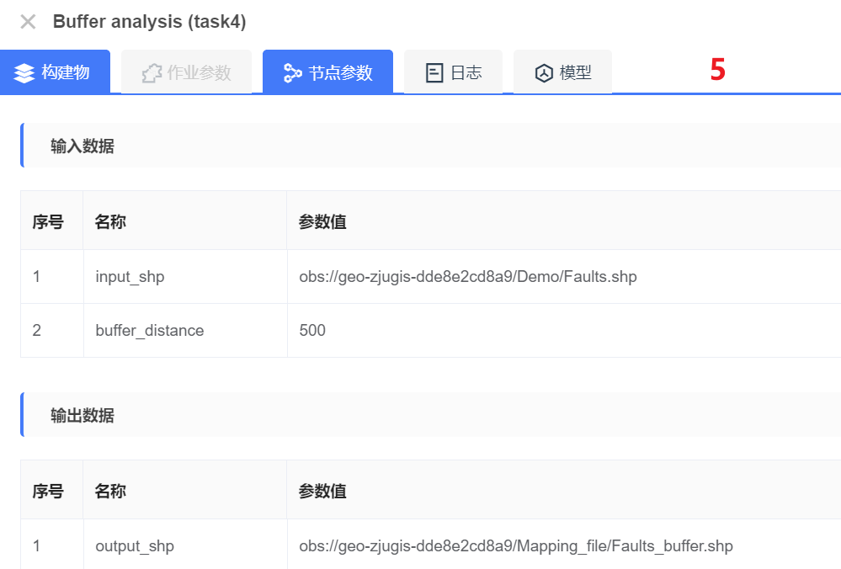

**输入数据**

| **序号** | | **名称** | **参数值** |
| --- | --- | --- | --- |
| 1 | input_shp | obs://geo-zjugis-dde8e2cd8a9/Demo/Faults.shp | |
| 2 | buffer_distance | 500 | |

**输出数据**

| **序号** | | **名称** | **参数值** |
| --- | --- | --- | --- |
| 1 | output_shp | obs://geo-zjugis-dde8e2cd8a9/Mapping_file/Faults_buffer.shp | |

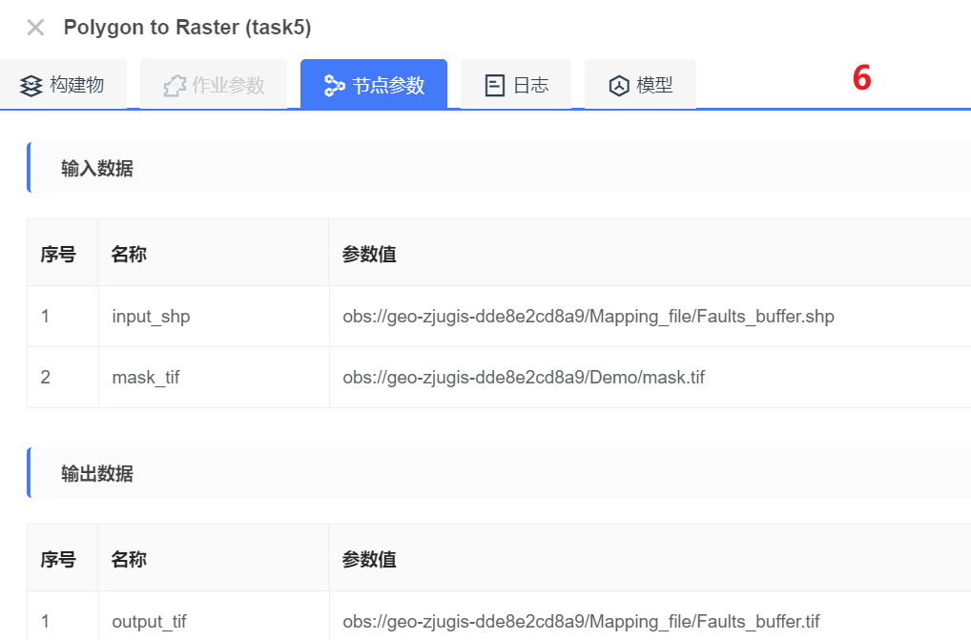

**输入数据**

| **序号** | | **名称** | **参数值** |
| --- | --- | --- | --- |
| 1 | input_shp | obs://geo-zjugis-dde8e2cd8a9/Mapping_file/Faults_buffer.shp | |
| 2 | mask_tif | obs://geo-zjugis-dde8e2cd8a9/Demo/mask.tif | |

**输出数据**

| **序号** | | **名称** | **参数值** |
| --- | --- | --- | --- |
| 1 | output_tif | obs://geo-zjugis-dde8e2cd8a9/Mapping_file/Faults_buffer.tif | |

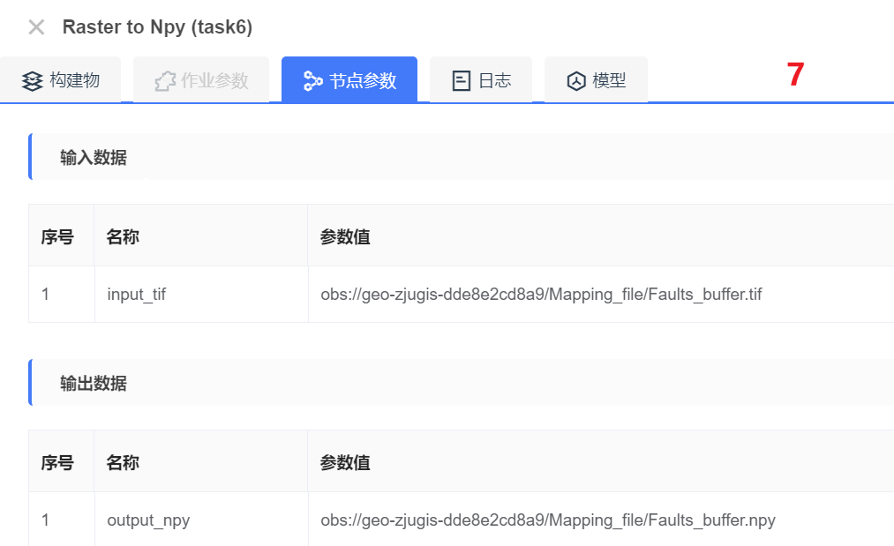

**输入数据**

| **序号** | | **名称** | **参数值** |
| --- | --- | --- | --- |
| 1 | input_tif | obs://geo-zjugis-dde8e2cd8a9/Mapping_file/Faults_buffer.tif | |

**输出数据**

| **序号** | | **名称** | **参数值** |
| --- | --- | --- | --- |
| 1 | output_npy | obs://geo-zjugis-dde8e2cd8a9/Mapping_file/Faults_buffer.npy | |

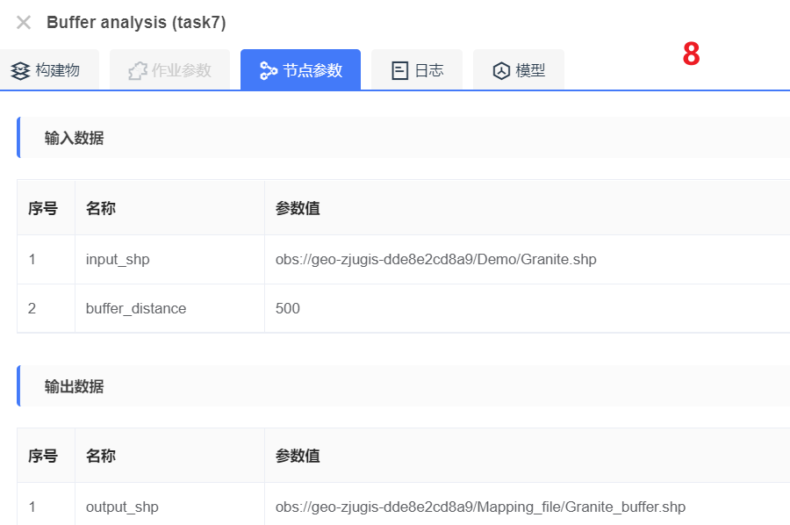

**输入数据**

| **序号** | | **名称** | **参数值** |
| --- | --- | --- | --- |
| 1 | input_shp | obs://geo-zjugis-dde8e2cd8a9/Demo/Granite.shp | |
| 2 | buffer_distance | 500 | |

**输出数据**

| **序号** | | **名称** | **参数值** |
| --- | --- | --- | --- |
| 1 | output_shp | obs://geo-zjugis-dde8e2cd8a9/Mapping_file/Granite_buffer.shp | |

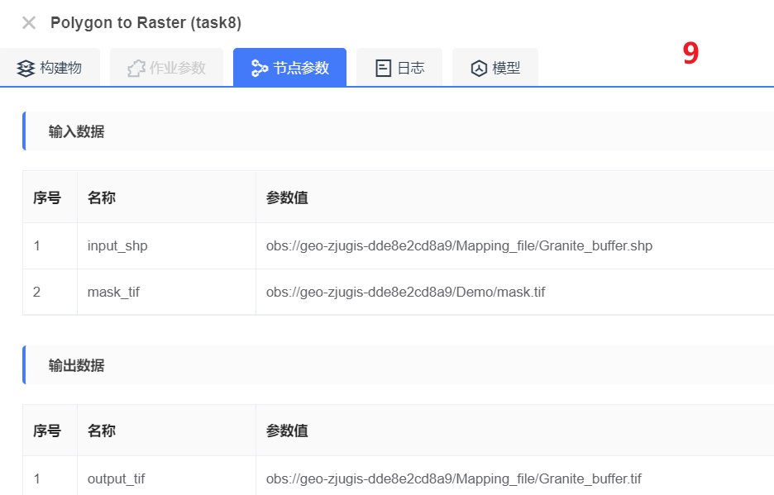

**输入数据**

| **序号** | | **名称** | **参数值** |
| --- | --- | --- | --- |
| 1 | input_shp | obs://geo-zjugis-dde8e2cd8a9/Mapping_file/Granite_buffer.shp | |
| 2 | mask_tif | obs://geo-zjugis-dde8e2cd8a9/Demo/mask.tif | |

**输出数据**

| **序号** | | **名称** | **参数值** |
| --- | --- | --- | --- |
| 1 | output_tif | obs://geo-zjugis-dde8e2cd8a9/Mapping_file/Granite_buffer.tif | |

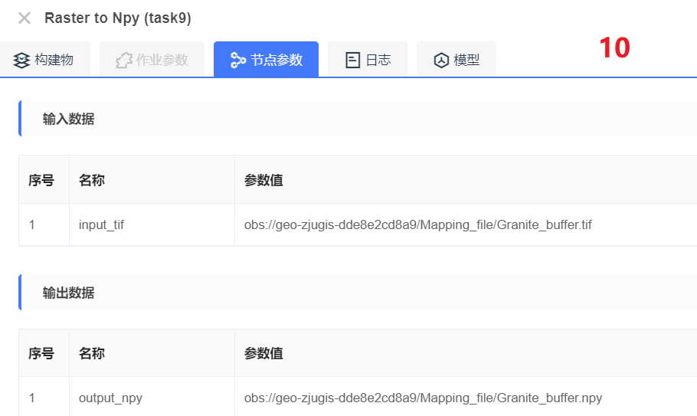

**输入数据**

| **序号** | | **名称** | **参数值** |
| --- | --- | --- | --- |
| 1 | input_tif | obs://geo-zjugis-dde8e2cd8a9/Mapping_file/Granite_buffer.tif | |

**输出数据**

| **序号** | | **名称** | **参数值** |
| --- | --- | --- | --- |
| 1 | output_npy | obs://geo-zjugis-dde8e2cd8a9/Mapping_file/Granite_buffer.npy | |

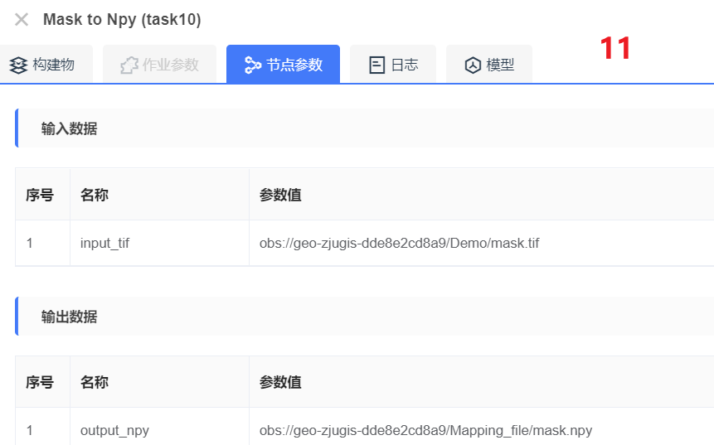

**输入数据**

| **序号** | | **名称** | **参数值** |
| --- | --- | --- | --- |
| 1 | input_tif | obs://geo-zjugis-dde8e2cd8a9/Demo/mask.tif | |

**输出数据**

| **序号** | | **名称** | **参数值** |
| --- | --- | --- | --- |
| 1 | output_npy | obs://geo-zjugis-dde8e2cd8a9/Mapping_file/mask.npy | |

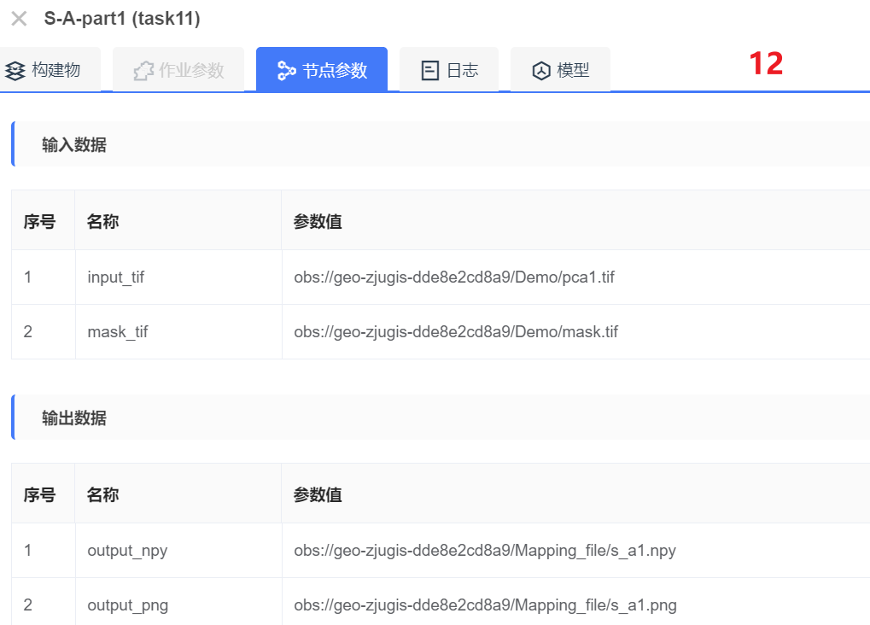

**输入数据**

| **序号** | | **名称** | **参数值** |
| --- | --- | --- | --- |
| 1 | input_tif | obs://geo-zjugis-dde8e2cd8a9/Demo/pca1.tif | |
| 2 | mask_tif | obs://geo-zjugis-dde8e2cd8a9/Demo/mask.tif | |

**输出数据**

| **序号** | | **名称** | **参数值** |
| --- | --- | --- | --- |
| 1 | output_npy | obs://geo-zjugis-dde8e2cd8a9/Mapping_file/s_a1.npy | |
| 2 | output_png | obs://geo-zjugis-dde8e2cd8a9/Mapping_file/s_a1.png | |

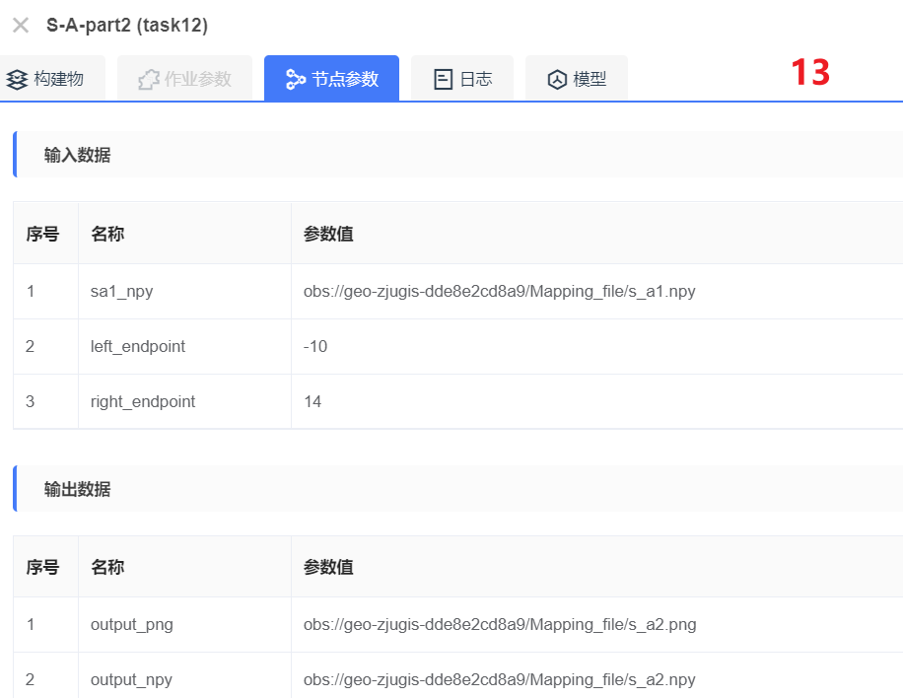

**输入数据**

| **序号** | | **名称** | **参数值** |
| --- | --- | --- | --- |
| 1 | sa1_npy | obs://geo-zjugis-dde8e2cd8a9/Mapping_file/s_a1.npy | |
| 2 | left_endpoint | -10 | |
| 3 | right_endpoint | 14 | |

**输出数据**

| **序号** | | **名称** | **参数值** |
| --- | --- | --- | --- |
| 1 | output_png | obs://geo-zjugis-dde8e2cd8a9/Mapping_file/s_a2.png | |
| 2 | output_npy | obs://geo-zjugis-dde8e2cd8a9/Mapping_file/s_a2.npy | |

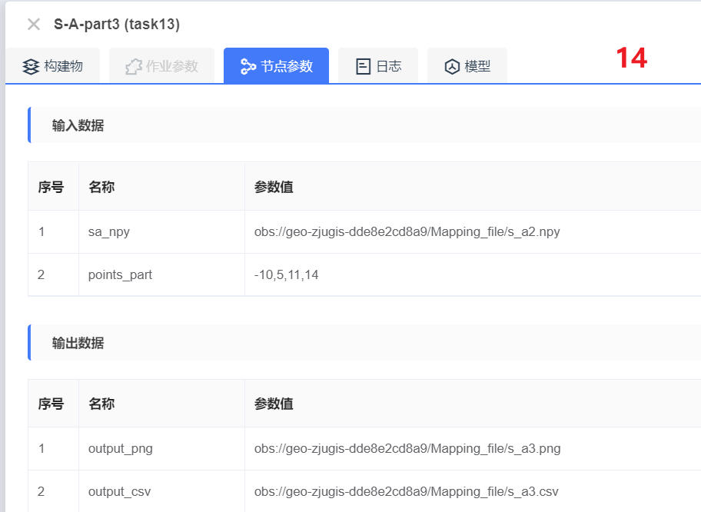

**输入数据**

| **序号** | | **名称** | **参数值** |
| --- | --- | --- | --- |
| 1 | sa_npy | obs://geo-zjugis-dde8e2cd8a9/Mapping_file/s_a2.npy | |
| 2 | points_part | -10,5,11,14 | |

**输出数据**

| **序号** | | **名称** | **参数值** |
| --- | --- | --- | --- |
| 1 | output_png | obs://geo-zjugis-dde8e2cd8a9/Mapping_file/s_a3.png | |
| 2 | output_csv | obs://geo-zjugis-dde8e2cd8a9/Mapping_file/s_a3.csv | |

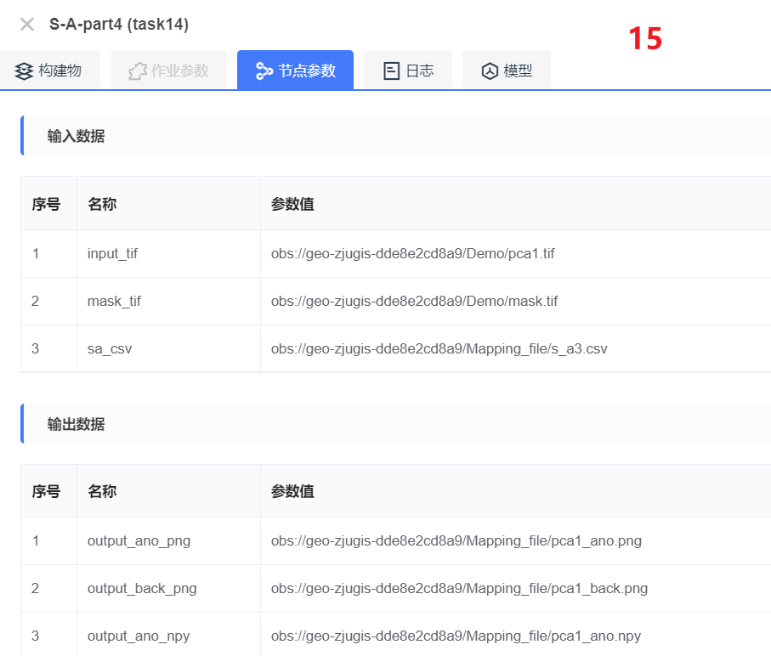

**输入数据**

| **序号** | | **名称** | **参数值** |
| --- | --- | --- | --- |
| 1 | input_tif | obs://geo-zjugis-dde8e2cd8a9/Demo/pca1.tif | |
| 2 | mask_tif | obs://geo-zjugis-dde8e2cd8a9/Demo/mask.tif | |
| 3 | sa_csv | obs://geo-zjugis-dde8e2cd8a9/Mapping_file/s_a3.csv | |

**输出数据**

| **序号** | | **名称** | **参数值** |
| --- | --- | --- | --- |
| 1 | output_ano_png | obs://geo-zjugis-dde8e2cd8a9/Mapping_file/pca1_ano.png | |
| 2 | output_back_png | obs://geo-zjugis-dde8e2cd8a9/Mapping_file/pca1_back.png | |
| 3 | output_ano_npy | obs://geo-zjugis-dde8e2cd8a9/Mapping_file/pca1_ano.npy | |
| 4 | output_back_npy | obs://geo-zjugis-dde8e2cd8a9/Mapping_file/pca1_back.npy | |

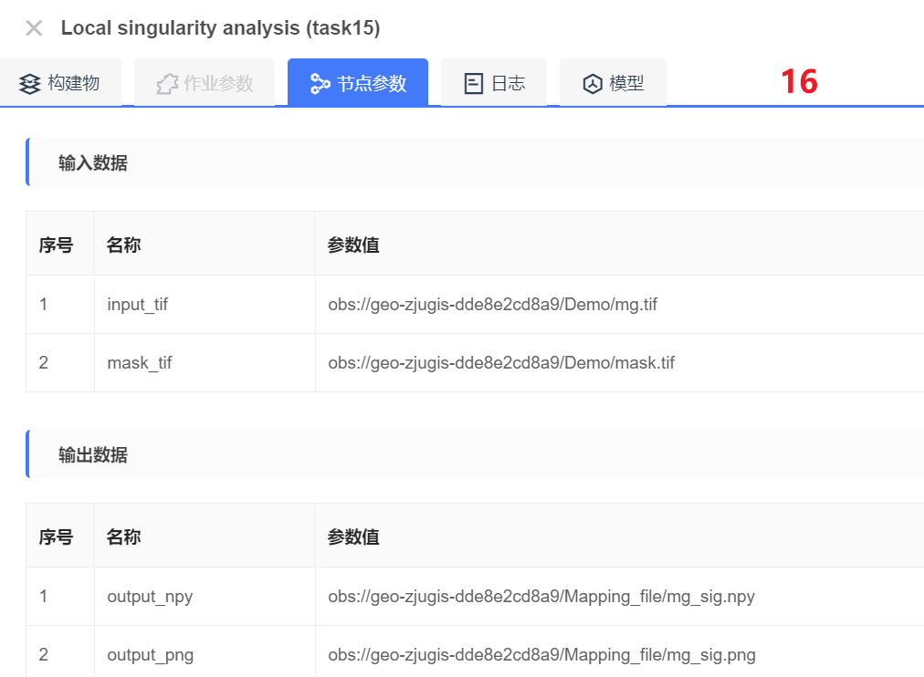

**输入数据**

| **序号** | | **名称** | **参数值** |
| --- | --- | --- | --- |
| 1 | input_tif | obs://geo-zjugis-dde8e2cd8a9/Demo/mg.tif | |
| 2 | mask_tif | obs://geo-zjugis-dde8e2cd8a9/Demo/mask.tif | |

**输出数据**

| **序号** | | **名称** | **参数值** |
| --- | --- | --- | --- |
| 1 | output_npy | obs://geo-zjugis-dde8e2cd8a9/Mapping_file/mg_sig.npy | |
| 2 | output_png | obs://geo-zjugis-dde8e2cd8a9/Mapping_file/mg_sig.png | |

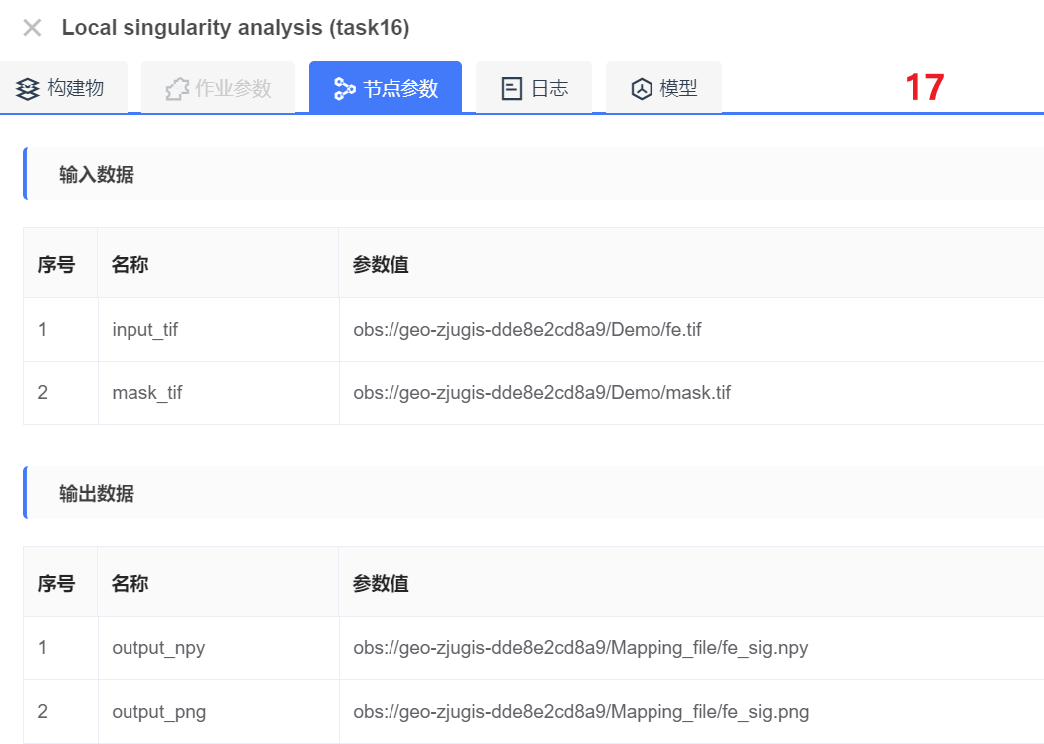

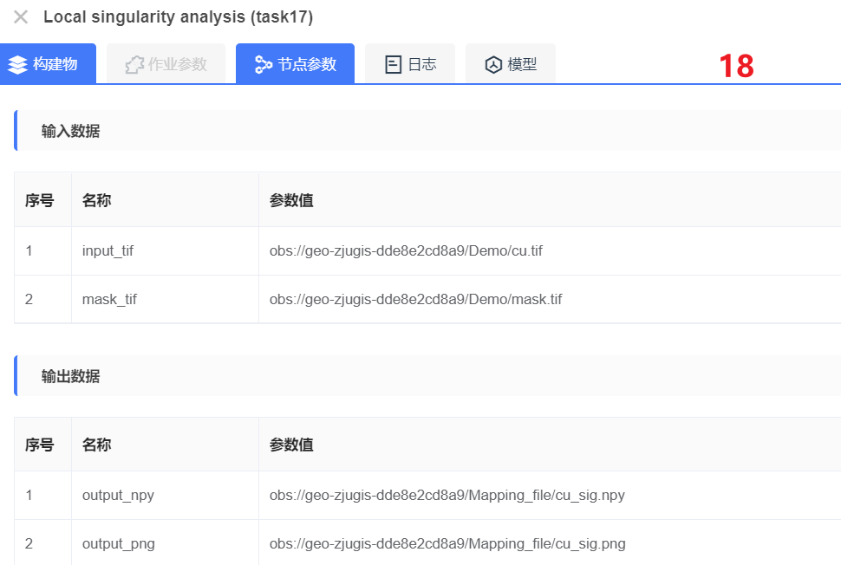

**输入数据**

| **序号** | | **名称** | **参数值** |
| --- | --- | --- | --- |
| 1 | input_tif | obs://geo-zjugis-dde8e2cd8a9/Demo/cu.tif | |
| 2 | mask_tif | obs://geo-zjugis-dde8e2cd8a9/Demo/mask.tif | |

**输出数据**

| **序号** | | **名称** | **参数值** |
| --- | --- | --- | --- |
| 1 | output_npy | obs://geo-zjugis-dde8e2cd8a9/Mapping_file/cu_sig.npy | |
| 2 | output_png | obs://geo-zjugis-dde8e2cd8a9/Mapping_file/cu_sig.png | |

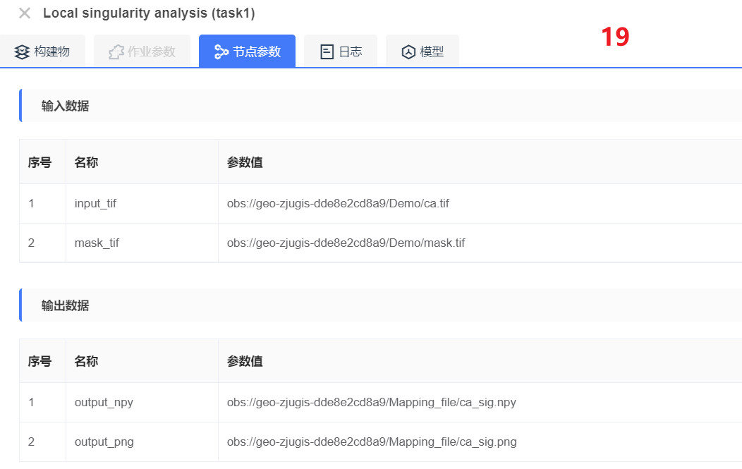

**输入数据**

| **序号** | | **名称** | **参数值** |
| --- | --- | --- | --- |
| 1 | input_tif | obs://geo-zjugis-dde8e2cd8a9/Demo/ca.tif | |
| 2 | mask_tif | obs://geo-zjugis-dde8e2cd8a9/Demo/mask.tif | |

**输出数据**

| **序号** | | **名称** | **参数值** |
| --- | --- | --- | --- |
| 1 | output_npy | obs://geo-zjugis-dde8e2cd8a9/Mapping_file/ca_sig.npy | |
| 2 | output_png | obs://geo-zjugis-dde8e2cd8a9/Mapping_file/ca_sig.png | |

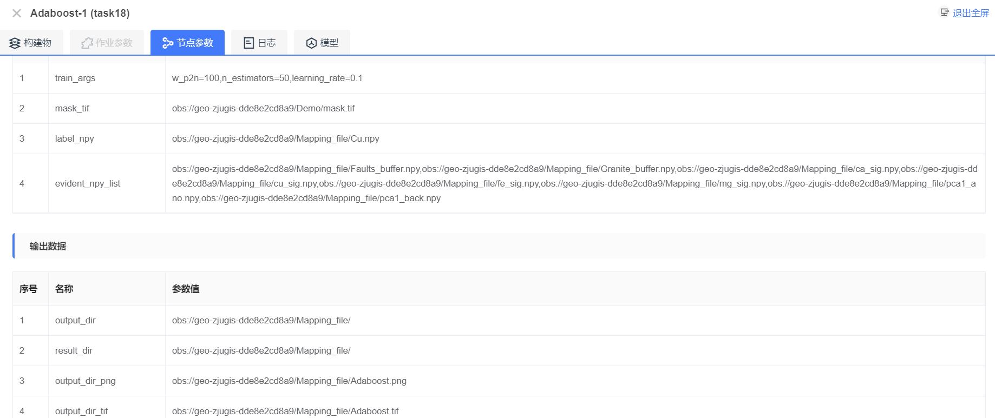

**输入数据**

| **序号** | | **名称** | **参数值** |
| --- | --- | --- | --- |
| 1 | train_args | w_p2n=100,n_estimators=50,learning_rate=0.1 | |
| 2 | mask_tif | obs://geo-zjugis-dde8e2cd8a9/Demo/mask.tif | |
| 3 | label_npy | obs://geo-zjugis-dde8e2cd8a9/Mapping_file/Cu.npy | |
| 4 | evident_npy_list | obs://geo-zjugis-dde8e2cd8a9/Mapping_file/Faults_buffer.npy,obs://geo-zjugis-dde8e2cd8a9/Mapping_file/Granite_buffer.npy,obs://geo-zjugis-dde8e2cd8a9/Mapping_file/ca_sig.npy,obs://geo-zjugis-dde8e2cd8a9/Mapping_file/cu_sig.npy,obs://geo-zjugis-dde8e2cd8a9/Mapping_file/fe_sig.npy,obs://geo-zjugis-dde8e2cd8a9/Mapping_file/mg_sig.npy,obs://geo-zjugis-dde8e2cd8a9/Mapping_file/pca1_ano.npy,obs://geo-zjugis-dde8e2cd8a9/Mapping_file/pca1_back.npy | |

**输出数据**

| **序号** | | **名称** | **参数值** |
| --- | --- | --- | --- |
| 1 | output_dir | obs://geo-zjugis-dde8e2cd8a9/Mapping_file/ | |
| 2 | result_dir | obs://geo-zjugis-dde8e2cd8a9/Mapping_file/ | |
| 3 | output_dir_png | obs://geo-zjugis-dde8e2cd8a9/Mapping_file/Adaboost.png | |
| 4 | output_dir_tif | obs://geo-zjugis-dde8e2cd8a9/Mapping_file/Adaboost.tif | |