**Password attacks**

**Brute-force attack:**

A brute-force attack is a trial-and-error method used by attackers to guess login credentials, encryption keys, or other sensitive information by systematically trying all possible combinations until the correct one is found. It is a straightforward but often effective approach, especially against weak passwords or poorly secured systems.

**Dictionary attack:**

A type of brute-force attack that uses a predefined list that has the common passwords.

**Task 1 code:**

In that code I create a system consists of three pages: Home, Brute-force, Dictionary. The system runs when execute home page which has two buttons each one can access the other two pages.

For brute-force attack code, it choose a random 5 alphabetical characters and try the password till it finds the right password.   
 For dictionary attack, the code search for the right password in a list of common passwords (in my case, it’s an array contains some words including the password). Both attacks have the same target password which is “abcde” and try to find it.

**How to run the code:**

Run the main method in Home page which will show a window that contians two buttons.

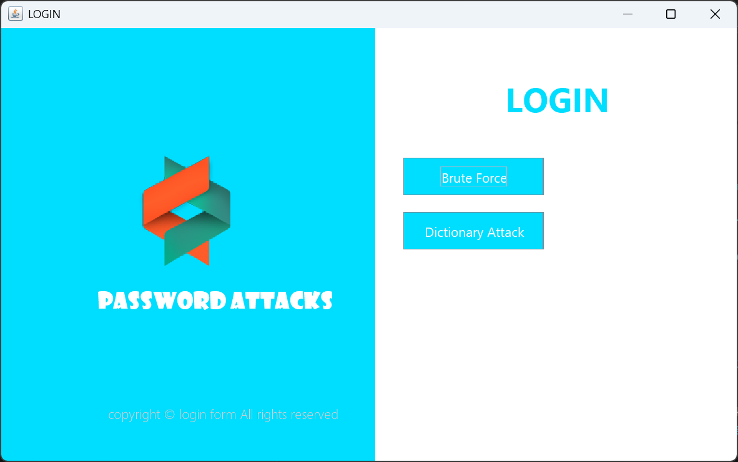

Then, choose which attack you want to run:

**Brute-Force attack:**

When choosing brute-force attack, another window that contains password field, and a logs area will appear. In the logs area, the password been tried will be shown in it till it gets the right password then stop.

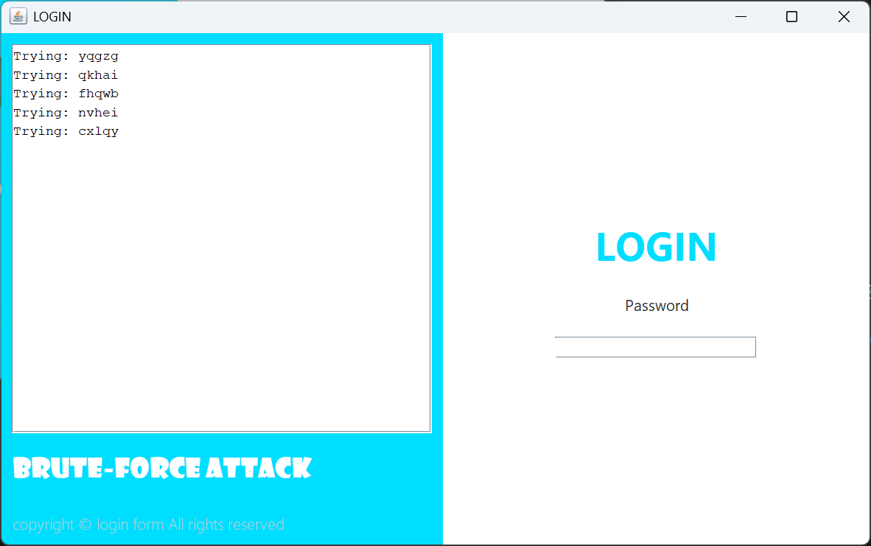

**Dictionary attack:**

The code used an array list consists of Arrays.asList("apple", "banana", "password", "hello", "world", "test", "12345", "abcde");

And the code try all the list till it finds the right password.

