|  |  |
| --- | --- |
| **Name** | عبدالله طه عبدالرحمن السيد عبدالرحمن |
| **B.N** | 492 |
| **Date** | 4-2-2020 |
| **Topic** | Artificial Intelligence |
| **Github link** |  |
| **Github page** |  |

**Application brief**

Artificial intelligence was established in 1955 as an academic discipline, and has undergone many waves of excitement in the years since, followed by frustration and loss of funding (known as "AI winter") followed by new strategies, progress and renewed funding. AI research has been divided into sub-fields for most of its history which often fail to interact with each other. These sub-fields are based on technical considerations, such as specific goals (e.g. "robotics" or "machine learning"), the use of specific tools ("logic" or artificial neural networks), or deep philosophical differences. Sub-fields have also been based on social factors particular institutions or the work.

Screenshots

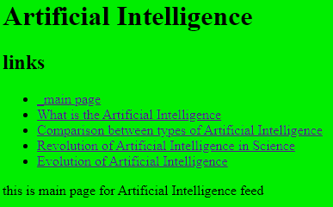

**1**

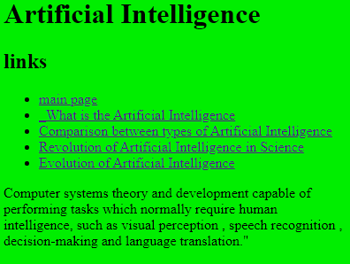

**2**

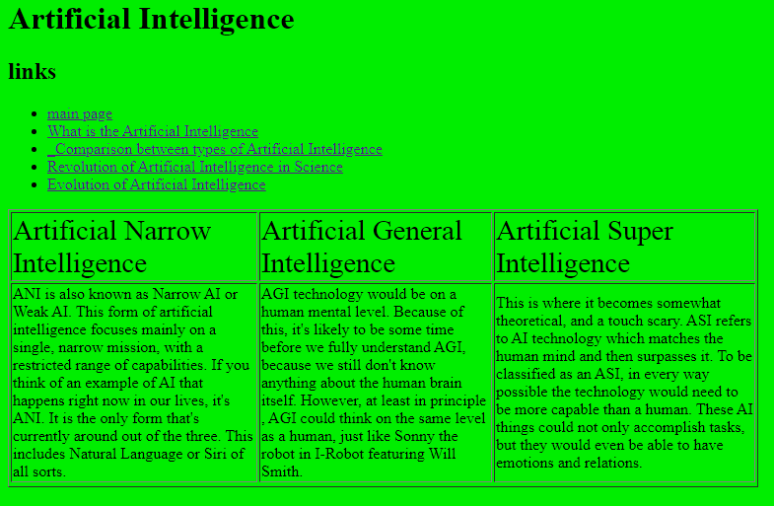

**3**

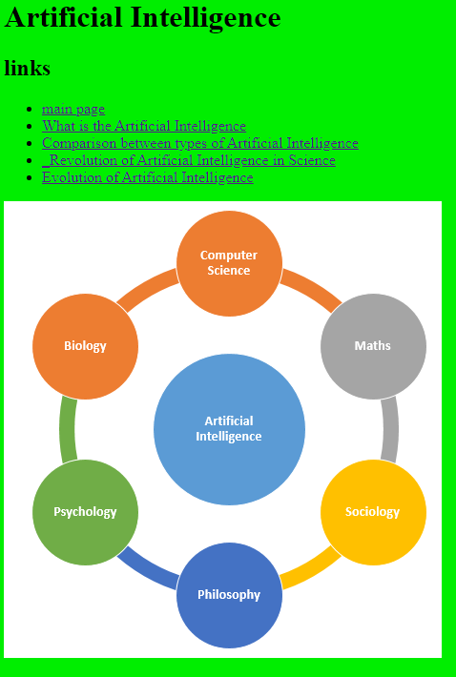

**4**

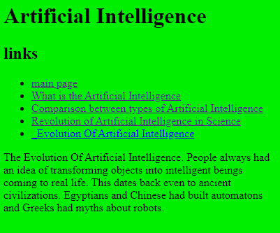

**5**

Source code

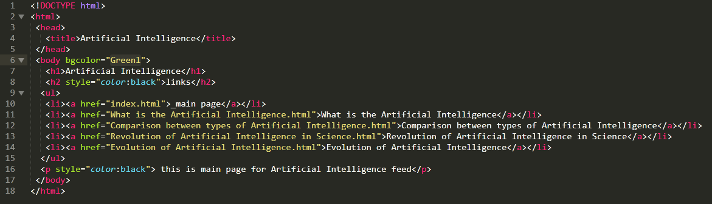

**Code of 1**

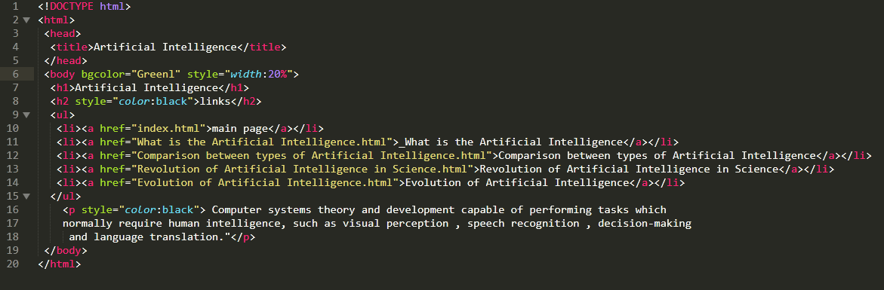

**Code of 2**

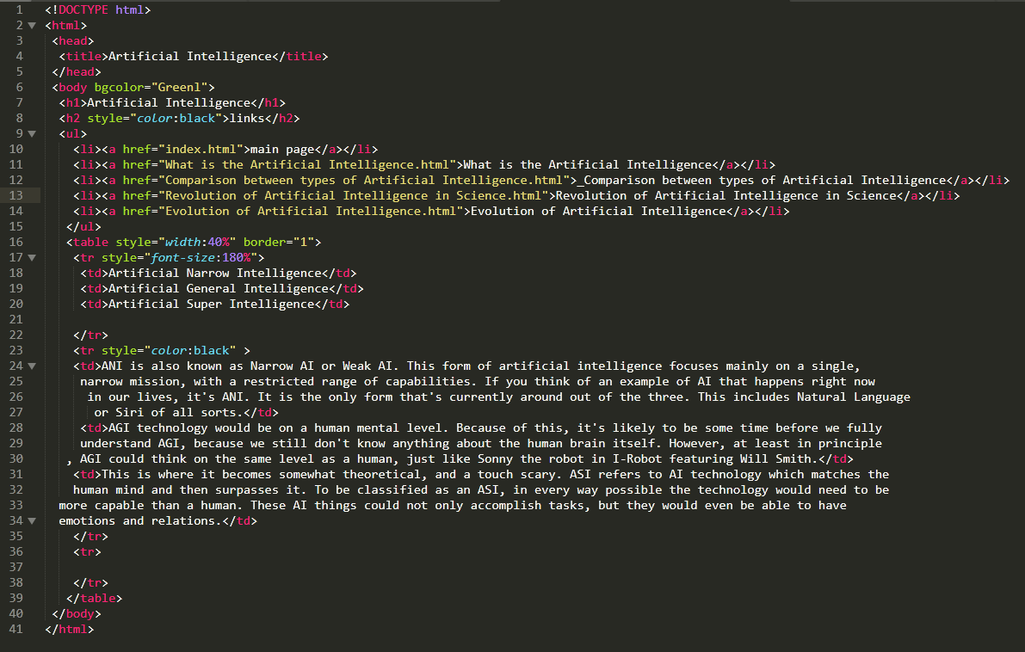

**Code of 3**

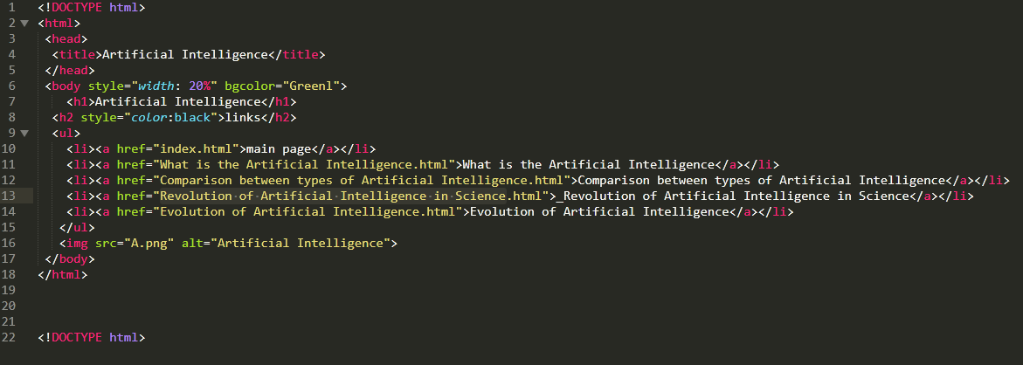

**Code of 4**

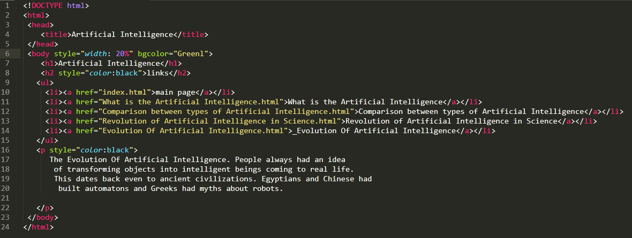

**Code of 5**