**Part 7: Summary**

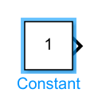

* Constant block: it gives a constant number or signal and can be specified by double click on it.



* Sum block: it can add or subtract any two or more numbers this by double click on it and choose the add or subtract and enter the number of summations.

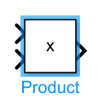

* Product block: it can product any two or more numbers.
* Gain: it can multiply the input by constant value so it acts as amplifier and attenuator.

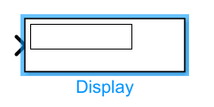

* Display: shows the value of the input data.