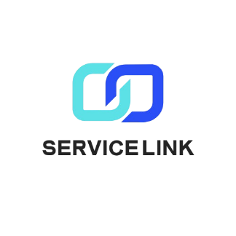

Service Link

# Project Overview:

**Service Link** is your go-to app for hiring trusted freelancers across a wide range of physical services. Whether you need a skilled craftsman, a legal advisor, or a medical professional, Supporter connects you with verified experts ready to assist with your needs. You can also showcase your own skills and offer your services to others, creating a community of reliable professionals and clients. With Service Link, finding and offering professional help has never been easier.

# Members

* Abdallah Amin Ibrahim
* Kerollos Nageh Gabrah
* Sofian Moaz Abd Elmohsen
* Kerollos Gamel Samwel