Software Requirements Specification

FOR

SMART LEARNING SYSTEM

Version 2.0 approved Arabic Speech

**Prepared by:**

**عبدالله احمد عبدالباسط محمد**

**عبدالله الورداني السيد**

**احمد عبداللطيف محمد**

**خالد سالمان احمد سالمان**

**Table of Contents**

**Overview--------------------------------------------------------------------------------3**

**what is Chatbot------------------------------------------------------------------------3**

**Purpose----------------------------------------------------------------------------------3**

**Intended Audience-------------------------------------------------------------------4**

**Scope of product----------------------------------------------------------------------4**

**Use case diagram---------------------------------------------------------------------4**

**Business case--------------------------------------------------------------------------5**

**What is speech recognition--------------------------------------------------------5**

**What is Google Cloud Platform---------------------------------------------------6**

**What is google cloud speech to text API---------------------------------------6**

**Key features----------------------------------------------------------------------------6**

**Functional Requirements-----------------------------------------------------------8**

**How technology for visually impaired is helping people get an education------------------------------------------------------------------------------10**

**What this product add to this field---------------------------------------------12**

**System Requirements--------------------------------------------------------------12**

**Database ------------------------------------------------------------------------------19**

## References-----------------------------------------------------------------------------20

**Overview**

This project is about a chatbot for helping blind people in their studies as students by controlling and managing the materials of their level and reading the pdf files by a flexible way of control and its considered as a **Traditional learning and corporate training have always revolved around gathering students together, in one space, and talking at them before quizzing them to see how much information was absorbed.**

**what is Chatbot**

A chatbot or chatterbot is a [software](https://en.wikipedia.org/wiki/Software_agent) application used to conduct an on-line chat [conversation](https://en.wikipedia.org/wiki/Conversation) via text or [text-to-speech](https://en.wikipedia.org/wiki/Speech_synthesis), in lieu of providing direct contact with a live human agent.[[1]](https://en.wikipedia.org/wiki/Chatbot#cite_note-target-1)[[2]](https://en.wikipedia.org/wiki/Chatbot#cite_note-:1-2) Designed to convincingly simulate the way a human would behave as a conversational partner, chatbot systems typically require continuous tuning and testing, and many in production remain unable to adequately converse, while none of them can pass the standard [Turing test](https://en.wikipedia.org/wiki/Turing_test).[[3]](https://en.wikipedia.org/wiki/Chatbot#cite_note-chatbots_and_Turing_Test-3) The term "ChatterBot" was originally coined by [Michael Mauldin](https://en.wikipedia.org/wiki/Michael_Loren_Mauldin) (creator of the first [Verbot](https://en.wikipedia.org/wiki/Verbot" \o "Verbot)) in 1994 to describe these conversational programs

**Purpose**

Creating this product to help Students and specially the blind who can not deal with computer and can not read or study their materials ,people and visually impaired in their study

**Intended Audience**

* Students
* Blind Students
* Visually Impaired

**Scope of product**

## Smart learning system is one of the best ways for helping students in studying.

## Open source and it easy to use smart learning system program.

## The lecturers can upload their subject materials for the students to access.

## The students can study the materials by the help of the system

## Its an accurate system in treating with the speech

**Use case diagram**

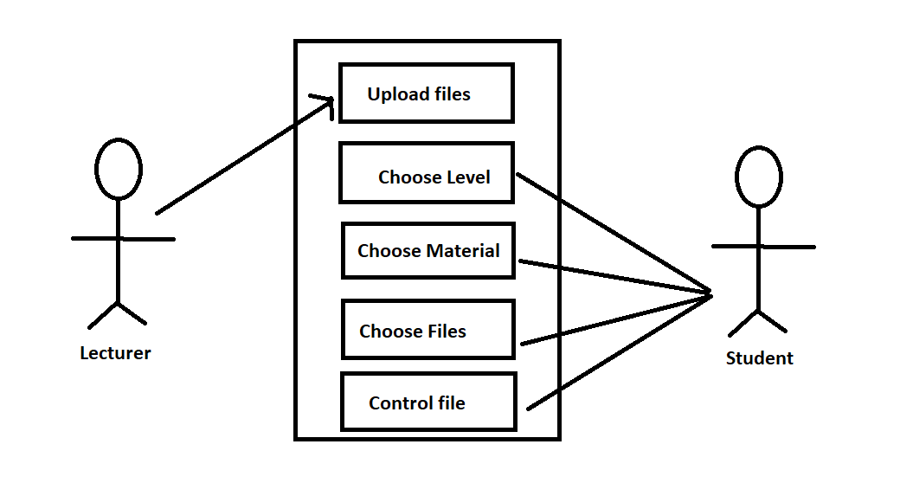

**Business case**

Organize the materials of the subjects and the students life.

The university need for such a product to develop the learning level.

The suffice of the people who can not read or see.

Saving lectures for any time access.

**What is speech recognition**

Speech recognition is an [interdisciplinary](https://en.wikipedia.org/wiki/Interdisciplinary) subfield of [computer science](https://en.wikipedia.org/wiki/Computer_science) and [computational linguistics](https://en.wikipedia.org/wiki/Computational_linguistics) that develops [methodologies](https://en.wikipedia.org/wiki/Methodology) and technologies that enable the recognition and [translation](https://en.wikipedia.org/wiki/Translation) of spoken language into text by computers with the main benefit of [searchability](https://en.wikipedia.org/wiki/Text_search). It is also known as automatic speech recognition (ASR), computer speech recognition or speech to text (STT). It incorporates knowledge and research in the [computer science](https://en.wikipedia.org/wiki/Computer_science), [linguistics](https://en.wikipedia.org/wiki/Linguistics) and [computer engineering](https://en.wikipedia.org/wiki/Computer_engineering) fields. The reverse process is [speech synthesis](https://en.wikipedia.org/wiki/Speech_synthesis).

**What is Google Cloud Platform**

Google Cloud Platform (GCP), offered by [Google](https://en.wikipedia.org/wiki/Google), is a suite of [cloud computing](https://en.wikipedia.org/wiki/Cloud_computing) services that runs on the same infrastructure that Google uses internally for its end-user products, such as [Google Search](https://en.wikipedia.org/wiki/Google_Search), [Gmail](https://en.wikipedia.org/wiki/Gmail), [Google Drive](https://en.wikipedia.org/wiki/Google_Drive), and [YouTube](https://en.wikipedia.org/wiki/YouTube). Alongside a set of management tools, it provides a series of modular cloud services including computing, [data storage](https://en.wikipedia.org/wiki/Computer_data_storage), [data analytics](https://en.wikipedia.org/wiki/Data_analysis) and [machine learning](https://en.wikipedia.org/wiki/Machine_learning). Registration requires a [credit card](https://en.wikipedia.org/wiki/Credit_card) or bank account details.

**What is google cloud speech to text API**

Accurately convert speech into text using an API powered by Google’s AI technologies.

### **Key features**

##### **Speech adaptation**

Customize speech recognition to transcribe domain-specific terms and rare words by providing hints and boost your transcription accuracy of specific words or phrases. Automatically convert spoken numbers into addresses, years, currencies, and more using classes.

##### **Domain-specific models**

Choose from a [selection of trained models](https://cloud.google.com/speech-to-text/docs/basics#select-model) for voice control and phone call and video transcription optimized for domain-specific quality requirements. For example, our enhanced phone call model is tuned for audio originated from telephony, such as phone calls recorded at an 8khz sampling rate.

##### **Easily compare quality**

Experiment on your speech audio with our easy-to-use user interface. Try different configurations to optimize quality and accuracy.

##### **Speech-to-Text On-Prem**

Have full control over your infrastructure and protected speech data while leveraging Google’s speech recognition technology [on-premises](https://cloud.google.com/speech-to-text/on-prem), right in your own private data centers. [Contact sales](https://cloud.google.com/contact) to get started.

**Functional Requirements:**

**1-Upload material**

The lecturer can upload subjects materials.

**2-Choose from multiple levels**

The student can choose by voice the level he want.

**3-Select subject**

The student can choose by voice the subject he want.

**4-select a PDF file**

The student can choose by voice the PDF file he want.

**5-voice reader for the pdf**

Start the voice reader by the command “Start Reading”

**6-Pause reading**

Pause the voice reader by the command “Stop Reading”

**7-resume reading**

Resume the voice reader by the command “Continue”

**9-go to next page**

By the command “page up”

**10-go to previous page**

By the command “page down”

**11-go to next bookmark**

By the command “section”

**12-select from multiple book markers**

You can select from the book content sections to read that section.

**13-registering and logging in**

registering and logging in allowed only for lecturers

**14-upload files**

The lecturer can upload subject files

**15-Delete subject**

The lecturer can delete any subject ana any level

**16-Delete files**

The lecturer can delete any file at any subject

# **How Technology for Visually Impaired is Helping People Get An Education**

With the [technology for visually impaired](https://brailleinstitute.org/technology-for-vision-impaired) available today, we can envision an exciting future of education for both visually impaired and blind people. Here’s three great reasons to get excited:

* **Access:** Technology gives blind students access to the same educational materials as sighted students. This means those students can utilize the same textbooks in audio format or braille for literacy, enrichment and more!
* **Engagement:** Technology for visually impaired students helps them to communicate with their teachers and peers. This helps students engage more effectively in the classroom.
* **Mobility:** Assistive technology for visually impaired and blind students allows them to continue their specialized education at home. When assistive technology is mobile, education is mobile, too.

An example that encapsulates these three features is the BrailleNote Touch. This mobile device operates completely with a Braille keyboard. It has easy access to Google Docs, Dropbox, and KeyMail. Humanware designed it to help students take notes easily, research effectively, and communicate with their teachers.

Still, the cost of assistive technology devices can feel defeating. But not all assistive technology for visually impaired and blind people comes in an isolated device. Rather, many of the tools are infused into hardware most of us use every day. When students know how to access those resources, they access tools that progress their education forward.

Another example, Voiceover and Talkback are the IOS and Android versions of an audible keyboard for your smart phone which are automatically installed. They both assist in navigating messages, apps, phone calls, and more. There are also applications you can download on your phone for typing accessibility.

BrailleTouch is an app, designed at Georgia Tech, which gives the Braille keyboard a place on the smart phone screen. All these resources in assistive technology for visually impaired and blind people can be catalytic in obtaining a quality education.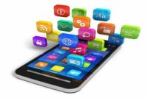

However, if using the newest technology sounds overwhelming, you are not alone. Navigating devices in an ever-changing world of tech is complicated. At Braille Institute, we [offer technology education](https://brailleinstitute.org/technology-for-vision-impaired) to make it simple. Our team has developed easy training programs to help you leverage the digital landscape one step at a time. We offer free online classes on all the latest assistive technology as we long to ensure you are getting the most out of your magnifiers, iPad, JAWS, or Android devices, etc. Do not hesitate to contact us and meet with one of our experts during an online workshop or class, or via a one-on-one phone consultation. We are here to help you utilize the latest technology and get the best education possible.

**What this product add to this field**

This program created specifically for managing and controlling pdf file for student.

PDF file can be accessed through it’s markers.

Student can start , pause and resume reading current pdf.

Change the current pdf

**System Requirements**

1. Microsoft Windows 10.
2. Arabic Language speech Installed.

How to Install and enable Arabic speech in Win 10:

Microsoft's Windows 10 operating system comes with a set of voices for each language installed on the device. Only some of the installed voices become available system-wide so that third-party software and services may make use of them as well. The majority of voices are restricted to internal use, e.g. for Cortana or other areas.

If you open Settings > Ease of Access > Narrator and select the "choose a voice" menu there, you get a list of voices that are available.

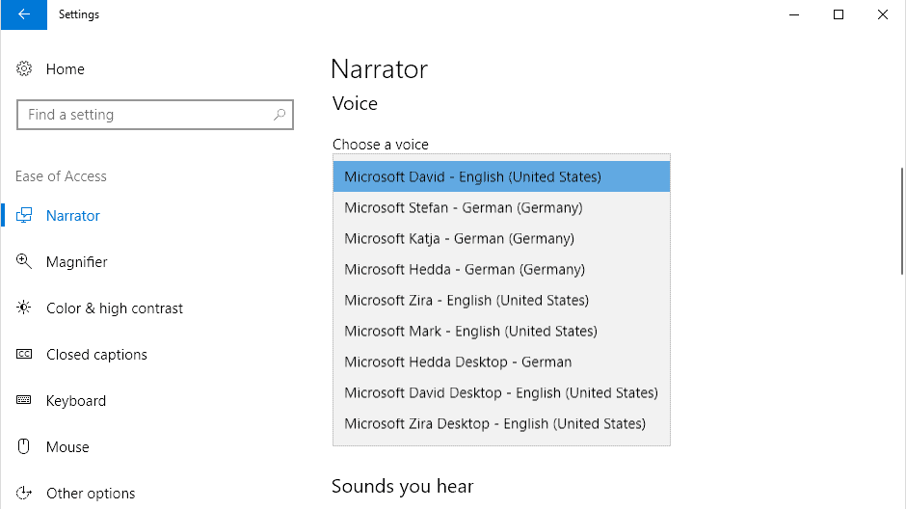

When you open a third-party program that uses voices on the Windows PC, only some of these are provided.

The screenshot above shows how many voices are available when you select the voice picker in Narrator.

The third-party program Balabolka displays only three voices that you may select even though you know that more are available on the device: frustrating.

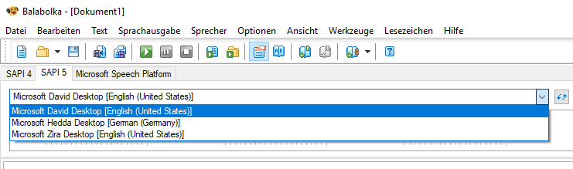

There is a way, however, to unlock all Windows 10 text-to-speech voices so that they become available to any program or app that uses the voices that Windows provides.

**Note**: The method requires Registry editing. I suggest you [create a backup of the Registry](https://www.ghacks.net/2008/08/24/back-to-basics-backup-registry/) or even your system before you make any modifications to the Windows Registry so that you can restore the initial state if things don't go as planned.

Here is how that is done:

### **Step 1: Open the Windows Registry Editor**

1. Activate the Start menu of the operating system.
2. Type regedit.exe to launch the Registry Editor.
3. Confirm the UAC security prompt that is displayed.

### **Step 2: Open the list of available voices**

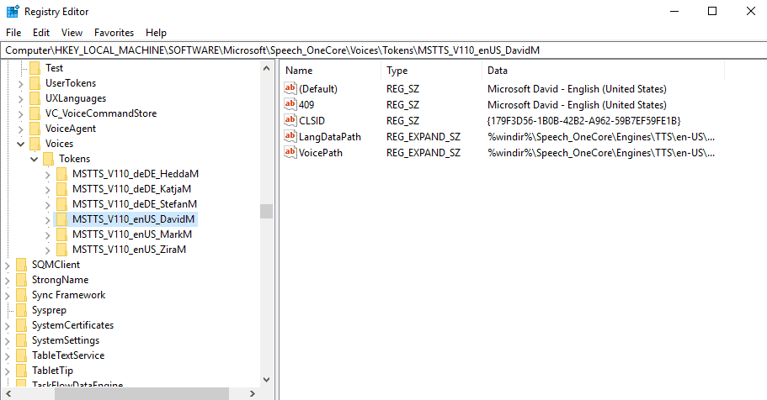

1. Go to the Registry key Computer\HKEY_LOCAL_MACHINE\SOFTWARE\Microsoft\Speech_OneCore\Voices\Tokens

It lists all the voices that are available (except for Cortana voices, more about that later).

### **Step 3: Export the voices**

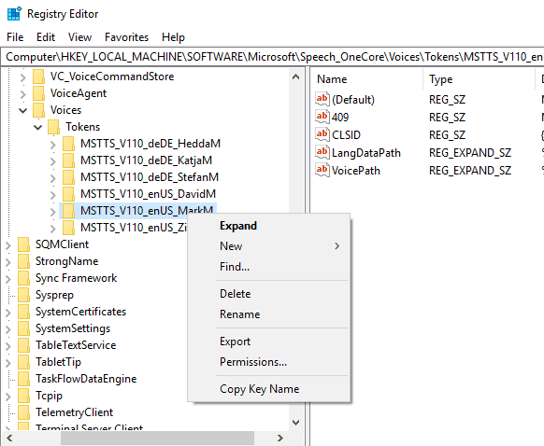

You need to export the voice information in the Registry in the first step.

1. Right-click on a key in the Registry Editor, e.g. MSTTS_V110_enUS_MarkM and select Export.
2. Type a name for the new Registry file, e.g. markm, and select save from the dialog.

### **4. Modify the exported Registry file**

Open the saved Registry file. It needs to be modified so that its values are added to two other locations in the Registry.

1. Copy all information except for the first line (Windows Registry Editor Version 5.00) and paste the information below the content of the file.
2. Replace the location in the first data set with HKEY_LOCAL_MACHINE\SOFTWARE\Microsoft\Speech\Voices\Tokens
3. Replace the location in the second data set with HKEY_LOCAL_MACHINE\SOFTWARE\WOW6432Node\Microsoft\SPEECH\Voices\Tokens

**Note**: Each set includes two paths that you need to replace. Take a look at the following modified Registry file to better understand the process (for the U.S. voice Mark):

**Original File:**

Windows Registry Editor Version 5.00

[HKEY_LOCAL_MACHINE\SOFTWARE\Microsoft\Speech_OneCore\Voices\Tokens\MSTTS_V110_enUS_MarkM]  
@="Microsoft Mark - English (United States)"  
"409"="Microsoft Mark - English (United States)"  
"CLSID"="{179F3D56-1B0B-42B2-A962-59B7EF59FE1B}"  
"LangDataPath"=hex(2):25,00,77,00,69,00,6e,00,64,00,69,00,72,00,25,00,5c,00,53,\  
00,70,00,65,00,65,00,63,00,68,00,5f,00,4f,00,6e,00,65,00,43,00,6f,00,72,00,\  
65,00,5c,00,45,00,6e,00,67,00,69,00,6e,00,65,00,73,00,5c,00,54,00,54,00,53,\  
00,5c,00,65,00,6e,00,2d,00,55,00,53,00,5c,00,4d,00,53,00,54,00,54,00,53,00,\  
4c,00,6f,00,63,00,65,00,6e,00,55,00,53,00,2e,00,64,00,61,00,74,00,00,00  
"VoicePath"=hex(2):25,00,77,00,69,00,6e,00,64,00,69,00,72,00,25,00,5c,00,53,00,\  
70,00,65,00,65,00,63,00,68,00,5f,00,4f,00,6e,00,65,00,43,00,6f,00,72,00,65,\  
00,5c,00,45,00,6e,00,67,00,69,00,6e,00,65,00,73,00,5c,00,54,00,54,00,53,00,\  
5c,00,65,00,6e,00,2d,00,55,00,53,00,5c,00,4d,00,31,00,30,00,33,00,33,00,4d,\  
00,61,00,72,00,6b,00,00,00

[HKEY_LOCAL_MACHINE\SOFTWARE\Microsoft\Speech_OneCore\Voices\Tokens\MSTTS_V110_enUS_MarkM\Attributes]  
"Age"="Adult"  
"DataVersion"="11.0.2013.1022"  
"Gender"="Male"  
"Language"="409"  
"Name"="Microsoft Mark"  
"SharedPronunciation"=""  
"Vendor"="Microsoft"  
"Version"="11.0"

**Modified File:**

Windows Registry Editor Version 5.00

[HKEY_LOCAL_MACHINE\SOFTWARE\Microsoft\Speech\Voices\Tokens\MSTTS_V110_enUS_MarkM]  
@="Microsoft Mark - English (United States)"  
"409"="Microsoft Mark - English (United States)"  
"CLSID"="{179F3D56-1B0B-42B2-A962-59B7EF59FE1B}"  
"LangDataPath"=hex(2):25,00,77,00,69,00,6e,00,64,00,69,00,72,00,25,00,5c,00,53,\  
00,70,00,65,00,65,00,63,00,68,00,5f,00,4f,00,6e,00,65,00,43,00,6f,00,72,00,\  
65,00,5c,00,45,00,6e,00,67,00,69,00,6e,00,65,00,73,00,5c,00,54,00,54,00,53,\  
00,5c,00,65,00,6e,00,2d,00,55,00,53,00,5c,00,4d,00,53,00,54,00,54,00,53,00,\  
4c,00,6f,00,63,00,65,00,6e,00,55,00,53,00,2e,00,64,00,61,00,74,00,00,00  
"VoicePath"=hex(2):25,00,77,00,69,00,6e,00,64,00,69,00,72,00,25,00,5c,00,53,00,\  
70,00,65,00,65,00,63,00,68,00,5f,00,4f,00,6e,00,65,00,43,00,6f,00,72,00,65,\  
00,5c,00,45,00,6e,00,67,00,69,00,6e,00,65,00,73,00,5c,00,54,00,54,00,53,00,\  
5c,00,65,00,6e,00,2d,00,55,00,53,00,5c,00,4d,00,31,00,30,00,33,00,33,00,4d,\  
00,61,00,72,00,6b,00,00,00

[HKEY_LOCAL_MACHINE\SOFTWARE\Microsoft\Speech\Voices\Tokens\MSTTS_V110_enUS_MarkM\Attributes]  
"Age"="Adult"  
"DataVersion"="11.0.2013.1022"  
"Gender"="Male"  
"Language"="409"  
"Name"="Microsoft Mark"  
"SharedPronunciation"=""  
"Vendor"="Microsoft"  
"Version"="11.0"

[HKEY_LOCAL_MACHINE\SOFTWARE\WOW6432Node\Microsoft\SPEECH\Voices\Tokens\MSTTS_V110_enUS_MarkM]  
@="Microsoft Mark - English (United States)"  
"409"="Microsoft Mark - English (United States)"  
"CLSID"="{179F3D56-1B0B-42B2-A962-59B7EF59FE1B}"  
"LangDataPath"=hex(2):25,00,77,00,69,00,6e,00,64,00,69,00,72,00,25,00,5c,00,53,\  
00,70,00,65,00,65,00,63,00,68,00,5f,00,4f,00,6e,00,65,00,43,00,6f,00,72,00,\  
65,00,5c,00,45,00,6e,00,67,00,69,00,6e,00,65,00,73,00,5c,00,54,00,54,00,53,\  
00,5c,00,65,00,6e,00,2d,00,55,00,53,00,5c,00,4d,00,53,00,54,00,54,00,53,00,\  
4c,00,6f,00,63,00,65,00,6e,00,55,00,53,00,2e,00,64,00,61,00,74,00,00,00  
"VoicePath"=hex(2):25,00,77,00,69,00,6e,00,64,00,69,00,72,00,25,00,5c,00,53,00,\  
70,00,65,00,65,00,63,00,68,00,5f,00,4f,00,6e,00,65,00,43,00,6f,00,72,00,65,\  
00,5c,00,45,00,6e,00,67,00,69,00,6e,00,65,00,73,00,5c,00,54,00,54,00,53,00,\  
5c,00,65,00,6e,00,2d,00,55,00,53,00,5c,00,4d,00,31,00,30,00,33,00,33,00,4d,\  
00,61,00,72,00,6b,00,00,00

[HKEY_LOCAL_MACHINE\SOFTWARE\WOW6432Node\Microsoft\SPEECH\Voices\Tokens\MSTTS_V110_enUS_MarkM\Attributes]  
"Age"="Adult"  
"DataVersion"="11.0.2013.1022"  
"Gender"="Male"  
"Language"="409"  
"Name"="Microsoft Mark"  
"SharedPronunciation"=""  
"Vendor"="Microsoft"  
"Version"="11.0"

### **Step 5: Import the new data**

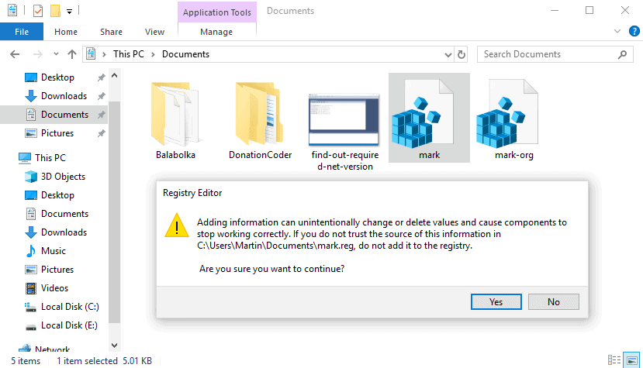

Importing is straightforward. Just double-click on the Registry file that you have modified and accept the warning prompt.

Note that you need to switch users, sign off and on again, or restart the PC before you may see the new voice in other programs.

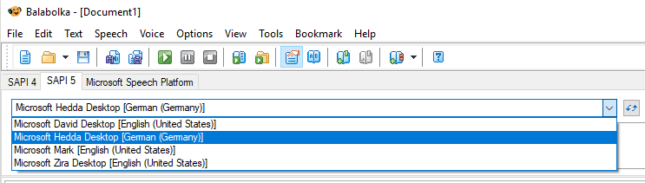

Also, you need administrative rights to add data to the Registry using .reg files.

**Database**.

It consists of two relations

1. The Subject

2-The File

The database were hosted on a remote server – Cloud Clusters-

To allow the students to access the files uploaded by the lecturers.

The program connects to the database to read the cubjects in every level, the files in every subject.

If the student selects a file, it will be downloaded from the database and will be opened.

The doctors can upload file and subjects, also they can delete files and subjects.

## References:

## [1].

## <https://cloud.google.com/tools/visual-studio/docs/deploy-asp-net-app?fbclid=IwAR0aFXNZi4payPrubruL90PLY2H7pDXAMNYZYhUiGk5E4ubBNdNwEtEKKFM>

## [2]

## <https://cloud.google.com/dotnet/docs/reference/Google.Cloud.Speech.V1/latest?fbclid=IwAR38Aqw3QrzUAfw4MUj0e12_ZJtP8_VDt6u6cyQ0ox18D_TZeE7KXfJ3dKo>

## [3]

## <https://codelabs.developers.google.com/codelabs/cloud-speech-text-csharp#0>

## [4]

## <https://ironpdf.com/examples/bookmarks/?fbclid=IwAR0uFJ63_vSd0HLnbDGJH4Skxbjp4eL-ogSPP3dMtP9q6eN0zJoWTtLquXk#title>

## [5]

## <https://www.ghacks.net/2018/08/11/unlock-all-windows-10-tts-voices-system-wide-to-get-more-of-them/>