**Game Manual**

**Installation and running:**

To install the game, download the project folder and place the file in a directory that easy to access. Once you installed the game, open the command prompt and type in the following command:

The code and resources of the game can be found in the /src folder. The executable jar files can be found in the /target folder.

**Purpose:**

This game was made for entertainment purposes. It is made to entertain all the lovers of ping pong as well as children, as now playing ping pong is difficult because of COVID-19.

**How to use:**

1. When the game opens, you will be introduced to the main menu, select a game mode to start playing.
2. To control the player on the left, use the W & S keys, and to control the player on the right use the UP & DOWN arrow keys.

FYI: These controls only work if the player is not being controlled by the computer

1. Keep the ball out of your area and try to score it on the opponent player
2. Enjoy!

**Features:**

1. **Play vs Friend:** In this game mode you are playing against a second user. And so, both players are controlled using the specified keyboard keys.
2. **Play vs Computer:** In this game mode you are playing against the computer. Your player will be the player on the left.
3. **Computer vs Computer:** In this game mode, two computers play against each other, you will only be able to spectate and will have no control over the players.

**Screen Captures:**

1. The main menu:

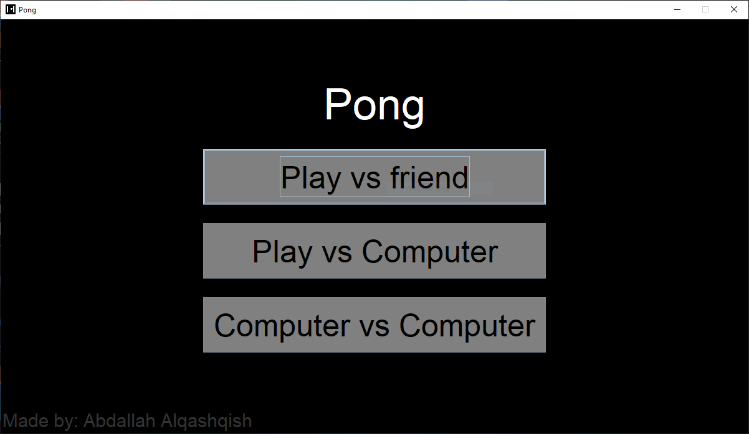

This is the screen where you select the game mode you would like to play

1. Game screen:

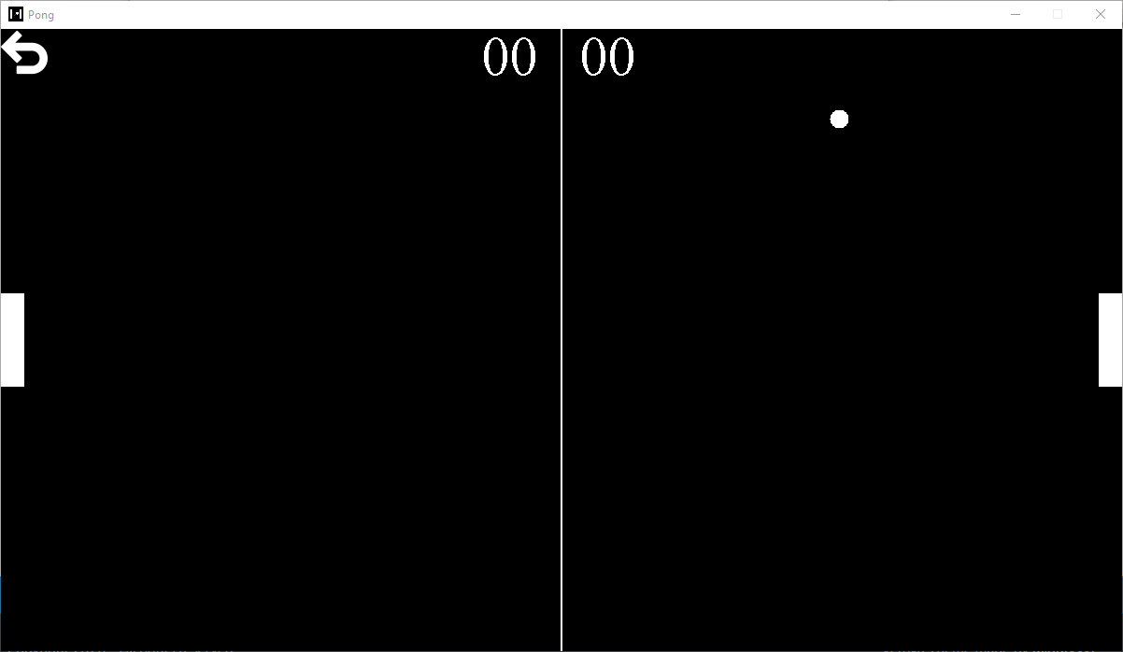

This is the game screen.

1. The game over popup:

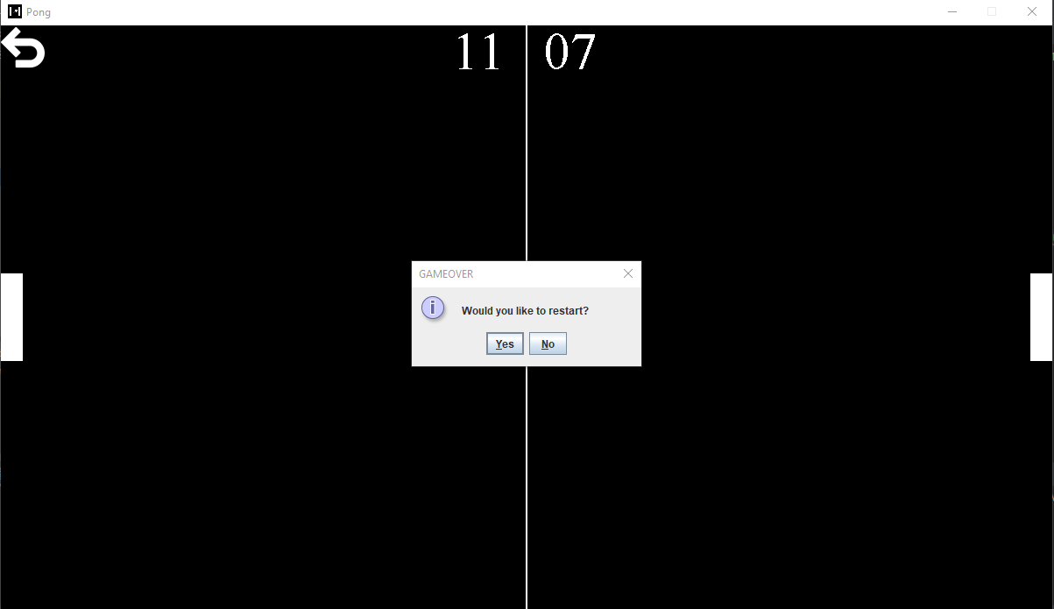

This is the game over popup. Pressing yes will restart the game and pressing no will send you back to the main menu of the game. The game ends when one of the players reach a score of 11.