PROPOSAL

Document title in two lines at most
One line on what this document is for

Prepared for | Client name
Prepared by | Name, Role · Fleetana
Date | DD/MM/YYYY
Reference | FL-2026-001

Summary
Lead paragraph. Say the point of the whole document in two or three sentences. A busy reader may stop here.
Body text is Inter 10.5 pt in Ink. Write in the second person, keep sentences short, and use numbers we can prove instead of adjectives. Replace this text with your own; every style you see here is in the Styles gallery.

Heading 2 for a sub-section
Use bullets for parallel items. Keep each one to a line where you can:
- Service reminders by km, engine hours or date, whichever comes first
- Fuel economy on every full fill with an odometer reading
- Istimara, insurance and Fahes listed 30 days before they expire
Callout: use it once or twice per document for the one thing the reader must remember.

Numbered steps
Use numbers when order matters:
- Add your vehicles, drivers and their document dates.
- Log fuel and service as it happens, from any device.
- Open Home to see what is due, overdue or expiring.

Heading 3 · a small labelled block
Tables use a Tint header row, hairline rules and Paper banding. Plates, IDs and dates are set in IBM Plex Mono. Status uses the app's colours, never brand blue.
Vehicle | Plate | Status | Next service
Toyota Hilux 2022 | ⁦4271 ح ط ر⁩ | Active | 90,000 km
Toyota Hiace 2021 | ⁦8834 ب ن م⁩ | Due soon | 01/11/2026
Isuzu NPR 2020 | ⁦1902 د ك ل⁩ | In shop | 1,200 h
Toyota Coaster 2019 | ⁦3150 ر ي د⁩ | Overdue | 15/10/2026
Table 1 · Example fleet. Copy this table to keep the house style.
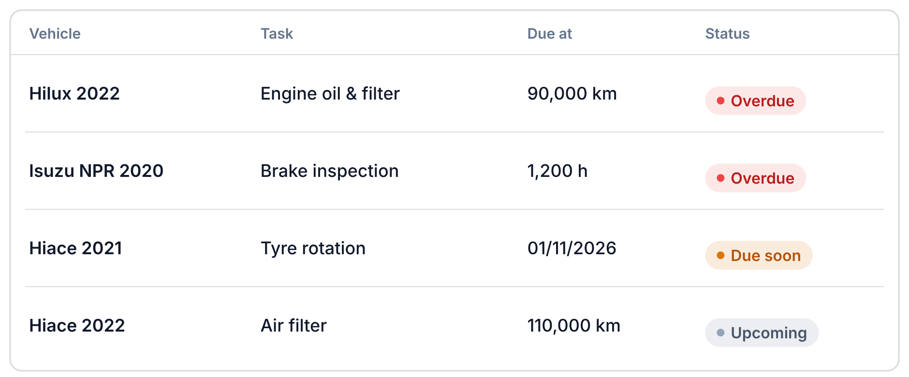
Figure 1 · Service reminders in Fleetana. Product screens are our illustrations; demo data must look like demo data.

Styles in this template
Pick styles from the gallery instead of formatting by hand, so every Fleetana document looks the same.
Title | Cover title, Hanken Grotesk 30 pt
Subtitle | Cover line under the title, Accent Blue
Eyebrow | Document type above the title
Heading 1 – 3 | Section, sub-section and labelled block
Lead | Opening paragraph of a section
Normal | Body text, Inter 10.5 pt
Callout | The one thing to remember (Tint panel)
Caption | Under tables and figures
Data | Plates, IDs, odometers (IBM Plex Mono)
Data style
WO-000123 · ⁦4271 ح ط ر⁩ · 21/10/2026 · 89,420 km

Regards,
Full name
Role, Fleetana
fleetana.sa

