Cairo University - Faculty of Engineering

Computer Engineering Department

Communication (ELC3252A6)

**Project Report**

**Team 2**

|  |  |  |
| --- | --- | --- |
| Name | Sec. | B.N |
| Abdallah Hussien | 2 | 2 |
| François Adham | 2 | 9 |

**Academic Year:**

**2020 – 2021**

1. **Modulated Signal**

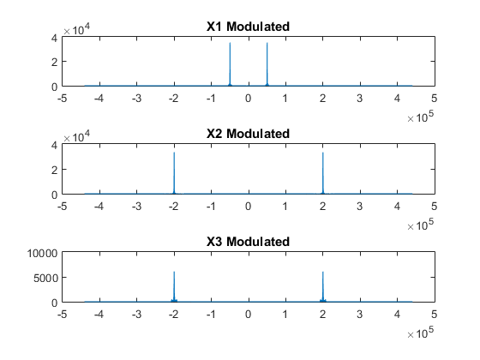

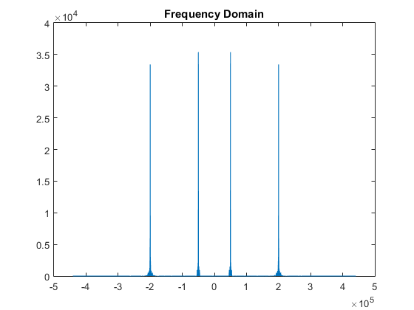

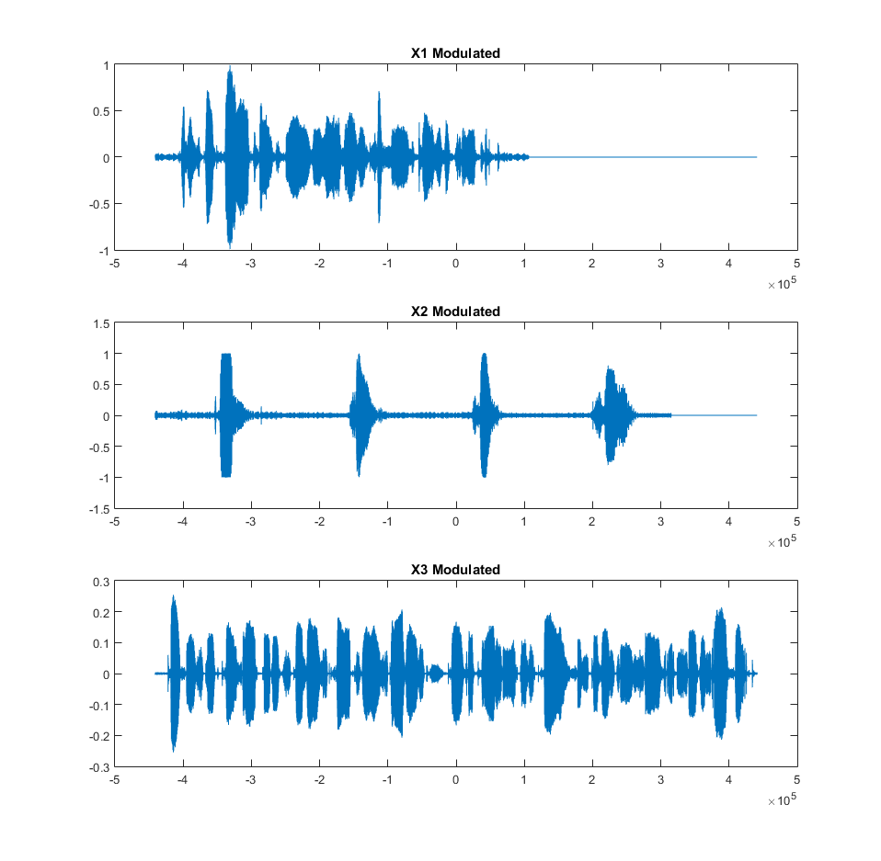

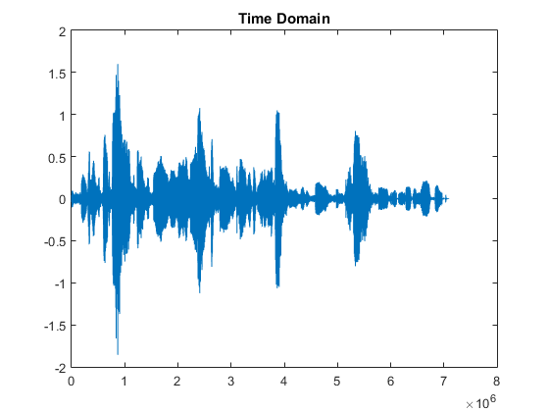

1. **Demodulated Signals**

The phase error may cause attenuation of the output signal without causing distortion as long as it is constant.

e(t)=1/2*m(t)*cos(α) , where α is the phase shift.

* 1. **phase shift 0 degree**

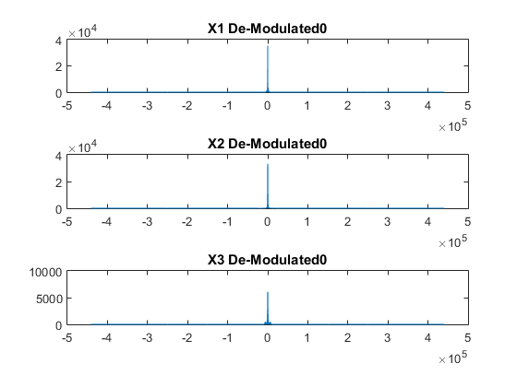

Restored signals have half magnitude of the original ones.

* 1. **phase shift 10 degrees**

For signal 1 it’s almost the same as the original.  
For signal 2 and 3 because they are modulated on the same frequency but one by sin and the other by cos, then an overlapping will happen with low interference from the other signal.

* 1. **phase shift 30 degrees**

For signal 1 it’s almost the same as the original.  
For signal 2 and 3 because of the previous reason an overlapping will happen, but with higher interference from the other signal than the case of phase 10.

* 1. **phase shift 90 degrees**

For signal 1 it’ll mute because cos(90)=0.  
For signal 2 and 3 they will be switched, because cos(α+90)=sin(α) and vice versa.

1. **Code**

% %*******************************************************************************

% %********************************* TIME DOMAIN *******************************

% %*******************************************************************************

%

clc ;

clear all;

%

% % ================================

% % ======== reading audios ========

% % ================================

%

[x1,fs1]=audioread('Team2_ speechsignal_1.wav');

[x2,fs2]=audioread('Team2_ speechsignal_2.wav');

[x3,fs3]=audioread('Team2_ speechsignal_3.wav');

L1 = length(x1);

L2 = length(x2);

L3 = length(x3);

x1=([x1' zeros(1,L3-L1)])';

x2=([x2' zeros(1,L3-L2)])';

x3=([x3' zeros(1,L3-L3)])';

x1=interp(x1,20);

x2=interp(x2,20);

x3=interp(x3,20);

fs1=fs1*20;

TS1 = 1/fs1;

N1 = [0:(length(x1)-1)];

L1 = length(x1);

f1 = [-L1/2:L1/2-1]*(fs1/L1);

fs2=fs2*20;

TS2 = 1/fs2;

N2 = [0:(length(x2)-1)];

L2 = length(x2);

f2 = [-L2/2:L2/2-1]*(fs2/L2);

fs3=fs3*20;

TS3 = 1/fs3;

N3 = [0:(length(x3)-1)];

L3 = length(x3);

f3 = [-L3/2:L3/2-1]*(fs3/L3);

% % ================================

% % ========== Modulating ==========

% % ================================

Fc1=50000;

carrier1 = cos(2*pi*Fc1*TS1*N1);

x1_modulated = x1'.* carrier1;

Fc2=200000;

carrier2 = cos(2*pi*Fc2*TS2*N2);

x2_modulated = x2'.*carrier2;

Fc3=200000;

carrier3 = sin(2*pi*Fc3*TS3*N3);

x3_modulated = x3'.*carrier3;

% figure();

% subplot(3,1,1);

% plot(f1,abs(fftshift(fft(x1_modulated))));

% title('X1 Modulated')

% subplot(3,1,2);

% plot(f2,abs(fftshift(fft(x2_modulated))));

% title('X2 Modulated')

% subplot(3,1,3);

% plot(f3,abs(fftshift(fft(x3_modulated))));

% title('X3 Modulated')

% %*******************************************************************************

% %******************************* COMBINED SIGNAL *******************************

% %*******************************************************************************

signal = x1_modulated + x2_modulated + x3_modulated ;

figure();

plot(signal);

title('Time Domain')

figure();

plot(f3,abs(fftshift(fft(signal))));

title('Frequency Domain')

[C1,R1]=size(x1);

[C2,R2]=size(x2);

[C3,R3]=size(x3);

% %*******************************************************************************

% %******************************* Demodulate ************************************

% %*******************************************************************************

for i = [0 pi/18 pi/6 pi/2]

    carrier1 = cos(2*pi*Fc1*TS1*N1 + i);

    x1_new = signal(1:R1, 1:C1) .* carrier1;

    lp = designfilt('lowpassfir', 'FilterOrder',128, 'CutoffFrequency',22*10^3, 'SampleRate', fs1);%lowpassfilter

    x1_new=filter(lp,x1_new);

    OUTPUT1=downsample(x1_new,20);

    audiowrite(strcat('audio1Out',int2str(i*180/pi),'.wav'),OUTPUT1,fs1/20);

    carrier2 = cos(2*pi*Fc2*TS2*N2 + i);

    x2_new = signal(1:R2, 1:C2) .* carrier2;

    lp = designfilt('lowpassfir', 'FilterOrder',64, 'CutoffFrequency',44*10^3, 'SampleRate', fs2);%lowpassfilter

    x2_new=filter(lp,x2_new);

    OUTPUT2=downsample(x2_new,20);

    audiowrite(strcat('audio2Out',int2str(i*180/pi),'.wav'),OUTPUT2,fs2/20);

    carrier3 = sin(2*pi*Fc3*TS3*N3 + i);

    x3_new = signal(1:R3, 1:C3) .* carrier3;

    lp = designfilt('lowpassfir', 'FilterOrder',64, 'CutoffFrequency',44*10^3, 'SampleRate', fs3);%lowpassfilter

    x3_new=filter(lp,x3_new);

    OUTPUT3=downsample(x3_new,20);

    audiowrite(strcat('audio3Out',int2str(i*180/pi),'.wav'),OUTPUT3,fs3/20);

%     figure();

%     subplot(3,1,1);

%     plot(f1,abs(fftshift(fft(x1_new))));

%     title(strcat('X1 De-Modulated ',int2str(i*180/pi)))

%     subplot(3,1,2);

%     plot(f2,abs(fftshift(fft(x2_new))));

%     title(strcat('X2 De-Modulated ',int2str(i*180/pi)))

%     subplot(3,1,3);

%     plot(f3,abs(fftshift(fft(x3_new))));

%     title(strcat('X3 De-Modulated ',int2str(i*180/pi)))

end;