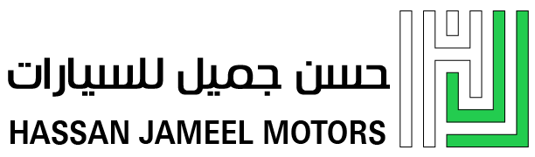 |   Authorized Dealer

Date: August 25, 2026
SUBJECT: AUTHORIZATION TO USE TOYOTA TRADEMARKS AND BRAND ASSETS
TO WHOM IT MAY CONCERN

This letter serves as official documentary evidence confirming that Hassan Jameel Motors (hereinafter referred to as "the Company"), headquartered in Al Khobar, Eastern Region, Kingdom of Saudi Arabia, is an Authorized Toyota Dealer operating under a franchise and dealer agreement with Abdul Latif Jameel Co. Ltd., the exclusive distributor of Toyota vehicles in the Kingdom of Saudi Arabia.
By virtue of this authorized dealership status, the Company is duly permitted to:

◆ Use the Toyota trade name, trademark, and logo in all official company communications, marketing materials, digital platforms, and mobile applications.
◆ Represent the Toyota brand in sales, aftersales, and customer service operations within the Eastern Region of Saudi Arabia.
◆ Display Toyota branding across all official channels, including websites, social media accounts, and published mobile applications, in connection with the Company's authorized dealership activities.
◆ Operate Toyota-branded service centers and showrooms under the Toyota dealer network throughout the Eastern Region.

This authorization explicitly covers the Company's official mobile application published on digital distribution platforms (including but not limited to the Apple App Store and Google Play Store), which serves as a customer-facing tool for our Toyota dealership operations. The use of Toyota trademarks within said application is directly tied to our authorized dealer status and is conducted in full compliance with Toyota's brand usage guidelines.
The Company affirms that all trademark usage is strictly limited to legitimate dealer activities and does not imply any ownership of the Toyota trademark. Hassan Jameel Motors is solely responsible for ensuring proper and compliant usage of Toyota brand assets in full accordance with its dealership obligations and applicable brand guidelines.
We trust this letter provides sufficient confirmation of Hassan Jameel Motors' authorized status. Should you require any further documentation or clarification, please do not hesitate to contact our head office directly.
This authorization is issued under the full authority of Hassan Jameel Motors and remains valid in conjunction with the Company's active dealership agreement with Abdul Latif Jameel Co. Ltd.

Authorized Signatory |  | Official Stamp / الختم الرسمي
HASSAN JAMEEL HASSAN
General Manager
Hassan Jameel Motors
Kingdom of Saudi Arabia — Al Khobar  Tel: 920018996  Headoffice@hassanjameel.com.sa | المملكة العربية السعودية — الخبر  920018996 :هاتف  Headoffice@hassanjameel.com.sa

