

**Orange Coding Academy**

**Master Project Report**

Snakes & Ladders

**Prepared by:**

Abdallah Kamal Marei

**March 2022**

**Contents**

Abstract 2

Chapter 1: Introduction 1

1.1 Description of the current situation and opportunity 1

1.2 Related work 1

1.3 Problem statement (limitation of current systems) 1

1.4 Problem solution 2

1.5 Project objectives 2

1.6 Technology and tools used. 3

Chapter 2: Requirements and Analysis 4

2.1 System scope with explanation 4

2.2 Functional Requirements & Non-Functional Requirements 4

2.2.1 List of Functional Requirements 4

2.2.2 List of Non-Functional Requirements 5

Chapter 3: Design 5

3.1 Use Case Diagram with Use Cases descriptions 5

3.2 Database Schema 6

Chapter 4: System Implementation 7

4.1 Main System Wireframes 7

Chapter 5: Conclusion & Future Work 16

6.1 Conclusion 16

6.2 Future work 17

Appendix 18

# Abstract

*Thousands of products and inventions have changed the world and made our life easier in many ways and allowed us to enjoy life with our friends and family. For example, shopping online have become indispensable in our daily life and a great luxury that we cannot put aside, but sometimes when looking for something you wish to find a dedicated source for it. Nowadays, many people play different kinds of board games every day, it even became a staple for them to play with family or friends when going out. However, it is difficult to find the right board game for you and your group, like the style and the type of board game to play is a hard topic to discuss, also many board games have a hard time explaining their game rules or the board game is hard to find online. Accordingly, we can notice many disadvantages to not having a dedicated e-commerce for board games. Instead of all of this we can make things easier, all we have to do is go to my website (****Snakes & ladders****), search for your favorite board game or browse our categories to fit your family or group that you are playing with. Moreover, the user can get in touch with us to add his own used board game to the shop that he wants to sell or a new board game that he invented.*

# Chapter 1: Introduction

## Description of the current situation and opportunity

Nowadays, it is hard to find the right board game for your squad as there is no dedicated shop for board games, also there are many board games that people own but no longer play with and want to sell them online to other people who are interested.

We want to solve this problem with a website to make it easier for them to find the right board game to play with.

## Related work

1. **Amazon:** is an e-commerce that sells millions of products to people all over the world. Their products range from books to appliances to furniture to anything your mind can think of.
2. **Open Sooq**: is a platform that allows users to sell anything they want from cars to houses to real state. It is a great platform to showcase things that you own and want to sell.
3. **Ebay:** e-commerce that facilitates consumer to consumer and business to consumer sales through its website. Ebay works very much like an auction where users can place their bet on products to win.
4. **AliExpress:** an online retail service based in China, it does not itself sell products directly to consumers, it connects Chinese businesses with buyers.

## Problem statement (limitation of current systems)

1. There is no dedicated e-commerce for board games where users can explore and maybe find the next amazing board game to play with their friends
2. Its is difficult for people to find a platform to sell board games that they invented and share it with the world.
3. People might find it hard to sell used board games that they own as it is hard to find the right audience.

## Problem solution

A website that is dedicated to sell board games and find the right board game. The application allows registered users to explore board games based on customized search filters:

1. New/used
2. Categories
3. Search for a board game

This application will allow its user to discover board games based on their play style. Therefore, this application will motivate more people to find the right board to play and enjoy with their friends. The application is targeted to people that are going out with their friends and family and want an activity for the group.

## Project objectives

## The project aims at addressing the following objectives:

1. To allow users to find and buy their favorite board game or explore available board games that might fit their play style.
2. To allow users to sell their newly invented board game.
3. To allow user to sell used board games that they might no longer play with or use,

## Technology and tools used.

1. **React (Front end)**
2. **Laravel (Back end)**
3. **MySql(Database)**

# Chapter 2: Requirements and Analysis

## System scope with explanation

Our system scope is expected to be within the main functions below:

1. Manage orders.
2. Selling.
3. Search and filter.
4. Login and Sign up.
5. View profile.
6. English support.

However, our future scope is:

* 1. Multi Language.
  2. Users to add products on their own.
  3. Videos showing the rules of every board game.
  4. Mobile application.

## Functional Requirements & Non-Functional Requirements

### List of Functional Requirements

1. User Login
   1. The user shall log in by correct entering email and password.
   2. The application shall show an error message if any entered login data is incorrect.
2. User Signup

2.1 The user shall create an account by entering his mandatory information.

1. Adding to cart
   1. The user can add to cart after creating an account and successful login.
   2. The user shall be directed to the homepage and explore available board games and add to cart as he pleases.
   3. The user can proceed to checkout by filling the some mandatory information:

* Name.
* Country.
* City.
* Address
* Phone number.

1. View profile:
   1. The user can view his profile which showcases his previous orders
2. Admin dashboard:
   1. The admin can add users, products or categories at will.
   2. The admin can view all orders and messages received from users.
3. Renting:
   1. The user shall be able to rent playgrounds depends on his needs.
4. search:
   1. The user shall be able to search for board games:
      * board name.
      * Categories.
      * New/used.

### List of Non-Functional Requirements

1. Availability

The application shall be available 25/5.

1. Reliability

The application shall be in real-time.

1. Maintainability:

The application shall be able to be maintained in the shortest time possible.

# Chapter 3: Design

## Use Case Diagram with Use Cases descriptions

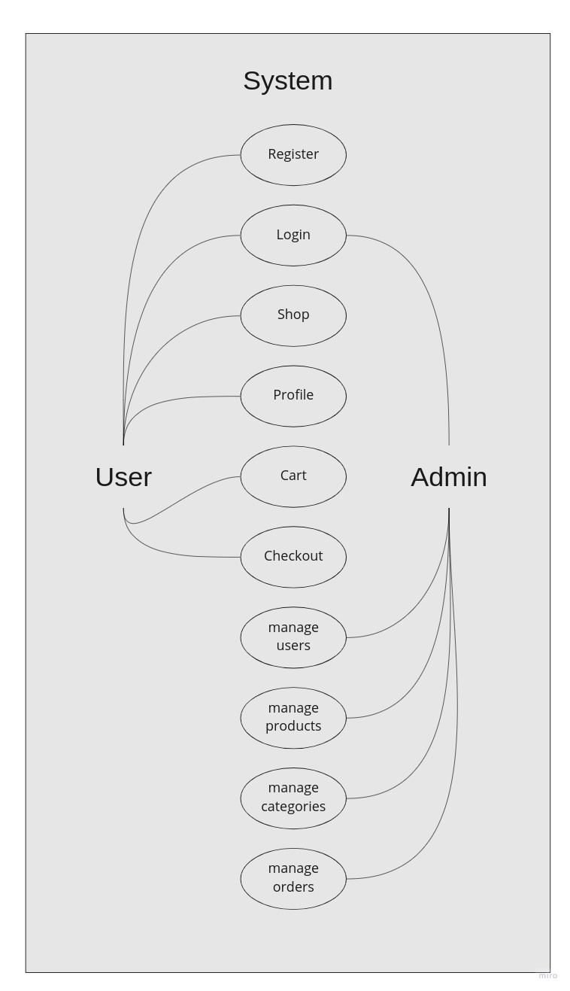

## Database Schema

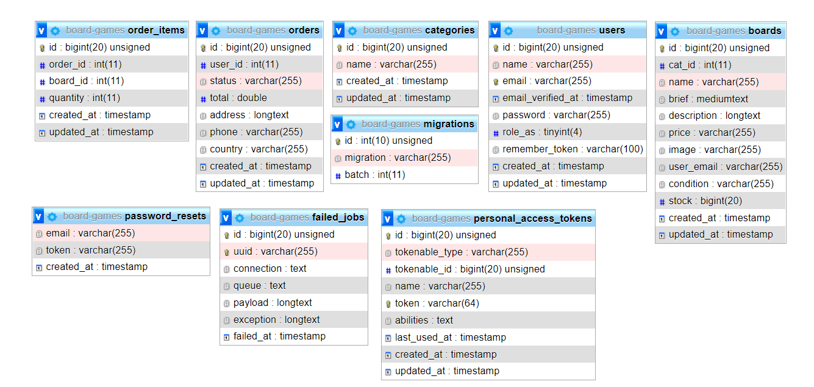

# Chapter 4: System Implementation

## Main System Wireframes

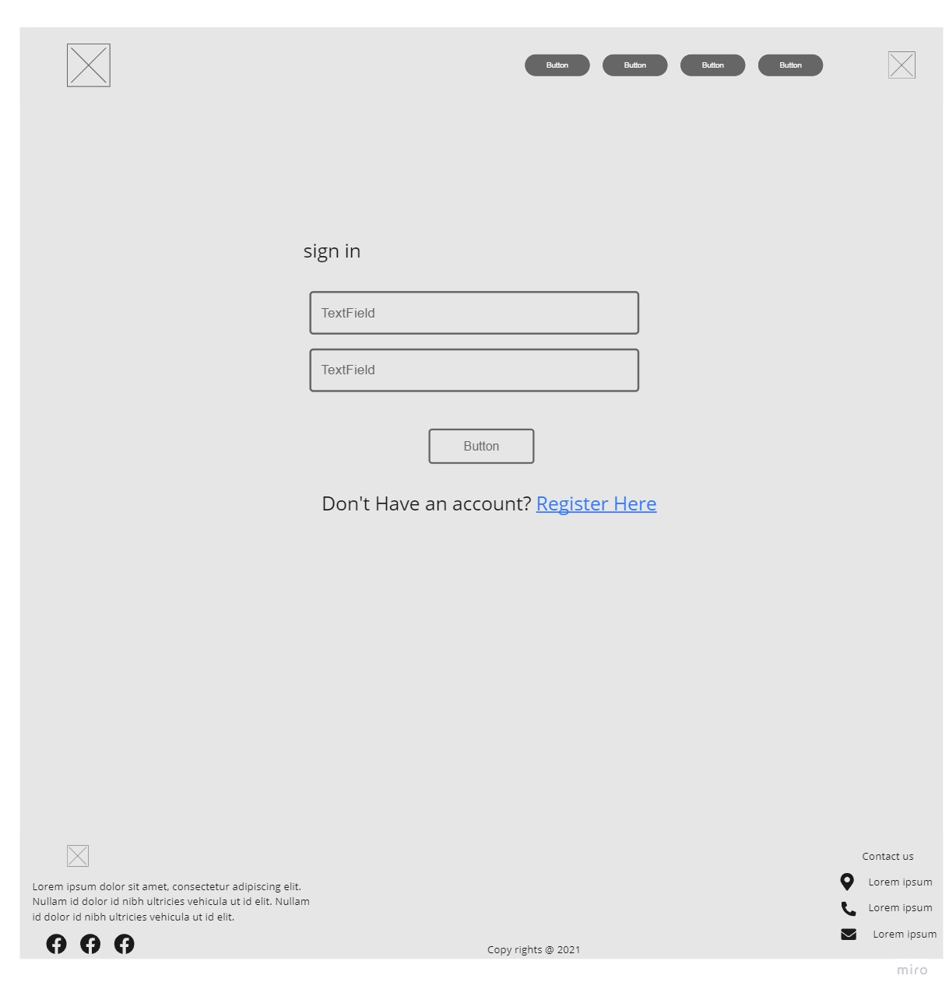

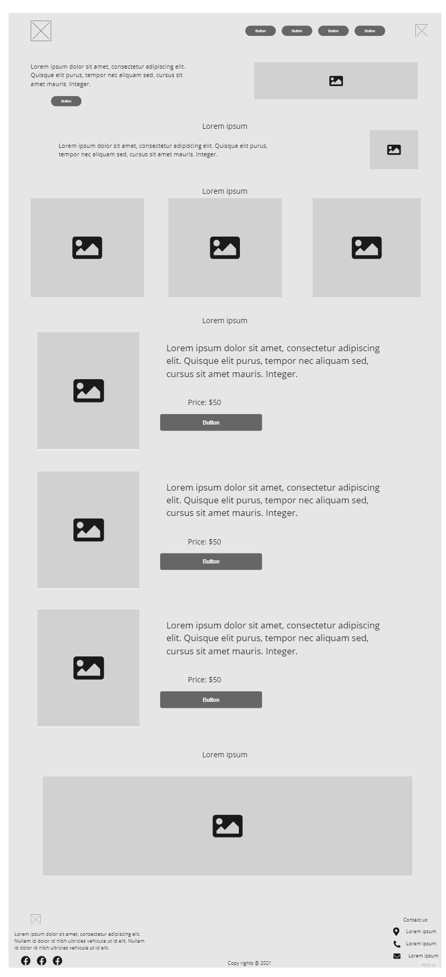

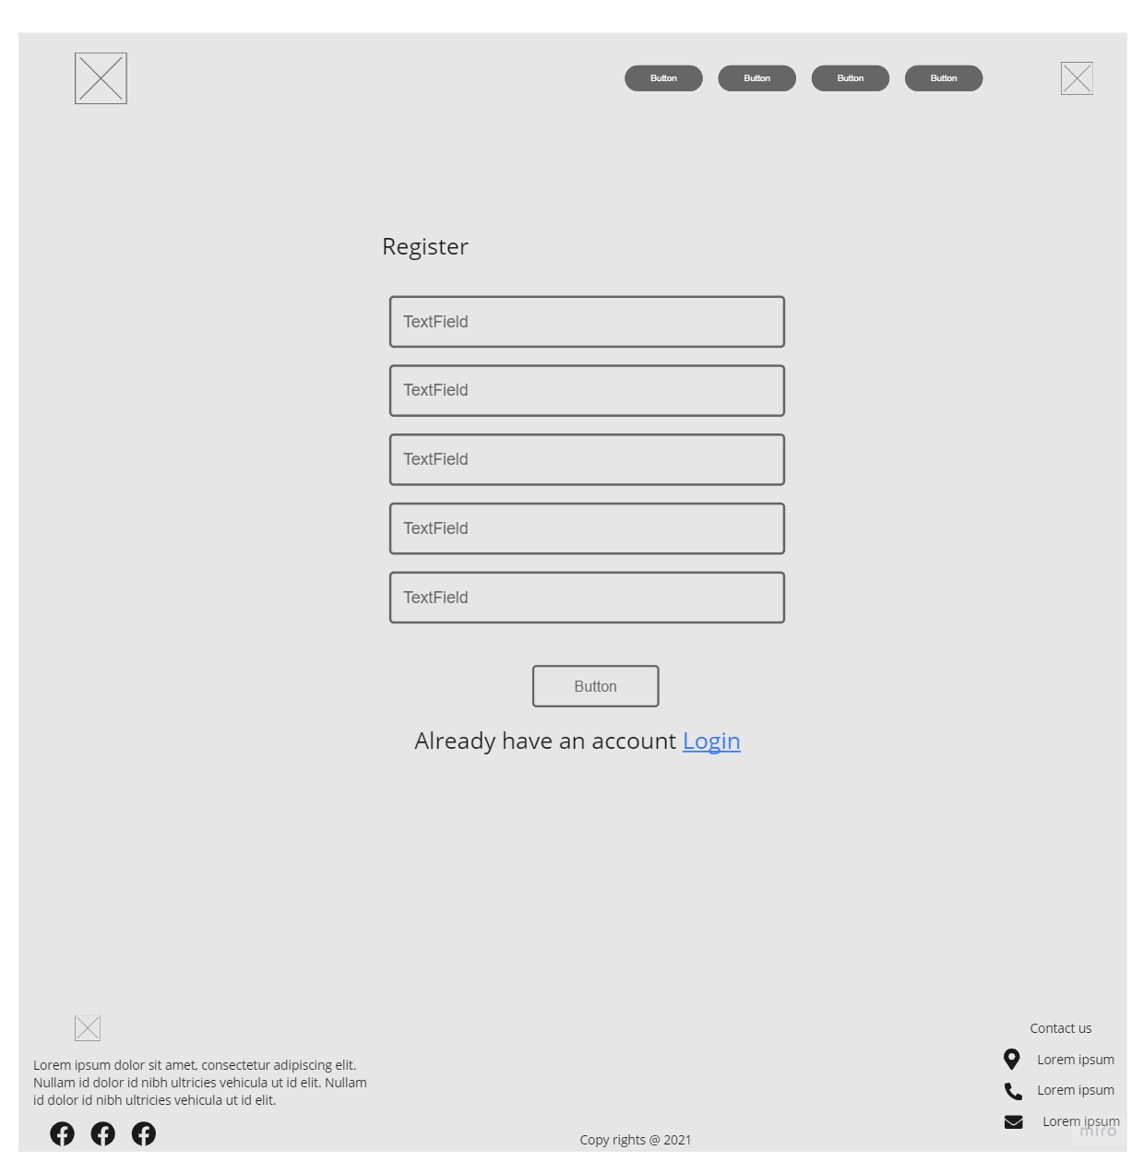

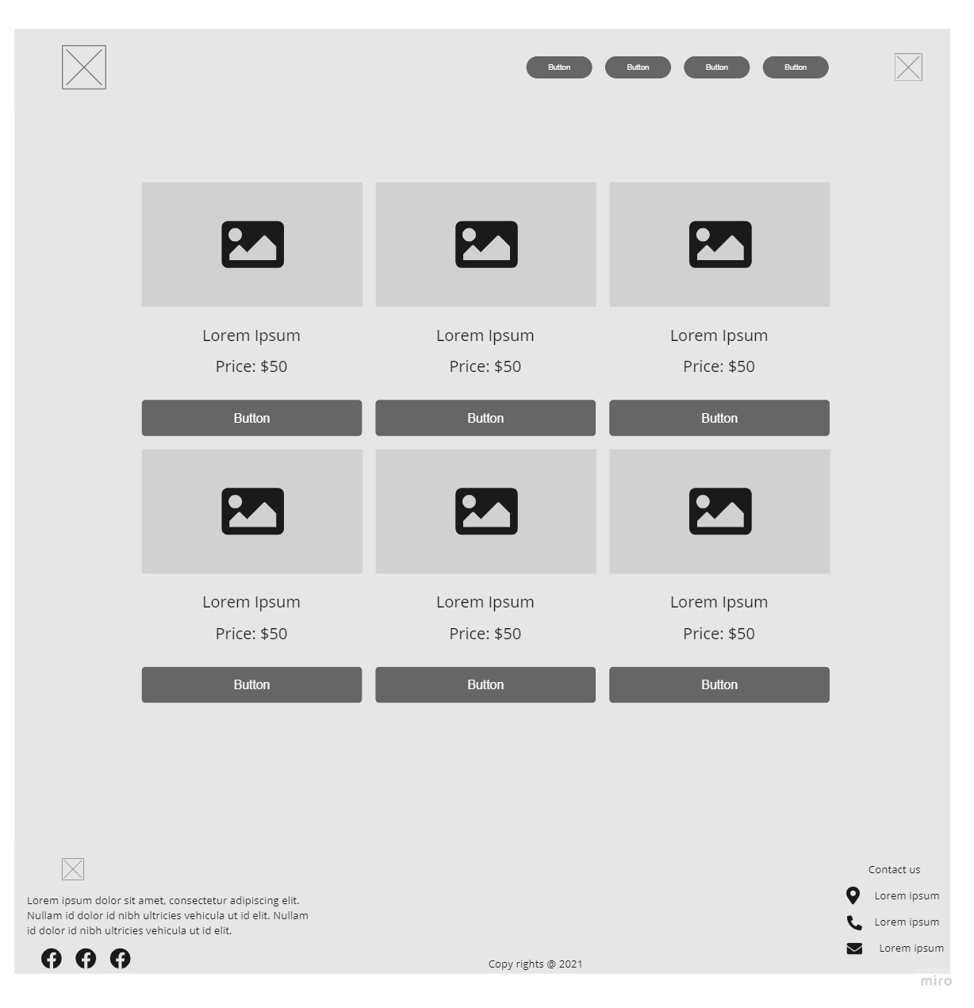

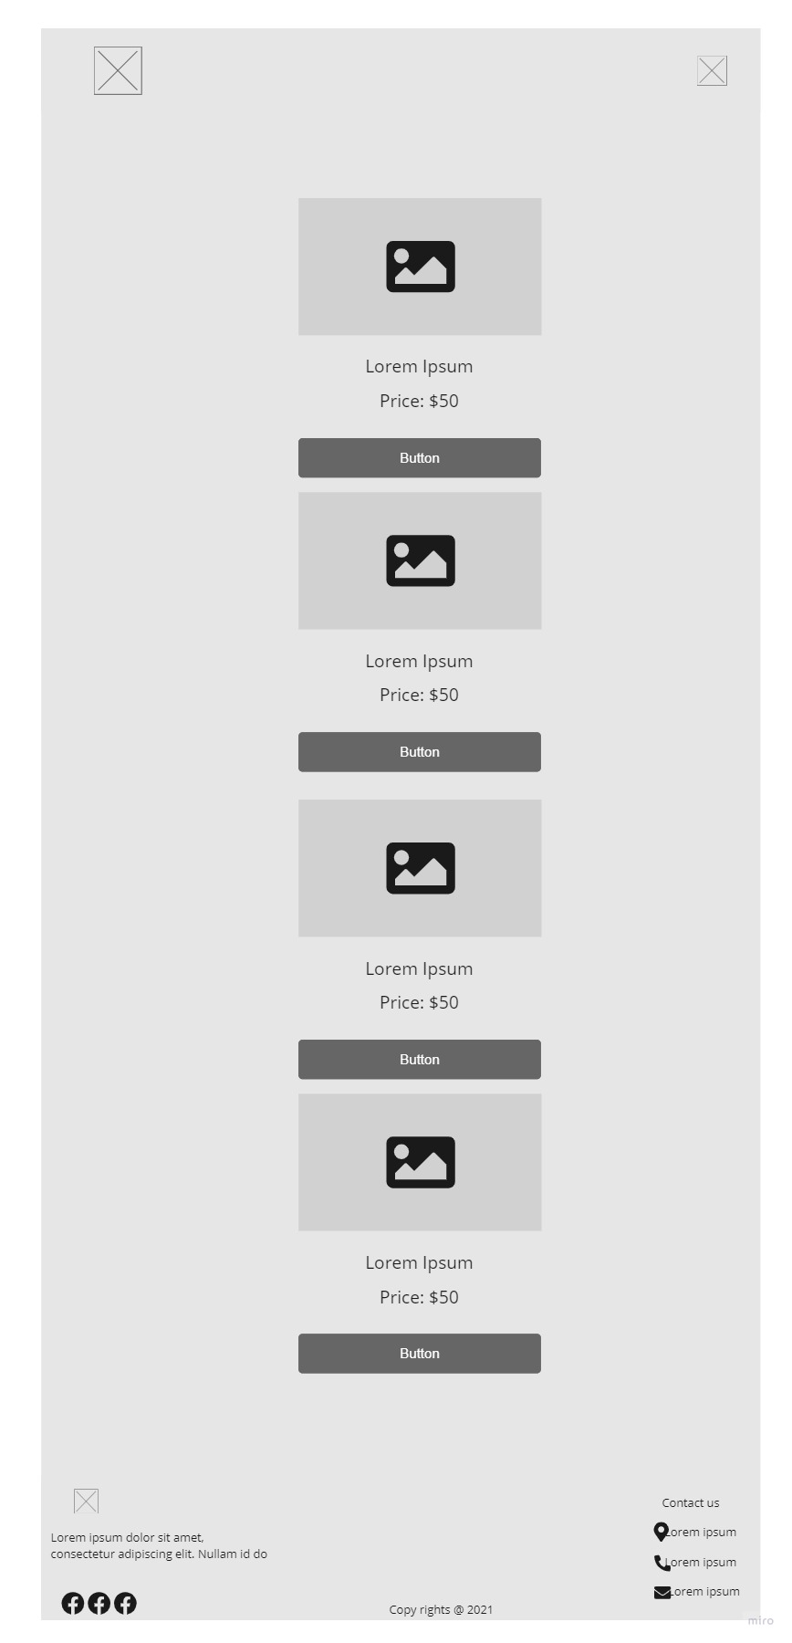

# 

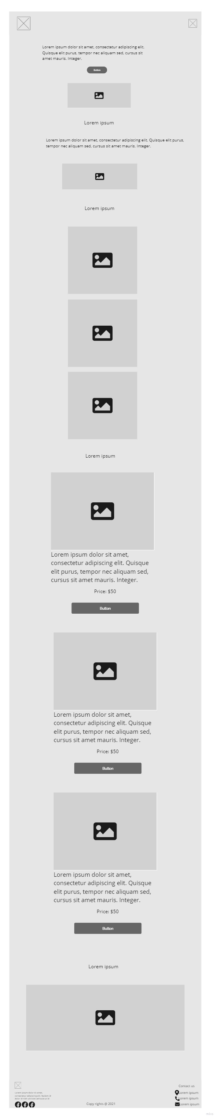

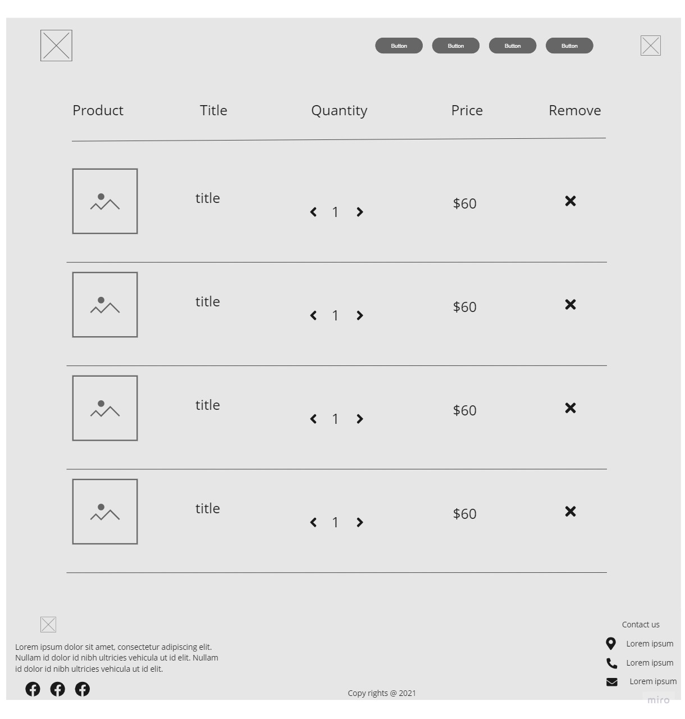

# Chapter 5: Conclusion & Future Work

## Conclusion

Everything nowadays is getting within reach to make our life much easier, and my website is here to help people have fun when going out with their loved ones.

My website will hopefully rekindle the love people have for board games and will help them choose and explore new board games to have fun with their group.

I learned a lot through the process of making this application, and I learned how to make a functional application connected to the database with live data. My searching and learning skills have improved a lot. It is not difficult to find something online and learn whole new concepts online.

Of course I had some difficulties and got stuck at some point but all of this made me learn more and fix every problem and learn a lot about what happened and how to fix a similar problem if I faced it in the future.

Even for the interfaces I had challenges dealing with how we are going to implement something in my mind as an interface or learning about the design patterns and the best way to implement them with.

Using React and Laravel together was a challenge but a welcome one, facing all these errors and learning a lot about their usage was an amazing journey that helped develop and enrich my programming experience and knowledge. Using MySQL proved to be a right choice as it is extremely easy and fun to use with laravel.

## Future work

I am planning to make a lot of things in my applications in the future:

* + 1. Allowing users to add board games on their own without contacting me.
    2. add more customized searches and filters based on users feedback.
    3. Allowing users to monitor their customers orders.
    4. Add following and followers for the application so that any user can follow each other.
    5. Add notifications so that other users can know when their favorite board games are back in stock.
    6. Add videos to each board game to showcase how to play the game and its rules.
    7. Add register with email and Facebook and phone number.
    8. Making users able to chat with other users.
    9. Making the application multi language.

# Appendix

Any additional information or data that supports or extends the main document or report.