Side Band Link Controller Unit (SB_LinkController)
Module Name: Link_Controller Unit: Side Band (SB) Version: 3.0
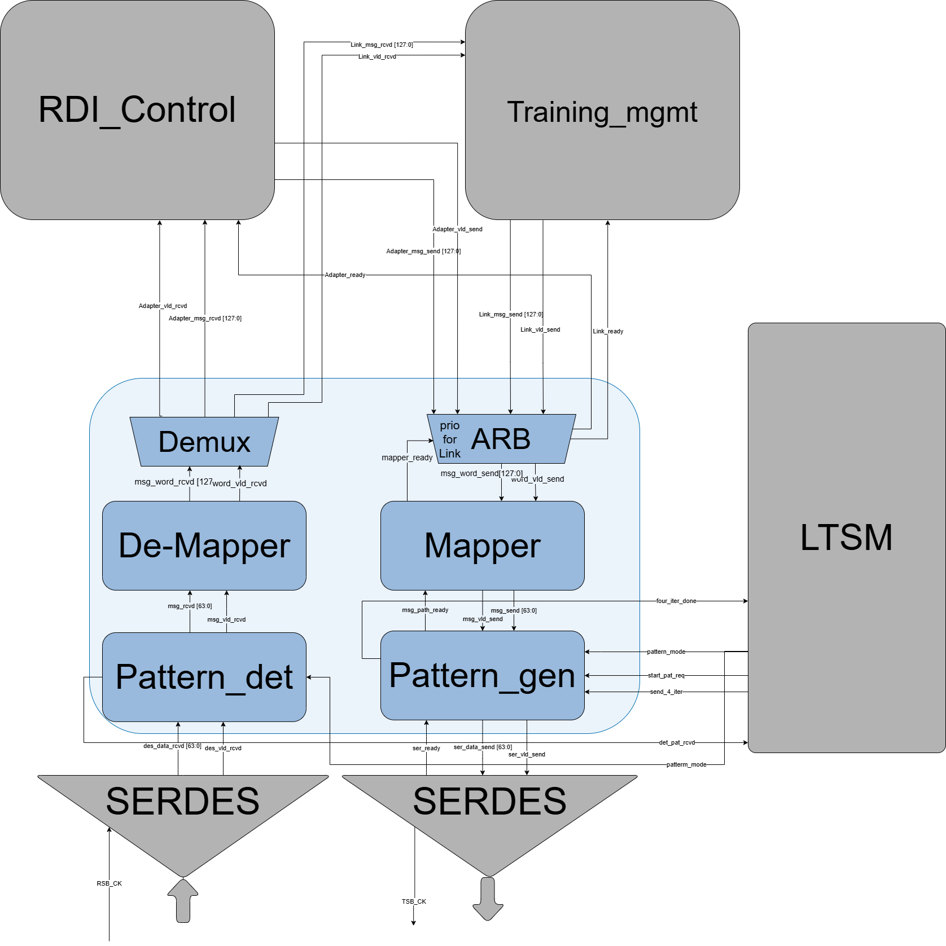

1. Features
The Link Controller manages the physical layer interaction for the Side Band channel, handling arbitration, data mapping, and SerDes timing requirements.
- Priority-Based Arbitration: Ensures Link_Management messages are prioritized over Adapter messages.
- Dynamic Mapping (TX): Automatically splits 128-bit packets into two 64-bit transfers or sends 64-bit packets in a single cycle.
- Strobe Management: Controls the tx_sb_clk (strobe) to latch data during the 32 UI idle window and handles idle states.
- Packet Reconstruction (RX): Reassembles 64-bit chunks from SerDes into full 128-bit or 64-bit messages based on header decoding.
- Smart Routing (Demux): Routes received messages to the appropriate internal destination (Link Management or Adapter).
- Pattern Generation (TX): The Pattern_gen block inserts configurable training patterns into the TX datapath under LTSM control. In normal operation, it acts as a transparent pass-through.
- Pattern Detection (RX): The Pattern_det block monitors incoming SerDes data for expected training patterns and reports detection status to the LTSM.
- LTSM Integration: A dedicated interface to the Link Training State Machine (LTSM) orchestrates full training sequences via pattern_mode, start_pat_req, req_iter_count, iter_done and det_pat_rcvd signals.

2. Architecture & Operations

2.1. Transmit (TX) Flow
1. Arbitration: The TX Arbiter monitors requests. If Link_vld_send (from training Management) is high, it takes priority. Otherwise, it services the Adapter_msg_send.
2. Packet Mapping: The Mapper decodes the message header. If it's 128-bit, it sequences the data over two 64-bit cycles. If 64-bit, it completes in one cycle.
3. Pattern Generation: The mapped data passes through the Pattern_gen block before reaching the SerDes.
○ Normal mode (pattern_mode = 0): data passes through transparently.
○ Training mode (pattern_mode = 1): Pattern_gen generates LTSM-controlled patterns. On start_pat_req assertion, the block begins pattern transmission. If send_iter_count is not equal zero, the pattern (64 UI of clock pattern (101010…..01) followed by 32 of zeros) is sent that number of iter consecutively; on completion, iter_done is pulsed to the LTSM.

4. SerDes Interface: Data is transferred to the SerDes via ser_data_send[63:0]. If a message is active, ser_vld_send is asserted. If the channel is idle during an active window, ser_vld_send remains at '0' to prevent false latches.

2.2. Receive (RX) Flow

1. Pattern Detection: Incoming SerDes data (des_data_rcvd[63:0]) is first processed by the Pattern_det block.
○ Training mode (pattern_mode = 1): Pattern_det monitors the data stream for the expected training pattern (64 UI of clock pattern (101010…..01) followed by 32 of zeros ) two times consecutively. On successful detection, det_pat_rcvd is asserted to the LTSM.
○ Normal mode (pattern_mode = 0): data passes through transparently to the De-Mapper as msg_rcvd[63:0].

2. De-mapping: The De-mapper captures the first 64 bits from Pattern_det. It checks the header to see if the message length is 128 bits; if so, it buffers the first half and waits for the second half in the next cycle.

3. Routing: The assembled message is passed to the Demux, which identifies the message type and asserts the valid signal to either Link Management or the Adapter.
3. Sub-Block Interface Tables

3.1. Block: TX Arbiter
Signal Name | Direction | Width | Description
Link_msg_send[127:0] [UPDATED] | Input | 128 | High priority message from Link Management.
Link_vld_send [UPDATED] | Input | 1 | Valid signal from Link Management.
Adapter_msg_send[127:0] [UPDATED] | Input | 128 | Message from the Die-to-Die Adapter (lower priority).
Adapter_vld_send [UPDATED] | Input | 1 | Valid signal from the Adapter.
mapper_ready | Input | 1 | Ready signal from the Mapper block.
Link_ready | Output | 1 | Ready signal to Link Management.
Adapter_ready | Output | 1 | Ready signal to Adapter.
msg_word_send[127:0] | Output | 128 | Selected message forwarded to the Mapper.
word_vld_send [UPDATED] | Output | 1 | Valid signal for the selected message.

3.2. Block: TX Mapper

Signal Name | Direction | Width | Description
msg_word_send[127:0] | Input | 128 | Message from the TX Arbiter.
word_vld_send [UPDATED] | Input | 1 | Valid signal from the TX Arbiter.
mapper_ready | Output | 1 | Backpressure to TX Arbiter.
msg_send[63:0] | Output | 64 | 64-bit data chunk forwarded to Pattern_gen.
msg_vld_send [UPDATED] | Output | 1 | Valid signal to Pattern_gen; stays 0 if no valid data.
msg_path_ready [NEW] | Input | 1 | Backpressure from Pattern_gen; Mapper pauses when de-asserted.

3.3. Block: RX De-Mapper

Signal Name | Direction | Width | Description
msg_rcvd[63:0] [UPDATED] | Input | 64 | 64-bit data received from Pattern_det (pass-through or training-filtered).
msg_vld_rcvd [UPDATED] | Input | 1 | Valid/strobe from Pattern_det.
msg_word_rcvd[127:0] | Output | 128 | Reconstructed 64-bit or 128-bit message.
word_vld_rcvd [UPDATED] | Output | 1 | Asserts when the full packet is ready for routing.

3.4. Block: RX Demux (Router)

Signal Name | Direction | Width | Description
msg_word_rcvd[127:0] | Input | 128 | Message from the De-Mapper.
word_vld_rcvd [UPDATED] | Input | 1 | Valid signal from the De-Mapper.
Link_msg_rcvd[127:0] [UPDATED] | Output | 128 | Message routed to Link Management.
Link_vld_rcvd [UPDATED] | Output | 1 | Valid signal for Link Management.
Adapter_msg_rcvd[127:0] | Output | 128 | Message routed to the Die-to-Die Adapter.
Adapter_vld_rcvd [UPDATED] | Output | 1 | Valid signal for the Adapter.

3.5. Block: Pattern_gen [NEW]
Inserted between the TX Mapper and SerDes. Transparently passes data in normal mode; generates LTSM-controlled training patterns in training mode.
Signal Name | Direction | Width | Description
msg_send[63:0] [NEW] | Input | 64 | 64-bit mapped data from TX Mapper.
msg_vld_send [NEW] | Input | 1 | Valid signal from TX Mapper.
pattern_mode [NEW] | Input | 1 | From LTSM: 0 = normal pass-through, 1 = training pattern generation.
start_pat_req [NEW] | Input | 1 | From LTSM: triggers start of pattern transmission.
send_iter_count [NEW] | Input | 3 | From LTSM: requests the pattern to be sent that number consecutive times.
ser_ready [NEW] | Input | 1 | SerDes ready indicator; Pattern_gen holds data until asserted.
msg_path_ready [NEW] | Output | 1 | Backpressure to TX Mapper; de-asserted when Pattern_gen is busy generating patterns.
ser_data_send[63:0] [NEW] | Output | 64 | 64-bit data stream to SerDes (normal data or training pattern).
ser_vld_send [NEW] | Output | 1 | Valid/strobe to SerDes; stays 0 when no data is being sent.
iter_done [NEW] | Output | 1 | Pulsed to LTSM when send_iter_count pattern iterations complete.

3.6. Block: Pattern_det [NEW]
Inserted between SerDes and the RX De-Mapper. Transparently passes received data in normal mode; monitors for expected training patterns in training mode and reports detection to LTSM.
Signal Name | Direction | Width | Description
des_data_rcvd[63:0] [NEW] | Input | 64 | Raw 64-bit data received from SerDes.
des_vld_rcvd [NEW] | Input | 1 | Valid/strobe from SerDes.
pattern_mode [NEW] | Input | 1 | From LTSM: 0 = normal pass-through, 1 = training pattern detection.
msg_rcvd[63:0] [NEW] | Output | 64 | Pass-through data to RX De-Mapper.
msg_vld_rcvd [NEW] | Output | 1 | Valid signal to RX De-Mapper.
det_pat_rcvd [NEW] | Output | 1 | Pulsed to LTSM when the expected training pattern is detected.

Top-Level Interface Summary

Signal Name | Direction | Width | Description
Link_Management
Link_msg_send[127:0] [UPD] | Input | 128 | High-priority TX message.
Link_vld_send [UPD] | Input | 1 | Valid flag for Link_msg_send.
Link_ready | Output | 1 | Ready/grant back to Link Management.
Link_msg_rcvd[127:0] [UPD] | Output | 128 | Received message routed to Link Management.
Link_vld_rcvd [UPD] | Output | 1 | Valid flag for Link_msg_rcvd.
Adapter / RDI_Control
Adapter_msg_send[127:0] [UPD] | Input | 128 | Low-priority TX message from Adapter.
Adapter_vld_send [UPD] | Input | 1 | Valid flag for Adapter_msg_send.
Adapter_ready | Output | 1 | Ready/grant back to Adapter.
Adapter_msg_rcvd[127:0] | Output | 128 | Received message routed to Adapter.
Adapter_vld_rcvd [UPD] | Output | 1 | Valid flag for Adapter_msg_rcvd.
SERDES — TX Path
TXDATASB | Output | 1 | Sideband serial output data lane.
TXCKSB | Output | 1 | Sideband output strobe clock.
ser_data_send[63:0] [UPD] | Output | 64 | Parallel TX data from Pattern_gen to SerDes for serialization.
ser_vld_send [UPD] | Output | 1 | Valid/strobe; SerDes latches data when asserted (was msg_vld_s).
ser_ready | Input | 1 | SerDes ready indicator during 32 UI idle window.
SERDES — RX Path
RXDATASB | Input | 1 | Sideband serial input data lane.
RXCKSB | Input | 1 | Sideband input strobe clock.
des_data_rcvd[63:0] [UPD] | Input | 64 | Parallel deserialized RX data; forwarded to Pattern_det (was msg_rcvd).
des_vld_rcvd [UPD] | Input | 1 | Valid strobe for received parallel data (was msg_vld_r).
LTSM [NEW]
pattern_mode [NEW] | Input | 1 | Enables training mode: 0 = normal, 1 = training. Broadcast to Pattern_gen and Pattern_det.
start_pat_req [NEW] | Input | 1 | Triggers pattern transmission in Pattern_gen.
send_iter_count [NEW] | Input | 3 | From LTSM: requests the pattern to be sent that number consecutive times.
iter_done [NEW] | Output | 1 | Pulsed by Pattern_gen when send_iter_count pattern iterations complete.
det_pat_rcvd [NEW] | Output | 1 | Pulsed by Pattern_det when the expected training pattern is detected.

