RDI Control Unit (SB_RDI_Control)
Module Name : RDI_Control Unit Version : latest

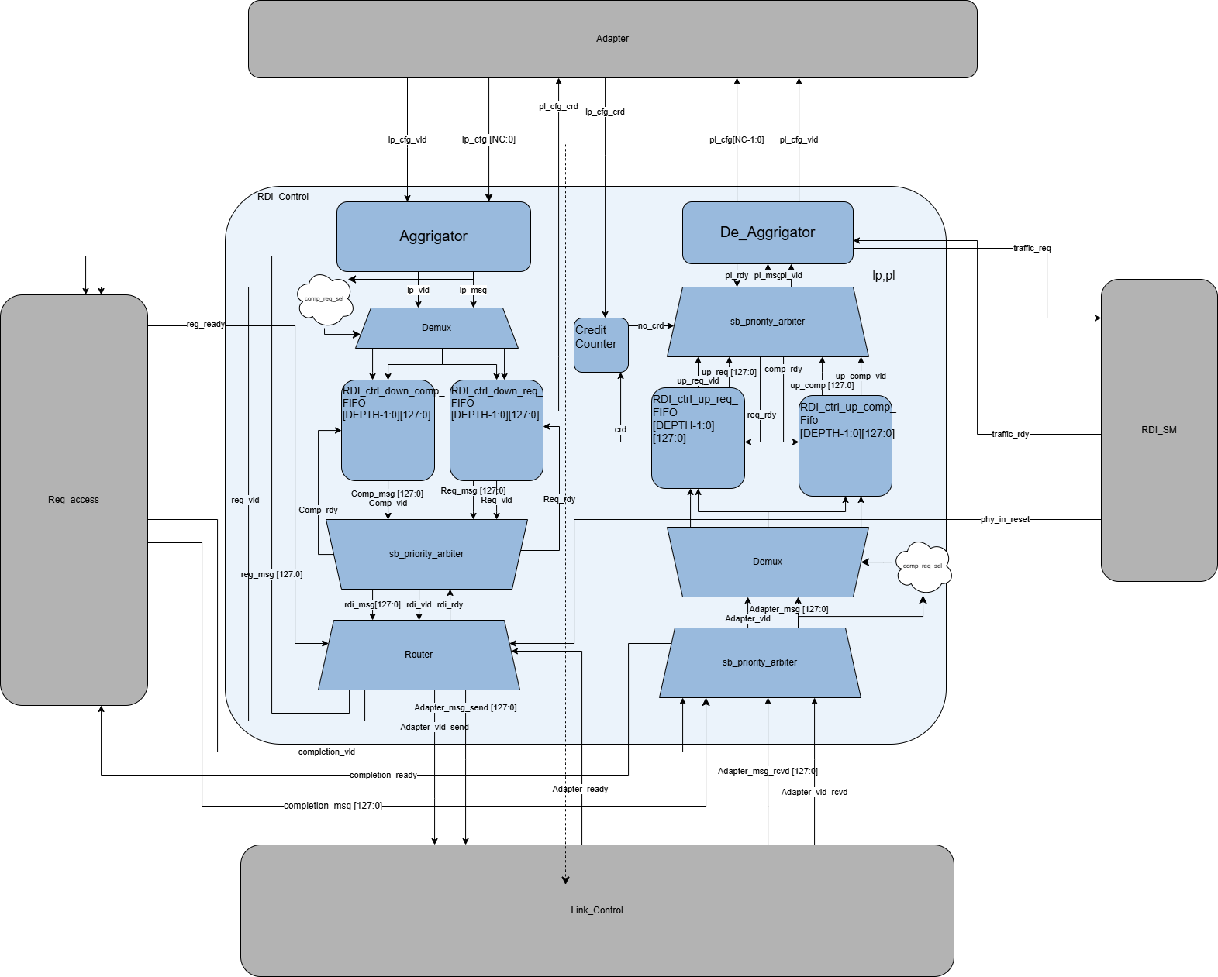

1. Feature
This block serves as the main controller for the UCIe Sideband RDI (Raw Die-to-Die Interface) protocol, managing the data flow between the Adapter (Upper Layer) and the Link Controller/Register Access blocks. Its main features include:
- Aggregation/De-aggregation: Converts the 32-bit interface from the Adapter (lp_cfg, pl_cfg) into 128-bit internal packets and vice versa, handling multi-cycle message assembly and disassembly based on packet opcodes.
- Flow Control & Credit Management: Manages the credit loop with the Adapter to prevent buffer overflow. It tracks upstream request credits using a dedicated credit counter (credit_counter) to gate requests when credits are exhausted, while allowing completion packets to bypass credit checks to avoid deadlocks. On the downstream path, it returns credits (pl_cfg_crd) to the Adapter once downstream requests are consumed from the queues.
- Routing & Demuxing: Decodes downstream packets to route them based on the destination ID (dstid) or the reset status (phy_in_reset). Under normal operation, local requests are routed to the Register Access block, and remote messages are sent to the Link Controller. During reset, requests are routed locally to return completions, and other messages are safely dropped to prevent system hangs.
- Multi-stage Priority Arbitration: Implements priority-based arbitration across three separate stages to optimize throughput and comply with protocol ordering:
  - Downstream FIFO Arbitration: Prioritizes downstream completion packets over downstream request packets.
  - Upstream Merge Arbitration: Prioritizes incoming remote traffic from the Link Controller over local completion messages from the Register Access block.
  - Upstream FIFO Arbitration: Prioritizes upstream completion packets over credit-gated upstream request packets.
- Traffic Isolation & Ordering: Separates requests and completions into dedicated queues (Dual-FIFOs) in both upstream and downstream paths to satisfy UCIe packet ordering rules and eliminate head-of-line blocking.
- Synchronous Buffering: Utilizes four synchronous FIFOs to manage bandwidth and rate discrepancies between the 32-bit Adapter interface and the 128-bit internal bus.

2. Architecture & Operations

2.1. Downstream Path (Adapter to Internal)
This path handles messages originating from the Adapter and destined for either the local register space (Register Access block) or the external link (Link Controller).

2.1.1. Aggregator (rdi_aggregator)
- Operation: Receives 32-bit data chunks (lp_cfg) from the Adapter when lp_cfg_vld is asserted.
- Assembly: Accumulates data chunks over multiple cycles to construct a standardized 128-bit internal sideband packet (lp_msg). The total expected cycles depend on the packet opcode decoded during the first cycle:
  - Header Only (64-bit): Requires 2 cycles.
  - Header + 32-bit Data (96-bit): Requires 3 cycles.
  - Header + 64-bit Data (128-bit): Requires 4 cycles.
- Output: Standardizes the assembled packet by zero-padding the upper unused bits and asserts lp_msg_vld once the assembly is complete.

2.1.2. Downstream Split Demux (sb_demux)
- Operation: Receives the fully assembled 128-bit packet from the Aggregator and routes it to the appropriate downstream FIFO based on packet classification.
- Classification: Utilizes the completion/request decoder (rdi_comp_req_decoder) to evaluate the opcode:
  - Completions: (Opcodes representing completions with or without data) are routed to port 1 (dmx_comp_data / dmx_comp_vld) targeting the high-priority queue.
  - Requests & remote messages: (Opcodes representing memory, configuration, register reads/writes or remote messages) are routed to port 0 (dmx_req_data / dmx_req_vld) targeting the low-priority queue.

2.1.3. Downstream Dual-FIFOs (RDI_ctrl_down_req_FIFO & RDI_ctrl_down_comp_FIFO)
- Specifications: Dual synchronous FIFOs, each featuring a 128-bit width and a configurable depth (default is 32 entries).
- Isolation: By segregating requests (reg or remote msg) and completions into separate queues, the design prevents lower-priority requests from blocking high-priority completions.
- Credit Release: Upon popping a request from the request FIFO (dfifo_req_rinc), a credit return pulse is immediately sent back to the Adapter via pl_cfg_crd to notify it of available buffer space.

2.1.4. Downstream Priority Arbiter (sb_priority_arbiter)
- Operation: Arbitrates between the read ports of the two downstream FIFOs to forward packets to the router.
- Priority Rule: Complies with UCIe ordering rules by giving strict priority to the high-priority completion queue (RDI_ctrl_down_comp_FIFO) over the low-priority request queue (RDI_ctrl_down_req_FIFO).

2.1.5. Router (rdi_router)
- Operation: Evaluates the arbitrated packet and routes it based on the destination ID (dstid) and the system's reset status (phy_in_reset).
- Normal Mode (phy_in_reset is de-asserted):
  - Local Destination: If dstid == LOCAL_PHY, the packet is routed to the Register Access block via reg_msg and reg_vld.
  - Remote Destination: Otherwise, the packet is routed to the Link Controller via adapter_msg_send and adapter_vld_send.
- Reset Mode (phy_in_reset is asserted):
  - Requests: All incoming requests (local and remote) are routed to the Register Access block so it can generate an unsupported request (UR) completion back to the Adapter.
  - Completions & Messages: Safely dropped (popped from the FIFO and discarded) to prevent clogging the interface during a link reset state.

2.2. Upstream Path (Internal to Adapter)
This path handles incoming remote packets from the Link Controller and local completion messages from the Register Access block, routing them back to the Adapter.

2.2.1. Upstream Merge Arbiter (sb_priority_arbiter)
- Operation: Merges the two internal upstream traffic sources into a single stream.
- Priority Rule: Prioritizes incoming remote packets from the Link Controller (adapter_msg_rcvd on the High-Priority port) over local completion messages from the Register Access block (completion_msg on the Low-Priority port) to prevent buffering bottlenecks on the link interface.

2.2.2. Upstream Split Demux (sb_demux)
- Operation: Receives the merged stream and splits it into dedicated request and completion paths based on opcode decoding (rdi_comp_req_decoder).
  - Completions: Routed to the high-priority upstream completion queue (RDI_ctrl_up_comp_FIFO).
  - Requests: Routed to the low-priority upstream request queue (RDI_ctrl_up_req_FIFO).

2.2.3. Upstream Dual-FIFOs (RDI_ctrl_up_req_FIFO & RDI_ctrl_up_comp_FIFO)
- Specifications: Dual synchronous FIFOs with a 128-bit wide data bus.
- Behavior:
  - Completion FIFO: Operates without credit limitations. It always allows completions to pass through to prevent deadlocks on the return path.
  - Request FIFO: Read access is controlled and gated by the credit manager. A read increment (ufifo_req_rinc) is only generated when a credit is available.

2.2.4. Flow Control Credit Counter (credit_counter)
- Operation: Tracks outstanding receiver slots available in the peer Adapter to regulate upstream request transmission.
- Credit Rules:
  - Increment (+1): Triggered when the Adapter returns a credit via a pulse on lp_cfg_crd.
  - Decrement (-1): Triggered when an upstream request is read and forwarded from the request FIFO (ufifo_req_rinc).
  - Gate Signal (no_crd): If the internal credit counter reaches zero, the no_crd status flag is asserted. This immediately blocks the read enable of the Request FIFO and masks its validity at the upstream FIFO arbiter. Completions are exempt from this gating and bypass the check.

2.2.5. Upstream FIFO Arbiter (sb_priority_arbiter)
- Operation: Selects between the buffered completions and requests before forwarding them to the De-Aggregator.
- Priority Rule: Prioritizes completions over requests (reg or msg). When no_crd is asserted, the request port is disabled, allowing completions to bypass pending requests.

2.2.6. De-Aggregator (rdi_de_aggregator)
- Operation: Serializes 128-bit internal packets (pl_msg) back into 32-bit segments (pl_cfg) for the Adapter.
- Serialization Cycles: Based on opcode decoding, the De-Aggregator determines the packet size and drives the transmission over 2, 3, or 4 cycles:
  - 2-cycle packets: Sends msg_reg[31:0] followed by msg_flat[63:32].
  - 3-cycle packets: Sends up to msg_flat[95:64].
  - 4-cycle packets: Sends up to msg_flat[127:96].
- RDI State Machine Handshake:
  - When a new packet becomes valid at the FIFO arbiter, the De-Aggregator transitions from IDLE to WAIT_READY and asserts traffic_req to the RDI_SM block.
  - It holds transmission and waits for the traffic_rdy acknowledgement from RDI_SM (which manages adapter wake-up sequences).
  - Upon receiving traffic_rdy, it enters the OUTPUT_STATE and starts serializing the chunks, asserting pl_cfg_vld to the Adapter during transmission.

Interfaces Signals Listn

1.RDI Control Full Interface

Signal Name | Direction | Width | Description
clk | Input | 1 | System clock.
rst_n | Input | 1 | Active-low reset.
Adapter Interface
lp_cfg | Input | 32 | Downstream: adapter → RDI_Control (32-bit config chunk).
lp_cfg_vld | Input | 1 | Valid signal for lp_cfg.
pl_cfg_crd | Output | 1 | Credit return: downstream req FIFO consumed → adapter notified.
lp_cfg_crd | Input | 1 | Credit grant: adapter consumed one pl_cfg chunk.
pl_cfg | Output | 32 | Upstream: RDI_Control → adapter (32-bit config chunk).
pl_cfg_vld | Output | 1 | Valid signal for pl_cfg.
Link Controller Interface
adapter_msg_rcvd | Input | 128 | Upstream: Link → RDI_Control.
adapter_vld_rcvd | Input | 1 | Valid signal for adapter_msg_rcvd.
adapter_msg_send | Output | 128 | Downstream: RDI_Control → Link.
adapter_vld_send | Output | 1 | Valid signal for adapter_msg_send.
adapter_rdy | Input | 1 | Back-pressure from Link Controller.
Reg_Access Interface
reg_msg | Output | 128 | Request → Reg_Access.
reg_vld | Output | 1 | Valid signal for reg_msg.
reg_rdy | Input | 1 | Ready signal from Reg_Access.
completion_msg | Input | 128 | Completion ← Reg_Access.
completion_vld | Input | 1 | Valid signal for completion_msg.
completion_rdy | Output | 1 | Ready signal for Completion.
RDI_SM Interface
traffic_req | Output | 1 | Upstream traffic pending (to RDI_SM).
traffic_rdy | Input | 1 | SM grants upstream send window.
phy_in_reset | Input | 1 | Link/Soft Reset → route all requests locally (UR).

2. rdi_de_aggregator

Signal Name | Direction | Width | Description
clk | Input | 1 | System clock.
rst_n | Input | 1 | Active-low reset.
pl_msg | Input | 128 (sb_packet_t) | Message from Arbiter.
pl_msg_vld | Input | 1 | Valid signal for pl_msg.
pl_msg_rdy | Output | 1 | Ready signal to Arbiter.
traffic_req | Output | 1 | Request to PHY/Link layer.
traffic_rdy | Input | 1 | Ready from PHY/Link layer.
pl_cfg | Output | 32 | Outgoing 32-bit chunk to adapter.
pl_cfg_vld | Output | 1 | Valid signal for pl_cfg.

2.3 rdi_router

Signal Name | Direction | Width | Description
rst_n | Input | 1 | Active-low reset.
reset | Input | 1 | Sideband or link reset flag.
rdi_msg | Input | 128 | Message from Arbiter (TX path).
rdi_vld | Input | 1 | Valid signal for rdi_msg.
rdi_rdy | Output | 1 | Ready signal back to Arbiter.
reg_msg | Output | 128 | Message to Reg_Access block.
reg_vld | Output | 1 | Valid signal for reg_msg.
reg_rdy | Input | 1 | Ready signal from Reg_Access block.
adapter_msg_send | Output | 128 | Message to Link (Adapter down-to-Link).
adapter_vld_send | Output | 1 | Valid signal for adapter_msg_send.
adapter_rdy | Input | 1 | Ready signal from Link.

2.4 sb_priority_arbiter (Used 3 times: Arb #1, #2, #3)

Signal Name | Direction | Width | Description
hip_msg | Input | 128 | High priority message.
hip_vld | Input | 1 | Valid for high priority message.
hip_rdy | Output | 1 | Ready to high priority source.
lop_msg | Input | 128 | Low priority message.
lop_vld | Input | 1 | Valid for low priority message.
lop_rdy | Output | 1 | Ready to low priority source.
out_msg | Output | 128 | Arbitrated output message.
out_vld | Output | 1 | Valid for output message.
out_rdy | Input | 1 | Ready from downstream receiver.

2.5 rdi_comp_req_decoder

Signal Name | Direction | Width | Description
pkt | Input | 128 | Incoming SB packet.
sel | Output | 1 | Select line: 0 = request, 1 = completion.

2.6 sb_demux (Used for Request/Completion Split)

Signal Name | Direction | Width | Description
data_in | Input | 128 | Incoming data.
vld_in | Input | 1 | Valid signal for data_in.
sel | Input | 1 | Select line (from Decoder).
data_out_0 | Output | 128 | Output port 0 (typically Requests).
vld_out_0 | Output | 1 | Valid for output port 0.
data_out_1 | Output | 128 | Output port 1 (typically Completions).
vld_out_1 | Output | 1 | Valid for output port 1.

2.7 credit_counter

Signal Name | Direction | Width | Description
clk | Input | 1 | System clock.
rst_n | Input | 1 | Active-low reset.
crd_in | Input | 1 | +1: credit received from peer.
crd_out | Input | 1 | -1: credit consumed.
no_crd | Output | 1 | 1 when count == 0 (used to gate requests).

2.8 FIFO (Used 4 times: Up/Down, Req/Comp)

Signal Name | Direction | Width | Description
W_CLK | Input | 1 | Write clock.
WRST_N | Input | 1 | Write reset (active-low).
WINC | Input | 1 | Write increment / Push.
WR_DATA | Input | 128 | Data to be written.
WFULL | Output | 1 | FIFO full flag.
WREADY | Output | 1 | FIFO ready to write.
R_CLK | Input | 1 | Read clock.
RRST_N | Input | 1 | Read reset (active-low).
RINC | Input | 1 | Read increment / Pop.
RD_DATA | Output | 128 | Read data output.
REMPTY | Output | 1 | FIFO empty flag.
RVALID | Output | 1 | Valid read data.

8.rdi_aggregator

Signal Name | Direction | Width | Description
clk | Input | 1 | System clock.
rst_n | Input | 1 | Active-low reset.
lp_cfg[31:0] | Input | 32 | Incoming config chunks from the adapter.
lp_cfg_vld | Input | 1 | Valid strobe for the incoming chunks.
lp_msg | Output | 128 | Fully assembled 128-bit Sideband packet (struct).
lp_msg_vld | Output | 1 | Valid strobe for the assembled packet.

