Module Name: Reg_Access

Unit Version: 3

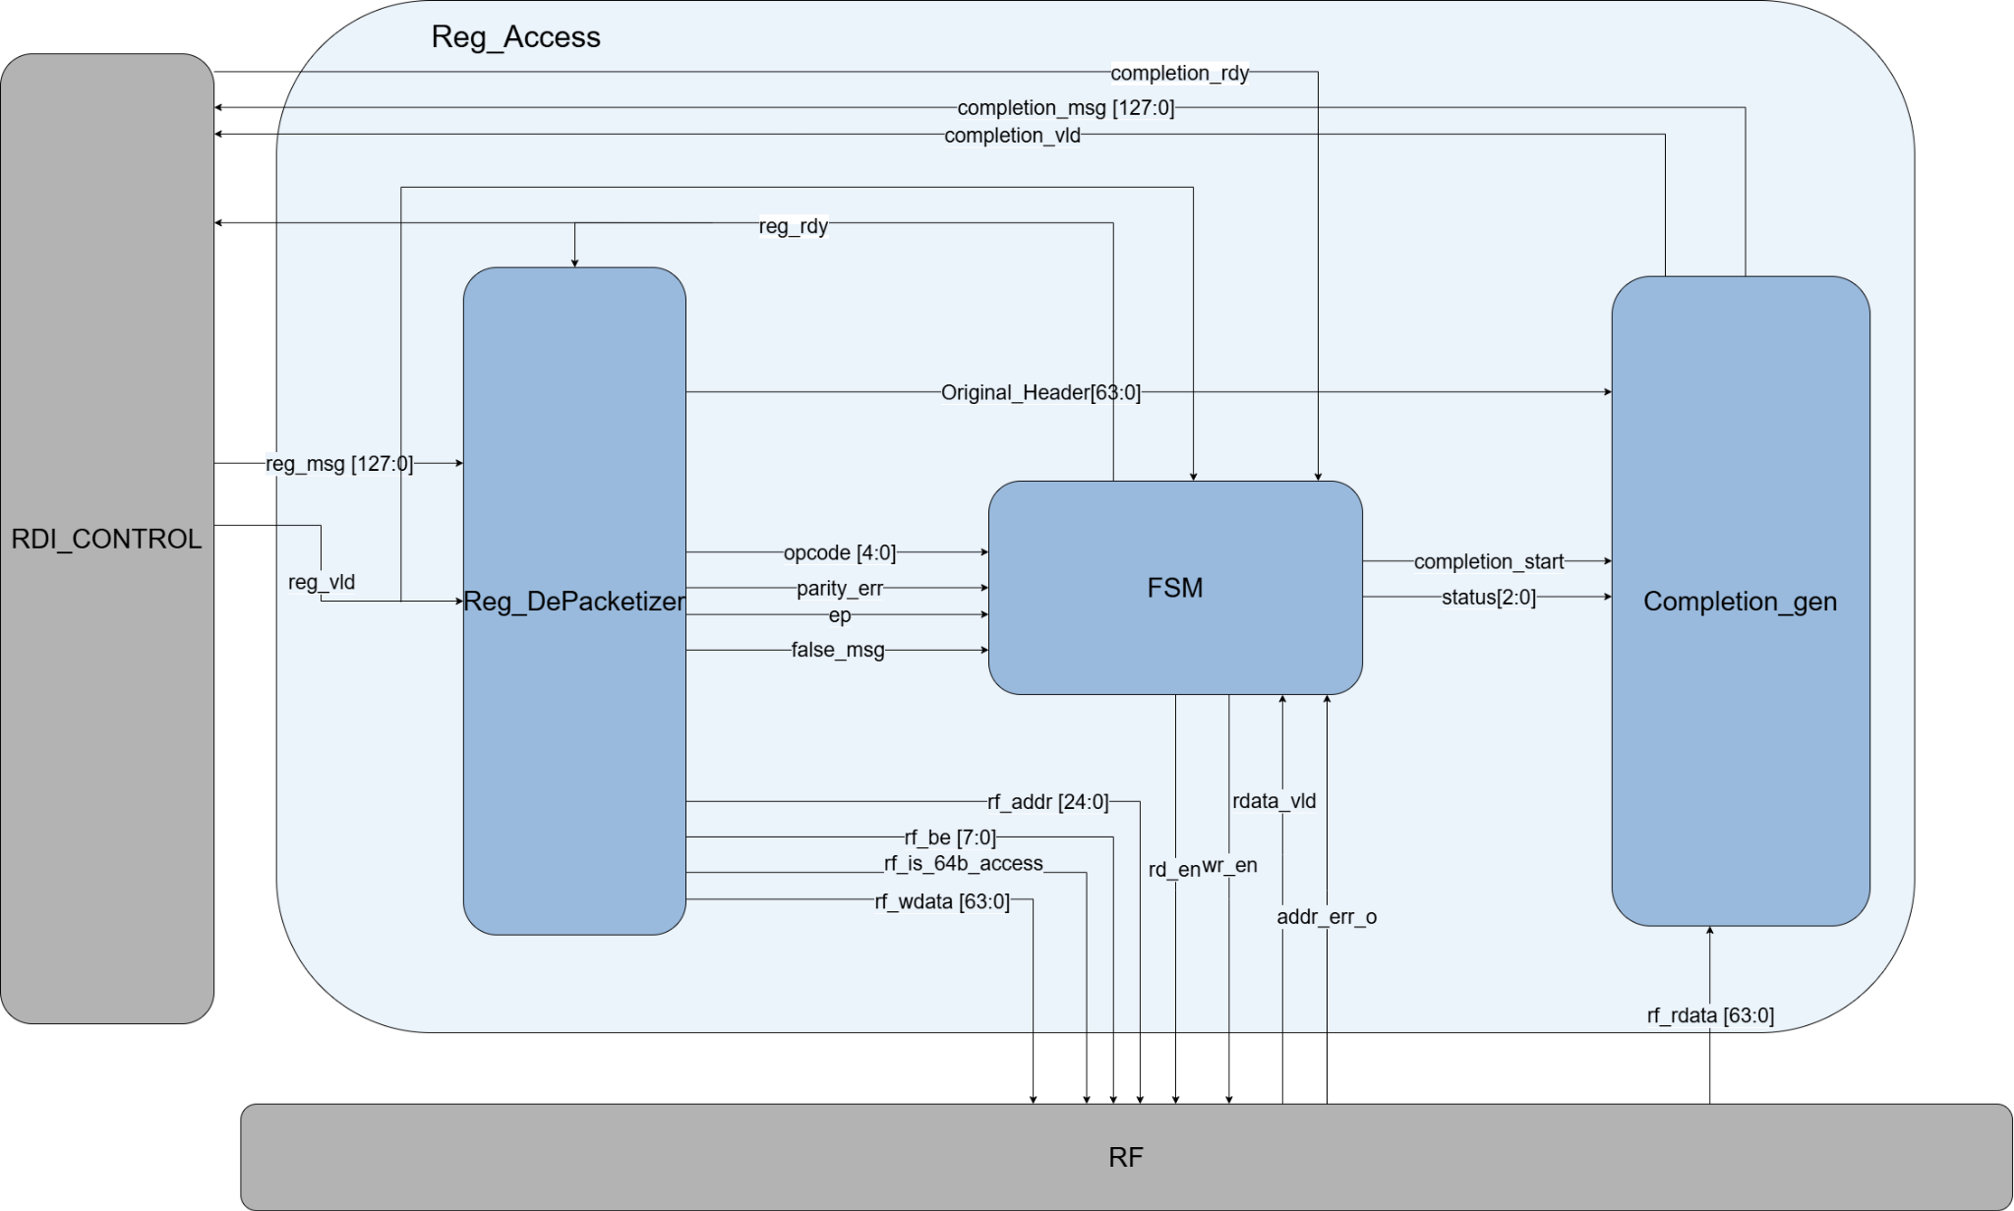

1. Feature
The Reg_Access module serves as the primary control and datapath wrapper for processing Register Access commands within the UCIe PHY Sideband (PHY_SB) layer. It decodes incoming 128-bit sideband packets (reg_msg), coordinates with the internal Register File (Reg_File) to execute 32-bit/64-bit Configuration (CFG) or Memory (MEM) Reads and Writes, and safely packages response packets (completion_msg) using even parity schemes.
A critical feature implemented in this RTL version is the UR/CA Fast-Forward Execution: any transaction flagged with a Parity Error, False Destination ID, or Poison bit bypasses the Register File execution entirely and immediately generates an Unsupported Request (UR) completion carrying the original request header as payload.

2. Architecture & Operations
The module decomposes the processing pipeline into three tightly-coupled sub-modules:

A. Reg_DePacketizer (Parsing Stage)
- Packet Capture: On a valid handshake (reg_vld && reg_rdy), the full 128-bit packet is registered into latched_pkt.
- Field Extraction: The lower 64 bits are mapped into the sb_header_u union to split fields like opcode, tag, be, and dstid. The upper 64 bits (latched_pkt[127:64]) are routed straight out as rf_wdata.
- Address Decoding: Extends the header's 24-bit address (hdr.req.addr) into a 25-bit internal address (rf_addr). Bit [24] is decoded as the space bit (asserted 0 for CFG opcodes, and 1 for MEM/DMS opcodes).
- Pre-Execution Error Checks: * Compares the received control parity bit (hdr.req.cp) against the calculated even parity over the lower 62 bits.
  - Asserts false_msg if the packet's destination ID (dstid) does not match LOCAL_PHY (3'b010).

B. Reg_Access_FSM (Control & Sequencing Stage)
The controller tracks a 4-state synchronous state machine (IDLE, DECODE, EXECUTE, GEN):
- IDLE (2'b00): Asserts reg_rdy. When reg_vld is sensed, transitions to DECODE.
- DECODE (2'b01): Evaluates compilation errors (error = parity_err || false_msg || ep || rf_addr_err). If any error flag is high, it branches directly to GEN to block malicious or corrupted inputs from hitting the hardware registers. Otherwise, it moves to EXECUTE.
- EXECUTE (2'b10): Asserts rd_en (for reads) or wr_en (for writes). For write operations, it exits instantly to GEN. For reads, it stalls until the register file drives rdata_vld high.
- GEN (2'b11): Strops completion_start high for 1 cycle. Sets status = 3'b001 (UR) if an error occurred, or 3'b000 (SC) for successful completion. It loops back to IDLE once downstream clears completion_rdy.
- 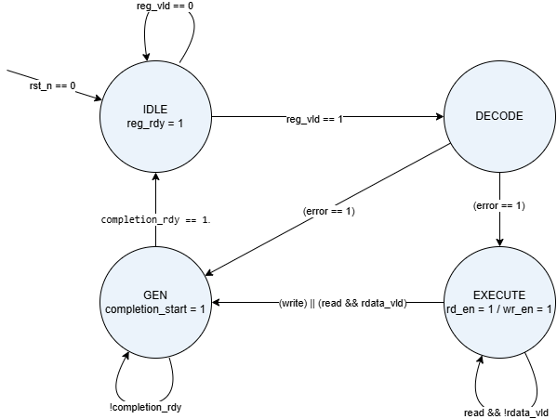

C. Completion_gen (Packet Construction Stage)
- Opcode Enforcement: Maps out response codes based on transaction success and sizing. Successful reads assign SB_COMPLETION_WITH_32_DATA or SB_COMPLETION_WITH_64_DATA. Successful writes trigger SB_COMPLETION_WITHOUT_DATA.
- Payload Muxing: Muxes the data returning to the network. For valid reads, it formats rf_rdata. For aborted transactions (status != 0), it automatically reflects the Original_Header back to the requester.
- Even Parity Generation: Computes Data Parity (dp) via a continuous XOR tree (^cpl_payload) over the payload. In the sequential block, it handles Control Parity (cp_final) by calculating the XOR reduction over the final 63 header bits (^hdr_low) before outputting the 128-bit transaction to the link.

3. Interfaces Signals List

Table 3.1: Top-Level Reg_Access Interface

Signal Name | Direction | Width | Description
clk | Input | 1 | System clock source for the sideband interface.
rst_n | Input | 1 | Active-low asynchronous reset.
reg_msg[127:0] | Input | 128 | Incoming raw 128-bit Register Access sideband request packet.
reg_vld | Input | 1 | Valid push signal from the RDI_control router.
reg_rdy | Output | 1 | Backpressure handshake signal indicating module is ready.
completion_msg[127:0] | Output | 128 | Formatted 128-bit sideband response message.
completion_vld | Output | 1 | Valid signal to Link TX Arbiter.
completion_rdy | Input | 1 | Clear-to-send handshake indicator from the TX path.
rf_addr[24:0] | Output | 25 | Fully formed register byte address {space, addr[23:0]}.
rf_be[7:0] | Output | 8 | Active-byte write enables derived from the request header.
rf_is_64b_access | Output | 1 | Status bit indicating a 64-bit transaction length when high.
rf_wdata[63:0] | Output | 64 | 64-bit write data payload extracted from reg_msg[127:64].
rd_en | Output | 1 | Active-high read prompt to the local Register File.
wr_en | Output | 1 | Active-high write prompt to the local Register File.
rf_rdata[63:0] | Input | 64 | Read data payload retrieved from the Register File.
rdata_vld | Input | 1 | Done status indicating valid read data is sitting on rf_rdata.
addr_err_o | Input | 1 | Address decode fault signal sourced from the Register File.

Table 3.2: Reg_DePacketizer Sub-module Interface

Signal Name | Direction | Width | Description
clk | Input | 1 | Clock input.
rst_n | Input | 1 | Asynchronous reset.
reg_msg[127:0] | Input | 128 | 128-bit raw request packet input.
reg_vld | Input | 1 | Valid incoming packet indicator.
reg_rdy | Input | 1 | Intercepted ready handshake signal used to latch the input.
opcode[4:0] | Output | 5 | Decoded transaction type code (sb_opcode_e).
parity_err | Output | 1 | High if the evaluated even parity check detects a corruption.
ep | Output | 1 | Error Poison flag extracted directly from request header bit [5].
false_msg | Output | 1 | High if dstid target is illegal (not matching LOCAL_PHY).
rf_addr | Output | 25 | Synthesized address layout for the Register File.
rf_be | Output | 8 | Extracted byte enable array.
rf_is_64b_access | Output | 1 | High if opcode maps to a 64-bit transaction.
rf_wdata | Output | 64 | Write payload stripped from packet upper half.
Original_Header | Output | 64 | Preserved 64-bit transaction header to pass to Completion_gen.

Table 3.3: Reg_Access_FSM Sub-module Interface

Signal Name | Direction | Width | Description
clk | Input | 1 | Clock input.
rst_n | Input | 1 | Asynchronous reset.
reg_vld | Input | 1 | Input transaction request valid signal.
reg_rdy | Output | 1 | Handshake state output (Asserted high in IDLE).
completion_rdy | Input | 1 | Readiness signal check from downstream TX logic.
opcode | Input | 5 | Current request opcode from parsing block.
parity_err | Input | 1 | Pre-calculated parity mismatch error line.
ep | Input | 1 | Poison bit indicator from packet.
false_msg | Input | 1 | Invalid target routing error flag.
rd_en | Output | 1 | Active-high read strobe out to Register File.
wr_en | Output | 1 | Active-high write strobe out to Register File.
rdata_vld | Input | 1 | Valid read data gate line from Register File.
rf_addr_err | Input | 1 | Target fault error feedback from Register File.
status | Output | 3 | Outbound response status code (3'b000 = Success, 3'b001 = UR).
completion_start | Output | 1 | One-cycle execution pulse triggering packet assembly.

Table 3.4: Completion_gen Sub-module Interface

Signal Name | Direction | Width | Description
clk | Input | 1 | Clock input.
rst_n | Input | 1 | Asynchronous reset.
completion_start | Input | 1 | FSM sequence generation trigger.
status | Input | 3 | FSM status block input routing.
Original_Header | Input | 64 | Cached header image preserved during parsing stage.
rf_rdata | Input | 64 | Active datapath line carrying register contents.
rdata_vld | Input | 1 | Read content flag from register block.
completion_msg | Output | 128 | Fully calculated 128-bit sideband output completion packet.
completion_vld | Output | 1 | Active-high output valid transaction line.
completion_rdy | Input | 1 | Backpressure line checking downstream buffer space.

