Training_Mgmt
Block Documentation | Unit Version: latest

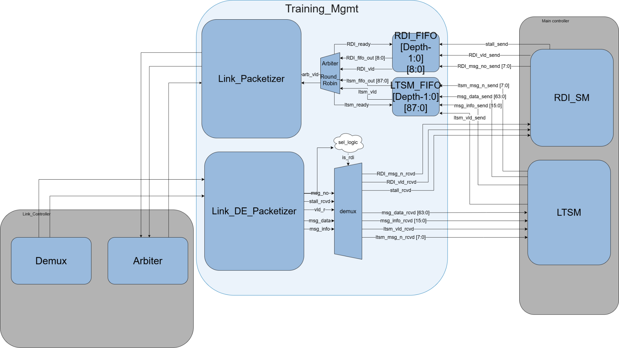

1. Feature
This block acts as the intermediate layer between the Protocol/Training logic (RDI_SM, LTSM) and the Physical transmission layer (Link Controller / SerDes). Its main features include:
Feature | Description
Packetization / De-packetization | Converts RDI_SM and LTSM coded control signals into standard 128-bit packets for transmission, and decodes received packets back to their respective destinations.
Protocol Isolation | Dedicated encoder/decoder pairs (RDI_Packetizer, LTSM_Packetizer, RDI_De-Packetizer, LTSM_De-Packetizer) ensure each protocol block receives only its relevant data with no cross-contamination.
Buffering | Two Synchronous FIFOs (RDI_MSG_FIFO and LTSM_MSG_FIFO, each 128-bit wide) absorb simultaneous messages from both sources and guarantee no data loss.
Arbitration | A Round-Robin Arbiter fairly schedules outgoing packets from the two FIFOs onto the shared Link Controller channel.
Flow Control | Manages handshake signals — Link_ready from the Link Controller (TX) and push_ready back to the Packetizers — to ensure data integrity throughout transmission.

2. Architecture & Operations
The Training_Mgmt block is internally divided into two independent data paths: the Transmit (TX) path and the Receive (RX) path. Each path has its own dedicated set of sub-blocks to ensure clean protocol isolation and predictable dataflow.
2.1 TX Path (Training_Mgmt → Link Controller)
The TX path is responsible for encoding & packaging outgoing messages from the RDI_SM and LTSM into 128-bit standard packets and forwarding them to the Link Controller in a fair, flow-controlled manner.

RDI_MSG_FIFO [DEPTH-1:0][127:0]
• Receives raw RDI transmit requests from RDI_SM.
• Buffers the RDI message opcode together with the stall indication.
• Exposes valid/ready handshake to the Arbiter.
• Does not perform packet formatting.

LTSM_MSG_FIFO [DEPTH-1:0][127:0]
• Receives raw LTSM message fields.
• Buffers.
- Message code.
- Message Info.
- Payload.
• Exposes valid/ready handshake to the Arbiter..

Arbiter (Round-Robin)

• Logic: Implements a Round-Robin algorithm, toggling between RDI_MSG_FIFO and LTSM_MSG_FIFO based on the not_empty status flags.
• Operation: Pops the selected message entry from either FIFO and forwards the corresponding message fields to the Packetizer.
• Handshake: Holds data and valid high until Link_ready is asserted by the Link Controller, then de-asserts valid and advances to the next cycle.
• Backpressure: Asserts push_ready toward both Packetizers to signal FIFO availability.

Packetizer
• Receives the arbitrated message fields from the Round-Robin Arbiter..
• Builds the standard 128-bit Training Packet.
• Inserts the proper packet header based on the message type.
• Generates trn_msg_send and trn_vld_send.
• Holds the packet until trn_rdy is asserted.
2.2 RX Path (Link Controller → Training_Mgmt)
The RX path receives raw 128-bit packets from the Link Controller and routes the decoded payloads to the appropriate destination block (RDI_SM or LTSM).

De-Packetizer
• Receives trn_msg_rcvd.
• Decodes the 128-bit Training Packet.
• Extracts.
- Message code.
- Message Info.
- Payload.
- Stall bit.
• Outputs decoded fields together with a valid indication.

Training_Mgmt_Demux
• Receives decoded fields from the DePacketizer.
• Determines the destination protocol based on the decoded Message Number.
• Routes RDI messages to RDI_SM.
• Routes LTSM messages to LTSM.
• Generates the corresponding valid signal for the selected destination.

1. Top Module: Training_Mgmt

Signal Name | Direction | Width | Description / Interface Domain
clk_main | Input | 1-bit | Main State Machine domain clock (LTSM/RDI_SM)
rst_main_n | Input | 1-bit | Main SM domain active-low reset
clk_sb | Input | 1-bit | Sideband domain clock
rst_sb_n | Input | 1-bit | Sideband domain active-low reset
RDI_msg_no_send | Input | [7:0] | RDI Message Number to be transmitted
stall_send | Input | 1-bit | Stall command from Main controller
RDI_vld_send | Input | 1-bit | Valid flag for outgoing RDI message
RDI_rdy | Output | 1-bit | Ready signal to RDI transmitter interface
ltsm_msg_n_send | Input | [7:0] | LTSM Message Number to be transmitted
msg_data_send | Input | [63:0] | LTSM Message payload data
msg_info_send | Input | [15:0] | LTSM Message additional metadata/info
ltsm_vld_send | Input | 1-bit | Valid flag for outgoing LTSM message
ltsm_rdy | Output | 1-bit | Ready signal to LTSM transmitter interface
RDI_vld_rcvd | Output | 1-bit | Valid flag for demuxed incoming RDI message
RDI_msg_no_rcvd | Output | [7:0] | Decoded incoming RDI message number
stall_rcvd | Output | 1-bit | Decoded incoming stall command
ltsm_vld_rcvd | Output | 1-bit | Valid flag for demuxed incoming LTSM message
ltsm_msg_no_rcvd | Output | [7:0] | Decoded incoming LTSM message number
msg_data_rcvd | Output | [63:0] | Decoded incoming LTSM payload data
msg_info_rcvd | Output | [15:0] | Decoded incoming LTSM message info
trn_msg_send | Output | [127:0] | 128-bit packetized message sent to external Link Controller
trn_vld_send | Output | 1-bit | Valid handshake for transmitted link message
trn_rdy | Input | 1-bit | Backpressure/ready signal from Link Controller
trn_msg_rcvd | Input | [127:0] | 128-bit raw message received from external Link Controller
trn_vld_rcvd | Input | 1-bit | Valid handshake for received link message

2. Internal Sub-Modules

2.1 DePacketizer Module

Signal Name | Direction | Width | Connected To / Description
clk | Input | 1-bit | System clock
rst_n | Input | 1-bit | Active-low reset
msg_in | Input | [127:0] | Raw packetized message from top input
vld_in | Input | 1-bit | Valid flag for msg_in
msg_no_out | Output | msg_no_e | Decoded message type enumeration
msginfo_r | Output | [15:0] | Decoded message info metadata
payload_r | Output | [63:0] | Decoded 64-bit message payload
vld_r | Output | 1-bit | Valid signal for the completely decoded fields
stall_rcvd | Output | 1-bit | Decoded stall status flag

2.2 Packetizer Module
Signal Name | Direction | Width | Connected To / Description
clk | Input | 1-bit | System clock
rst_n | Input | 1-bit | Active-low reset
msg_data_send | Input | [63:0] | Payload data coming from the Arbiter block
msg_info_send | Input | [15:0] | Metadata info from the Arbiter block
msg_no_send | Input | [7:0] | Message code from the Arbiter block
valid_send | Input | 1-bit | Valid status signal from the Arbiter block
trn_rdy | Input | 1-bit | External ready handshake from the Link Controller
stall_send | Input | 1-bit | Special RDI stall flag bit to packetize
trn_msg_send | Output | [127:0] | Final formatted 128-bit link message packet
trn_vld_send | Output | 1-bit | Handshake valid flag for the 128-bit link message
rdy | Output | 1-bit | Ready flow-control feedback to the Arbiter block

2.3 Training_Mgmt_Demux Module
Signal Name | Direction | Width | Connected To / Description
rx_msg_no_raw | Input | msg_no_e | Decoded message enumeration from DePacketizer
rx_msginfo_raw | Input | [15:0] | Decoded message metadata info from DePacketizer
rx_payload_raw | Input | [63:0] | Decoded message payload from DePacketizer
rx_vld_raw | Input | 1-bit | Decoded valid flag from DePacketizer
rx_stall_raw | Input | 1-bit | Decoded stall flag from DePacketizer
RDI_vld_rcvd | Output | 1-bit | Demultiplexed valid flag for the RDI client interface
RDI_msg_no_rcvd | Output | [7:0] | Demultiplexed RDI message identification code
stall_rcvd | Output | 1-bit | Demultiplexed active stall command indicator
ltsm_vld_rcvd | Output | 1-bit | Demultiplexed valid flag for LTSM client interface
ltsm_msg_no_rcvd | Output | [7:0] | Demultiplexed LTSM message identification code
msg_data_rcvd | Output | [63:0] | Demultiplexed 64-bit LTSM message payload data
msg_info_rcvd | Output | [15:0] | Demultiplexed 16-bit LTSM message metadata info

2.4 Round-Robin Arbiter (RR_arbiter) Module
Signal Name | Direction | Width | Connected To / Description
clk | Input | 1-bit | System clock
rst_n | Input | 1-bit | Active-low reset
ltsm_valid | Input | 1-bit | Valid data ready signal from LTSM FIFO module
ltsm_data | Input | [DATA_WIDTH-1:0] | Data payload coming directly out of LTSM FIFO
ltsm_ready | Output | 1-bit | Pop read-enable acknowledgement to LTSM FIFO
rdi_valid | Input | 1-bit | Valid data ready signal from RDI FIFO module
rdi_data | Input | [DATA_WIDTH-1:0] | Data payload coming directly out of RDI FIFO
rdi_ready | Output | 1-bit | Pop read-enable acknowledgement to RDI FIFO
link_ready | Input | 1-bit | Ready signal from down-stream Packetizer block
link_valid | Output | 1-bit | Arbitrated valid grant flag given to Packetizer
link_data | Output | [DATA_WIDTH-1:0] | The selected winning data stream passed to Packetizer

2.5 Parameterized FIFO Module (fifo) عاوزة اضيف بلوك ليها لوحده
Signal Name | Direction | Width | Connected To / Description
W_CLK | Input | 1-bit | Write-side domain clock
WRST_N | Input | 1-bit | Write-side domain active-low asynchronous reset
WINC | Input | 1-bit | Write push increment enable
WR_DATA | Input | [DATA_WIDTH-1:0] | Input data vector (88 bits for LTSM, 9 bits for RDI)
WFULL | Output | 1-bit | Synchronized full flag status indicator
WREADY | Output | 1-bit | Inverted full flag indicating ready to receive write
R_CLK | Input | 1-bit | Read-side domain clock (connected to clk_sb)
RRST_N | Input | 1-bit | Read-side domain active-low asynchronous reset
RINC | Input | 1-bit | Read pop increment enable from arbiter grant
RD_DATA | Output | [DATA_WIDTH-1:0] | Output data vector sent directly to arbiter inputs
REMPTY | Output | 1-bit | Synchronized empty flag status indicator
RVALID | Output | 1-bit | Inverted empty flag indicating valid data is available

