RDI SM
The primary mission of the RDI State Machine (SM):
abstract the PHY states for the upper layers specifically the Die-to-Die Adapter.
It acts as a logical coordinator that translates the underlying physical hardware status into a standardized set of interface states (such as Active, Reset, and PM) that the Adapter can interact with using simple hardware signals.


Key aspects of its mission include:
• State Synchronization: The RDI SM coordinates state transitions with the remote link partner by originating and receiving {LinkMgmt.RDI.*} sideband messages, forgetting both sides of the link are in a reliable operational state.

• Bring-Up Coordination: It manages the Active Entry handshake, which is a mandate sequence that ensures the physical link is fully trained and the remote partner is ready before the RDI status transitions to Active.

• Error Content: A critical part of its mission is to provide an immediate path for error containment by transitioning the link to the LinkError state when it detections fatal internal PHY failures or receipts an emergency signal from the Adapterlp_linkerror.1

• Power Management: The RDI SM orchestrates transitions into and out of L1 and L2 power states, allowing the Physical Layer to perform power optimizations (like turning off PLLs) while maintaining a sideband path for link wake-up.

- wake_handshake_block
It is a central component within the Raw Die-to-Die Interface (RDI) responsible for managing clock gating and the synchronization of wake-up procedures between the Physical Layer (PHY) and the Adapter logic.

Core Responsibilities
• Clock Control: The module triggers the system clock to be ungated to allow digital logic to operate.

• Handshake Coordination: it manages the "wake-up" signal exchange to ensure that both the local adapter and the remote partner die are ready before the link initiates training or data transfer.

Finite State Machine (FSM) Operation
the AWAKE handshake block module operates using a three-state FSM:
- IDLE state:
This is the default state upon reset.
The output pl_awak_ack is de-asserted, meaning no awak request is done.
and ungating_req is also de-asserted, meaning no clock gating request.
- Ungating state:
This state is entered when the adapter asserts lp_awak_req
and the phy starting ungating it’s clk
- ACK state:
This state is entered after ungating is done by asseting ungating_done and the output pl_awak_ack is asserted to acknowledge the wake request.

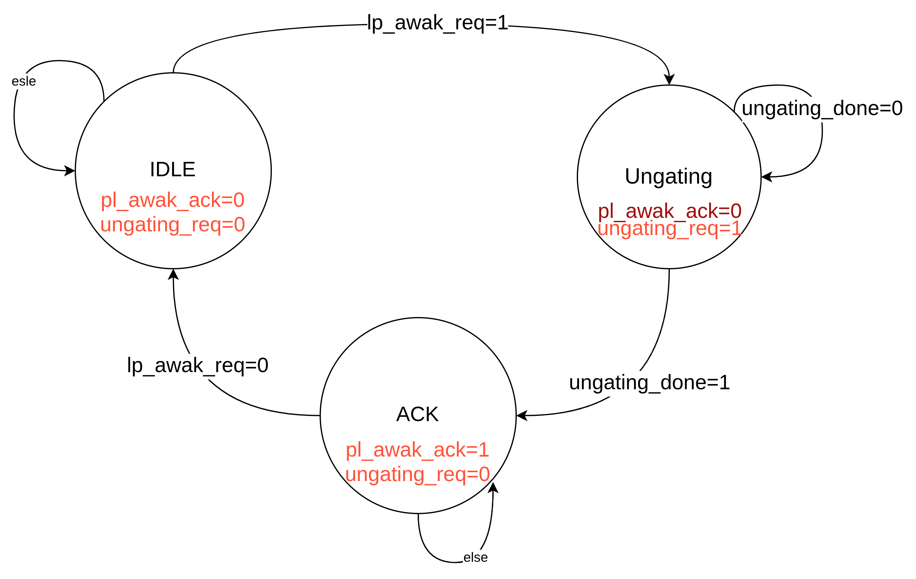
Key Signals
Signal | direction | width | Description
lp_clk_ack | input | 1 | Acknowledges the adapter's wake request.
pl_clk_req | input | 1 | Indicates the adapter’s wake request
gating_req | output | 1 | Starts the phy’s clk ungating
gating_req_done | output | 1 | Indicates the phy’s clk ungating is done

Handshake (lp_wake_req/pl_wake_ack handshake):

Adapter requests removal of clk gating by asserting lp_wake_req.
Steps :
- Adapter asserts lp_wake_req
- The Physical Layer asserts pl_wake_ack to indicate that clock gating has been removed.(There must be at least one clock cycle bubble between lp_wake_req assertion and pl_wake_ack assertion.)
- lp_wake_req must de-assert before pl_wake_ack de-asserts.

- clk_handshake_block:
It is a fundamental component of the Raw Die-to-Die Interface (RDI) responsible for the clock wake-up negotiation between the RDI controller and the adapter logic.
Its primary purpose is to ensure that the adapter is properly awakened and its physical-layer clock is active and aligned before any subsequent link activity or data transmission begins.

Core Functionality
The module manages the power-up sequence of the adapter's clock domain through a coordinated request and acknowledgment process.
By ensuring the adapter is "clock-ready," the system maintains power management reliability and prevents communication errors that could occur if logic attempts to operate without a stable clock.

Finite State Machine (FSM) Operation
The CLK handshake block module operates using a simple two-state FSM:
• IDLE State:
This is the default state upon reset.
The output signal pl_clk_req is de-asserted, meaning no clock request is currently being made to the adapter.
and clk_handshake_done is also de-asserted, meaning no clock request is done.

• REQ State :
When the RDI FSM enables the handshake, the module transitions to this state and asserts pl_clk_req.
This signal instructs the adapter to initiate or resume its
physical-layer clock.
      - DONE state :
When adapter acknowledges with lp_clk_ack, the module transitions to this state and asserts clk_handshake_done and transition to IDLE state without any conditions.
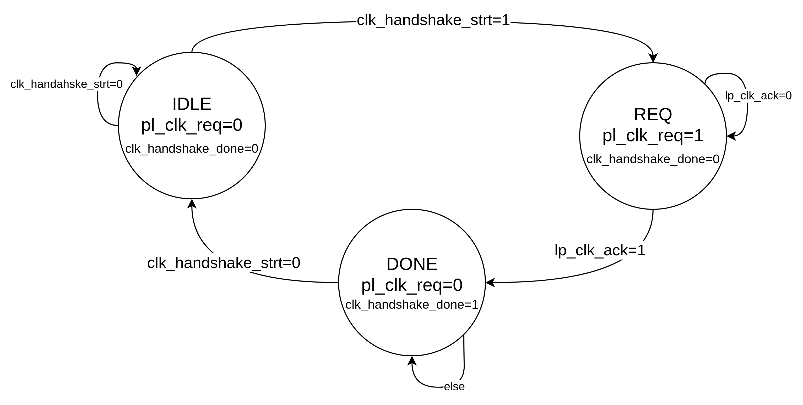
Key Signals:

Signal | direction | width | Description
lp_clk_ack | input | 1 | Acknowledges the phy's clk request.
clk_handshake_strt | input | 1 | Activate pl_clk_req/lp_clk_ack handshake
pl_clk_req | output | 1 | Starts the phy's clk request
clk_handshake_done | ouput | 1 | Indicates that the handshake is done

Handshake(pl_clk_req/lp_clk_ack handshake):
Physical Layer initiate pl_clk_req/lp_clk_ack handshake at any time and the Adapter must respond.

Triggers:
• Level-Oriented Status Transitions:
The Lower Layer must initiate this handshake to ensure the Upper Layer is awake to observe transitions of level signals (pl_inband_pres, pl_phyinrecenter, pl_trainerror).
• Autonomous LinkError Transitions from a Reset or PM state
• Remote Power Management (PM) Exit
• Lower-to-Upper Sideband Traffic
• Error Pulse Signaling(pl_cerror or pl_nferror)
• Active Training Indications (pl_phyinrecenter)
Steps:
      - Physical Layer asserts pl_clk_req.
      - The Adapter asserts lp_clk_ack to indicate that clk gating has been removed.
(There must be at least one clock cycle bubble between pl_clk_req assertion and lp_clk_ack assertion. )
      - pl_clk_req must de-assert before lp_clk_ack

3.Gating block
it’s a fundamental block in RDI to manage the clock gating when the entire interface is in a low activity or PM state
Core Functionality
save significant power by stopping the toggling of operational clocks when the interface is in a low-activity or power-management state,. By halting the primary operational clock (lclk), the system can reduce dynamic power consumption during periods of inactivity,.

Finite State Machine (FSM) Operation
The CLK gating block module operates using a simple two-state FSM:
- gating state:
entered when the triggers of the global gating is happened and starting gating lclk
- ungating state:
entered when any condition of the triggers has been violated and starting ungating lclk
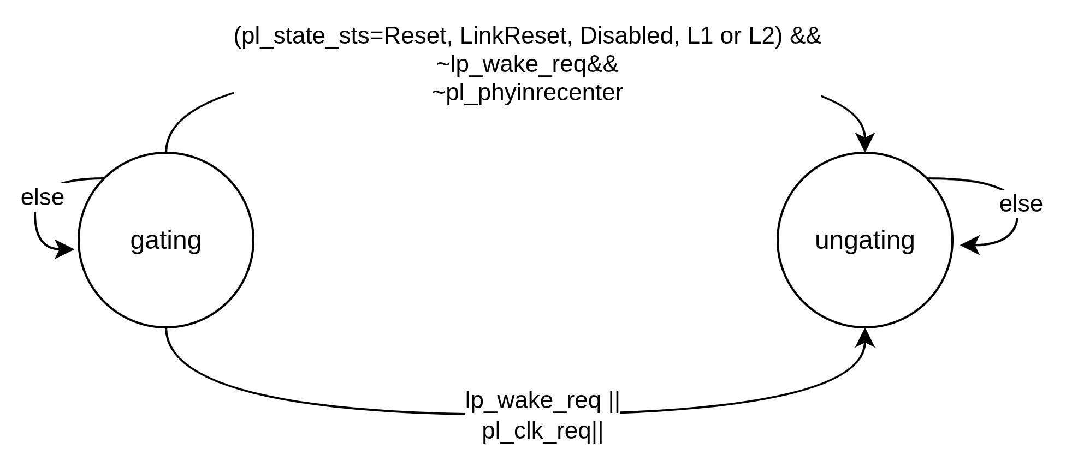

key signal:
Signal | direction | width | Description
pl_state_sts[3:0] | Input | 4 | To indicate the state of the LTSM
pl_phyinrecenter | Input | 1 | To indicate the phy is in training
ungating_req | Input | 1 | To request ungating phy’s clk
pl_clk_req | Input | 1 | To indicate that the phy is requesting adapter’s clk ungating
ungating_done | Output | 1 | Acknowledges the phy's clk ungating req

Global (or coarse) clock gating :
refers to stopping the operational clock (lclk) when the entire interface is in a low- activity or power-management state.

Status-Based Permissive Triggers
Global clock gating is permitted only when the interface status (pl_state_sts) indicates Reset, LinkReset, Disabled or Power Management (L1 or L2)
Hardware Handshake Triggers
• De-assertion of lp_wake_req
• De-assertion of pl_clk_req
Internal Blocking Conditions (Negative Triggers)
• Active Training or Retraining indicated by the assertion of pl_phyinrecenter.

Triggers for removing general (coarse) clock gating
• The assertion of the asynchronous lp_wake_req
• pl_clk_req/lp_clk_ack handshake.

Stall handshake block
For the Physical Layer (PHY) on the Raw Die-to-Die Interface (RDI), the Stallreq/Ack handshake (pl_stallreq/lp_stallack) is a mandatory mechanism used to stop the Adapter's data stream at a clean flit boundary in preparation for an interface state transition.
Finite State Machine (FSM) Operation
The stall handshake block module operates using a simple two-state FSM:
- IDLE state:
this is the default state upon reset where is pl_stallreq is low and lp_stallack is also low
- stall_req state:entered this state when pl_stallreq is asserted and the data from adapter will be aligned
- stall_ack state :
this state entered when adapter finished aligning the data.
stall_done is asserted and the phy starting transition actions
- stall_done state:
this state entered when phy finished transition actions and de-assert stall_strt then pl_stallreq is de-asserted then move to the idle state when lp_stallack is de-asserted.
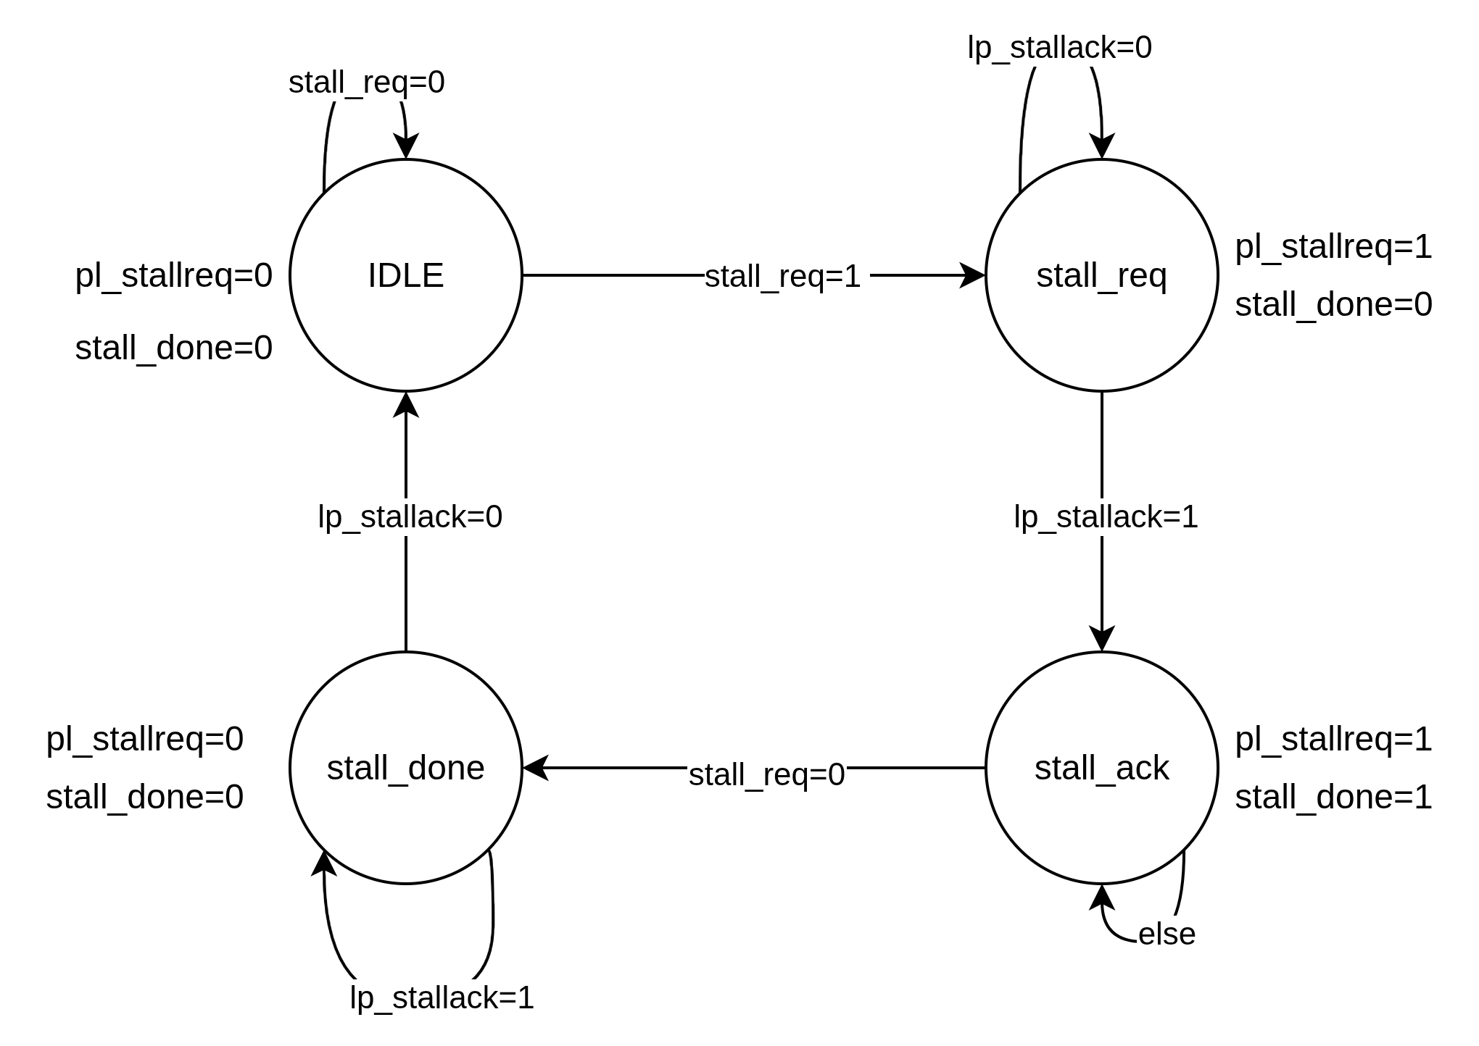
Key signals:
Signal | direction | width | Description
stall_req | Input | 1 | To request stall handshake
lp_stallack | Input | 1 | To acknowledge the stall req from the phy
pl_stallreq | Output | 1 | To request stalling
stall_done | Output | 1 | To indicate that the stall handshake is done
stallreq/ack mechanism
The specific triggers for the PHY to initiate this handshake are:
1. Exiting the Active State
The Phy must initiate the Stallreq/Ack handshake whenever the RDI is exiting the Active state to transition into any of the following states:
• Retrain
• Power Management (L1 or L2)
• LinkReset
• Disabled
2. Retrain-Specific Triggers
• PHY-Initiated Retrain: Upon detecting a valid framing error
• Adapter-Initiated Retrain: lp_state_req
• Remote-Die Request
3. Power Management Entry Coordination
Before send a "PM Request" to its remote partner

Important Exception: LinkError
It is not mandatory for the PHY to complete the Stallreq/Ack handshake before entering the LinkError state. In cases of severe hardware failure, the PHY may transition immediately to protect against error propagation, though it may optionally choose to perform the handshake if it is possible to allow the Adapter to drain remaining packets.

RDI_SM_controller:

abstract the Physical Layer (PHY) states for the upper layers specifically the Die-to-Die Adapter.
It acts as a logical coordinator that translates the underlying physical hardware status into a standardized set of interface states (such as Active, Reset, and PM) that the Adapter can interact with using simple hardware signals.

The Raw Die-to-Die Interface (RDI) State Machine consists of the following standardized states:

• Reset: This is the initial state following a domain reset exit, where the Physical Layer performs its internal initialization while mainband transmitters are tri-stated,,.
• Active: The primary operational state where functional protocol flits and data transactions are actively exchanged between the two dies,,.
• Active.PMNAK: A specific sub-state of Active entered when a power management (PM) entry request is rejected by the remote link partner,,.
• L1: A power management state that allows the Physical Layer to perform power saving optimizations; exiting this state requires transitioning to the Retrain state,,.
• L2: A deeper power management state compared to L1; exiting this state requires the
interface to transition back to the Reset state for full retraining,,.
• Retrain: A state used for runtime recovery from errors, such as valid framing failures, or for software-directed link retraining,,.
• LinkReset: This state is used for reset flows to convey device or Link resets across the UCIe Link, functioning simply to a PCIe HotReset,,.
• Disabled: A state entered when the link is intended taken down due to protocol requests or software writing to a Link Disable bit,,.
• LinkError: A mandatory state for error containment, requiring a minimum resistance of 16 ms to ensure the remote link partner also enters the error state due to timeouts,,,.

The exit conditions for the Raw Die-to-Die Interface (RDI) State Machine states are governed by a combination of hardware signals (, , and ), sideband link management messages, and internal Physical Layer (PHY) requirements lp_state_req lp_linkerror, pl_state_sts.

1. Reset State
• To Active: The Adapter must transition lp_state_req from NOP to Active. The transition is only complete once the Active Entry Handshake (exchange of and ) is successful{LinkMgmt.RDI.Req.Active} {LinkMgmt.RDI.Rsp.Active}.

• To LinkReset: The Adapter transitions to LinkReset after a NOP transition, or
a request is received from the remote partner over the sidebandlp_state_req.

• To Disabled: The Adapter transitions to Disabled after a NOP transition, or
a request is received from the remote partnerlp_state_req.

• To LinkError: Triggered by an internal PHY request, the assertion of lp_linkerror, or
a remote partner request via sideband.
2. Active State
• To Retrain: Occurs if the Adapter requests lp_state_req = Retrain, the PHY detects an internal error (like a valid framing error), or the remote die requests retraining.

• To L1 or L2 (Power Management): The Adapter must transition to the responsive PM statelp_state_req. This requires all Adapter LSMs to be in PM and the Retry buffer to be empty.

•To Active.PMNAK: occurs if the partner replies with {RDI.LinkMgmt.PMNAK.Resp} when
requesting PM entry.

• To LinkReset, Disabled, or LinkError: Triggered by the Adapter, internal PHY events,
or remote partner requests. These transitions (except LinkError) require the completion of a Stallreq/Ack handshake to ensure data is stopped at a clean boundary.

3. Active.PMNAK sub-State
• To Active: The Adapter must initiate an Active request on the RDI.

• To Retrain, LinkReset, Disabled, or LinkError: These are triggered by link events or remote requests while the interface wants for the Adapter to return to Active.
4. Retrain State
• To Active:
◦ If entered from L1:
The PHY Begins Active Entry Handshakes Once lp_state_req = Active.
◦ If entered from ActiveRequires a NOP-to-Active transition on followed by the successful Active Entry handshakelp_state_req.
• To LinkReset, Disabled, or LinkError:
Follows the common transition rules based on internal errors or sideband requests.

5. L1 (Power Management) State
• To Retrain: Triggered when the local Adapter requests Active or
the remote partner requests an L1 exit.
6. L2 (Power Management) State
• To Reset: Triggered when the local Adapter requests Active or
the remote partner requests an L2 exit.
7. LinkReset State
• To Reset:
Triggered by an internal request (such as a reset pin) or
when lp_state_req Active after all LinkReset actions are complete.

• To Disabled:
The Adapter requests = Disabled or
an internal PHY request occurslp_state_req.

8. Disabled State
• To Reset:
Triggered by an internal reset request or
when lp_state_req = Active once the disabled transition has finalized.
9. LinkError State
• To Reset:
Triggered by an internal request to move to Reset or
when lp_state_req = Active and lp_linkerror = 0.
This state requires a minimum resistance of 16 ms to ensure the remote link partner also enters the error state via timeouts.

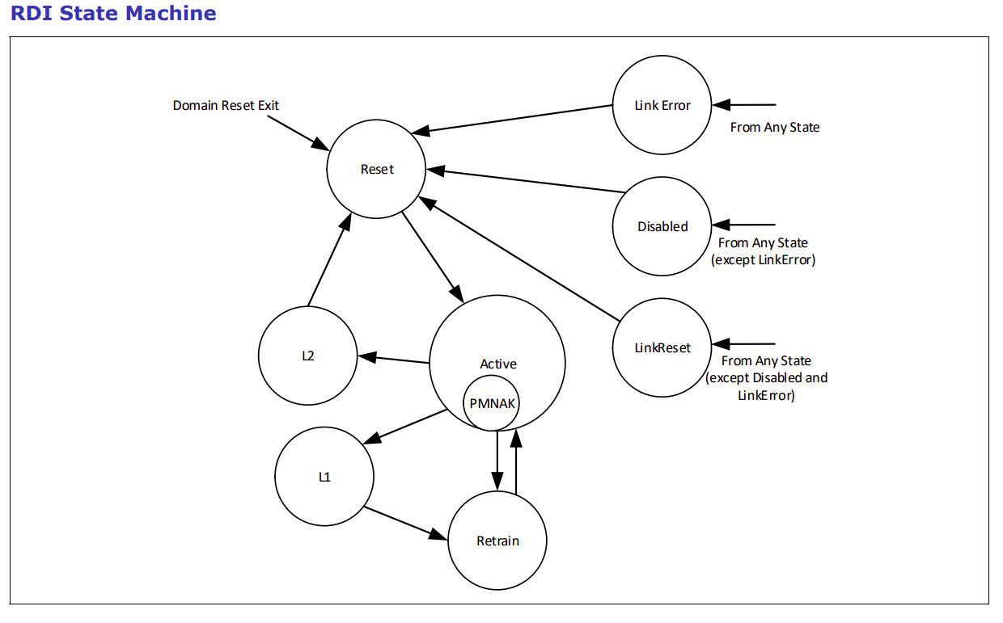

Key signal :
Signal | direction | width | Description
pl_state_sts | Output | 4 | To request stall handshake
pl_trainerror | Output | 1 | To acknowledge the stall req from the phy
pl_inband_pres | Output | 1 | To request stalling
pl_phinrecenter | Output | 1 | To indicate that the stall handshake is done
pl_max_speedmode[2:0] | Output | 3 | Negotiated Maximum Data Rate.
pl_speedmode[2:0] | Output | 3 | Current Link speed.
pl_lnk_cfg[2:0] | Output | 3 | Current Link Configuration.Indicates the current operating width of a module.
Link Mgmt Msg Send [4:0] | Output | 5 | To tell what is the massage need to be sent
valid_s | Output | 1 | To indicates that the massage code is considered.
state_req | Output | 1 | To move the LTSM to certain state
clk_handshake_strt | Output | 1 | To start clk handshake
stall_req | Output | 1 | To requesting a stall
lp_state_req[3:0] | Input | 4 | Requesting a certain state to enter.
lp_linkerror | Input | 1 | Indicates that an error has occurred which requires the Link to go down.
Link Mgmt Msg Receive [4:0] | Input | 5 | Indicates that a certain massage has arrived on the sideband.
valid_r | Input | 1 | To indicates that the massage code is considered.
state_status | Input | 1 | To tell the RDI SM which state is the LTSM in.
clk_handshake_done | Input | 1 | To indicates that the clk handshake is done
stall_done | Input | 1 | To indicates that the stall is done

