“Digital IC Design Diploma”
ASYC_FIFO Assignment

Under supervision of:
Eng. Ali Eltemsah

Submitted by
Member | group
Abdallag Mohamed Salah | 13

1. Introduction
This report documents the testing of the ASYC_FIFO module. It includes test cases, results, and observations.
Depth calculations
Read: 1/40mhz= 25 ns, Write: 1/100mhz= 10 ns
Burst = 9 byte, Write total time = 9 *10 =90ns
Readable data in such time = 90/25 ~= 3
Depth = 9-3=6
Memory depth =8 , address width = 3

2. Test Cases

2.1 Test Case 1
Description: reset the read and write domains almost simultaneously.
Expected Result: almost reset at the same time.
Actual Result: as expected.
Status: Pass

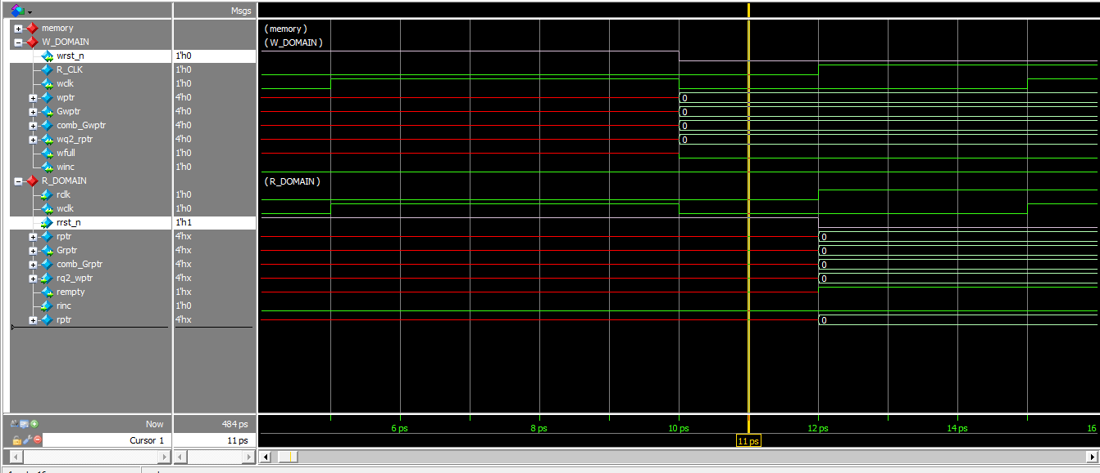

3.2 Test Case 2
Description: writing data into memory while full is low and winc is high.
Expected Result: data is written into memory.
Actual Result: as expected.
Status: Pass

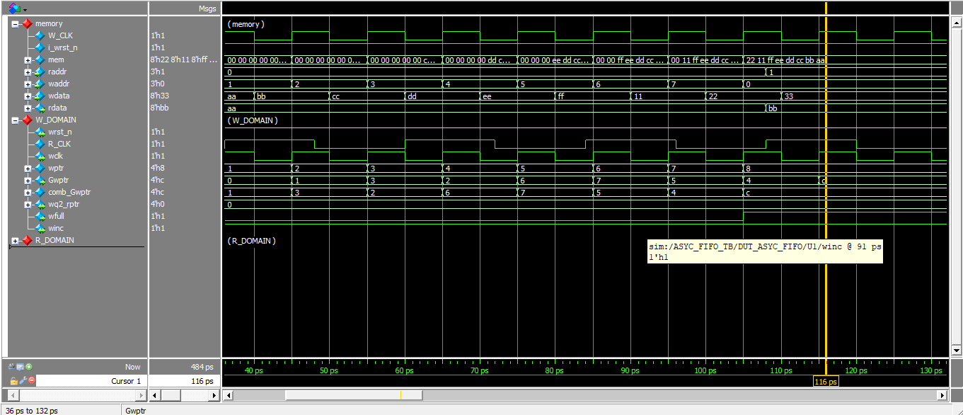

3.3 Test Case 3
Description: read written data in parallel with writing considering different clk.
Expected Result: first written first read .
Actual Result: as expected.
Status: Pass
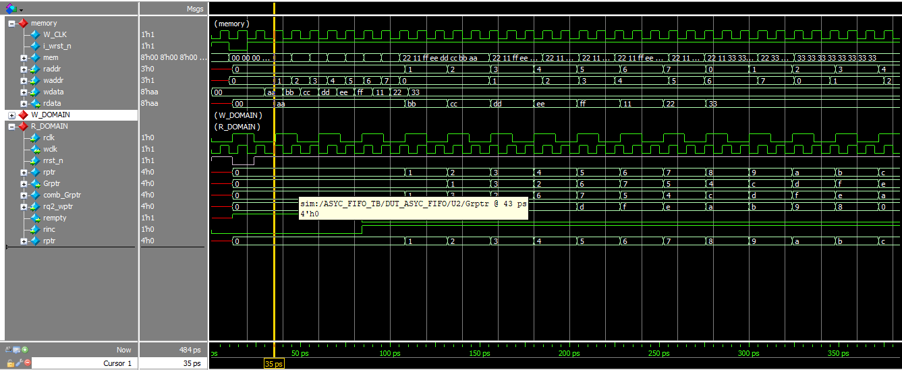

3. Summary
If the data change or winc became low while we are trying to write the last byte that will cause data lose because we didn’t consider the latency caused by synchronizer and flopping the addresses which is 2/3 cycle
