“Digital IC Design Diploma”
Clock Divider Assignment

Under supervision of:
Eng. Ali Eltemsah

Submitted by
Member | group
Abdallag Mohamed Salah | 13

The following snippets are some of the testing scenarios of the functionality of the Clock Divider block:

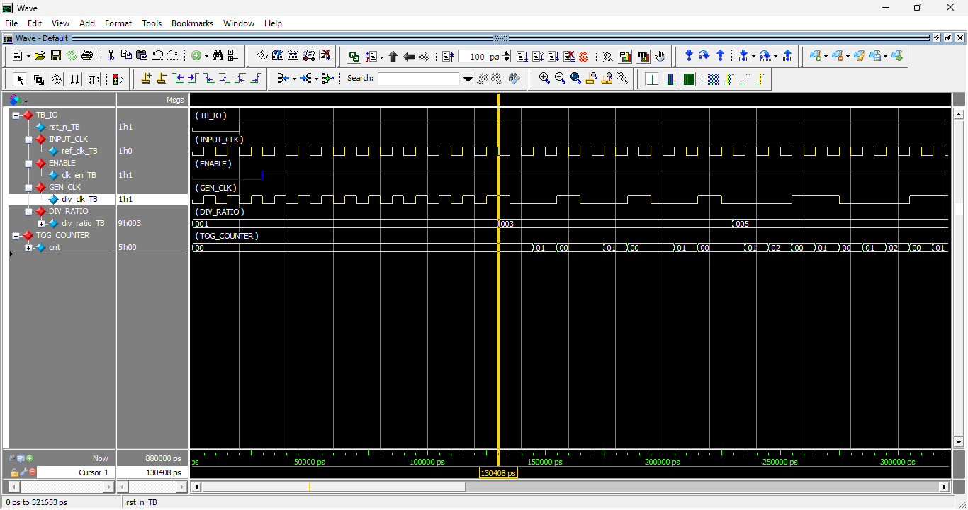
Figure 1: start of the simulation showing the reset and at div_ratio 0 bypass ref_clk

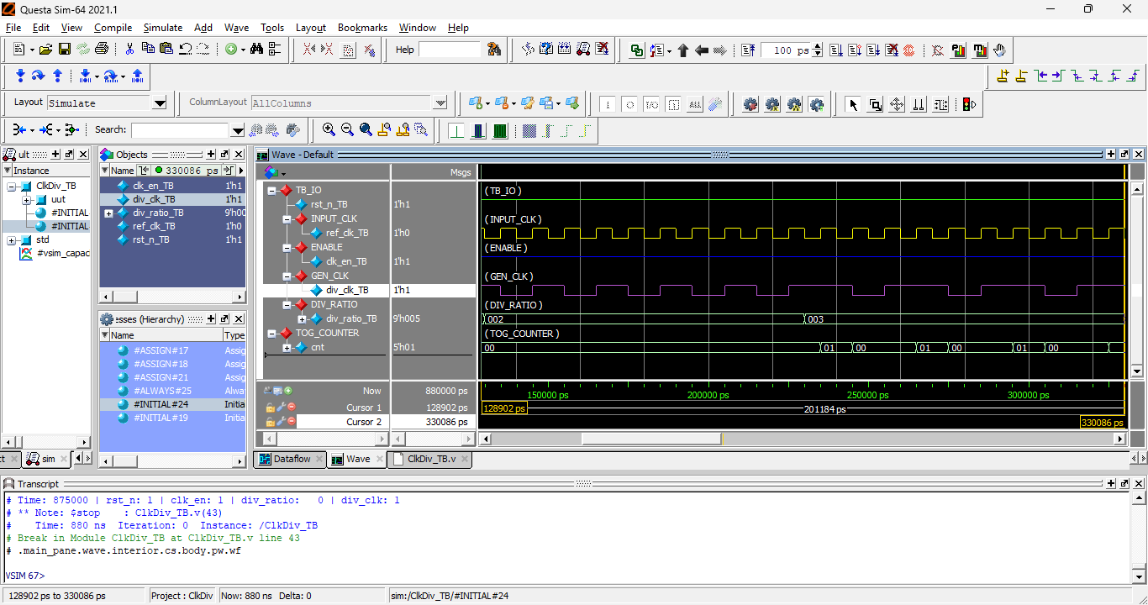
Figure 2 : wave at minimum even/odd div_ratio (2,3)
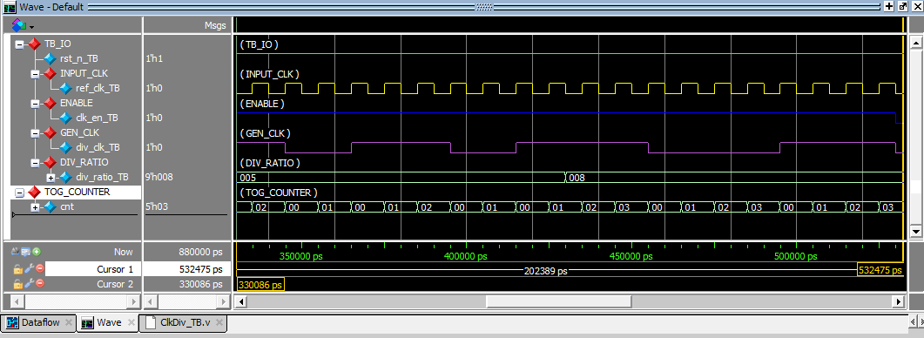
Figure 3:wave at div_ratio 5,8

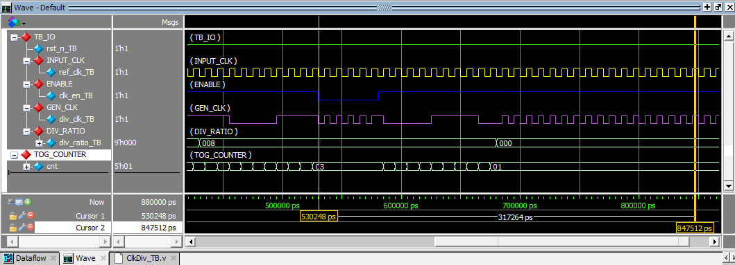
Figure 4: out_clk when Enable is low and if div ratio is 1 (i_clk is bypassing)

