“Digital IC Design Diploma”
DATA_SYNC Assignment

Under supervision of:
Eng. Ali Eltemsah

Submitted by
Member | group
Abdallag Mohamed Salah | 13

1. Introduction
This report documents the testing of the DATA_SYNC module with 2 stages FF. It includes test cases, results, and observations.

2. Test Cases

2.1 Test Case 1
Description: reset all FF’s.
Status: Pass

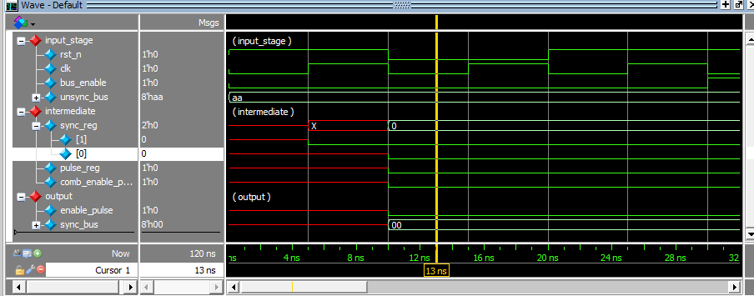

3.2 Test Case 2
Description: enable propagate and gen_pulse.
Status: Pass

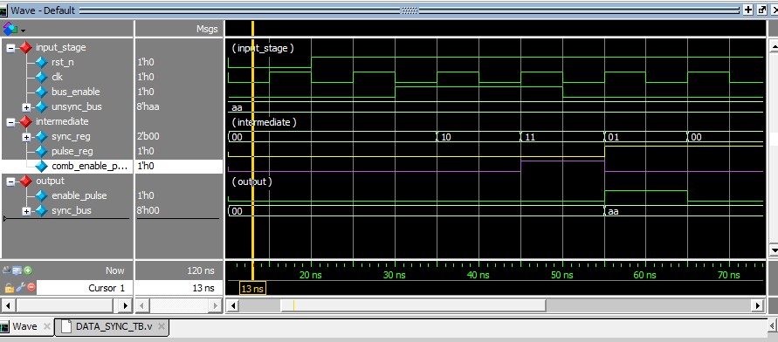

3.3 Test Case 3
Description: output is flipped out.
Status: Pass
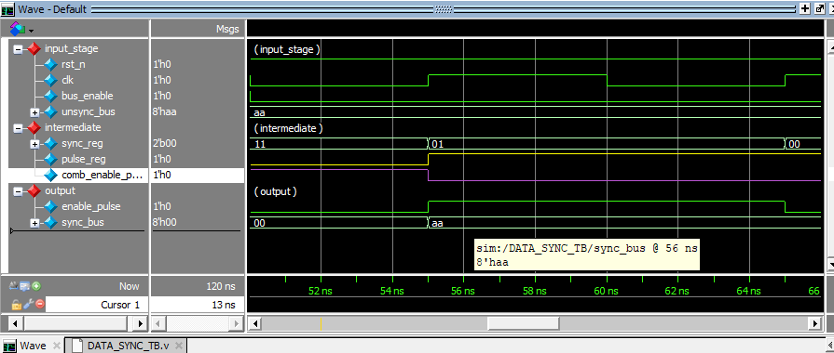

3. Summary
Enable take 2 cycle to go high then go low after full cycle no matter how long was the enable input was

