# Database Examination System Documentation

# 1. Introduction

## 1.1 Overview

The Database Examination System is a structured database designed to manage and store examination-related data for ITI. The system efficiently handles student records, exam schedules, questions, and results within SQL Server. Data retrieval and reporting will be facilitated using SQL Server Reporting Services (SSRS) to generate insightful reports for administrators and instructors. The database ensures secure and efficient data management while providing structured queries and reports for examination tracking and analysis.

## 1.2 Purpose and Objectives

* Automate exam creation and management.
* Provide secure student authentication.
* Store and retrieve exam results efficiently.
* Facilitate real-time evaluation and reporting.

## 1.3 Scope

* User roles: Admin, Instructor, Student.
* Functions: Exam scheduling, question management, result processing.
* Security: Role-based access control, data encryption.

# 2. System Requirements

## Hardware Requirements

* Server with SQL Server installed.
* Minimum 8GB RAM, 100GB storage.

## Software Requirements

* SQL Server 2019 or later.
* Windows Server/Linux.

­

# 3. Database Design

## 3.1 Entity-Relationship Diagram (ERD)

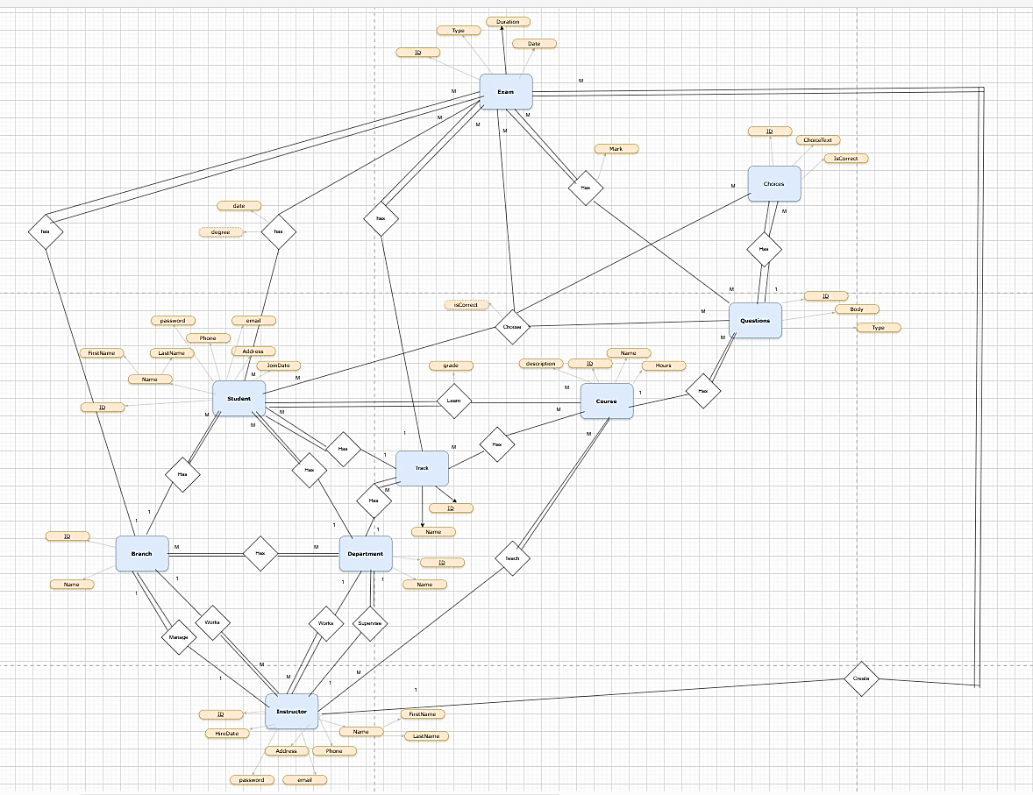

## Database Schema

* Branch (BranchID, BranchName)
* BranchDepartments (BranchDepartmentID, BranchID, DepartmentID)
* Choices (ChoiceID, QuestionID, ChoiceText, IsCorrect)
* Courses (CourseID, CourseName, TrackID)
* CourseInstructors (CourseInstructorID, CourseID, InstructorID)
* CourseStudents (CourseStudentID, CourseID, StudentID)
* CourseTracks (TrackID, TrackName)
* Department (DepartmentID, DepartmentName)
* Exams (ExamID, Title, Date, Duration, ExamTypeID, InstructorID)
* ExamQuestions (ExamQuestionID, ExamID, QuestionID)
* ExamType (ExamTypeID, TypeName)
* Instructors (InstructorID, Name, Email, PhoneNumber)
* Questions (QuestionID, QuestionTypeID, QuestionText)
* QuestionType (QuestionTypeID, TypeName)
* StudentAnswers (StudentAnswerID, StudentExamID, QuestionID, SelectedChoiceID)
* StudentExams (StudentExamID, StudentID, ExamID, Score)
* Students (StudentID, Name, Email, PhoneNumber)  
   Tracks (TrackID, TrackName)

# 4. Implementation Details

## 4.1 Stored Procedures and Functions

* BranchInsert: Adds a new branch.
* BranchUpdate: Updates an existing branch
* BranchDelete: Deletes a branch.
* ChoicesInsert: Adds choices for a question.
* ChoicesUpdate: Updates choices for a question.
* ChoicesDelete: Deletes choices for a question.
* CourseStudentsSelect: Retrieves students in a course.
* StudentExamsInsert: Registers a student for an exam.
* StudentExamsUpdate: Updates the score of a student.
* QuestionsSelectAll: Retrieves all questions.

**With the same Stored Procedures, they are added to each table in the same way.**

# 5. Queries and Reports

## 5.1 Sample Queries

Fetch all students registered for an exam:  
```sql  
SELECT S.StudentID, S.Name, E.ExamID, E.Title  
FROM Students S  
JOIN StudentExams SE ON S.StudentID = SE.StudentID  
JOIN Exams E ON SE.ExamID = E.ExamID;  
```

Retrieve top-performing students:  
```sql  
SELECT TOP 10 S.StudentID, S.Name, AVG(SE.Score) AS AverageScore  
FROM Students S  
JOIN StudentExams SE ON S.StudentID = SE.StudentID  
GROUP BY S.StudentID, S.Name  
ORDER BY AverageScore DESC;  
```

Generate detailed exam reports:  
```sql  
SELECT E.Title, Q.QuestionText, SA.SelectedChoiceID, C.ChoiceText  
FROM Exams E  
JOIN ExamQuestions EQ ON E.ExamID = EQ.ExamID  
JOIN Questions Q ON EQ.QuestionID = Q.QuestionID  
JOIN StudentAnswers SA ON Q.QuestionID = SA.QuestionID  
JOIN Choices C ON SA.SelectedChoiceID = C.ChoiceID;  
```

# 6. Security and Backup

## 6.1 User Roles and Permissions

* Admin: Full access.
* Instructor: Manage exams and results.
* Student: Take exams and view results.

## 6.2 Backup and Recovery Strategies

* Scheduled backups.
* Disaster recovery plan.

# 7. Future Enhancements

* AI-based question generation.
* Enhanced reporting and analytics.
* Desktop app integration.

## Desktop Application Integration

* To enhance user interaction and facilitate database management, a desktop application has been developed. This application provides a user-friendly interface for administrators, instructors, and students to interact with the database seamlessly. The desktop application communicates with the SQL Server database using secure and optimized queries, ensuring efficient and real-time data access.

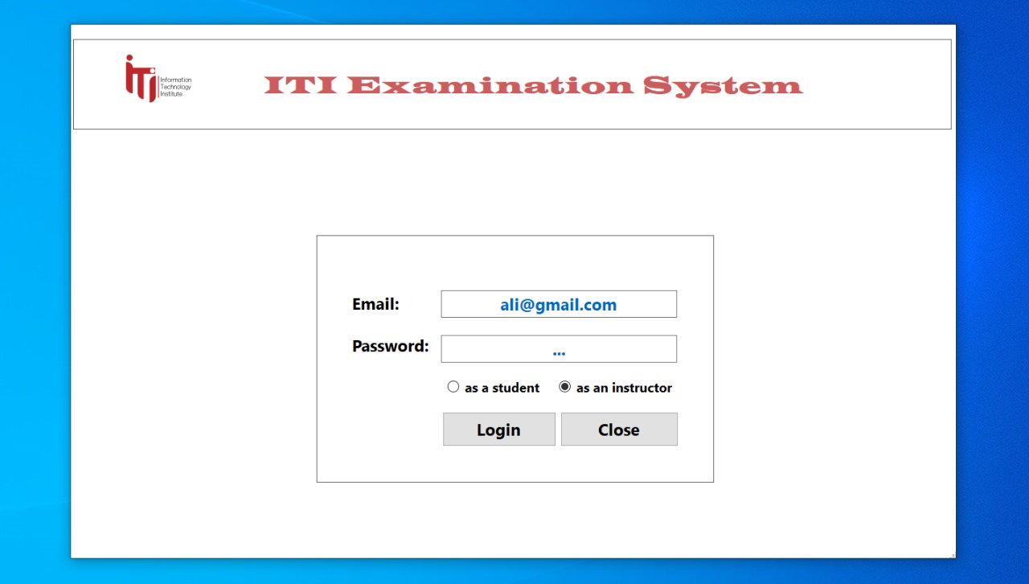

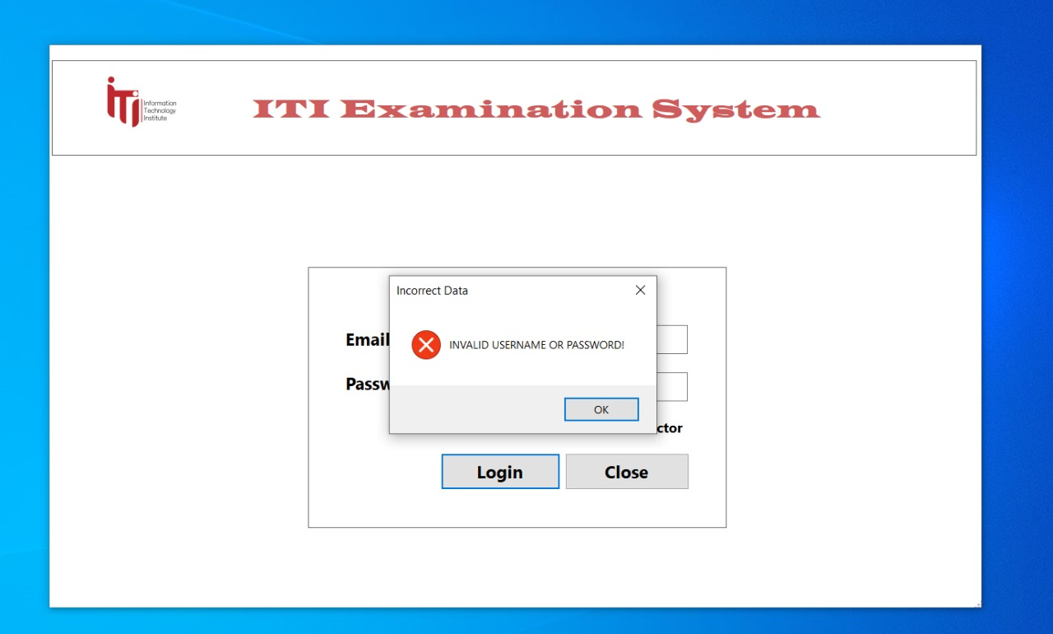

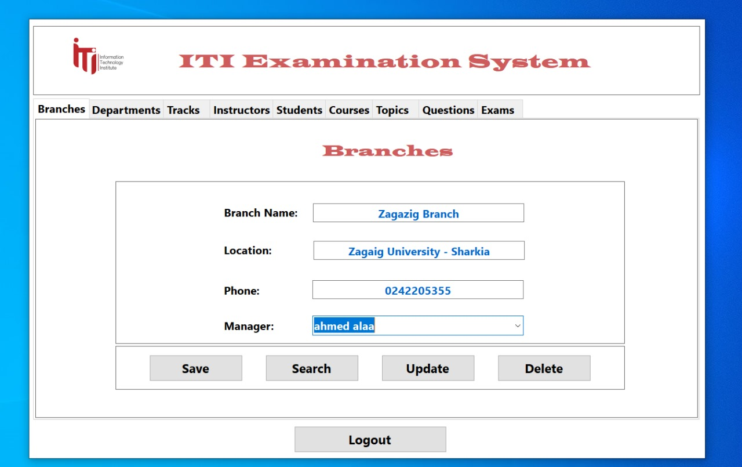

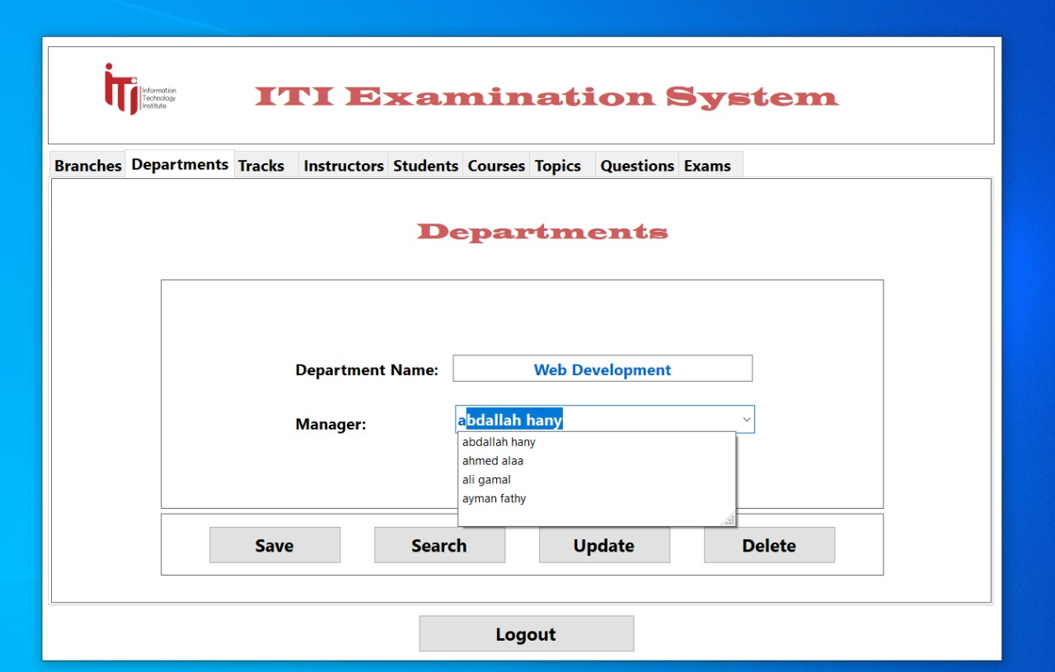

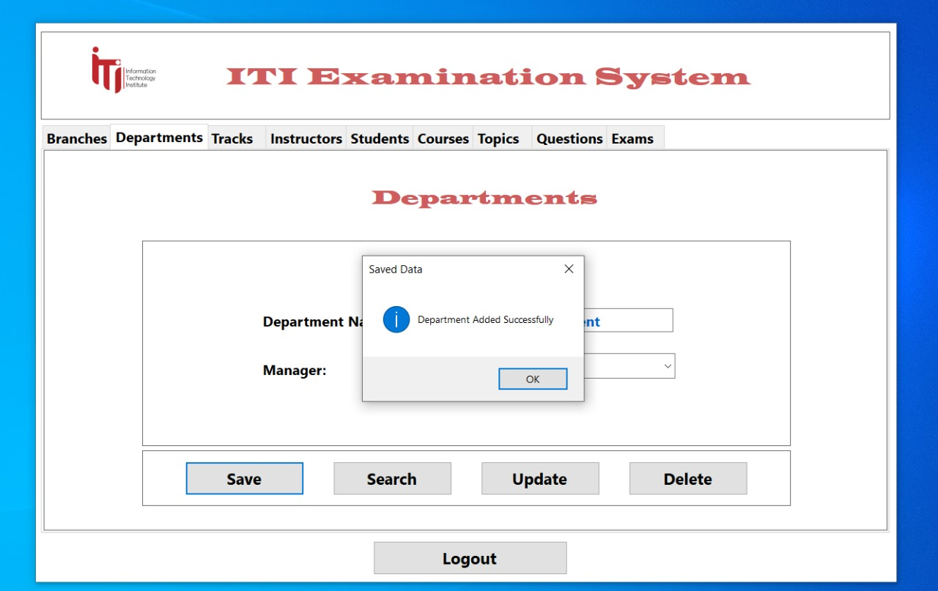

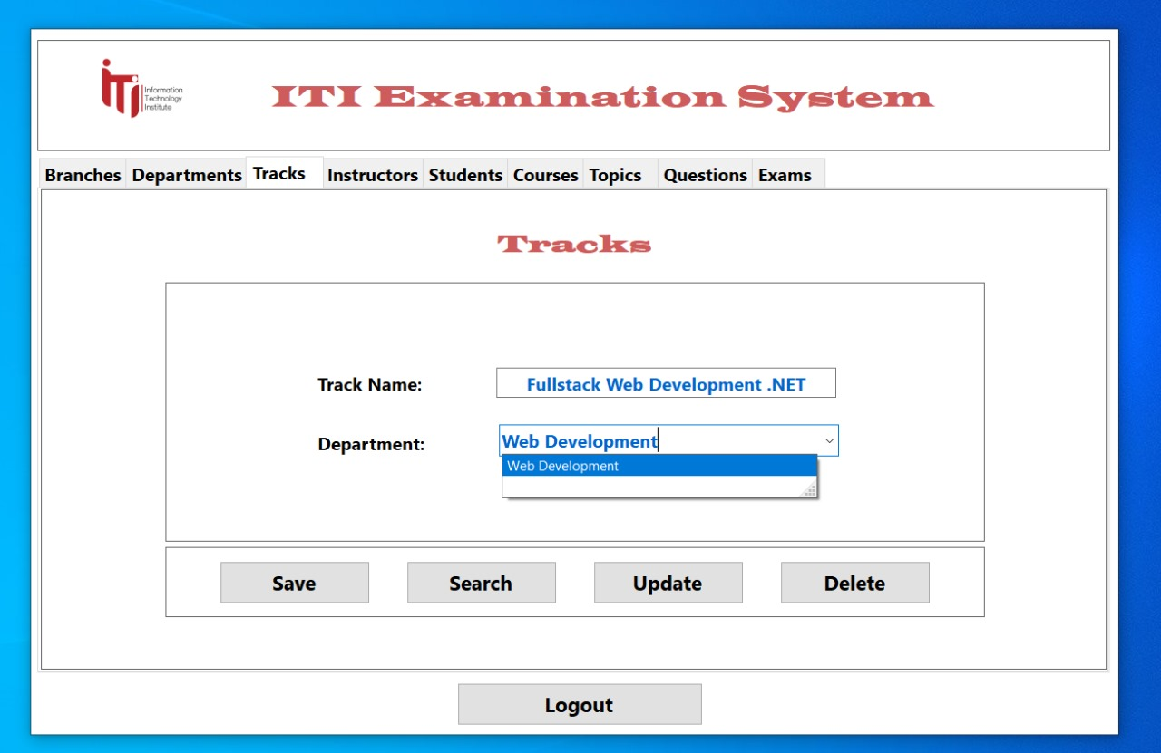

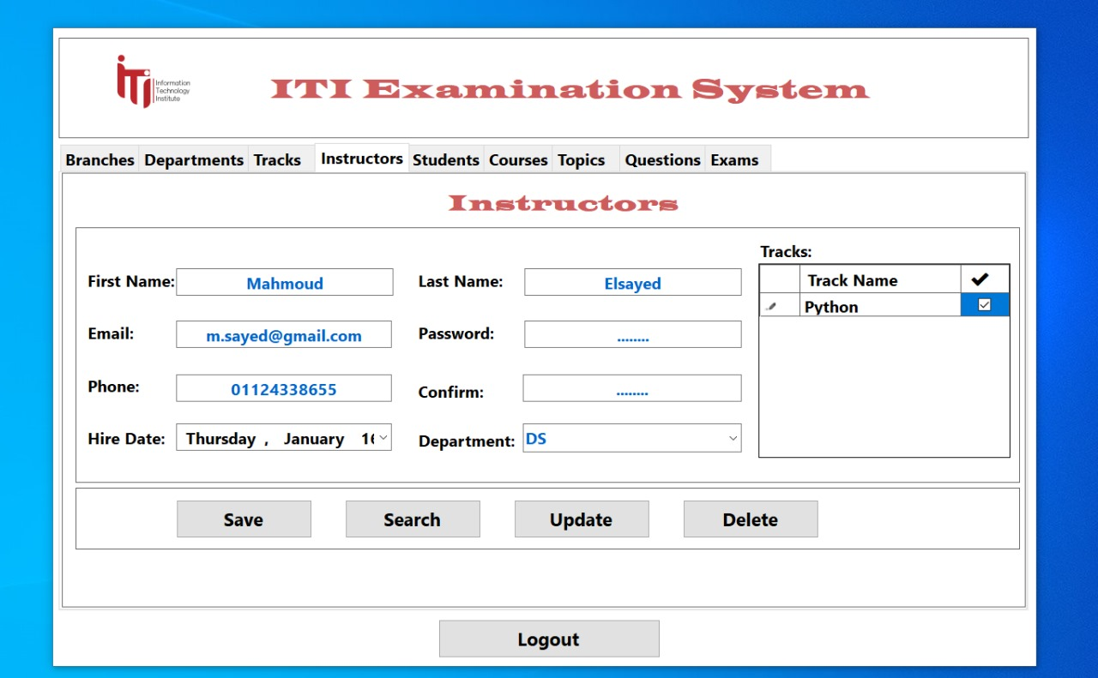

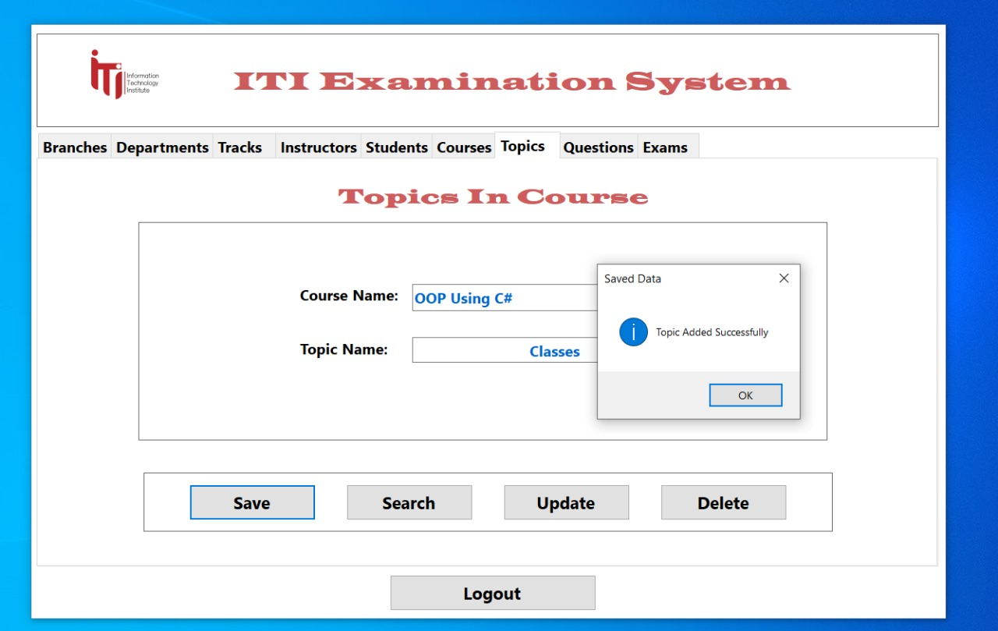

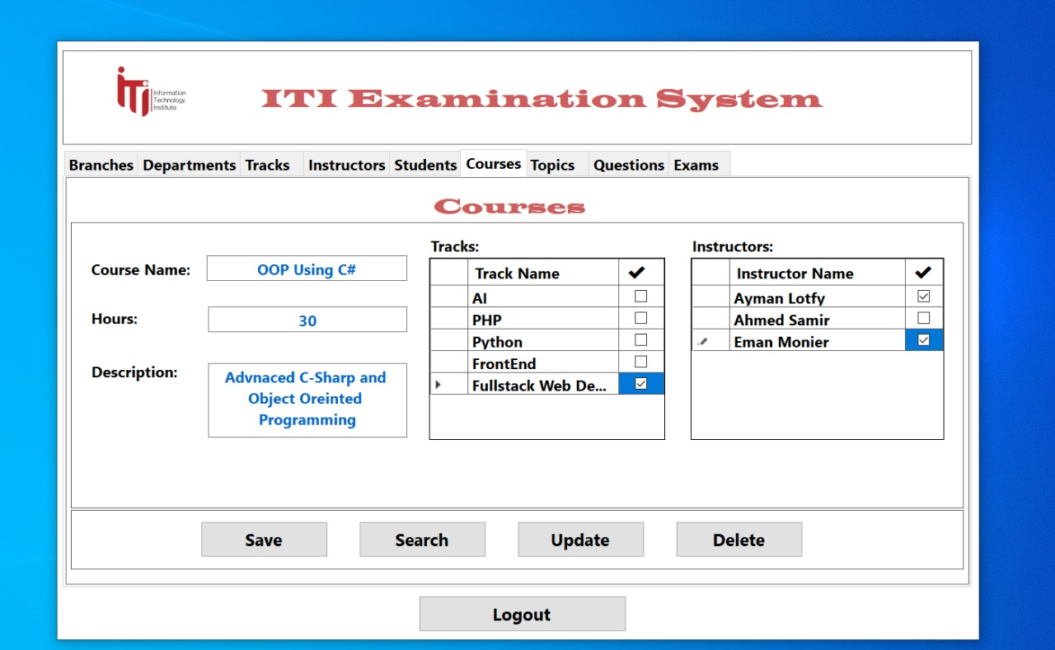

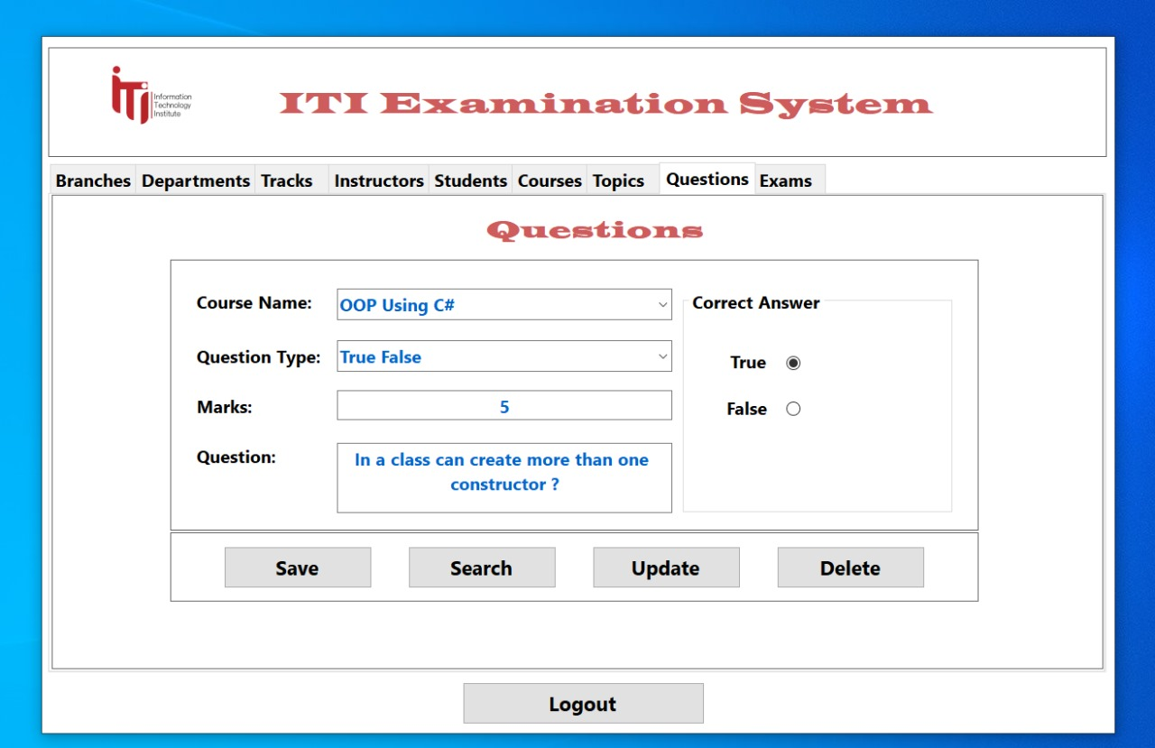

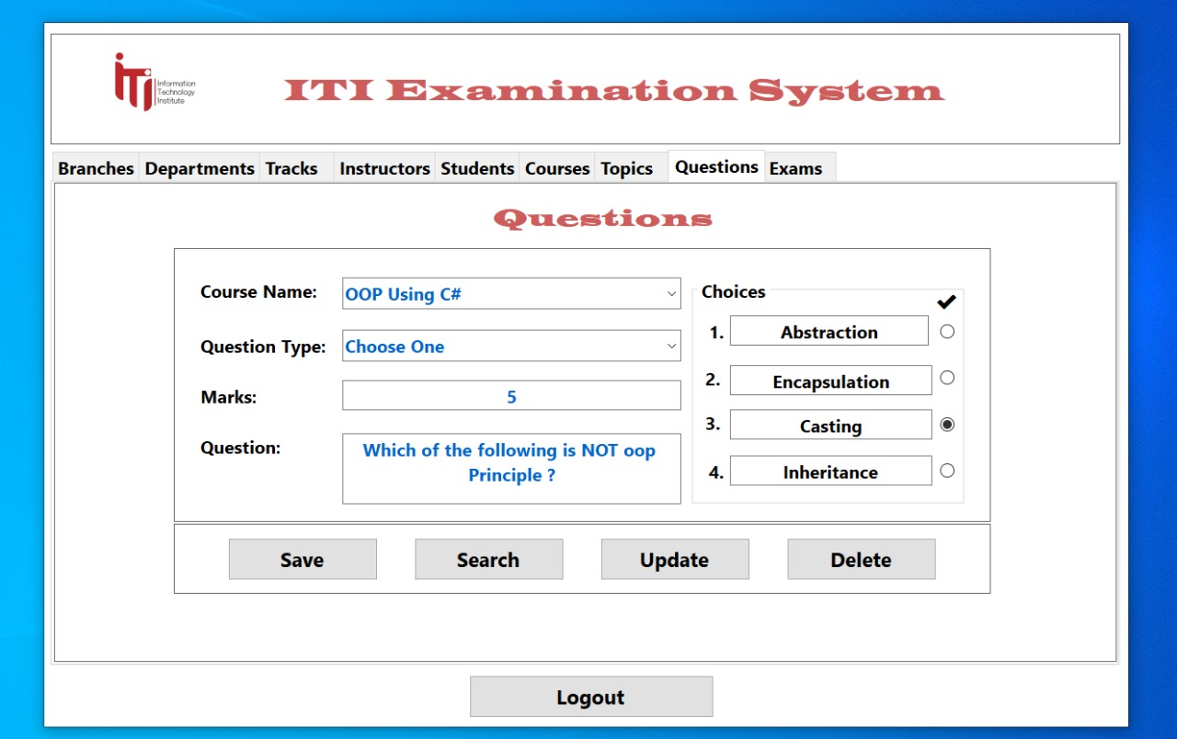

**8- Reports using (SSRS)**

* Report that returns the students' information according to Department No parameter:

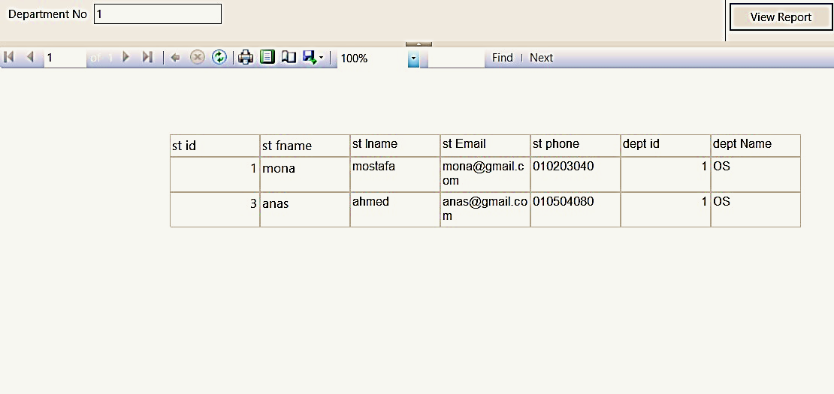

* 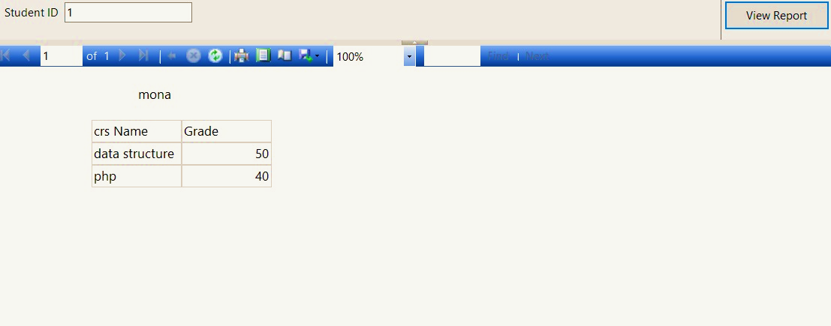Report that takes the student ID and returns the grades of the student in all courses:

Report that takes the instructor ID and returns the name of the courses that he teaches and

* number of students per course:

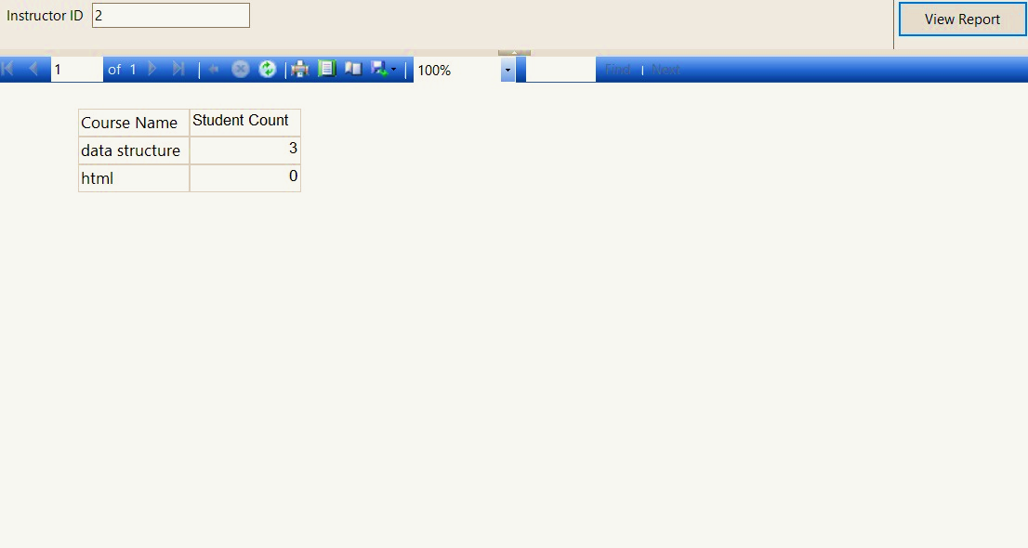

* Report that takes course ID and returns its topics:

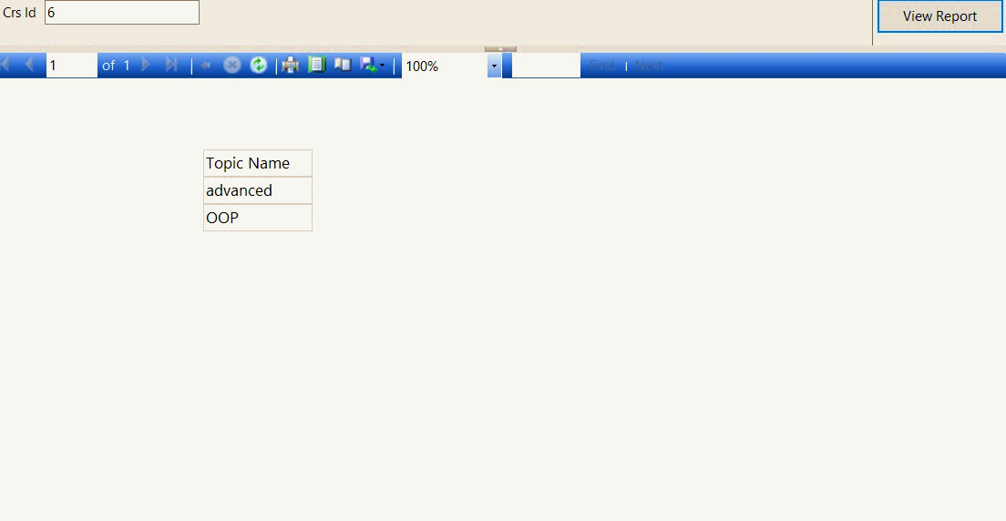

* Report that takes exam number and returns Questions in it:

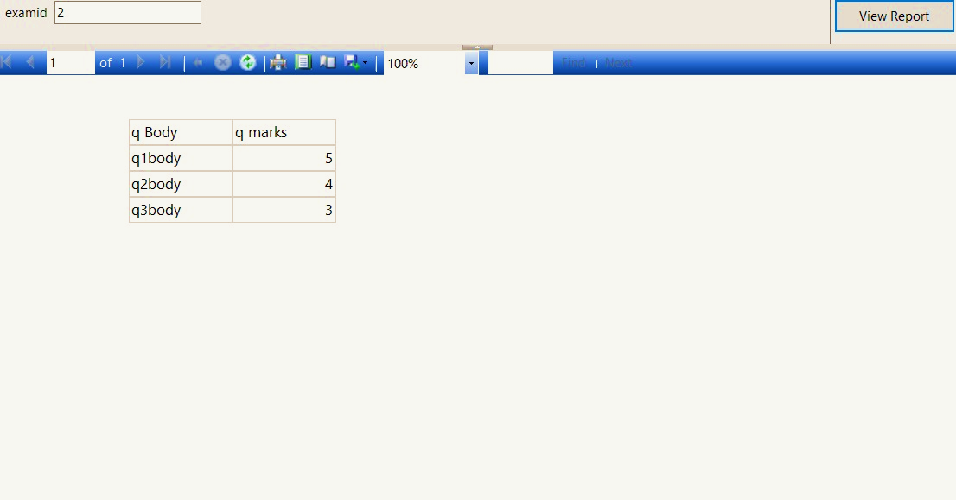

* Report that takes exam number and the student ID then returns the Questions in this exam with the student answers:

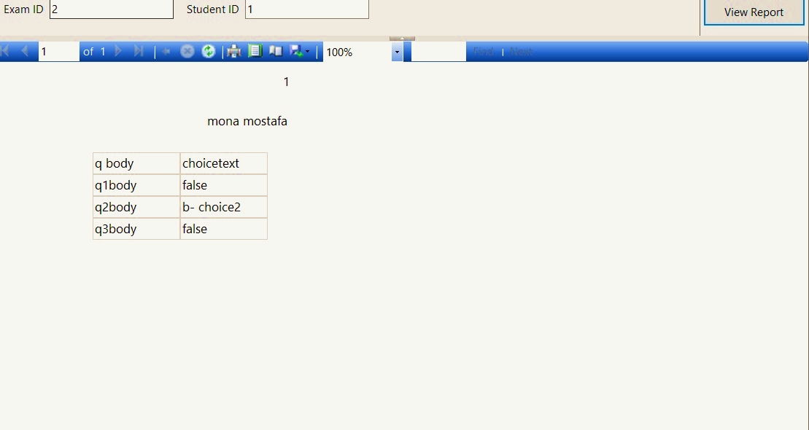

Thank you ,,,