**Diagram**

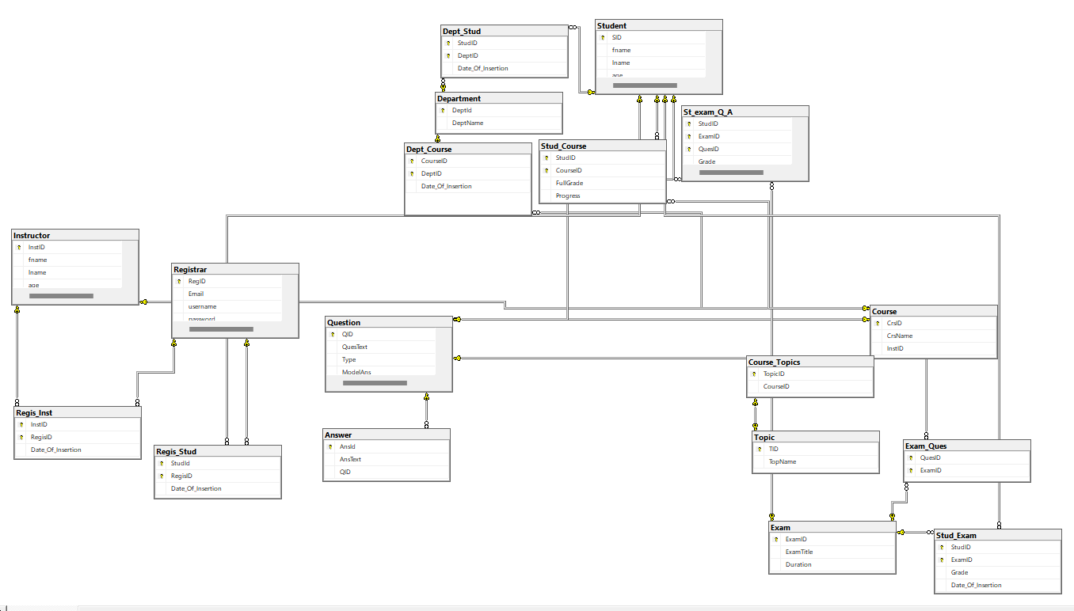



**Entities**

**Table:** Student

|  |  |  |  |  |  |  |
| --- | --- | --- | --- | --- | --- | --- |
| Name in D.B | Student | | | | | **Constraints** |
| Description | This table will have all the details of the “Student” entity. | | | | |
| **Field Name** | **Data Type** | | **Description** | | |
| INT | • | | | Student ID |
| **SID** | Not null |
| • | | | | Primary key (PK) of the table |
| **fname** | Not null |
| Varchar(20) | | | Student’s first name | |
| **lname** | Varchar(20) | | | Student’s last name | | Not null |
| **age** | INT | Student’s age | | | | Accept null value |
| **address** | Varchar(30) | | | Student’s address | | Accept null value |

**Table:** Instructor

|  |  |  |  |  |  |  |
| --- | --- | --- | --- | --- | --- | --- |
| Name in D.B | Instructor | | | | | **Constraints** |
| Description | This table will have all the details of the “Instructor” entity. | | | | |
| **Field Name** | **Data Type** | | **Description** | | |
| INT | • | | | Instructor ID |
| **InstID** | Not null |
| • | | | | Primary key (PK) of the table |
| **fname** | Not null |
| Varchar(20) | | | Instructor’s first name | |
| **lname** | Varchar(20) | | | Instructor’s last name | | Not null |
| **age** | INT | Instructor’s age | | | | Accept null value |
| **address** | Varchar(30) | | | Instructor’s address | | Accept null value |

**Table:** Department

|  |  |  |  |  |  |  |  |  |
| --- | --- | --- | --- | --- | --- | --- | --- | --- |
| Name in D.B  Description  **Field Name**  **DeptId**  **DeptName** | Department  This table will have all the details of the “Department” entity. | | | | | | | |
| **Data Type** | | **Description** | | | **Constraints** | | |
| INT | • | | | Department ID | | Not null | |
| • | | | | Primary key (PK) of the table | | | |
| Varchar(50) | | | Department’s name | | | | Accept null value |



**Table:** Course

|  |  |  |  |  |  |  |
| --- | --- | --- | --- | --- | --- | --- |
| Name in D.B  Description  **Field Name**  **CrsID** | Course  This table will have all the details of the “Course” entity. | | | | | |
| **Data Type** | | **Description** | | **Constraints** | |
| INT | • | | Course ID | | Not null |
| • | | | Primary key (PK) of the | | |

table

|  |  |  |  |  |
| --- | --- | --- | --- | --- |
| **CrsName** | Varchar(50) | Course’s name | Not null | |
| • | Not null |
| **InstID** | INT | ID of the Course’s Instructor |
| • | Foreign key refers to the |

column “InstID” in

“Instructor” table

**Table:** Topic

|  |  |  |  |  |  |  |
| --- | --- | --- | --- | --- | --- | --- |
| Name in D.B | Topic | | | | | **Constraints** |
| Description | This table will have all the details of the “Topic” entity. | | | | |
| **Field Name** | **Data Type** | | **Description** | | |
| INT | • | | | Topic ID |
| **TID** | Not null |
| • | | | | Primary key (PK) of the table |
| **TopName** | Accept null value |
| Varchar(100) | | | Topic’s name | |

**Table:** Exam

|  |  |  |  |  |  |  |  |  |
| --- | --- | --- | --- | --- | --- | --- | --- | --- |
| Name in D.B | Exam | | | | | | | **Constraints** |
| Description | This table will have all the details of the “Exam” entity. | | | | | | |
| **Field Name** | **Data Type** | | | | **Description** | | |
| INT | • | | | | | Exam ID |
| **ExamID** | Not null |
| • | | | | | | Primary key (PK) of the table |
| **ExamTitle** | Accept null value |
| Varchar(20) | | | | | Exam’s title | |
| **Duration** | float | | Duration of the exam in minutes | | | | | Accept null value |
| **date** | datetime | | | Student’s address | | | | Not null |



**Table:** Answer

|  |  |  |  |  |  |  |  |
| --- | --- | --- | --- | --- | --- | --- | --- |
| Name in D.B | Answer | | | | | **Constraints** | |
| Description | This table will have all the details of the “Answer” entity. | | | | |
| **Field Name** | **Data Type** | | **Description** | | |
| INT | • | | | Answer ID |
| **AnsID** | Not null | |
| • | | | | Primary key (PK) of the table |
| **AnsText** | Not null | |
| Varchar(30) | | | Answer’s text | |
| • | Not null |
| **QID** | INT | ID of the answer’s question | | | |
| • | Foreign key refers to |

the column “QID” in

“Question” table

**Table:** Question

|  |  |  |  |  |  |  |  |
| --- | --- | --- | --- | --- | --- | --- | --- |
| Name in D.B | Question | | | | | | **Constraints** |
| Description | This table will have all the details of the “Question” entity. | | | | | |
| **Field Name** | **Data Type** | | **Description** | | | |
| **QID** | INT | • | | | | Question ID | Not null |
| • | | | | | Primary key (PK) of the table |
| **QuesText** | Not Null |
| Varchar(200) | | | | Question’s text | |
| **Type** | Varchar(10) | | | It only expects values of “MCQ” or | | | Not null |

“T/F”

|  |  |  |  |  |
| --- | --- | --- | --- | --- |
| **ModelAns** | Varchar(30) | Question’s model answer. | Not Null | |
| • | Accept null value |
| **CrsID** | INT | ID of the question’s course |
| • | Foreign key refers to |

the column “CrsID”

in “Course” table

|  |  |  |  |
| --- | --- | --- | --- |
| **advLevel** | Varchar(50) | Defines the level of difficulty of the | Accept null value |

question.



**Table:** Registrar

|  |  |  |  |  |  |  |  |
| --- | --- | --- | --- | --- | --- | --- | --- |
| Name in D.B | Registrar | | | | | | **Constraints** |
| Description | This table will have all the details of the “Registrar” entity. | | | | | |
| **Field Name** | **Data Type** | | | **Description** | | |
| INT | • | | | | Registrar ID |
| **RegID** | Not null |
| • | | | | | Primary key (PK) of the table |
| **Email** | Not null |
| Varchar(50) | | | | User’s email address | |
| **username** | Varchar(50) | | | | Username | | Not null |
| **password** | Nchar(50) | | Password | | | | Not null |
| **usertype** | Varchar(20) | | | | Type of the user, it should be | | Accept null value |

“student” or “instructor”

_________________________________



**Relationships**

**Table:** Department & Student

|  |  |
| --- | --- |
| Name in D.B  Description | Dept_Stud  This table will have all the details of the “Department & |

Student” relationship.

|  |  |  |  |  |
| --- | --- | --- | --- | --- |
| Relation Type | One (Department) to many (Student) | | **Constraints** | |
| **Field Name** | **Data Type** | **Description** |
| • | Refers to “SID” column of |
| **StudID** | INT | |

“Student” table

|  |  |  |  |  |
| --- | --- | --- | --- | --- |
| **DeptID** | INT | Composite primary key (PK) | • | Not Null |
| • |
| of the table |
| Refers to “DeptID” column of |

“Department” table

|  |  |  |  |
| --- | --- | --- | --- |
| **Date_Of_Insertion** datetime | Define the date when the | • | Not null |
| Accept null value | |

student (StudID) joined the

department (DeptID)

**Table:** Department & Course

|  |  |
| --- | --- |
| Name in D.B  Description | Dept_Course  This table will have all the details of the “Department & |

Course” relationship.

|  |  |  |  |  |
| --- | --- | --- | --- | --- |
| Relation Type | Many (Department) to many (Course) | | **Constraints** | |
| **Field Name** | **Data Type** | **Description** |
| • | Refers to “CrsID” column of |
| **CourseID** | INT | |

“Course” table

|  |  |  |  |  |
| --- | --- | --- | --- | --- |
| **DeptID** | INT | Composite primary key (PK) | • | Not Null |
| • |
| of the table |
| Refers to “DeptID” column of |

“Department” table

|  |  |  |  |
| --- | --- | --- | --- |
| **Date_Of_Insertion** datetime | Define the date when the | • | Not null |
| Accept null value | |

course (CourseID) joined

the department (DeptID)



**Table:** Course & Topic

|  |  |
| --- | --- |
| Name in D.B  Description | Course_Topics  This table will have all the details of the “Course & Topic” |

relationship.

|  |  |  |  |  |
| --- | --- | --- | --- | --- |
| Relation Type | One (Course) to many (Topic) | | **Constraints** | |
| **Field Name** | **Data Type** | **Description** |
| • | Refers to “CrsID” column of |
| **CourseID** | INT | |

“Course” table

|  |  |  |  |  |
| --- | --- | --- | --- | --- |
| **TopicID** | INT | Composite primary key (PK) | • | Not Null |
| • |
| of the table |
| Refers to “TID” column of |

“Topic” table

|  |  |
| --- | --- |
| • | Not null |

**Table:** Student & Exam & Question

|  |  |
| --- | --- |
| Name in D.B  Description | St_exam_Q_A  This table will have all the details of the “Student & Exam & |

Question” relationship.

|  |  |  |  |  |  |
| --- | --- | --- | --- | --- | --- |
| Relation Type  **Field Name**  **StudID** | Many (Student) to many (Exam) to Many (Question) | | | | |
| **Data Type** | **Description** | | **Constraints** | |
| INT | | • | | Refers to “SID” column of |

“Student” table

|  |  |  |  |  |
| --- | --- | --- | --- | --- |
| **ExamID** | INT | Composite primary key | • | Not Null |
| • |
| Refers to “ExamID” column of |
| “Exam” table |
| • |
| (PK) of the table |
| **QuesID** | INT | Not null |
| • |
| Refers to “QID” column of |

“Question” table

|  |  |  |  |  |
| --- | --- | --- | --- | --- |
| **Grade** | INT | Student(StudID)’s grade in | • | Not null |
| Accept null value | |

question(QuesID) in exam

(ExamID)

|  |  |  |
| --- | --- | --- |
| **Answer** | Varchar(50) Student(StudID)’s answer | Accept null value |

in question(QuesID) in

exam (ExamID)

**Table:** Student & Exam

|  |  |
| --- | --- |
| Name in D.B  Description | Stud_Exam  This table will have all the details of the “Student & Exam” |

relationship.

|  |  |  |  |  |
| --- | --- | --- | --- | --- |
| Relation Type | Many (Student) to many (Exam) | | **Constraints** | |
| **Field Name** | **Data Type** | **Description** |
| • | Refers to “SID” column of |
| **StudID** | INT | |

“Student” table

|  |  |  |  |  |
| --- | --- | --- | --- | --- |
| **ExamID** | INT | Composite primary key | • | Not Null |
| • |
| (PK) of the table |
| Refers to “ExamID” column of |

“Exam” table

|  |  |  |  |  |
| --- | --- | --- | --- | --- |
| **Grade** | INT | Student(StudID)’s grade in | • | Not null |
| Accept null value | |

exam (ExamID)

|  |  |  |
| --- | --- | --- |
| **Date_Of_Insertion** datetime | Define the date when the | Accept null value |

student (StudID) took/ will

take the exam(ExamID)

**Table:** Student & Course

|  |  |
| --- | --- |
| Name in D.B  Description | Stud_Course  This table will have all the details of the “Student & Course” |

relationship.

|  |  |  |  |  |
| --- | --- | --- | --- | --- |
| Relation Type | Many (Course) to many (Student) | | **Constraints** | |
| **Field Name** | **Data Type** | **Description** |
| • | Refers to “SID” column of |
| **StudID** | INT | |

“Student” table

|  |  |  |  |  |
| --- | --- | --- | --- | --- |
| **CourseID** | INT | Composite primary key | • | Not Null |
| • |
| (PK) of the table |
| Refers to “CrsID” column of |

“Course” table

|  |  |  |  |  |
| --- | --- | --- | --- | --- |
| **FullGrade** | INT | Student(StudID)’s overall | • | Not null |
| Accept null value | |

grade



**Table:** Exam & Question

|  |  |
| --- | --- |
| Name in D.B  Description | Exam_Ques  This table will have all the details of the “Exam & Question” |

relationship.

|  |  |  |  |  |
| --- | --- | --- | --- | --- |
| Relation Type | Many (Exam) to many (Question) | | **Constraints** | |
| **Field Name** | **Data Type** | **Description** |
| • | Refers to “ExamID” column of |
| **ExamID** | INT | |

“Exam” table

|  |  |  |  |  |
| --- | --- | --- | --- | --- |
| **QuesID** | INT | Composite primary key | • | Not null |
| • |
| (PK) of the table |
| Refers to “QID” column of |

“Question” table

|  |  |
| --- | --- |
| • | Not null |

**Table:** Registrar & Student

|  |  |
| --- | --- |
| Name in D.B  Description | Regis_Stud  This table will have all the details of the “Registrar & |

Student” relationship.

|  |  |  |  |  |
| --- | --- | --- | --- | --- |
| Relation Type | One (Registrar) to one (Student) | | **Constraints** | |
| **Field Name** | **Data Type** | **Description** |
| • | Refers to “SID” column of |
| **StudId** | INT | |

“Student” table

|  |  |  |  |  |
| --- | --- | --- | --- | --- |
| **RegisID** | INT | Composite primary key | • | Not Null |
| • |
| (PK) of the table |
| Refers to “RegID” column of |

“Registrar” table

|  |  |  |  |
| --- | --- | --- | --- |
| **Date_Of_Insertion** datetime | Define the date of | • | Not null |
| Accept null value | |

registration



**Table:** Registrar & Instructor

|  |  |
| --- | --- |
| Name in D.B  Description | Regis_Stud  This table will have all the details of the “Registrar & |

Instructor” relationship.

|  |  |  |  |  |
| --- | --- | --- | --- | --- |
| Relation Type | One (Registrar) to one (Instructor) | | **Constraints** | |
| **Field Name** | **Data Type** | **Description** |
| • | Refers to “InstID” column of |
| **InstID** | INT | |

“Instructor” table

|  |  |  |  |  |
| --- | --- | --- | --- | --- |
| **RegisID** | INT | Composite primary key | • | Not Null |
| • |
| (PK) of the table |
| Refers to “RegID” column of |

“Registrar” table

|  |  |  |  |
| --- | --- | --- | --- |
| **Date_Of_Insertion** datetime | Define the date of | • | Not null |
| Accept null value | |

registration