Name : Abdallah Reda Hamed

Id :41910272

Number: 01090125698

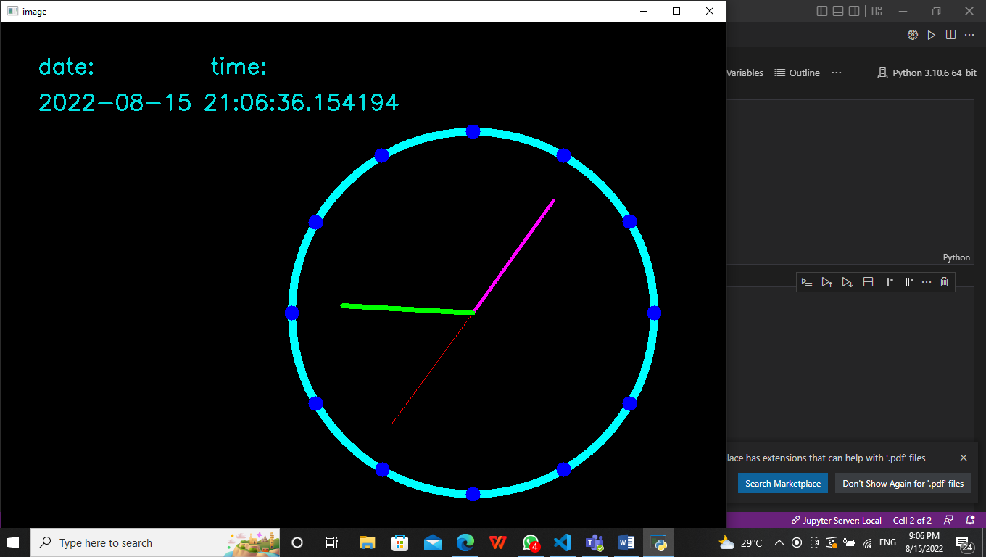

This is the run of the code .

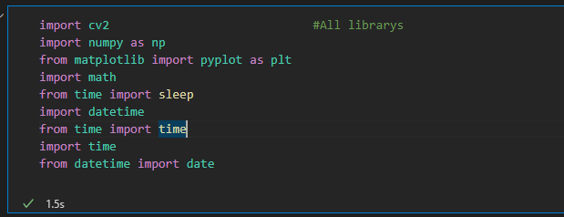

This is a group of libraries needed to complete the project

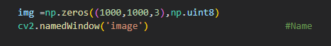

We wrote this code to make black background with big size named ‘image’

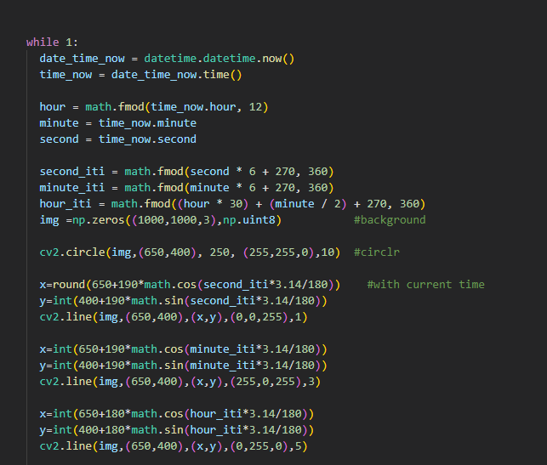

I used this code with these complex equations to relate the clock to the current time

I drew a circle with scorpions inside

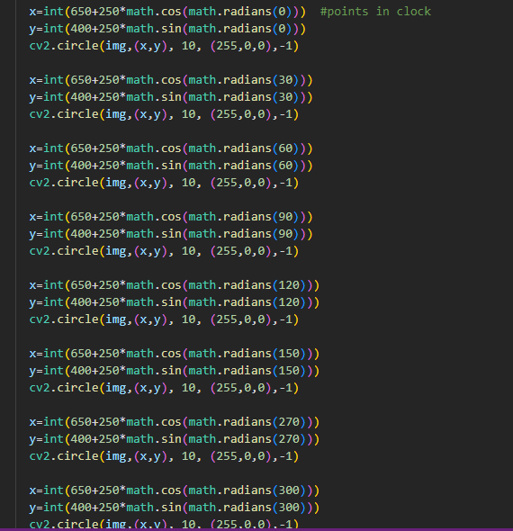

I drew points to make good clock

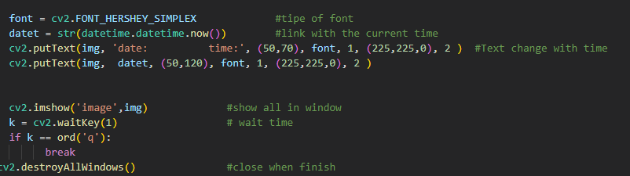

Finally I wrote date and time digital that move with current time and show it in window